BRAND QUESTIONNAIRE

Thank you for choosing GS Creative Services for your brand design. To create a brand that perfectly represents your company and meets your expectations, please take a few minutes to fill out this questionnaire. Your responses will guide the design process.

If you do not know the answer to a question, leave it blank.

1. Brand Overview:
- What are the mission and core values of the Brand?

- Can you describe the spirit or personality of the Brand in a few words?

2. Target Audience:
- Please describe your primary audience. What are some key characteristics of your typical client?

- What do you want your audience to think or feel when seeing your logo and brand?

3. Design Preferences:
- Do you want to include any specific colors, fonts, or symbols in the logo and brand?

- Are there any design elements you do not want included in the logo and brand?

4. Logo Usage:
- Where will the logo primarily be used? (e.g., digital, print, merchandise)

5. Competitors and Differentiation:
- Who are your main competitors?

- What differentiates your brand from these competitors?

6. Project Details:
- What is your deadline for the brand?

- Do you have a specific budget range for this project?

10. Communication Preferences:
- How would you like to receive updates and provide feedback throughout the project?

- What is the best way to contact you for quick questions or clarifications?

PRICING

To align my design efforts with your financial planning, it is crucial to understand the pricing for the branding project.

A basic branding package typically lands between $1,500 to $5,000.
(See list below for brand deliverables)

GSCS Price for your brand: $1,500-$5,000

More consultation will be involved throughout the design process.

GS Creative Services Brand Deliverables

- Logo Design
  - Main logo in various configurations
  - Alternative logo versions for different uses
  - Scalable vector files (SVG)
  - Raster files (JPEG, PNG)
  - Black/white and monochrome versions
  - Logo usage guidelines
- Brand Guidelines Document
  - Overview of brand identity (mission, vision, values)
  - Detailed color palette (CMYK, RGB, Pantone, HEX codes)
  - Typography specifications
  - Imagery and iconography guidelines
- Stationery Suite
  - Business cards
  - Letterhead design
  - Email signature design.
- Digital Assets
  - Social media graphics and icons
  - Digital advertising templates
  - Presentation templates (e.g., PowerPoint)
- Website Design
  - Wireframes and web design mockups
  - User interface (UI) elements
  - Icons and buttons
  - Responsive design for mobile and tablet

- Marketing and Promotional Materials
  - Brochures and flyers
  - Posters and banners
  - Promotional merchandise designs (e.g., T-shirts, tote bags)
- Advertising Materials
  - Print and digital ad designs
- File Handover
  - All final design files in their native and applicable formats
  - Usage documentation for each file type
- Support and Revisions
- Details on the scope of post-delivery support
- Number of included revisions and conditions for additional work

Thank you for taking the time to fill out the form. If you have any questions, please write them below:

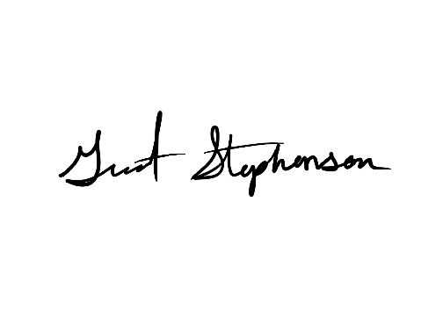
If you have any additional information or documents that could inform my design process, feel free to include them.

Thank you.

Contact:
Email: grant@gscreativeservices.com
Phone: (810) 580-0126


