LOGO QUESTIONNAIRE

Thank you for choosing GS Creative Services for your logo design. To create a logo that perfectly represents your company and meets your expectations, please take a few minutes to fill out this questionnaire. Your responses will guide the design process.

If you do not know the answer to a question, leave it blank.

1. Brand Overview:
- What are the mission and core values of the brand/logo?

- Can you describe the spirit or personality of the brand/logo in a few words?

2. Target Audience:
- Please describe your primary audience. What are some key characteristics of your typical client?

- What do you want your audience to think or feel when seeing your logo?

3. Design Preferences:
- Do you want to include any specific colors, fonts, or symbols in the logo?

- Are there any design elements you do not want included in the logo and brand?

4. Logo Usage:
- Where will the logo primarily be used? (e.g., digital, print, merchandise)

5. Competitors and Differentiation:
- Who are your main competitors?

- What differentiates you from these competitors?

6. Project Details:
- What is your deadline for the logo?

10. Communication Preferences:
- How would you like to receive updates and provide feedback throughout the project?

- What is the best way to contact you for quick questions or clarifications?

PRICING

To align my design efforts with your financial planning, it is crucial to understand the pricing for the logo.

Logo

A basic logo typically lands between $250-$500.
(See list of examples below)

Small Business or Startup: $300 to $1,500. This range is suitable for smaller businesses that need a basic but professional logo.

Mid-size Businesses: $1,500 to $5,000. Companies in this category often require a more unique, researched, and strategically thought-out logo.

Large Businesses or High-End Custom Logos: $5,000 to $30,000 or more. This price includes extensive brand identity development, multiple revisions, and high-touch customer service from top-notch design agencies.

More consultation will be involved throughout the design process.

GS Creative Services Logo Process

- Research
- After the form is completed, we can meet on zoom or in-person to discuss initial thoughts on the information you have provided. After, this consultation I will start my research phase

- GSCS Mood Board
- A GSCS Mood Board is a curated collection of images, colors, textures, typography, and design elements that represent the look and feel you want for your logo. It serves as a foundational guide, helping us to visualize and conceptualize the design direction before starting the actual work.

- Sketch Phase
- During this phase, we transform the ideas and inspiration gathered from the GSCS Mood Board and logo questionnaire into opening visual concepts. This stage allows me to explore various design directions and ensure that we are on the right track before moving into more detailed and refined designs.

- Rough Drafts
- The Rough Drafts phase is where I begin to transform the initial sketches into more detailed and structured design concepts. 2-3 Roughs will be provided for you to choose from. This phase bridges the gap between rough ideas and refined designs, allowing me to develop the logo.

- Finals
- The Finals phase is the finale of my design process. During this phase, I take the refined rough drafts and develop them into fully, high-quality final designs. 1-2 Finals will be provided for you at this phase. This is where every detail is perfected to ensure that the result meets and exceeds your expectations.

- Final Logo and Deliverables
- In the Final Logo and Deliverables phase at Grant Stephenson Creative Services (GSCS), we provide you with all the necessary files and materials for your new logo.
What Happens:
- Final Touches:
  - We make any last adjustments to ensure your logo looks perfect.
- High-Quality Files:
  - We create high-resolution versions of your logo.
- Logo Variations:
  - We provide different versions of your logo (full-color, black and white, etc.).
- File Formats:
  - You receive your logo in multiple formats (AI, EPS, PDF, PNG, JPG, SVG).
- Brand Guidelines:
  - We give you a guide on how to use your logo correctly.
- Additional Materials:
  - Depending on your needs, we can also provide business cards, letterheads, and social media images.

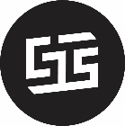

Thank you for taking the time to fill out the form. If you have any questions, please write them below:

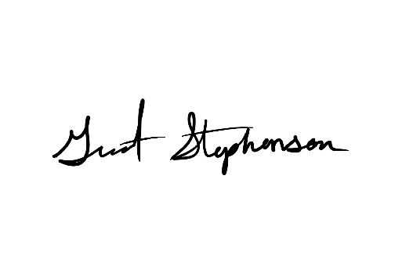
If you have any additional information or documents that could inform my design process, feel free to include them.

Thank you.

Contact:
Email: grant@gscreativeservices.com
Phone: (810) 580-0126

