**PERSONAL REQUEST QUESTIONNAIRE**

Thank you for choosing GS Creative Services for your personal design needs. To create a design that perfectly represents your expectations, please take a few minutes to fill out this questionnaire. Your responses will guide the design process.

If you do not know the answer to a question, feel free to leave it blank.

**Examples of Personal Design Requests:**

**Custom Artwork:**

* Personalized illustrations
* Custom digital art

**Event Invitations:**

* Wedding invitations
* Birthday invitations
* Baby shower invitations
* Holiday cards

**Personal Branding:**

* Personal logos
* Custom business cards
* Resume design

**Social Media Graphics:**

* Social media branding
* Profile pictures
* Banners

**Print Materials:**

* Custom letterheads
* Custom greeting cards

**Custom Sports Edits:**

* Sports poster
* Sports edit

**Photo Editing:**

* Photo retouching
* Background removal
* Photo color correction
* Photo collages

**Resume and Portfolio:**

* Custom resumes
* Digital portfolios
* Printed portfolios

**Education and Learning:**

* Custom flashcards
* Personalized study guides
* Custom educational posters

**PRICING**

To align my design efforts with your financial planning, it is crucial to understand the pricing for your personal request. Consultation will be involved throughout the design process based on the personal request.

**Please fill out the form below.**

If you do not know the answer to a question, feel free to leave it blank.

**1. Personal Information:**

* Name:
* Email Address:
* Phone Number:
* Preferred Method of Contact:

**2. Project Overview:**

* What type of design are you requesting? (e.g., custom artwork, event invitations, personal branding, social media graphics)
* Briefly describe your project and what you hope to achieve:

**3. Design Preferences:**

* Do you have any specific colors, fonts, or styles you prefer?
* Are there any design elements or styles you do not want included?
* Please provide links to any inspiration or reference designs you like:

**4. Purpose and Goals:**

* What is the primary purpose of this design? (e.g., personal use, gift, event promotion, social media)
* What message or feeling do you want the design to convey?

**5. Audience:**

* Who is the intended audience for this design?
* Are there any specific characteristics or preferences of the audience we should consider?

**6. Content:**

* Do you have any existing content (text, images, logos) that should be included in the design?
* Will you need help with content creation (e.g., copywriting, photography)?

**7. Timeline and Budget:**

* What is your desired completion date for the project?
* Do you have a budget range in mind for this project?

**8. Review and Feedback:**

* How would you like to receive updates and provide feedback throughout the project? (e.g., regular emails, scheduled calls)
* What is the best way to contact you for quick questions or clarifications?

**9. Final Deliverables:**

* What file formats do you need for the final design? (e.g., JPG, PNG, PDF, AI)
* Will you need any additional materials? (e.g., printed copies, social media versions)

**10. Additional Information:**

* Is there any other information you would like us to know about your project?
* Do you have any questions or concerns about the design process?

**Thank you for taking the time to fill out the form. If you have any questions, please write them below:**

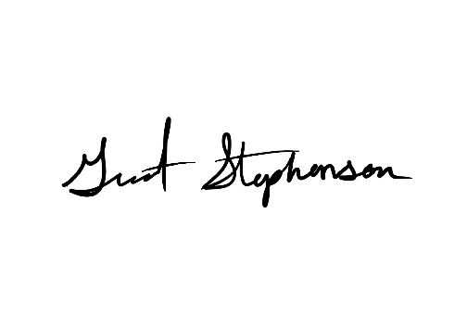If you have any additional information or documents that could inform my design process, feel free to include them.

Thank you.

**Contact:**

**Email:** grant@gscreativeservices.com

**Phone:** (810) 580-0126