**WEBSITE QUESTIONNAIRE**

Thank you for choosing GS Creative Services for your website design needs. To create a website that perfectly represents your company and meets your expectations, please take a few minutes to fill out this questionnaire. Your responses will guide the design process.

If you do not know the answer to a question, feel free to leave it blank.

**1. Company Information:**

* Company Name:
* Contact Person:
* Email Address:
* Phone Number:
* Current Website (if applicable):

**2. Project Overview:**

* What is the main purpose of your website? (e.g., informational, e-commerce, portfolio, blog)
* What are your primary goals for the website?

**3. Target Audience:**

Who is your primary audience?

What are some key characteristics of your typical clients?

What do you want your audience to think when they visit your website?

**4. Design Preferences:**

Do you have any specific colors, fonts, or styles you prefer for the website?

Are there any design elements or styles you do not want included in the website?

Please provide links to websites you find inspiring or would like to model your site after.

**5. Content:**

* Do you have existing content (text, images, videos) ready for the website?
* Will you need help with content creation (e.g., copywriting, photography)?
* What key pages do you need? (e.g., Home, About, Services, Contact, Blog)

**6. Features and Functionality:**

* What specific features or functionalities do you need? (e.g., contact forms, e-commerce, blog, booking system)
* Are there any third-party services or tools you need integrated? (e.g., CRM, email marketing tools)

**7. Technical Details:**

* Do you have a domain name and hosting service? If so, please provide details.
* Are there any specific technical requirements or preferences? (e.g., CMS preference, mobile responsiveness)

**8. Timeline and Budget:**

* What is your desired launch date for the website?
* Do you have a budget range in mind for the website project?

**9. Maintenance and Updates:**

* Will you need ongoing maintenance and updates for the website?
* Would you like training in how to update and manage the website yourself?

**10. Additional Information:**

* Is there any other information you would like us to know about your project?
* Do you have any questions or concerns about the website design process?

**PRICING**

To align my design efforts with your financial planning, it is crucial to understand the pricing for the website.

**Website**

**Website Design Costs**

Here are some example costs for different types of websites:

**Basic Website**

* **Cost**: $500 - $1,500
* **Includes:** Up to 5 pages, basic design, mobile-friendly, contact form, initial SEO.

**Standard Business Website**

* **Cost: $1,500 - $2,500**
* **Includes:** Up to 10 pages, custom design, enhanced SEO, advanced contact forms, blog setup.

**E-commerce Website**

* **Cost: $2,500 - $4,000**
* **Includes:** Online store setup, product pages, shopping cart, payment integration, basic inventory, SEO.

**More consultation will be involved throughout the design process.**

**Website Design Process**

1. **Initial Consultation**
   * After you complete the form, we can meet via Zoom or in-person to discuss your vision and initial thoughts. This helps us understand your needs and set clear goals for your website.
2. **Research and Planning**
   * We conduct research based on your industry, competitors, and target audience. This helps us create a solid foundation and strategy for your website design.
3. **GSCS Inspiration Board**
   * We create a GSCS Inspiration Board, a curated collection of images, colors, fonts, and design elements that represent the look and feel you want for your website. This guides the design direction.
4. **Wireframing**
   * During this phase, we create basic wireframes or blueprints of your website’s layout. This helps us plan the structure and flow of the website before adding design elements.
5. **Design Phase**
   * We transform the wireframes into detailed visual designs. This includes selecting colors, fonts, and images to create a cohesive look. You will be presented with design concepts to review and provide feedback.
6. **Development**
   * Once the design is approved, we start building your website. This involves implementing the design into a functional website. We ensure the website is responsive and works well on all devices.
7. **Content Integration**
   * We add your content (text, images, videos) to the website.
8. **Testing and Review**
   * We thoroughly test the website for any issues. This includes checking functionality, browser compatibility, and mobile responsiveness. You will have the opportunity to review the website and request any final changes.
9. **Launch**
   * After final approval, we launch your website. We ensure everything is set up correctly, including domain, hosting, and any necessary integrations.
10. **Support**
    * Ongoing support is available to ensure your website continues to run smoothly.
11. **Maintenance and Updates**
    * If you need ongoing maintenance, we offer plans to keep your website updated and secure.

By following this structured process, GS Creative Services ensures that your website is designed to meet your goals and exceeds your expectations.

**Thank you for taking the time to fill out the form. If you have any questions, please write them below:**

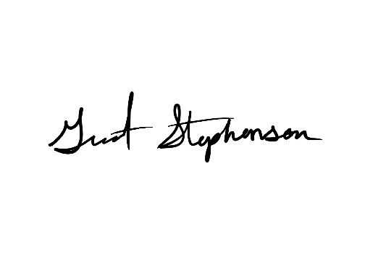If you have any additional information or documents that could inform my design process, feel free to include them.

Thank you.

**Contact:**

**Email:** grant@gscreativeservices.com

**Phone:** (810) 580-0126