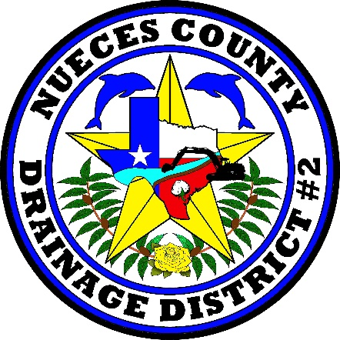

MEETING CANCELLATION

Due to a lack of quorum,
The November 12, 2019,
Nueces County Drainage District No 2
Meeting has been canceled.
All agenda items will be heard at the next regularly scheduled meeting of
November 26, 2019.

