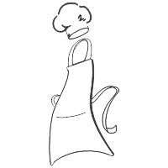
Nana Clare’s Kitchen
Basic Decorating Cake Classes &
Basic Cake Class Fun
Registration Form - 2023
*Please fill out one form for each participant*
Student Name (Please Print clearly)_____________________________________
Age:______________ Birthday:_____________
Address:__________________________City:___________________Zip:___________
Phone________________________ Email:______________________________
If participant is under 18 years of age, please fill out the following parent information:
Mom’s Name:_____________________ Cell Number:____________________________
Dad’s Name:______________________ Cell Number:____________________________
*Emergency Contact:_____________________________________________________
Phone:____________________________ Relationship:__________________________
May we use images of your child in future NCK brochures, ads, web page, FB or literature? Y / N
Please advise ALL food allergies or sensitivities here:
______________________________________________________________
Payment Information

June 28th - $35.00 $__________

Total $_________
Check #______________

Credit Card Info:
Type:________ Card #:_______________________
Exp:__________ Security Code:________________
Zip of billing address:_____________________

Signature:_________________________________
Basic Decorating Cake Classes & Basic Cake Class Fun

Basic Cake Class Fun
Wednesday, June 28th 5p – 7p

*They will bake their own 2 layer cake
*They will learn to smooth frost and a few basic decorating techniques
*They will create their own design/image

Payments are NON REFUNDABLE
But we will turn it into credit towards any other Nana Clare’s hosted program/class.

