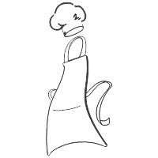Nana Clare’s Kitchen/

Sugarfield Flowers

***Event Registration Form***

***2020***

Name(s):_________________________________________________________________

Name(s):_________________________________________________________________

Address:____________________________ City:____________________ Zip:_____________

Phone:_______________________________ Email:________________________________

May Nana Clare’s Kitchen or Sugarfield Flowers use images of you in future brochures, ads, web, FB or literature? **Y / N**

How did you hear about the event?_______________________________________

List any allergies that we should be aware of:______________________________________

___________________________________________________________________________

**Payment Information**

**Adult $60 X_____ = $__________**

**Child (12 – 17) $60 X_____ = $__________**

**Total** **$_________**

**Check #**______________

**Credit Card Info:**

Type:________ Card #:_____________________________

Exp:__________ Security Code:________________

Zip of billing address:_____________________

Signature:_________________________________

**Create & Bake Event**

**Wednesday, April 8 / 7p – 9p**

**Create a Spring bulb centerpiece with Kris**

**Bake “no fuss” Easter breads with Gina**

**This event is very hands-on. You will create and bake yourself with our instruction.**

**You will go home with all of your creations!**

**Cancel Policy:**

**Non-refundable within 10 days of the event**

**Outside of 10 days, $25 will be withheld**