Olympia Lions Recycling Project –
Keeping plastic out of our landfills & Puget Sound
For information contact: Olympia Lions 360 790 8667

Please collect these plastics. All plastic must be clean, dry, and completely free of food or other debris.

- Plastics marked with the number:
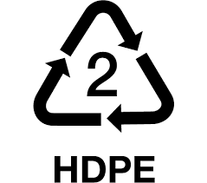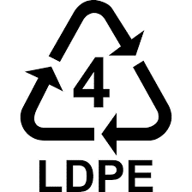

2 High-density polyethylene or 4 Low-density Polyethylene
- Plastic that stretches (if no number on item, then the item must stretch)
- Produce & bread bags
- Grocery bags
- Cereal box liners
- Ice bags
- Ziploc & other re-closable bags
- Case overwrap – like wrap on bulk tissue or water
- News paper bags
- Amazon, Macys, Costco plastic order bags (please turn inside out)
- Plastic shopping bags
- Bubble wrap and plastic envelopes with bubble wrap lining
- Shrink wrap film – but not Saran type kitchen wrap
- Salt bags

We cannot recycle
- Plastic that makes a crinkling sound or that does not stretch.
- Hard plastic type of containers, etc.
- Paper envelopes lined with plastic bubbles attached to the paper.
- Plastic bags from dog food
- Kitchen food wrap

