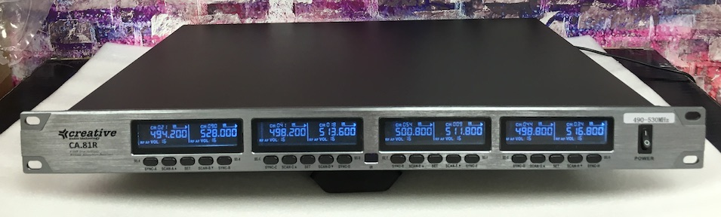

CREATIVE is a brand of Reilly SR LLC/bodymics 283 Lincoln Blvd, Middlesex NJ 08846 ph: 908-899-1277

**OCTO (8) TRUE DIVERSITY WIRELESS SYSTEM**

**CA.81**

8 receivers in 1u rack mount case

8

**CHANNELS**

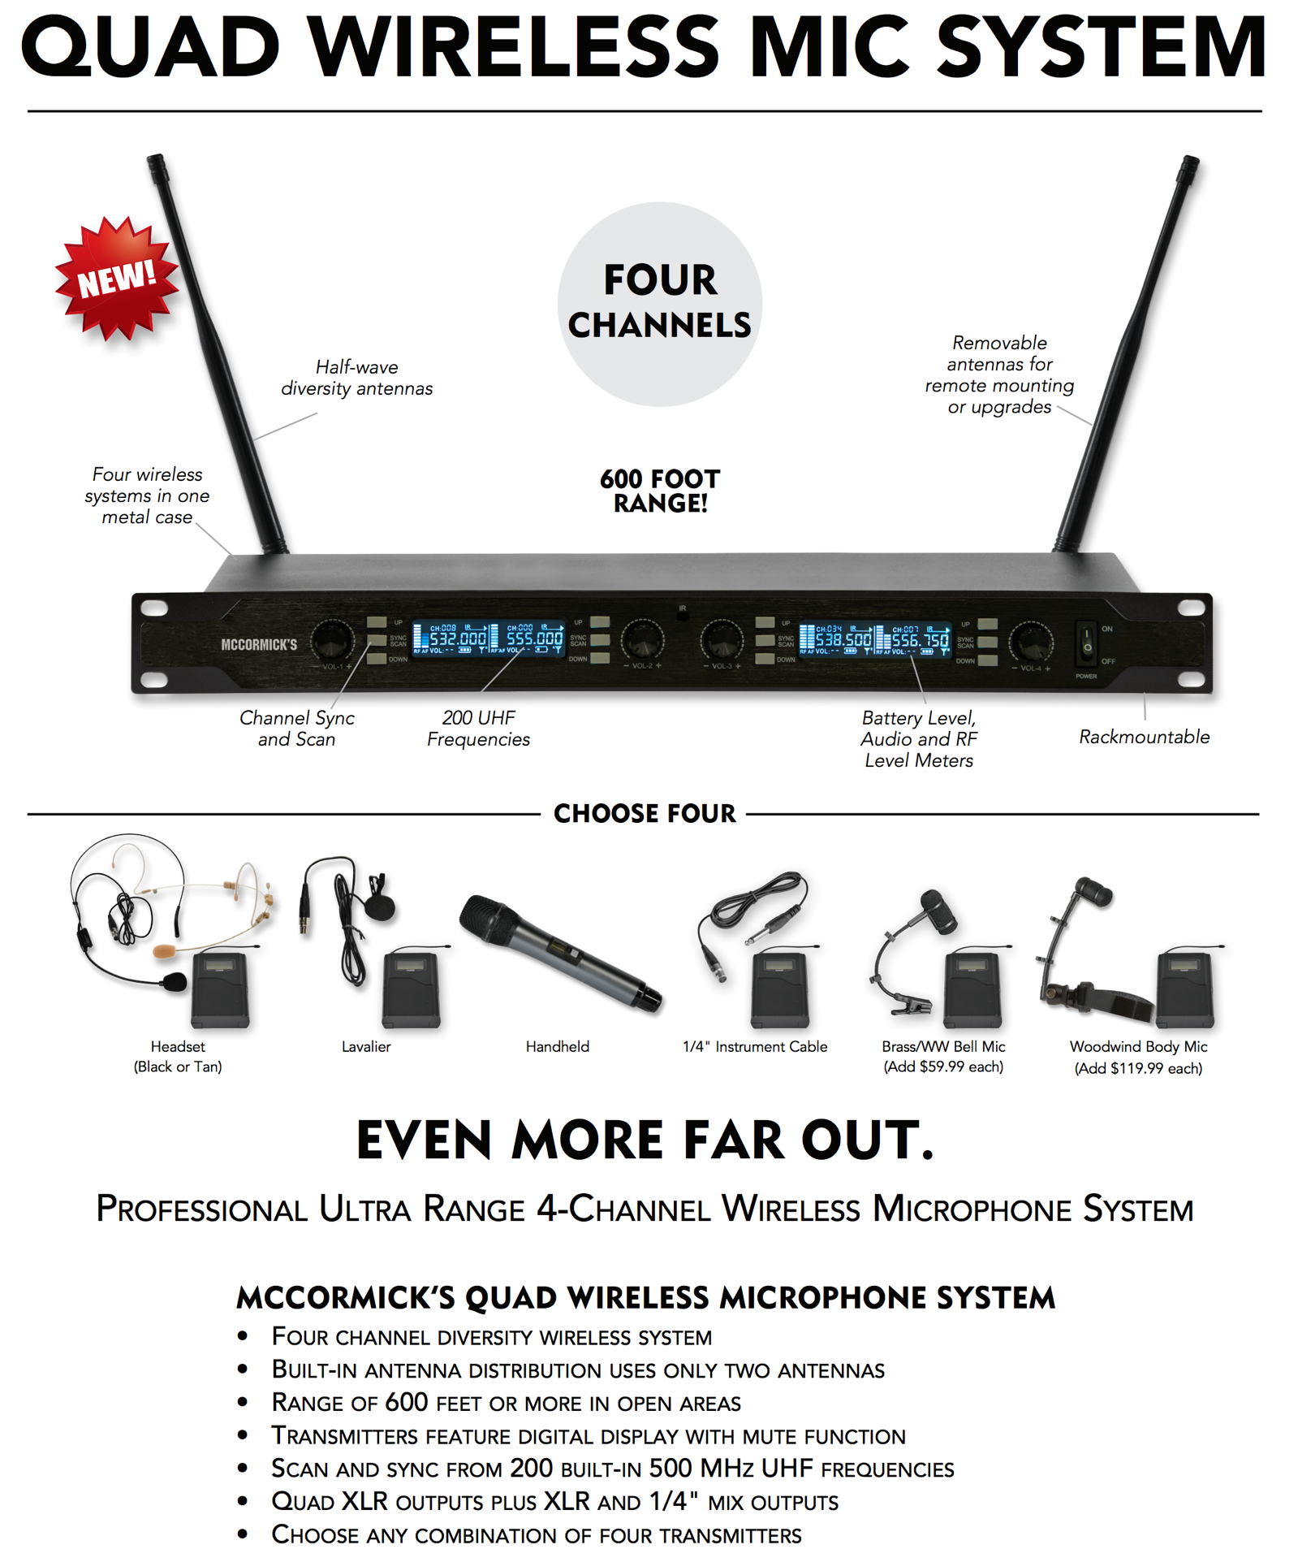

**SELECT TRANSMITTER**

**.. BODYPACK**

**.. HANDHELD**



**CA.81**

.. EIGHT TRUE DIVERSITY RECEIVERS IN A 1u RACK MOUNT CASE

.. BUILT-IN ANTENNA DISTRIBUTION – 4 ANTENNAS TOTAL

.. TRUE DIVERSITY RECEIVERS ENSURE MINIMAL DROP OUTS

.. AVAILABLE IN TWO FREQUENCY BANDS – 490-530MHZ & 530-580MHZ

.. UP TO 64 CHANNELS POSSIBLE IN APPRPRIATE LOCATIONS

.. SCAN FOR OPEN FREQUENCIES – ~400 AVAILABLE CHANNELS PER BAND

.. INFRA-RED TRANSMITTER SYNC

.. MUTE FUNCTION AND LOCK FUNCTIONS ON ALL TRANSMITTERS

.. EIGHT (8) TRUE BALANCED XLR OUTPUTS + A ¼” MIX OUTPUT

.. WE CAN MIX AND MATCH TRANSMITTER OPTIONS – BODYPACKS OR HANDHELDS

.. BODYPACKS COME WITH A ¼” OMNI LAVALIER MICROPHONE IN CREAM

Transmitter SYNC

Open Channel SCAN

RF Vertical Bar Meter

Audio Level Bar Meter

Battery Level Meter

Transmitter Mute Indicator

Power Switch

SPECIFICATIONS

System CA.81:

Carrier Frequency: G: 490-530MHz and H: 530-580MHz

Frequency Stability: 0.05%

Modulation Type: FM

Frequency Response: 40Hz – 18kHz

Signal to Noise Ratio: >105dB

Total Harmonic Distortion: <=0.5%

Workable Range: 500FT (160m) clear line of sight

Safe Operating Temperature: -5 to +133 degree F (-20 to +60 degrees C)

Receiver CA.81R:

Tuning System: PLL Loop, True Diversity Antennas (2 sets)

Sensitivity: -105dB

Signal to Noise Ratio: >105dB

Mix Out Level: Unbalanced .” Tip Sleeve – 0.5v @ 5k ohms

Balance XLR Output Level: Balance Line on XLR – 0.5v @ 2k ohms

Power Requirement: 12-15v DC @ 2A (included power supply)

Dimensions: 19” x 1.75” x 12” (plus connectors)

Weight: 8lb 13oz (4.0kg)

Transmitters (Common Specs)

Transmitter Power: 5mW or 10mW selectable

Spurious Emission: >45dB

Battery Requirement: 2x AA Alkaline or NiMH cells

Current Consumption: 100-130mA

Battery Life: approx. 8 hours on premium alkalines

Bodypack Transmitter CA.81B:

Dimensions (HxWxD): 4.25” x 2.375” x 0.8” (plus antenna & belt clip)

Weight: 3.1oz (88g) (plus batteries)

Bodypack Handheld CA.81H:

Dimensions (HxWxD): 10.25” x 2.” dia”

Weight: 10.6oz (302g) (plus batteries)

WARRANTY – 2 YEAR LIMITED

Reilly SR LLC – CREATIVE AUDIO TECHNOLOGY– warrants this product against faulty

materials or workmanship for 2 years from date of purchase. Coverage DOES NOT extend to

physical damaged incurred after delivery, damage caused by failing to follow the guidelines in

this instruction guide, damage caused by any attempt to repair the item by third parties or

any product that has had its Serial Number erased, changed or removed.

We will repair or replace covered items at our discretion.

Email us at [creative@av2020.com](mailto:creative@av2020.com) before returning an item