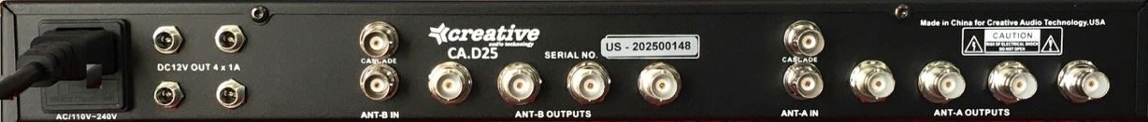

**SPECIFICATIONS:**

Operating Frequency: …………….…………... 470-928MHz

Gain: ………………....………….…………………….. 6dB

Antenna Input Connector: …………….…..……. 50ohm BNC

Antenna Cascade Output Connector..….……..… 50 ohm BNC

Antenna Output Connectors: …………...……… 50ohm BNC

AC Power Input: …..………………..…… 100-265v AC on IEC

DC Output Connector: ........................ 5.5 x 2.1mm DC Coaxial

DC Output: ..……………………. -12v DC max 55watts (4.6A)

Dimensions (WxHxD) ------------- 19” x 1.75” x 7” plus connectors

Weight (net) ……………..

Weight Packaged: ………

**IN THE BOX:**

* Antenna Distributor
* IEC Power Cable – 5-6ft
* 8x BNC-BNC cables 8”,10, 12”
* 4x DC cables
* Instructions

**FEATURES:**

The Creative Audio Technology CA.D25 is a dual 4 way antenna distribution unit with cascade outputs operating wideband in the UHF 470-928MHz bands..

* BNC inputs
* BNC cascade outputs
* BNC outputs (with 8x short BNC-BNC cables)
* IEC AC power input with (5-6ft IEC to Edison able)
* 4x 5.5x2.1mm DC outputs (with 4x locking DC out cables)
* Built in 60w 12v DC power supply
* DC voltage and current meters

**FLAT RATE SERVICE:**

We will repair your CA.D25 for a flat rate for any reason, failure out of warranty, broken, damaged.

See [www.bodymics.com.flatrateService.html](https://www.bodymics.com/flatrateservice.html) for details.

**WARRANTY – 24 MONTHS:**

Reilly SR LLC – Creative Audio Technology – warrants this product against faulty materials or workmanship for 2 years from date of purchase. Coverage DOES NOT extend to physical damaged incurred after delivery, damage caused by failing to follow the guidelines in the instruction guide, damage caused by any attempt to repair the item by third parties or

any product that has had its Serial Number erased, changed or removed. We will repair or replace items at our discretion.

**CA.D25**

**CA.D25 ANTENNA DISTRIBUTION UNIT**

Dual 4 way plus cascade antenna distribution amplifier