HYBOT INC ALASKA

55-Gallon Barrel Wood Heat Assembly

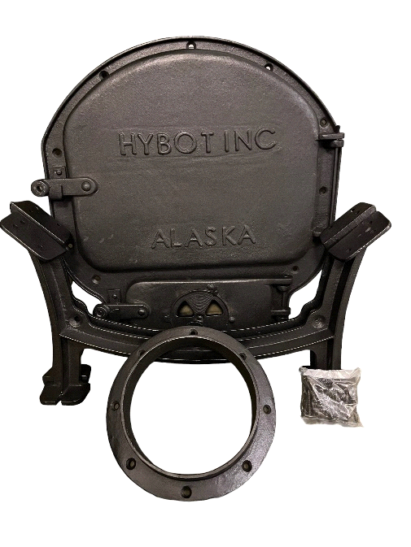

INSTRUCTIONS FOR ASSEMBLY: Video Tutorials at www.hybotinc.com

* Stand barrel on one end depending on which heat assembly you are using. Large: use the end of the barrel that is flat and without bung holes. Medium assembly you can use the end with bung holes. If you put the large bung hole at the bottom you can use it as a secondary air flow if needed.
* Set the frame and doors where you want it positioned on the top of the barrel. Open large and small doors and scribe or trace the area on the inside edge of the frame Sharpie works best.
* Cut the openings for the small and large doors using a cutting wheel or jigsaw. Make sure you cut off the line about 1/8 of an inch to ensure that the door frame will slide down into the barrel and fit correctly. Do not force the frame into the barrel top as it will cause it to buckle the metal. Do not install main frame at this point.
* Place legs on the floor less than barrel length apart. Ensure feet are facing out towards ends of barrel. The flat side of legs go inward towards middle. Place barrel on top of legs. Ensure the cut door is centered and straight on the legs before marking. The best practice is to measure with your fingers the distance from the edge of the barrel front and rear. Make it 2-3 fingers distance from the edge. Make sure the barrel is level on the legs to ensure it does not teeter in either direction. This can be done by lifting slightly and sitting back down on the legs to ensure level. Mark the screw leg holes with a sharpie or nail.
* Place 6-inch flue on top of barrel, ensure it is centered and straight to ensure proper fit of stove pipe. Placement is normally 1 inch from the back edge to ensure you get past the inside ring. Mark the front screw hole and the back screw hole. Mark your 6-inch flue hole by drawing a line around the inside.
* Remove flue, cut marked 6-inch flue hole. Ensure to cut off the line slightly so metal is not protruding from the edges when you put the flue on. Drill small pilot holes front and back holes only for your metal screws.
* Take barrel off legs and turn over and drill small pilot holes for your metal screws.
* Screw legs in place. Make sure not to over tighten the screws as it is possible to break cast iron legs if over tightened.
* Paint barrel with 2000-degree high heat paint. If you want to paint your barrel, ensure that you have removed all previous paint or impurities from the surface. Doing so will help keep your barrel from rusting. 2000-degree paint will not burn off.
* After the barrel is painted and dried. Install 6-inch flue by screwing down front and back hole, lining up with your pilot holes. Pre-drill remaining holes for the flue and screw down do not over tighten. For main frame drill top hole and bottom hole first and screw down so you can predrill the rest of the holes and the frame will stay in place. Install Frame and doors with metal screws. Fill with wood or other burning materials and enjoy…
* If you want to install a damper, suggest installing a minimum of 12” above the wood stove in the stove pipe. This helps with air flow and draft.

**Note:** For the best results use the sanding wheel on grinder to remove paint from your barrel. Burning paint off does not remove all the paint. (Burning paint is toxic, be safe) 1/8 inch Pilot holes are just to get your metal screws started. Make sure your pilot holes are small. Do not over tighten your screws. There is no need to. Use PH 3 Phillips head bit for metal screws. PH 3 fits perfect.

For more information on safety, and installation videos visit our website: **hybotinc.com**