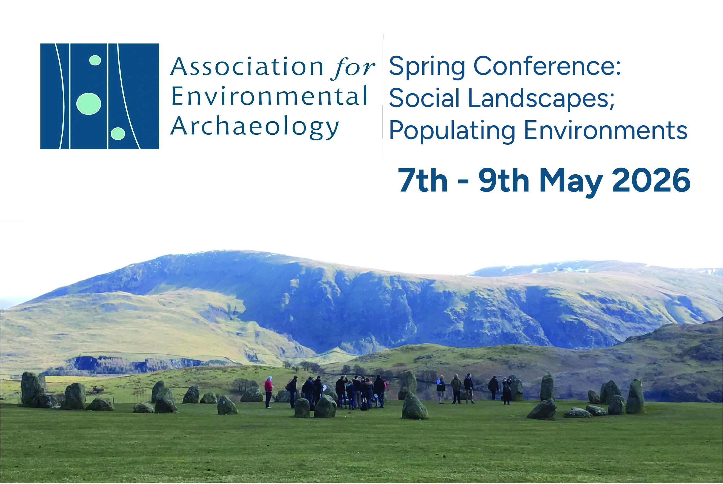


Draft
Conference Booklet

Welcome
Welcome to the University of Lancashire, Preston, Uk and spring conference of the Association for Environmental Archaeology.

The theme of this this is ‘Social landscapes; populating environments’, which allows us to focus on people and how environmental reconstructions can help us understand the social landscapes they inhabited.
The conference has a wild range of papers covering many different time periods exploring the interplay between people and environments, not just as drivers of environmental change, but as embedded agents, reacting and adapting through practical and social actions. We are also pleased to have papers that explore the social dimension, using environmental archaeology offers a tool for exploring the lives of people and non-human animals. Overall, the conference aims to foster a dialogue on how our discipline can contribute towards understanding the lives of those living within the environments we study.

The conference is hosted by Archaeology & Anthropology at the University of Lancashire. The University of Lancashire has a long history, established in Preston in 1828 as the Institution for the Diffusion of Knowledge. It most recently in 2026 changed its name from the University of Central Lancashire (UCLan) to the University of Lancashire. We are one of the youngest archaeology departments in the UK, being established in 2005. From the small beginnings of two members of staff, we have grown to become an established team and discipline within the university.

You’ll find the University and the city of Preston to be a small but friendly place. With our wide range of engaging papers, poster presentations and keynotes over the conference we will have many opportunities to engage with the above themes, meet friends and have a fun time talking all things environmental archaeology.

Organising Committee and Helpers
The conference is organised by Dr James (Jim) Morris and Dr. Jennifer (Jen) Jones.
They are assisted by Dr Monica Garcia, Hannah Gardiner, Catherine Sharpe, Sarah Hunt, Howell Garside and Jessica Atkinson.

Venue
The conference is held in the Foster Building of the University of Lancashire, Preston. Registration will be by the main entrance to the building. The main entrance faces Kendal St a small pedestrian street just off Corporation St.

The Thursday keynote lecture will be in Foster Lecture Theatre 2 followed by a drinks reception in on the student centres roof terrace.

The Friday and Saturday talks will be in Foster Lecture Theatre 1, just beside registration. Coffee and lunch will be provided in the Scholars canteen also within the Foster building.

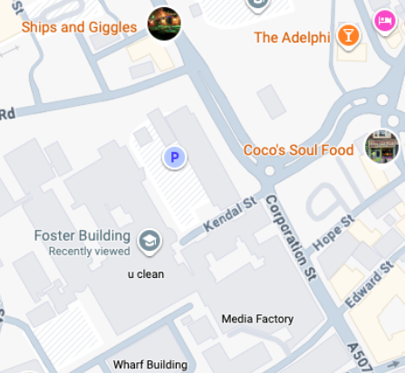
Google map link to the main entrance to Foster Building https://maps.app.goo.gl/wdZSVBWKf17LYL7h9
What3words ///gates.line.logo

Timetable
Thursday 7th May
The registration desk in the main entrance to foster will be open from 16.30.

18.00 Welcome and Keynote Prof Jacqui Mulville
19.00 Wine reception
20.30 We have booked tables at the Chew’s Yard Food Hall and everyone is welcome to join us there.

Friday 8th May
Time | Author | Paper title
9.50am |  | Welcome
10.00am | Kay Hamilton | Embedded Landscapes, Sculpting Environments: Human–environment interactions across 6000 years in five upland sites
10.20am | Isobel Harvey, Nicki Whitehouse, Eileen Tisdall & Derek Alexander | A Cultural and Natural History of Scotland's Peatlands
10.40am | Sarah Ruth Hunt | An attempt to understand Heaning Wood Bone Cave Faunal Deposit
11.00am |  | Coffee break
11.40am | Samantha Jones, Campbell, E & Holliday, N: | Farmers, monks and raiders: exploring cultural and environmental transitions in the Inner Hebrides during the 1st millennium AD
12.00pm | Zara Evans, Samantha Jones & Linus Girdland Flink | Optimizing sedaDNA for multiproxy environmental reconstruction: a case study at Loch Gàrradh a’ Chapuill
12.20pm | Julia Best | Small shoreline stories
12.40pm |  | Lunch Break
1.30pm | Fraser Brown | Keynote
2.30pm |  | Poster presentations and coffee
3.20pm | Victoria García-Martínez, Marta Portillo & Francisco Contreras | Management of plant resources in Bronze Age southeastern Iberia analysing phytoliths and calcitic microfossil evidence.
3.40pm | Molinari Chiara, Menozzi Bruna Ilde, Menéndez-Blanco Andrés, Santeramo Riccardo & Stagno Anna Maria | Environmental resources management in NW Iberian mountains over the last millennium: a multi-proxy analysis
4.00pm | Mónica Fernández-García, Pere M. Guillem Calatayud, Cristina Real & Valentín Villaverde | LGM environmental impact in Iberia: stable isotope data from the Upper Paleolithic sequences of Cova de les Cendres and Cova de les Malladetes
4.20pm | Jeniffer Jones, James Morris, Hannah Gardiner & David Robinson | California Cattle Rustling
4.40pm | Closing discussion

Saturday 9th May

Time | Author | Paper title
9.50am |  | Welcome
10.00am | Yuxi Xie, Amy Bogaard & Michael Charles | Early Neolithic Plant Use Strategies at WF16, Southern Jordan: An Archaeobotanical Perspective
10.20am | Phil Gould | People and Changing landscapes: Palynological and Archaeological Analysis of Landscape Change in the Scottish Highlands, 1250 AD-present
10.40am | Don O’Meara | Going against the grain: oat cultivation in medieval Cumbria
11.00am |  | Coffee
11.40am | David Robinson | Rock art in the landscape
12.00pm | Tomás Paya & Kevin Lane | Water and Stone: Hydraulic Engineering, Rock Art and Social Landscapes in Prehispanic Northwest Argentina
12.20pm | Kate Dudgeon, Albert Gaitan-Roca & Umberto Lombardo | LiDAR mapping of Pre-Colombian engineered landscapes in the Llanos de Moxos, Bolivia
12.40pm |  | Lunch
1.30pm | Kate Britton | Keynote and poster prize awarded
2.30pm | Neal Payne, Rachel Ballantyne, Matthew Brudenell, Joshua Harry, Vida Rajkovača & Phil Stastney | Five and a half millennia of agriculture in the Fens: new perspectives from large-scale archaeological data
2.50pm |  | Coffee break
3.20pm | Djernæs, S. H., F. Reide, N. N. Johannsen, & S. M. Kristiansen | Soil analytical evidence of early horticulture in Southwest Scandinavia
3.40pm | Jonas Bergman | Archaeoparasitological studies from Scandinavia – parasites from Mesolithic to modern period
4.00pm | Matthew Law, Yasmine de Gruchy, Kimberley Davies, David Dawson, Gavin Gillmore, Rebecca Hart, Nigel Harvey, Don O’Meara & Edward Parsons | Palaeoparasitology and multi-proxy palaeoecology at a high-status ecclesiastical residence, Wells, Somerset, UK: reconstructing lived environments across five centuries
4.20pm | James Morris | At the heart of the community; deposits in Roman wells
4.40pm | Closing discussion

Conference dinner and trip (more info to add once numbers confirmed)

The conference dinner will be at the Flower Bowl entertainment centre north of Preston. https://www.theflowerbowl.uk

We will have a hour to try the sport of Curling at one of only three centres in England that have curling lanes.

This will be followed by dinner in the Ocean Fish and Chip restaurant.

The coach will leave from Preston at 5.30pm (TBC) from outside the Lancashire Student Union on Fylde rd. See map below

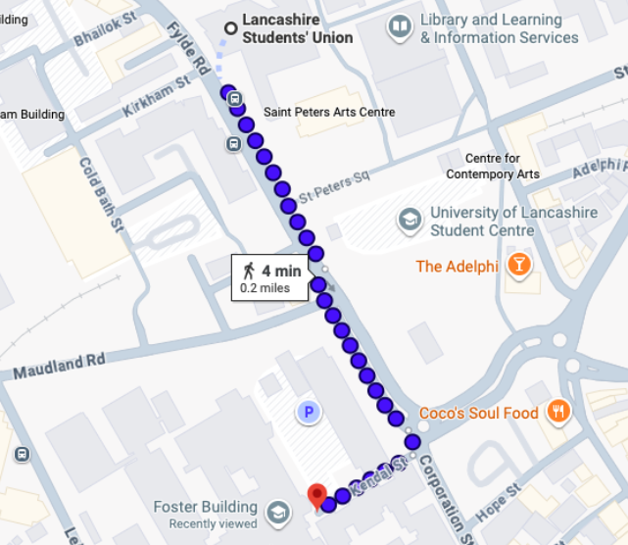
On Sunday there is the optional field trip to archaeological sites in Cumbria. This will include stone circles, Neolithic henges and Medieval Castles.

The coach will set off at 9.30am from the same location outside the Lancashire Student Union on Fylde road. See map above.

The trip will return by 5pm.

Preston recommendations

Food and drink

Preston has lots of food and drinks options. Friargate is where lots of student focused options are. National chains can be found in the town centre. Below are some of our recommendations.

Coco’s Soul Food
A Preston institution, small colourful, vibrant and popular with staff and students at the university. Caribbean-inspired comfort food at a reasonable price.

Chamos Street Food
South American inspired street food, a good vibes causal food spot. Good vegan options and great tacos at a reasonable price.

PLAU Gin and Beer House
Good beer selection and a medieval well in the basement bar. The food is small sharing plates.

Chew’s Yard
A vibrant contemporary place to eat and drink with a mix of street food vendors to suit everyone’s tastes!

All Hopes No Promises
Tucked away in a side street a great American burger bar – National burger award finalists and good selection of beers. Toto’s Africa was not written in this building in 1982.

Himalayan Monal
Small and charming restaurant with Nepal and Indian food. Good sized portions and good value for money.

East Z East
If you’re after a curry the food is good and is massive so will be able to fit in most parties.

Winedown Preston
A basement wine bar that also does locally sourced cheese and meat platters. Not a place for dinner, but if you’re after late night wine and discussion a great place.

The Black Horse
If you want to step back in time to Victorian Preston this grade II listed pub still has many of its original features and serves a good pint of beer.

Accommodation
Nearby hotels we recommend are;

Preston Legacy - closest to the university, 5min walk to the conference venue
Preston International Hotel – Legacy Hotels & Resorts

Premier Inn - 10min walk to the conference venue and close to the town centre
Preston City Centre Hotels | Book Hotels In Preston | Premier Inn

No.10 Preston, Apartments - 10min walk to the conference venue, comfortable apartments
Hotels Preston | Luxury Hotel Preston | No 10 Preston

Holiday Inn, Preston - 15min walk to the conference venue, one of the cheaper options
Hotels In Preston City Centre: Holiday Inn Preston

City Studios - 15min walk to the conference venue, student style apartments
City Studios - Best Price Guaranteed Direct - City Studios

For Air B&B accommodation we recommend you look around the Winkley Square area.

Travel

Preston has excellent transport links. There are direct trains from London, Glasgow, Edinburgh, Leeds, Manchester and Liverpool to Preston. On the quickest trains it is 2hours from London and Glasgow to Preston.

There are direct trains from Manchester Airport to Preston connecting international delegates to the city.

If you are staying outside of Preston and driving into the city please contact the conference organisers for parking at the university.

The Archaeology of… podcast

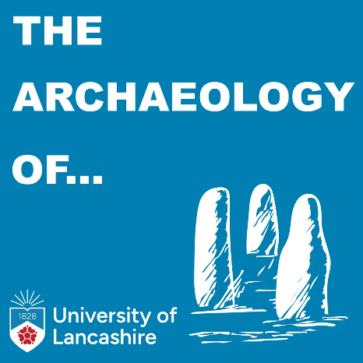

On your journey to Preston why not listen to The Archaeology of… podcast. Avalaible in video format on Youtube and Spotify and audio from all other podcast providers.

