HEAD START ANNUAL REPORT 2017

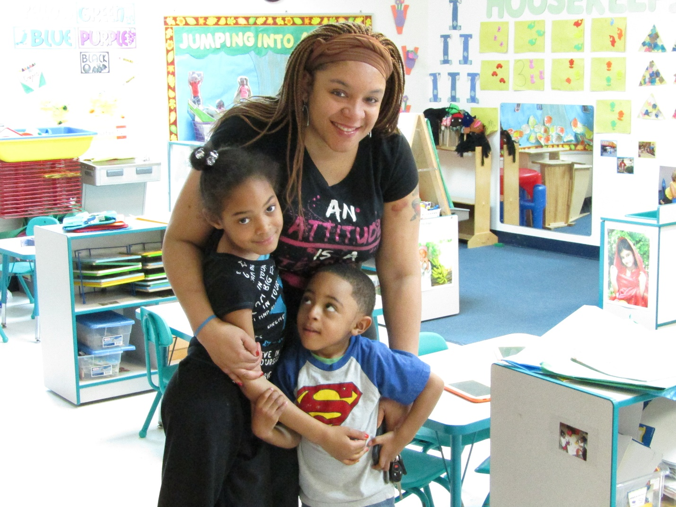
22025 Governors Highway
Richton Park, IL 60471
(708) 747-3000

First Step Annual Report 2017

First Step Child Care Center – Partner Agency

Program Name: First Step Child Care Center, Inc.
Address: 22025 Governors Highway Richton Park, IL 60471
Phone Number: (708)747-3000
Fax Number: (708) 747-5000
Head Start Director Name: Laura Foster
Head Start Director Email: Lfoster@fs3c.com
Agency Web Site Address firststepofrichtonpark.com
Agency Type: For-Profit

Agency Description:

First Step Child Care Center is a for-profit center that provides a program which involves the development of the whole child, through carefully designed experiences that tap into the child’s natural curiosity and developmental readiness.

Since 1999, First Step Child Care Center in Richton Park, IL has been providing an environment that is safe and nurturing to the children in its care from ages 6 weeks right up to 5 years. At First Step Child Care Center each child’s learning experience reflects the results of rigorous research in child development as well as an awareness of what constitutes best practices in early childhood education. All children are eligible to apply if they are enrolled in the daycare center.

In April of 2015 First Step added a federally-funded Head Start program for 14 preschool children and by the end of the 2016-2017 program year this program expanded to include 33 children 3-5 years of age. Head Start/Early Head Start advances the principles that First Step holds dear and provides a framework for supporting the wellbeing of the whole family.

First Step Child Care Center knows that every child’s emotional well-being is vitally important. Our warm, loving staff provides a stable environment in which children thrive.

Community Areas Served
- Crete
- Park Forest
- Richton Park
- Riverdale
- Steger
- University Park
- The Beacon Hill area of Chicago Heights

Overall Grantee Budget 2017

Total Public and Private Funds received: $442,796.51

Source | Public | Private
Federal | $340,195.00
State and Local
Individuals, Corporations, |  | $102,370.93
Foundations, etc. and In-kind
Total | $340,195.00 | $102,370.93

Children and Families Served in the 2017 Program Year

 | Head Start Enrollment | Early Head Start Enrollment
Center-based Program
a. 5 days per week
1. Full-day enrollment | 33
2. Part-day enrollment
b. 4 days per week
1. Full-day enrollment
2. Part-day enrollment
Home-based Program
Services to Pregnant Mothers
Family Child Care Homes
Total: | 33

Number of Families Served in 2017
First Step

Total Children Served: 52 Total Families Served: 50

Average monthly enrollment (as percentage of funded enrollment): 100%

Number of Eligible Children in Community, ages 3-5 | 1,493
Percentage of Eligible Children Served in Agency | 3.4%

Health
Percentage of enrolled children who received medical and dental exams | Received Medical Exams | Received Dental Exams/ Oral Care
First Step | 100% | 100%

Parental involvement in Directly Operated, Delegate and Partner Agencies

Parent Education Activities

Health

In 2017 we expanded upon the initiatives begun the year prior, identifying family needs and providing education and resources to enhance the health of our First Step Families. Oral health educational materials were presented to our families and information on the significance of lead screenings/testing and implications of high lead levels in children continued to be an important focus of our parent education initiative. Nutrition education for both children and families took center stage as we received assistance from both our Nutrition Consultant and the University of Illinois Extension Program. The UIC Extension Program presented fun, nutrition-related activities for our Head Start children and sent home enrichment information for our families. In addition, we added an oral health initiative to inform families of the importance of identifying and utilizing a dental home to meet the needs of the family throughout their stay in the community.

Mental Health
In the infancy of our Head Start program we learned about resources available to our staff and families regarding mental health. We contracted with a Wellness Specialist who worked with our staff and parents, providing a wealth of information on the social-emotional development of children.

Education and Literacy
Home visits offer our Head Start families an opportunity to ask questions about the program, give voice to their concerns and provide input on the individual needs of their child. Kindergarten readiness is of paramount importance to our families, as discovered during our home visits, and we provided trainings on language development and enrichment at our Parent Advisory Board meetings. The monthly newsletter keeps our families informed regarding education projects and the highlights of the upcoming month. Parents are encouraged to join in the classroom fun as well as engage in learning outside the center at field trips.

Community and Social Services
Connecting families to resources, our Family Support Specialist consults individually with families to identify their needs and work diligently to assist them in accessing services they need. Tapping into a variety of social service/public service agencies, the FSS invites speakers into the center, provides referrals to families, and develops partnership agreements with providers. Client-driven care is the goal of the program and thus the resources will evolve as needs are identified. In 2016-2017 we developed relationships with educational institutions and community health providers that service families in all aspects of child health and wellness.

Parent Committee Meetings
- Our Parent Advisory Board meetings are held on the first Monday of every month, providing an opportunity for families to connect, share their experiences and get involved in the operations of the program. Parents are encouraged to be active participants in the decision-making process and their input is invaluable to planning at First Step. Staff changes, curriculum changes, fiscal reports, and policy decisions are presented to our Parent Advisory Board for consultation.

Other special gatherings or activities
In addition to our monthly Parent Advisory Board meetings, we offer family activities during the day so that families get to join in the fun right in the classroom. From Grandparents’ Day to Male Involvement activities, tea parties and field trips, we offer multiple opportunities for families to spend quality time with their child and their child’s classmates. It is the policy across the center that any parent may drop in anytime to see how their child is enjoying the day, learning new skills and interacting with others. We welcome volunteers and love working alongside the child’s first teachers.

Special Efforts to Prepare Children for Kindergarten

First Step Child Care Center curriculum aligns our goals with the Head Start Framework and the Illinois State Learning Standards and Guidelines. In doing so, our goals are also aligned with Common Core Standards. The Teaching Strategies GOLD is aligned as well. Utilizing all of these tools, continually evaluating our children’s needs as well as our practices, we seek to respond to the data in order to meet the child’s individual needs.

Individual child checkpoint data (Learning and Development Report) is shared with parents three times per year during a scheduled home visit or parent conference. During these meetings, parent(s), in partnership with the education staff, develop specific educational goals for the child. Together they discuss how these goals will be implemented and progress communicated. Education staff references the goals when planning classroom or home visit/socialization activities and experiences so as to provide individualized opportunities for children to accomplish their goals. Child observations, documenting the progress children are making in accomplishing the goals, are collected daily. These observations are used to inform continued individualization for children. Finally, Kindergarten Transition events are held each spring to inform parents about their local school enrollment processes and LEAs are invited to answer questions and provide additional information for families.

Summary of Annual Review Findings

From 8/16/2016-6/17/2016 the Administration of Children and Families (AFC) conducted a Leadership/Governance/Management Systems review event for the Ounce of Prevention Fund Head Start and Early Head Start Programs.

Based on the information gathered, no area of noncompliance was found during the course of the review. Accordingly, no corrective action is required at this time.

