David Hay
In his own words, here is the short version of David Hay's "who am I",  "Who am I? I am husband, father, grandfather, teacher, Christian, Lion and Scouter. "  but here's the rest of the story. Although he left his birthplace 45 years ago when he moved to Woodstock, David is still a Montrealer at heart: he cheers on the Canadiens and spends time each summer at the family cottage in the Laurentians, but he is | 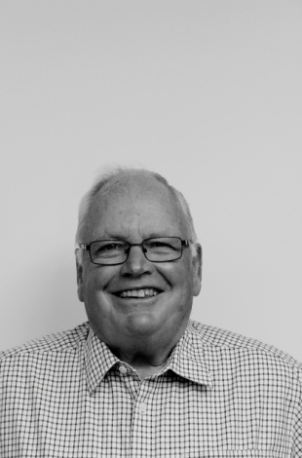
also very proud of his adopted city. Life in Woodstock has been good for him and his wife Claudia: both have had successful careers, they raised and educated three children: Lorraine, Jonathan and Krista, and are now the proud grandparents of eight.
Why Woodstock? After graduating from Sir George Williams University and obtaining his teaching qualifications, Dave taught in Montreal for six years. During that time he met and married Claudia. In 1969 they were expecting their first child. 1969 also saw the initial violence brought on by the Separatists movement. Bombs planted in mailboxes, in stock exchanges and in armories. Was Montreal going to be a safe place to raise a family?
Family and friends urged prudence and that's why David found himself in Toronto one Saturday in March. He was at the Royal York Hotel for the "cattle auction" (a day-long marathon where teachers and school boards sized each other up, filled out applications and contracts were signed). With a leap of faith he returned to Montreal with a signed contract from a place he had never heard of - Woodstock.
David's teaching career started at Huron Park where he taught mainly maths and it there that he met up with a group of young teachers including Bob Thornton, Tony Sheldon and Dan Byers among others. After 12 years he moved on to Norwich where he was able to teach his first love, history. Dave also took on his first administrative role as the school's night school principal. This led to a daytime job of vice principal at both College Ave Secondary School, where he met the redoubtable Moe Cousyns and Ingersoll Collegiate.
The Hays moved to Sweaburg in 1990 where Dave became the principal of both East Oxford School and Sweaburg School. This meant he was working with the families in their new neighbourhood, 'a positive experience". Dave's final months were spent in a town he referred to as "Brigadoon", the mystical Scottish village that appears but once in a hundred years. He was talking about Princeton, which he described affectionately as "the town that time forgot,'
On January first of 1998 he retired from the Oxford board but not from teaching. For the next 12 years he worked as a 'marker' for history exams: a necessary but not always exciting task. Much more to his liking is his ongoing connection with teaching history to seniors with our fellow Probian Deward Yates. This highly successful program has enriched the lives of scores of seniors who gather once a week to look back at where we have come from.
Dave's life was not all teaching. The Hays established roots in their new community. They joined St. Davids United Church. After the kids were in school Claudia joined the nursing ream at the Woodstock General. Dave started coaching. He coached football, hockey and wrestling. With his mentor, Cecil Gracie, he led the HPSS wrestlers to the Oxford-Elgin championship seven years out of nine. The memories of many in the audience were jogged by his recounting of the influence Cecil Gracie had played in his life. Dave also took an active role in the scouting movement. At its conclusion David's presentation was greeted by a hearty round of applause from those of us in the audience.

