Glen McDonald
Glen, the youngest of three children, was born to Sam and Nellie McDonald in
Clinton, Ontario. His father had been born in the township of Zorra between Embro and Kintore, while his mother was born in Eastwood, just east of Woodstock.

His mother was a teacher but was required to give up her
profession upon marrying. His father worked for the Canadian Oi1 Company, better known to many as White Rose. Around 1925 he was awarded a distributorship in the Clinton area. By the time Glen was 15 years of age, Dad had eight gas trucks and Glen drove one of them.
Bureaucracy was apparently in its infancy in Ontario at that time. At the age of sixteen Glen applied for a driving licence but was told by a friendly examiner, a customer, that he didn’t need to bother since he had been driving so well for so long. But he got it anyway, without a test.
During his presentation, Glen philosophied that through his life he had been influenced by "five fathers". First, his own father from whom he learned the work ethic. Then others who, in one way and another, directed him into the field of education and ultimately teaching. George Simmons being one.
In 1972, in consequence thereof, Glen became Vice Principal at Woodstock’s CASS, and Principal in 1975. Five years later he became Principal at Huron Park Secondary School. Later he became Superintendent of the Board of Education and retired in 1994 after over thirty years in the educational system.
By far the most important of Glen's "fathers" has been his Heavenly Father. A man of strong Christian belief, he is a member of Oxford Street Baptist Church and a volunteer with the Upper Deck Youth Centre. He is also a chorister in a gospel quartet called the Bonds of Love which, for the past 14 years, has been performing all over Ontario. His outreach goes still farther as current co-chairman of the loca1 United away appeal campaign.
Married to his wife Bev, he is the proud father of three children.

Glen McDonald, on Australia
The Who Am I segment at February’s meeting was presented by Glen McDonald. Glen spoke on his travels to Australia. Glen‘s son, a schoolteacher, has lived in Moree, New South Wales, for a number of years. To keep in touch, Glen and Beverley have made the long trek to Australia several times. Apart from visiting family, they have also toured extensively.
Like son, like father. I guess you could say that when it comes to teaching, Glen is definitely an “old block off a new chip”. In a remarkably short time, he gave us a very well organized thumbnail sketch of the geography and some of the history of this far off land.
The pictures Glen showed us were taken during their most recent trip and included scenes from the Great Barrier Reef, Ayers Rock, Cairns, Sydney and Brisbane.
Interspersed with these sunny scenes from 2008, were some really spectacular pictures showing the devastating effect of the recent flooding in Queensland. But remember, just one year ago, rivers were drying up, and great swaths of the Australian state of Victoria were consumed by bushfires. Global warming? Climate change? | 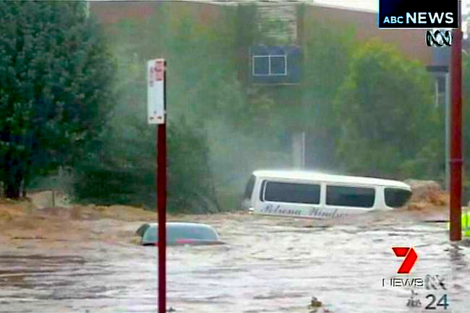  Toowoomba Floods 2001
When we think of Australia, we think of a hot, sunny, and dry land, baked red by the sun, but as Dorothea Mckellar pointed out in her iconic poem, My Country,
I love a sunburnt country,
A land of sweeping plains,
Of ragged mountain ranges,
Of droughts and flooding rains.
extremes of drought and flooding have always been part of Australian life.

