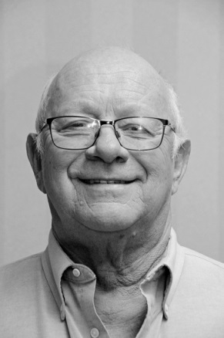**David Lorne King**

|  |  |
| --- | --- |
| I was born Friday Sept 13th 1946. My parents both grew up on  farms in Victoria County and ran a family farm for over 50 yrs. My grandmother was a Bernardo girl, Maud Fane. I have lived in, rented or owned 21 houses in my life. While my family lived in or near Cambray I completed my primary |  |

education in seven yrs. Then I went to Lindsay Collegiate and

Vocational School where I completed grade 13. There I played

on several championship teams and also won a Gold medal for

Poetry.

My son, Eddy, was born on Dec 7th1965. He was 7 weeks premature with pyloric stenosis but after some struggles was just fine. In 1967 a second son Rodger arrived for centennial and a celebration of the last Leaf Cup. I got a job at Firestone Tire and Rubber Co in Lindsay and started a career that took me from the factory floor to the Vice President. After Firestone closed up shop in 1968 I went to work for Goodyear Tire for the next 25 years rising to Engineering Mgr.

From my parents farm I moved into my father-in-law’s house then to a 2 room apt in Cambray and, after the 2nd baby, to a small house also in Cambray. Shorty after Rodger arrived I started in the real estate business, and I bought my first house, a 2 bedroom bungalow, for $11,500 on an agreement of purchase and sale @ $90 per month PIT, and my father-in-law co-signed. Over the next several years we moved between Collingwood, Oshawa, Orono, Quebec City and Bowmanville. I also started my coaching career and studied under Roger Neilson, Captain Video. I achieved a level III coaching certificate in the OMHA.

After my divorce I met Norma. We bought a house on Catherine Street and joined our families just one short of the Brady bunch. I was now working in Toronto as Plant manager and we purchased a home in Oakville. The Goodyear plastics operation has sold to the Huntsman Corp.

Tragedy struck in 1989. My son Eddy and his wife Tina were killed in a drunk driving crash near Bowmanville. As a result of this tragedy my wife Norma and I started a chapter of MADD in Toronto and Halton. I was the 1st chairman of MADD Canada. We went on to build a national organization with over 100 chapters across Canada. We received the Queens Golden Jubilee Award for our efforts.

After being a weekend farmer in Lindsay and managing the plant in Toronto we moved to Danville, Kentucky, as plant manager of the biggest operation in the USA. We purchased a home. Along about here we started having grandchildren and now have 8; 4 boys and 4 girls. In 1999 we moved to North Canton, Ohio, as Vice President of manufacturing.

In 2001 we moved to a house on Bunker Hill as Vice president and General Mgr of Huntsman International. My responsibilities were for manufacturing and sales in Europe, Austral Asia, Mexico and Canada. I travelled to one of those countries each week. Then in 2003 we moved to Orillia to manage a new acquisition and the plants in Toronto and a plant in Barrie.

After moving to Orillia I retired and lived in Bayshore Village where both my wife and I spent time on the management board including president. I also served as president of the Orillia Heart and Stroke Chapter, and received the Heart and Soul award.

Two years ago we moved to Woodstock to be the support our daughter needed. I enjoy golf, curling and Probus.

Thank you for the opportunity to give you a glimpse of my life story because that’s certainly all you will get in 10 minutes. A good friend of mine once told me when giving a speech you need a strong beginning and a good close with not too much time in between. We have accomplished pretty much everything we are going to accomplish in life, and I am okay with that as it has been a pretty good ride.