PROBUS CLUB OF WOODSTOCK-OXFORD
Box 20052, Woodstock, Ontario N4S 8X8

Web Site woodstockprobus.ca

Meets monthly – 2nd Tuesday at 9:45 A.M. Quality Hotel - Woodstock
President Dave King Vice President Jerry Klages 2nd Vice President Bill Weir
Past President Phil Thorne Secretary Robert Ball Treasurer Ken Shrubsall
Club Auditor Bob McTavish Probus Website Chris Hannon Audio/Visual John Richardson
Club Archives Bob McTavish Who Am I David Palmer Club Services David Tabor
Speakers Chair Peter Harrison Special Events Bob Axon, Rob Bryant, John Carley, Dave Hay, Bill Meek
Speakers Ian Clark, Brian Schlegel Membership Larry Asp, Richard Orton
Directory Bruce Hartley, Tony Sheldon Newsletter Bob Axon, Phil Thorne, Bill Weir
Get Well/Sympathy Robert Ball

VOLUME 30, ISSUE 1 October, 2018

President’s Message October 2018

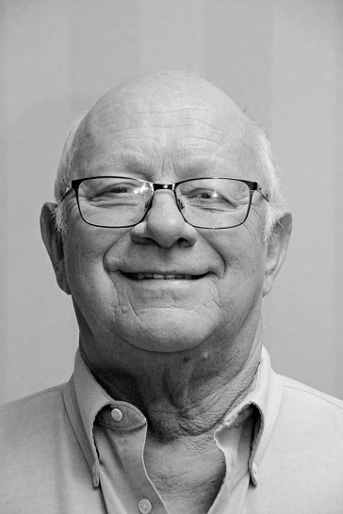
President’s October Message

This is my 1st message of the 2018/2019 term only 11 more to go. My 1st
day on the job was a big loss as our exceptional News Letter Editor Ron
Hannon has stepped down due to failing health issues. What Big shoes
to fill?? I need some volunteers to step forward to fill this role. Ideally a
committee of three could share the duties and lighten the load. This is an
essential role in a well run club. If you can help out please call.

With the official start to fall we can look forward to the changing of the
colours and the Witches and Goblins later this month.
Dave King
Dave
Who Am I – Bill Hardy

Bill Hardy was born and raised in Woodstock, living first on Huron Street and then around the corner on Devonshire. His parents were Doug and Anne Hardy and his father worked first as superintendent of the Woodstock sewage treatment plant and after retiring from that he took up long haul truck driving. Bill and his younger brother had the task of building a garage to house his father's truck tractor.  Bill attended Huron P.S. and then Huron Park S.S. where Bob Thornton was one of his science teachers. Bill then went to college where he roomed with Jack Pasma who he hadn’t seen for many years before joining Probus. Following college Bill got a job in a funeral parlor business in London where he learned embalming. Bill worked there for three years before a slowdown caused multiple layoffs and he was out of a job. | 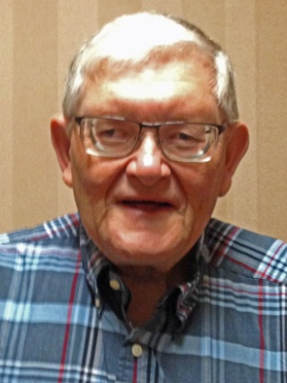

Bill enjoyed the undertaking business and decided to continue to pursue it by taking a job with a firm in Little Current on Manitoulin Island. With an absentee boss who was often away boating, flying or otherwise travelling, Bill had a major part in running the business. Bill got great satisfaction from helping families, often in times of stress. It also helped that his immediate clients never talked back or complained about the service. Part of the job included working with and getting to know the First Nations community which had a higher than average rate of sudden and accidental deaths. Bill said that he got to know the best and sometimes the less than good of these people. He also was often called on by the Police to attend at death scenes and developed a close relationship with the officers on the island. One of the drawbacks to being the main employee of the business was that Bill was on call 24/7 and seldom had much time for vacations.

On one of those rare occasions when he did get away to visit his family in Woodstock his brother arranged a dinner date for him at the Woodstock Inn where he met Darlene. They soon became a couple and eventually married. Along with Darlene, Bill got a ready made family including two daughters. Everyone joined Bill in Little Current and he went through the adventures of parenthood of teenage girls including trips to the First Nations reserve to pick up one of his daughters who wanted to live there instead of at home. In the end all was well and the two girls now have families of their own, one in Saskatchewan and one in Quebec.

About 5 years ago Darlene, having decided to take up ministry, graduated with her B. Div. With a call to a church in Timmins Bill decided that after 25 years in Little Current he was ready for a change and they went off to the north. Following their time there they decided to return to their roots and moved back to Woodstock, buying a house on Lansdowne just south of Devonshire. They attend St. David’s United Church on Springbank where Darlene is a voluntary associate minister.

While they are enjoying their retirement there have been some tragedies in their life as one of Bill’s younger twin brother’s was killed in a car accident on the 401 and his mother was also killed by a car when she was out walking one day. Bill is a hobby woodworker and is also looking forward to an upcoming Caribbean Cruise and a reunion of the Class of ‘69’.

Future Who am I

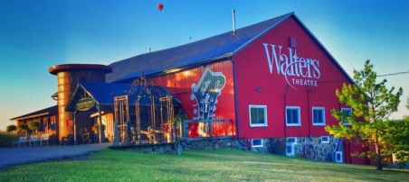
Special Events Calendar 2017

18 October Drive2Eat will include Annandale House
Meet at the Quality Inn parking lot at 9:00 am

Christmas lunch at Odies dining room upstairs will follow
the December 11th meeting – spouses welcome, details to follow at the November meeting

An Historic Woodstock walk will be led by Murray Coulter and Dave Hay in the Spring. Details to follow closer to the time.

CLUB NEWS

Al Driedger announced that the next Science Club meeting will be at 8:30 am in the Probus meeting room before the next Probus meeting on November 13th. The topic will be Alternate Medecine presented by Dr. Paul Carter.

Nominating Committee

The following positions for the 2018/2019 Probus management board need to be filled.

Directory Committee members

In order to keep the success of your club rolling along please put your name forward to your nominating committee. Dave King President, Phil Thorne Past President or Bob Axon past Past President

Guests

Brian Currah, Ed Donmoyer, John Hollinger, Dr. Paul Willoughby

Membership numbers on the roll - are 121

October Birthdays

Rick Bell Len Brooks Rob Bryant Murray Coulter
Wayne Geall Peter Harrison Dave Hay Laird Norris
Don Post Art Robar David Stock

October Greeters Rob Bryant, Peter Harrison

PROBUS SPEAKER

Jude St. John, former Toronto Argonaut and Western Mustang

Ian Clark introduced our speaker, Jude St. John, as the lead pastor at West London Alliance Church, on Wonderland Road across from Costco. Jude’s topic is the story of his 14 year career as a lineman in the CFL.

At 6’ 4” and 320 lbs. Jude played high school football at Banting Secondary School and Western University in London. At Western Jude was team captain when they won the Vanier Cup in 1994. Jude played 3 years with the Hamilton Tiger Cats and 11 years with the Toronto Argonauts, winning the Grey Cup in 2004.

Pinball Clemons said of Jude,

“I love Jude St. John the player, the person and the family man.”

Jude is married and has 5 children.

Future Speakers
November 13 Remembrance Meeting Stephen Smith
December 11 History of Christmas Celebrations Murray Coulter

DUES ARE NOW DUE
Please make your cheques payable to
Probus Club Woodstock Oxford
Fee is remaining the same as last year
$55.00 for email $65.00 for snail mail

Please prepare separate cheques for social events which are due this coming meeting

Aways Leave Them Laughing

A man was walking down the street when he was accosted by a particularly dirty and shabby-looking homeless man who asked him for a couple of dollars for dinner.
The man took out his wallet, extracted ten dollars and asked, "If I give you this money, will you buy some beer with it instead of dinner?"
"No, I had to stop drinking years ago," the homeless man replied.
"Will you spend this on green fees at a golf course instead of food?" the man asked.
"Are you NUTS!" replied the homeless man. I haven't played golf in 20 years!"
"Well," said the man, "I'm not going to give you money. Instead, I'm going to take you home for a hot shower and a terrific dinner cooked by my wife."
The homeless man was astounded. "Won't your wife be furious with you for doing that?"
The man replied, "That's okay. It's important for her to see what a man looks like after he has given up drinking and golf."

