PROBUS CLUB OF WOODSTOCK-OXFORD
Box 20052, Woodstock, Ontario N4S 8X8

Web Site: woodstockprobus.ca

Meets monthly – 2nd Tuesday at 9:45 A.M. Quality Hotel - Woodstock
President Dave King Vice President Jerry Klages 2nd Vice President Bill Weir
Past President Phil Thorne Secretary Robert Ball Treasurer Ken Shrubsall
Club Auditor Bob McTavish Probus Website Chris Hannon Audio/Visual John Richardson
Club Archives Bob McTavish Who Am I David Palmer Club Services David Tabor
Speakers Peter Harrison, Ian Clark, Membership Larry Asp, Richard Orton
Directory Bruce Hartley, Tony Sheldon Newsletter Bob Axon, Phil Thorne, Bill Weir
Get Well/Sympathy Robert Ball Special Events Bob Axon, Rob Bryant, John Carley, Dave Hay, Bill Meek

Our December Club Newsletter
(Volume 30, Issue 3 Dec. 2018)

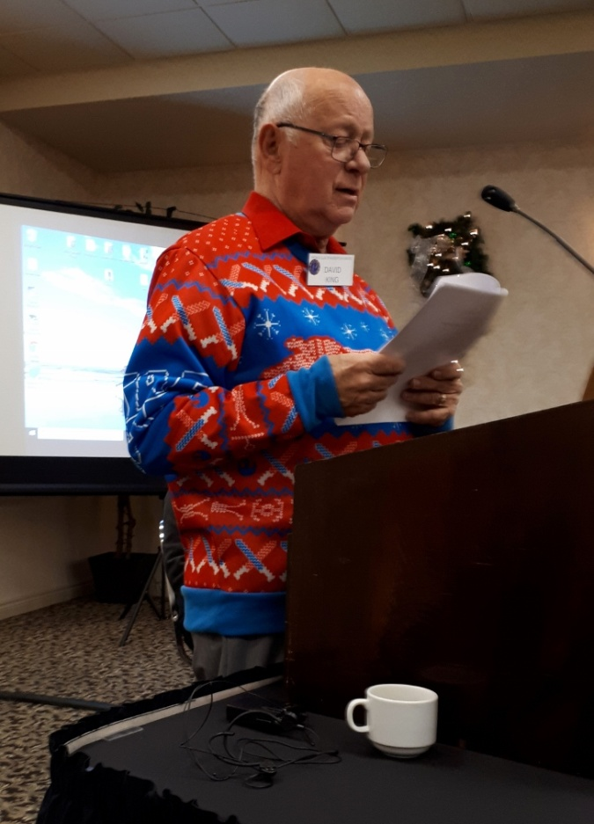
President’s Message

T’is the season to be jolly - while planning family gatherings, enjoying Christmas parties and shopping for the perfect gift.
Watch those calories over the holidays - or face the consequences with those News Years’ resolutions.

Our November meeting and Remembrance Day memorial was excellent. The video suggested by Larry LeGallais was well received as a reminder of the suffering of our returning soldiers from combat.

Further to our discussions about enhanced services for our members we ask members to advise the board of any illness or injuries so we may take the appropriate actions and follow up with those individuals.
Also check out our web site – to make sure your photo and contact details are correct!

Best wishes from my family to yours.
Merry Christmas.
Dave.

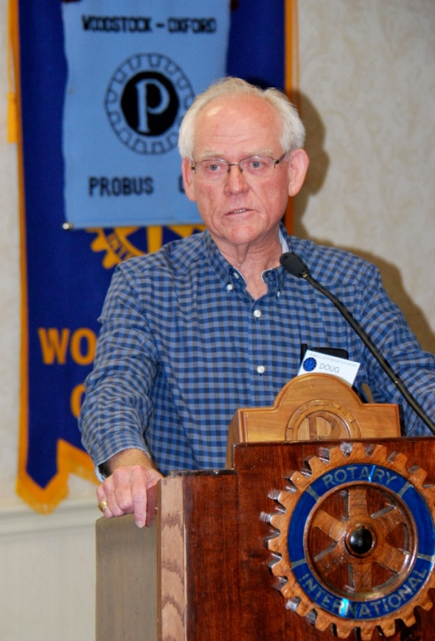
Who Am I – Dr. Doug Neal

I attended a conference once where Alex Halley, the author of Roots, was a keynote speaker. He recounted a saying apparently common in the Kentucky area: “If you find a turtle on top of a fence post, you can be sure it had help getting there!” I can relate to that saying.
I was born in Brantford in 1943. From an early age I understood that if I wanted things, I would have to work for them. I inherited my first job from my brother, 4 & ½ years older than I, when I was 9. It was a simple chore. The company, Atlas Powder, made chemicals for water treatment and the food industry. They had a small office, about 10 people. I would ride my bike there after school, empty waste baskets, gather the mail, and take it to the post office, about a 3 mile trip. Pay was $2.50 a week. The experience etched in my mind the desire to go to university. There were two chemical engineers that I enjoyed talking with, and there and then, I set my goal to be a chemical engineer.
After about 4 years at that job, I became a delivery boy for a small local grocery store. We had on line ordering and free delivery - me!
Our family did not have a car and I desperately wanted to drive so as soon as I turned 16, I got a job at a service station where I worked after school and on weekends during high school. That driver’s licence was highly prized. One day a customer stopped for gas. He was driving a ’58 OLDS ‘98 and had a fire extinguisher bolted on the transmission hump. He paid with a credit card and I took note of his name, John Yaremko. I asked him if he was the man who signed my driver’s licence. He seemed surprised but said yes. John Yaremko was Ontario Minister of Transport, 1958 - 1960.
There were many memorable experiences in high school. A first year English teacher took several of his class on a field trip to tour McMaster University. I was impressed and that reinforced my goal to go to university.
In Latin class, on a day that I was asked to read my translation of a Latin passage, I had stealthily put my Cole’s Notes in my text book and read confidently. The teacher calmly said: “I have heard Mr. Cole’s translation many times; I was really looking forwarding to hearing yours”! That was the best put down that I have ever received but it’s an ill wind that blows no good. The girl sitting in front of me always had her homework done. That’s 59 years ago and the story of how I met my wife.
In 1962, my father died suddenly. In 1907, at the age of 10, he had emigrated from Lincolnshire, England to Brantford with his brother and sister. At 12 years of age, he apprenticed to a harness maker. When the first war broke out, he enlisted in the artillery as a saddler. His first action was at Vimy Ridge. There was never any mention of his war experience except that he had been wounded when a cart he was driving overturned in a mine crater. He was buried with live ammunition on top of him and the Jerry’s shelling the area. He dug and crawled out but suffered a crushed chest. I always assumed that I knew what a mine crater was until I read a book by Sebastian Faulk entitled Birdsong. It was reading a description of how both aggressors actually dug mine shafts and tunnels beneath enemy entrenchments with the goal of blowing up the opposition that I finally understood what he had endured. He continued to the end of the war but upon return spent 3 ½ years at Chedoke Sanitarium on Hamilton mountain which was used for treatment of Tuberculosis and for veterans who had sustained lung injuries including gas.
My parents married in 1937; my father was 40 and my mother 36, both first marriages. I always knew my father could not tolerate loud noise and crowds. Factory work was out of the question. He worked as a gardener in the summer and tended to furnaces in the winter, both for well off clients. One client was W.E. Cockshutt. My mother was the Cockshutt housekeeper.
One day in the fall of 1962, a few months after my father died, my mother had a visit from a gentleman from the Department of Veteran’s Affairs. He reviewed our situation and told mother that we had been entitled to far more assistance from the government than we had been receiving. There was an increase in her allowance and my tuition to post-secondary education would be paid! My father was entitled to a Burned Out Pension. In preparation for this talk, I decided to research this pension. In 1930, the Canadian government passed a bill that gave assistance to returned soldiers who would not be able to support themselves because of war injuries.
My future wife signed up for 3 years of ‘indentured service’ at a nursing school and I continued to Grade 13, and then enrolled at the Ontario Agricultural College in Guelph. When Linda graduated, we decided to get married just prior to my third year. I had become interested in microbiology and one professor encouraged my interest in the brewing industry. Between 3rd and 4th year, I worked at Carling’s in Waterloo. I was given all the hardest, dirtiest jobs in the brewhouse!
After graduation, I joined Labatt’s in London in their Production Trainee Programme. There you were required to do every job in the plant, as a union worker watched, to learn the process. There were also academic studies and exams in brewing science. The goal of this programme was higher management so I investigated MBA studies. There were no part-time or online studies then! I enrolled in night classes with the Canadian Institute of Management and completed 4 years, first at the business school at Western, and then at the University of Manitoba. The courses followed the case-study method of the Harvard Business School.
Labatt’s at that time had breweries in every province except PEI. It was understood that trainees would work in several plants to gain an understanding of the national nature of the business. In the fall of 1968, Linda & I had booked a holiday in Alberta to visit friends. Just prior to leaving, I was told that on my return, I would be transferred to Montreal in two weeks. I told Linda who immediately resigned from her job. A week later, when I returned to work, I was told the move was cancelled. Astonished, I said that my wife had quit her job. I was told: “We don’t employ your wife!” That was true but it was also a realization that I didn’t forgot!
As a couple, we had been unsuccessful in having a family and applied to adopt. In the Spring of 1969, I was transferred to Winnipeg. We went for one hectic week to buy a house. The following Monday, Linda called me at work to say there were twin boys waiting for us at St. Joseph’s Hospital. Four weeks later, we moved to Winnipeg where we spent 3 ½ years in Winnipeg and learned to like it very much. However, looking at the future, we weren’t thrilled at the prospect of frequent transfers. Friends from London visited - Don was a psychiatrist that Linda had worked with & we talked at length about medical school. I had also read a book about the founding of the Mayo Clinic and the Mayo brothers. Medicine became an obsession! I applied and was turned down the first year but in July of 1972, I received a letter of acceptance from UWO. I knew from the late date that I was not their first choice! We agonized about what to do but finally decided to sell up, packed a U-Haul truck, and the four of us headed back to London.
The first year was hell! I had quit a very good job and found myself in a class of 106, 105 of whom I considered much smarter than I. The first midterms gave some assurance: if I was dumb then there were others who were stupid and they would be my saving grace. Linda was also fortunate to land a teaching job at Fanshawe College and the boys were enrolled in one of the first daycares at the college.
In April of ’73, the VP of production at Labatt’s dropped by my house and asked if I would go to New Westminster, BC, to run the brewhouse for the summer as the Head Brewer was ill. I asked, of course, about my family and he replied that they would go too & live in a house rented by Labatt’s. Linda also saw it as a great opportunity and at the end of the summer; we agreed it was a wonderful reward for a difficult year.
Throughout my second to fourth year of Med school, I worked every other week for the Red Cross Blood Bank delivering to the London hospitals or arranging shipping to hospitals in south western Ontario. When I was unavailable, Linda did the work, often with kids in the car at all hours. It sure was a welcome addition to our income!
I completed a two-year residency in Family Medicine after 4 years of med school. Then it was time to look for a practice location. Brantford, our home town was out of the question as was London. I preferred a smaller community in order to have a solo practice, where I could do hospital work, minor surgery, and obstetrics along with an office practice.
On July 3rd, 1978, I opened my practice in Woodstock. The six of us made the move; along with twin boys now 9 years old, we had adopted as infants, two girls who were now almost 3 and 1. Woodstock was a good choice for raising a family. I always told friends that if you can’t find something in Woodstock in 15 minutes then it’s not here. So you have the rest of the day to enjoy. I also learned that one half of the community were related and the other half knew each other so if you had an aberrant lifestyle, you’d better go somewhere else.
I enjoyed the collegiality of the medical community. Over the years I participated in the ongoing management of the hospital, serving on the hospital board, first as President of the Medical Staff and subsequently as Chief of Staff for 6 ½ years.
In December 2008, Mike Bragg from Oxford County Public Health phoned me & invited me to lunch. I replied: “Mike, I have known you for 30 years. What do you want?” His request was for me to consider taking on the responsibility of Acting Medical Officer of Health for Oxford and I agreed.
For three years I actively tried to find a physician to take over my practice. The search was discouraging and unsuccessful so in June 2013, I closed my office but continued as Acting MOH. The Ministry of Health had been pressing me to obtain further academic training in public health so in September 2013, I started Master of Public Health studies at the University of Guelph - 50 years after starting there as an undergrad!
In April of this year, I retired as MOH. I still do surgical assisting on an ‘as needed’ basis. It’s good to remain in the loop and I may need the expertise of one of these surgeons in the future.
In the early 1980s, a cottage on Georgian Bay just north of Parry Sound that we had rented for 5 years became available for purchase. I have enjoyed renovations and upgrades over the years. I am the carpenter, plumber, electrician and ditch digger. The family all enjoy time there. In addition to our four children & their spouses, there are 10 grandchildren, 2 step-grandchildren, & 2 great grandchildren, and the dog. Rascal.
I enjoy woodworking, golfing, boating & fishing, and reading, especially at the cottage. Linda & I have travelled extensively throughout Canada and the US as well as several trips to Europe and the UK. We also have good friends in Australia that have welcomed us on visits there & were our tour guides in New Zealand. Finally, as a child I always asked for an electric train. My brother died 6 years ago and I have acquired his extensive collection of O scale 2-rail train equipment. This winter finds me busy setting up a large train layout in my recreation room.

Future “Who am I”

January Bill Mackesy

Special Events Calendar 2018-19

Friday, Dec. 21st. at Charles Dickens Pub was the day for our historic live Face Time chat with the Woodstock UK Probus Club. They served a yummy “Full English” breakfast – for only $ 20.00.

A Historic Woodstock Walk will be led by Murray Coulter and Dave Hay in the spring. Details to follow closer to the time.

CLUB NEWS

New Members – we officially welcome Bill Mackesy and Jim Leslie to our club.

Nominating Committee

The following positions for the 2018/2019 Probus management board need to be filled.

Newsletter Editor and Directory Committee members

In order to keep the success of your club rolling along please put your name forward to your nominating committee. Dave King President, Phil Thorne or Bob Axon

December Birthdays

Bob Axon Ash Holloway Bob McLeod
Les Goodall Art Jones Jim McNamara
Sid Hewitt George McEwen Ken Thompson

PROBUS SPECIAL GUEST SPEAKER – Murray Coulter

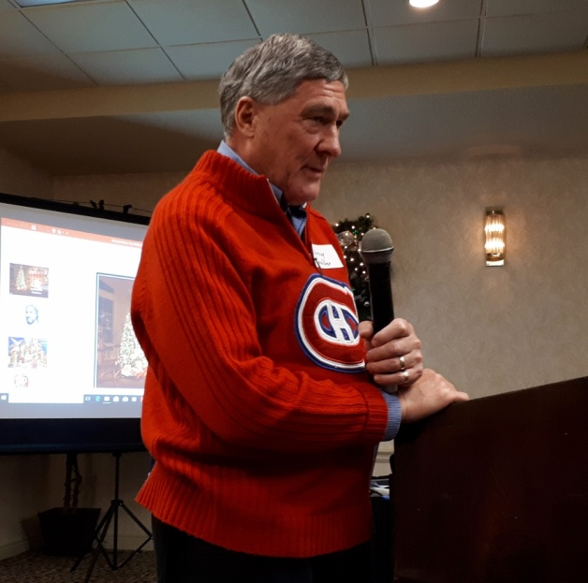
Our own well-travelled Probus brother, Murray Coulter, came decked out in what should have won the ugliest sweater contest. Despite that, he provided a fascinating look back at the History of Christmas Celebrations, that we are now so familiar with.
This religious and cultural holiday was created to celebrate the birth of Jesus. Technically, he became a man before his time, because historians believe he was actually born around 4BC. Also it is unlikely the birth was in December which would have been too cold in that part of the world. The current date of Dec. 25th. wasn’t officially sanctioned until Roman Times – when Constantine (the first Holy Roman Emperor) declared that it was okay to celebrate Christmas, and the 25th. date was a convenient day that tied in with other celebrations of the winter solstice.

Much later, in the 17th century, Christmas was actually banned by the Puritans – who associated the event with drunkenness, etc. Using evergreen trees as a symbol of the coming of light and life – started during the 1520 reformation (Martin Luther) and candles were put on the trees. That idea was popular in Germany and the Netherlands, but did not move over to the UK until about 1714 when British Royalty started decoration their palaces with Christmas evergreens. During Queen Victorian times about 1840, the upper class started putting presents under their trees.

In the fourth century, Saint Nicholas was a Bishop in Asia Minor (now Turkey) who was known as a very giving person. One old tale involves him dropping gold down a chimney to help a poor farmer provide a dowry for his daughters. The gold landed in stockings that had been hung in the fireplace to dry. The Dutch had their own magical legend in Sinterklaas. These stories made their way to North America and evolved into the magic of Santa Claus. Cartoonist Thomas Nast drew some of the first published images of Santa, which were later modernized in ads for Coca Cola.

The true spirit of Christmas was perhaps best demonstrated in 1914 during World War 1. In the battlefield trenches of Ypres and Flanders, the soldiers from both sides stopped fighting on Dec. 25th. to share a sense of peace and brotherhood – if only for one night!

Since then, Christmas has become a huge holiday, with other familiar characters from books like Dickens’ “A Christmas Carol”, and movies such as “It’s a Wonderful Life”

~~~~~~~~~~~~~~~~~~~~~~~~~~~~~~~~~~~~~~

** After Murray’s excellent presentation, the Probus Choir came to the front to lead the gang in some well known Christmas Carols. Sadly the words to some of those songs were not so well known!

Lunch

After the regular meeting was over, many members and some of their spouses – enjoyed a delicious Christmas lunch of beef or turkey with all the trimmings.

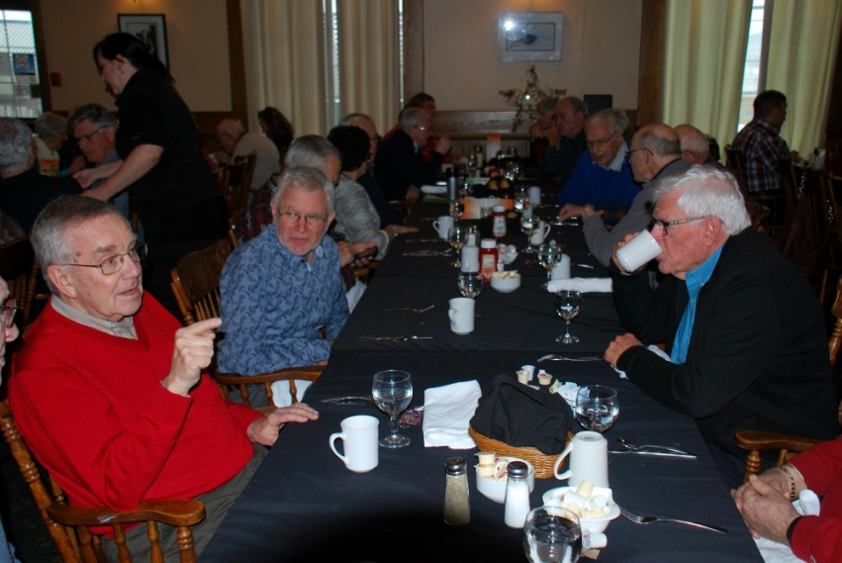

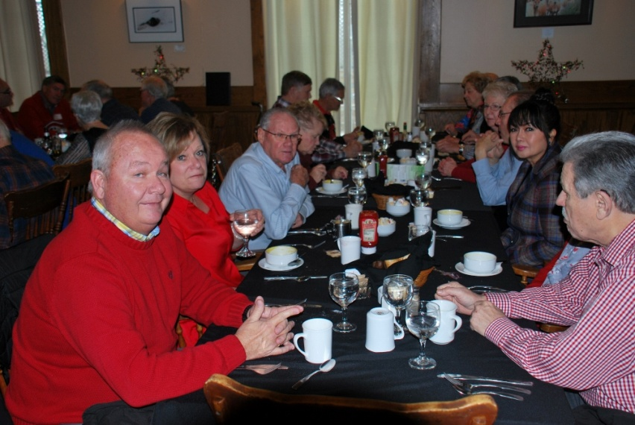

Always Leave Them Laughing
His request approved, the CNN News photographer quickly used a cell phone to call the local airport to charter a flight. He was told a twin-engine plane would be waiting for him at the airport.
Arriving at the airfield, he spotted a plane warming up outside a hanger. He jumped in with his bag, slammed the door shut, and shouted, 'Let's go!'
The pilot taxied out, swung the plane into the wind and took off. Once in the air, the photographer instructed the pilot,
'Fly over the valley and make low passes so I can take pictures of the fires on the hillsides.'
'Why?' asked the pilot.
'Because I'm a photographer for CNN’, he responded, 'and I need to get some close-up shots.'
The pilot was strangely silent for a moment, but finally he stammered,

'So, what you're telling me is...
You're NOT my flight instructor?'

