Who Am I? A-D
Brian Armstrong
Brian was born in 1943 at the Stratford General Hospital on the 11th. “A healthy 8 lbs, 5 oz, red headed baby”, he tells us. He started his schooling in Stratford, continued in Wallaceburg and completed high school in Sarnia. Brian studied classics at Western.
His best summer job was as a member of the Fort Henry Precision Military Guard. This led to a second summer working as a freelance “Fort Henry Guard” at Macy's in Cleveland. It was part of a summer long promotion for Expo '67. Summing up that summer, Brian said, “The girls in Cleveland were great!” Notwithstanding, on a blind date, during his last year at Western, he met his wife, Mary Jane. This fortuitous event resulted in their marriage in 1968 and in the fullness of time, two beautiful daughters, Erin and Brenda.
Following graduation Brian taught Latin and coached football at Ridley College in St. Catherines. Why Ridley? “It was the only place I could teach without going to that dreaded institution, teachers college”. However, during subsequent summers he gained his full teaching qualifications.
In 1974 it became clear that the 'sell-by date' for Latin teachers was fast approaching. Luckily for Oxford County, Brian found a position at Oliver Stephens, teaching geography and history.
His new school was quite a culture shock. At Ridley his class size never exceeded 12, whereas at OS he was greeted by a class of 33. Brian's first impression, “they didn't appear to have much interest in history”. After five years he was promoted to Vice Principal at Harris Heights and for the balance of his career served as principal at Thamesford, Princeton, South Side, Tollgate and Kintore before retiring in 1998.
In retirement, his resume is awesome: he delivers new and used cars for two local dealers to the GTA, he is the secretary for his Masonic lodge, and he serves on the board of the local retired teachers association, and is an executive with the Woodstock Shrine Club. He also revs-up his Harley to ride with the Shrine Mocha Motor Corp a motorcycle group that performs at local parades and fall fairs.
Postscript - Brian's older brother Bob played defense for the Boston Bruins during the 50's. In 1990, at the age of 59, Bob succumbed to Parkinson's. In his role of an 'enforcer' during the pre-helmet era, Bob must have taken many blows to the head. In 1990 the connection with neurological disorders and concussions was not well established, but latterly, particularly with the passing of Derek Boogaard, Brian can't help but feel that his brother's 'policing role' as a young man might have contributed to his Parkinson's.

Larry Asp
Born in Edmonton in 1941, John Lawrence Asp has had an interesting life. Since his father was a bank manager the family moved often. Towns in Alberta, Saskatchewan and BC all had banks. After graduation" the wanderlust continued Larry lived and worked in Vancouver, Calgary, Toronto and Guelph. A chip off the old block, Larry worked in a bank for six years but then he left to start a new career in underwriting. His career in insurance took him to Calgary where he worked for five years before transferring to Toronto. Finally he settled in Guelph | 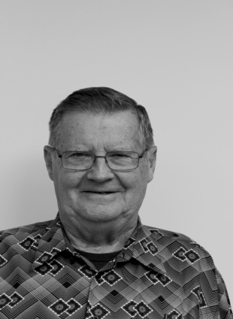
where he joined the Ayr Farmers Mutual Company until his retirement thirteen years later. It wasn't all work. Larry married twice and became the proud father of four successful children. Larry seemed very comfortable in front of the audience at last month's PROBUS meeting so it didn't come as too big a surprise to learn that he had belonged to Toastmasters.
Since the age of fifteen Larry has been a ham radio operator. He has made radio contact with ‘hams' in more than two hundred and fifty countries and territories. Growing out of his interest in 'wireless' he now volunteers at the Hammond Radio Museum in Guelph, with its collection of over three thousand radio-related artifacts. A potential Probus excursion, perhaps?
But there was one event in Larry’s life that really stands out.

One Friday, afternoon I was the accountant at a bank branch in Vancouver. I still remember it. It was five o'clock in the afternoon and two guys came in. One of them had a sawed off 22 rifle. He jumped up on the counter and put the gun in my face and said, "You go over there und fill this bag with money". I went to the first teller cage and emptied the loose cash in the drawer. Along the way, I pushed the burglar alarm and the robber saw my hand move and he said, "Did you push that button?" and I said. "No". Anyway, he emptied that teller’s cage and then two more and then they went off down the street and got away.
His tale continued with a light-hearted account of the robbers' falling-out and their ultimate capture, so perhaps for that reason, upon first hearing. I didn't absorb the enormity of what had actually happened. Like most of us, I have probably seen hundreds, if not thousands, of punch-ups, muggings, shootings, stick-ups, rapes and murders on TV so, at some level, a mere armed robbery, can seem almost ho-hum. But the more I thought about it, and the more I think about it, that Friday afternoon so many years ago, must have changed Larry's life forever. It was the real 'McCoy’, it wasn't fiction. Larry actually had a menacing stranger, stick a real gun in his face and ask for the money. It really happened.

Bob Axon
Everybody knows that who you are is different wherever you are asked to explain “Who am I”. For example – my boys have a different definition of who I am, than my curling buddies. The cancer Society sees one side of my personality and my wife has a more realistic picture of who I am  I’m……….  - Robert Oliver Axon - Born in Leamington, raised in London, University education with a bachelor’s degree and a Master’s in Education | 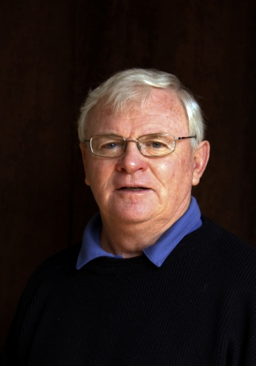
- Married to Keri Bowman with two sons with MBA’s and 5 grandchildren
- A successful career in education
- 4 years as a truant officer/adjustment counselor
- 4 years as a high school teacher
- 3 yrs as an elementary VP and 15 yrs an elem Principal
- I love sports and still golf, curl, hike and skiing
- My major contributions
- Gold cord Queen Scout in my youth
- Steering committee organizer and Chair of Relay For Life for ten years and helped to raise 3 million Dollars for cancer support and research
- Travelled to 40 different countries
- That’s the boring stuff they write in your obituary
But here’s WHO I really AM
Bob Axon – MY Actual name at birth was Ronald Eric Holly son of Iris Holly.
- Iris Placed me in an orphanage at 9 months of age as a war baby – unwanted because of marital tension
- I was adopted by Laura and Ernie Axon in 1946 in Windsor Orphanage and raised in a supportive nurturing home
- I travelled to BC at the age of twelve under the care of two uncles and their families. A great adventure -
- On this trip I walked with guides through a mountain train tunnel 2 km long, helped catch a rattle snake
- And as a camp helper, got held down & kissed in a CGIT girls cabin by 14 older girls
- Known by many for organizing Whitewater rafting adventures in eastern Ontario
- I was a one-time nudist
- I was known as a principal that kissed animals
- As a young adult I was arrested at Checkpoint Charlie in East Berlin, Germany
- As a travelling backpacker I stayed in Tehran, Iran and in Baghdad, Iraq when times were safer
- I was the only principal in Oxford County to Bungee Jump 160 feet over a river
I successfully did a tandem parasail over a glacier in the Swiss Alps
So Who am I? As Paul Harvey would say
And here’s the rest of the story
In my career as a principal, I always believed that kids who want to come to School are better learners and happier kids generally. So I always tried to make school fun. Back when computers were first available, I raised money for new computers & improvements to my school by motivating kids to reach a dollar goal in fundraising. In order to make kids eager to help with the fundraising I agreed to kiss – lip to lip the animal that appeared the worst to smooch so I have kissed two pigs, a cow and an Iguana and raised oodles of money to buy computers.
I also was known by many as Bungee Bob
I was the organizer of 12 white water adventures to Renfrew on the Ottawa River back in the 80’s and 90’s. Each year it was a 4 day event with carnage and danger and lots of laughs. On one of these 12 trips, I was able to collect $300 from 54 local people to go as a Woodstock group – over $10,000 we paid in total. A week before we left a letter arrived addressed to me that was a thank you for my hard work getting everything organized and enclosed was a voucher for a free BUNGEE JUMP. My thought was to give it to one of kids who couldn’t afford the $60 that it cost to jump. Nope…everybody voted that I had to jump. So the second last day of the trip at 5:00 pm all 53 of the Woodstock Group headed to the edge of the Ottawa River where the 160 foot high Bungee tower was standing. Scared to death but not one to miss an adventure, I climbed 160 feet straight up and walked out on the large platform where the jumpers get weighed and the elastic rope was attached to my ankles. A loud public address system announced “Here comes Bungee Bob” and so I jumped – BACKWARDS –plummeting 160 feet head first and splashed with head and shoulder in the Ottawa R. An unforgettable experience which created the name forever of Bungee Bob.
And the parasailing over a glacier in Switzerland is true and was a Father’s Day gift from my son Steve who lived and worked in Switzerland. The word tandem means that there are two seats - one for the passenger and one for the expert parasailer who steered the kite.
Oh the best story is when we were on a cruise and the supper challenge for our table of eight was to bring back an interesting story after an excursion on shore.
At the Island of St Maarten, I discovered there was a nude beach 2 km north of the ship called Orient Beach. Four of us jumped in a cab for a tour of the north shore on the French side and for some shopping but I forgot to mention that we would be shopping beside Orient Beach. The TWO wives went shopping the two men went into the bar to sit and wait.
But I got itchy feet and started out on a MEMORABLE walk to see some nudity, spectacular views, and to add another accomplishment to my Bucket List. The beach was 1 km. long with a “lounge and beach chairs” area along the full length, about 20 miters from the water.
I left my clothes on and I headed off to the other end of this beach packed with about 800 naked men and women – some gorgeous, but mostly they were old…!
When I got to the furthest point of the beach, I hid behind a bush and stripped my clothes of and wrapped, even my sandals, into a ball. Now the thought flashed through my mind….IT’S SHOWTIME!
Nervous but eager, I walked towards the thickly occupied beach noticing the hello’s and nods from friendlier nudists, that had not happened on my first trip up the beach. But I suddenly noticed that my plan had a flaw…. My specimen of “manhood” was not even visible and had tucked in like the head of a turtle. So I took a right turn into the water to coax some enthusiasm from Mr. Johnson.
VICTORY – and the rest of my strut back to the bar was purely EPIC!
Everything after the beach walk was a blur. I got dressed, met my wife and friends, and rode in the taxi back to the Cruise Ship. At dinner, our table of 8 travel mates gathered, in “dressed up” clothes, for an elegant lobster meal – but our dinners were always preceded by stories of the best things in our day and everybody contributed. I asked to go first as we waited for the last pair, a mother and daughter, to arrive. I KNEW my story would be raucous!
To my surprise, the mother, daughter pair seemed anxious and pleaded to go first ahead of me. Whoops – this seemed disappointing!
Glancing at each other they described a rather boring day of shopping in French shops and searching for emeralds and a watch. Then Mom said that she suggested that they go visit ORIENT BEACH but they found it boring until…….
ALONG CAME BOB – TOTALLY NAKED – AND HIS CLOTHES WERE WRAPPED UP UNDER HIS ARM. The shock of their story and my downfall from “stud status” has never left my sensitive memory.
My last Who Am I story was actually the start of my lifelong story and explains why I have two names. In 1945 the war was ending and soldiers were returning home to a changed world and a happy heroes’ welcome. In this excitement I was conceived but I was an unwelcome pregnancy for my Mom, whose husband George was still overseas. Abortion was not an option for women back then, THANK GOD, and George was very angry when he found out that I was there to greet him. My name was officially given as RONALD ERIC HOLLY and most of my relatives embraced me as the new bubbly baby. At nine months of age George wanted me gone - or he was leaving so my mom wrapped me up in a blue blanket and walked into Windsor Children’s orphanage and said good bye. I was adopted one month later by the Axon family and would NOT be here today, if they had chosen someone else to be their child. So the other pieces of my life fit together after my new name was paid for by my Dad for $5.
I grew up in London, got married to Keri, became a teacher, had kids, but the interesting part about being adopted is that you get the yearning to find your genetic roots. So I started a search for the Holly family and found my Mom, retired with her husband George. It was a warm friendly reunion at their home in Florida. I learned that I had three brothers and a ton of new relatives.
So when Phil asked me to say a few words about Who Am I – I realized that my life so far has been a winding series of good luck adventures that have carved some wrinkles and put some white hair on my aging face.
THAT’S WHO I AM
Robert Norman Ball
The surname Ball is a familiar one here in Oxford. In fact, starting with an 'A Ball' in Tillsonburg, and ending with a 'W Ball' in Salford there are no fewer than forty three entries listed under 'Ball' in the local directory. But curiously enough, considering that Robert was born right here in Woodstock, none of these 'Balls' are related to him. Robert's father was an only child, and, so too, is Robert. But just to set the record straight, he has lots of cousins on his mother's side all over the county. Robert lives on Mary Street, in the same | 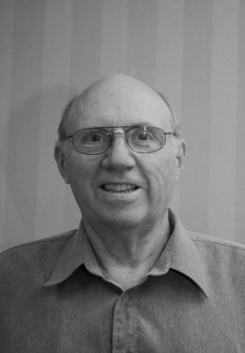
house his parents bought in 1948, just four doors down from where he was born. On the surface its suggests a sort of 'stick in the mud' kind of guy. Not so. After graduating from WCI, he left Woodstock in1964 and didn't return until 2002
.
Bob was good at math. At WCI, he discovered that the chemistry lab was too messy; the biology lab was too smelly, but the physics lab was nice and clean and was full of "neat stuff to play with". Football was his other great enthusiasm and you could say he grew into it, weighing a hefty 265 pounds (120 kg) when he moved on to the University of Waterloo. After one year in Engineering he switched to Honours Physics and continued on to earn a master's degree in 1972. Apart from achieving his advanced degree, Robert accomplished something that should make him the envy of at least half the people on this planet. While earning his master's, he shed 90 pounds, and when he launched himself into the 'real world' he weighed a remarkably trim 175 pounds (79 kg).After qualifying as a teacher he moved to Bermuda where he taught at Bermuda College (the only post-secondary institution on the island). Bob described his time in Bermuda as 'like living in a tropical paradise". His apartment was in a hundred year old Bermuda style house and from his kitchen window he could look out over 'the sound'. Good company. Good friends. Many expats from Canada, the US and Britain. Leisure time was occupied with golf and tennis and we were told that a fire at the Swan Co. Rum Distillery caused no end of distress.

However, Bermuda was not completely immune to the forces at work in the real world. The culture in Bermuda still bore the after effects of the racial segregation that had previously been accepted on the island. In March 1973 Sir Richard Sharples, the island's Governor General was assassinated while walking his dog on the promenade. Sadly, the dog perished as well. His murderer was hanged in 1977 and this was followed by three days of rioting. But calm returned.

All good things have to end and after 11 yrs in Bermuda, Bob returned to Canada, where he took up a position at the College of New Caledonia in Prince George, BC, where he taught a course in Physics for Technology and, on occasion, presented courses on computer programming. He observed that living in Prince George was little like living in Bermuda, but this time the ocean was replaced by a sea of trees five hundred miles wide.

In 2002, he took advantage of a generous buy-out from the College and returned to Woodstock to be closer to his now elderly mother. Often his time was occupied with travel to many of the most exciting destinations worldwide. His mother and Robert enjoyed ten good years together until her passing at age 92 in 2012. In 2014 hints of his own mortality struck when Robert experienced not chest pains, but a vague feeling of unease in his upper body that proved to have been a mild heart attack. A warning to all of us. Heart attacks don't always present the way they do in the movies. It might sound like that after 2002 Robert was here for good, but that was not the case. For at least half of the time he travelled extensively on his own and he and mother enjoyed three wonderful trips to Spain and the Canary Islands. Just next month Bob is on his way to visit friends in Sabah in East Asia. While there, he'll be taking a side trip to visit the ancient ruins of Angkor Wat. Take plenty of pictures!

Brian Banush
I was born in Winnipeg in 1944. My parents, Kazys Beniusis was from Lithuania and my mother, Helen Allen was from Ireland. My dad started a second hand store which was very popular with the flood of immigrants arriving in Canada. He grew this business to 11 stores all while becoming the linoleum king of Winnipeg. My Mom was working for him when they met and wed. I worked in the store and went with my Dad when on his buying trips where I helped load the | 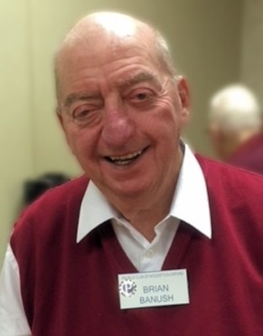
furniture he purchased and learned the fine art of negotiation. He also ran an auction every week. Mom would record the sales and I would deliver the goods and collect. The auction facility being very hot in the summer brought out the entrepreneur in me. I started buying cold pop from a local store and sold it during the auctions. I also set up a used comic book stand and had a paper route.
I was working at a local drug store when I, at 16, bought a car, motor boat and trailer. My part time job in a grocery store paid for the car and an expanding life style. My father’s store and rooming house were in a rough part of town. Among the compensations, for me, was a house of ill repute behind us. I took many opportunities to talk to the girls while they, scantily clad, washed their cars on the weekends, much to my mother’s chagrin. I had friends who fell in with the local roughs and ended up in jail. Sports… hockey, football and baseball saved me from a similar fate.I started working for Burns Meats after leaving school, on the order desk. I was rewarded for devising a cost saving plan by filling in for a salesperson while he was on vacation. The thought of getting paid, commission based, on sales I promoted was exciting for me. I soon got a sales territory in Sault St. Marie. It was here I married, Diane, who had been introduced to me by a co-worker of mine.
After a year in the Sault it was off to Timmons where my two daughters were born. Next stop was North Bay where a third daughter was born. It was here that Hartz made me that proverbial “offer I could not refuse”. One year later we moved to St. Thomas where I became the district manager. We managed to buy a new car and a house in one day. It was in St. Thomas that my fourth daughter was born. I would ultimately rise to the position of Vice President of Hartz.
Giving up the cushy life and after much deliberation with Diane, I yielded to the desire to strike out on my own and “be my own man’. At 60 years old, with friends and family questioning my sanity I started a distributor and importing firm. With all my family’s assets on the line and spurred on by the constant fear of failure my company flourished until I was completely computerized and owning five warehouses. When I eventually sold out my company was, according to “Entrepreneur Magazine” in the top five fastest growing companies in Canada. At 50 years old and having racked up some four and one half million air miles throughout Southeast Asia it was time to spend more time at home.
Not quite ready for a rocking chair I did some business consulting. We also, moved to Delhi where we were closer to grand kids and our cottage in Long Point. I joined the Delhi Golf and Country Club. Diane and I travelled to Europe and Asia before tragedy in the form of a CVA that took her life at age 58. We had grown up together, raised a family and were enjoying the fruits of our labour, our family was devastated.
After being alone for five years and discovering that loneliness was everything it was cracked up to be, I met and married Susan Fenlon who was widowed three years earlier. The newly combined family now numbered seven kids and fourteen grandchildren.
Succumbing to the travel lust we travelled and travelled some more. When not globetrotting I play golf with a great bunch of guys in Woodstock.
Looking back over my life I realize have fortunate I have been; born in Canada, being able to say I have truly loved and been loved by two women and to have lived the “Canadian dream”.

Bob Beattie
Bob was born in Bright, Ontario on October 18, 1936. While living on Dundas St. east in Woodstock, he remembers when the Army had their gas pumps at the corner of Dundas and Huron streets. His father was an attendant at the Ontario Hospital, had a heart attack at work and died in the arms of a fellow Probus member, Ken Rutherford. Shortly after, they moved in with his grandparents in Bright, where his grandfather was a veterinarian. When he passed away, he moved back to
Woodstock, where he attended central school and W.C.I.
His first job was with Perry Radio where his first assignment was to install a 90 foot antenna. This career ended at the 30 foot mark. He then worked for York Knitting Mills and Paquette Hosiery.
Bob joined the Navy in January, 1955 and went to Cornwallis for his basic training. He went in at 230 lbs. and finished his 19 weeks training at 185 lbs. An aptitude test indicated he would be suited for Communications, so he was sent to HMCS Gloucester near Ottawa to learn morse code and typing. After 10 months training he was sent to Aklivic, NWT, arriving on June 6th. Around 10 pm it was still light so he asked when it would get dark. The answer was mid-October. He spent 2 years there, then back to Ottawa for a radio warfare course. Next stop was the HMCS St. Croix in Halifax, with trips to Bermuda, the Azores, and England.
In 1959, when the Queen was coming to Canada to open the seaway, she came on the St. Croix. In preparation, the crew had to remove the heavy ammo, and one of the men dropped a 90 lb. unit which struck Bob on the head, which led to a 10 month stay in hospital in Halifax with extensive therapy. This injury led to 4 brain operations, one lasting 18 hours. After leaving the service, he worked for 35 years at the Ontario Hospital.
Bob is married to Doreen, and they have 2 children and 4 grandchildren. In closing, he read a thought-provoking poem "Are you indispensable? “

Rick Bell
Rick Bell came into the world on Oct 7, 1946 in the town of Brampton. Rick weighed in, at a mere 5 lbs, 3 oz. at birth and in his words, “in my early years I spent more time in Sick Kids than anywhere else”. He modestly concluded, “you’d wonder how this fine specimen of manhood ever survived, but I did”. Rick’s family operated a dairy farm just north of Georgetown and Rick loved the life. After finishing high school he would have been perfectly content to start farming
Full time, but his father insisted that Rick continue his education and so Rick found himself at the University of Guelph studying microbiology
After graduating in 1968, Rick’s first job was with the Ontario Ministry of Agriculture and Food, working as a milk inspector. This involved travelling from farm to farm talking to dairymen. Rick was then in his very early twenties. Rick asked us to imagine how well his advice on farming was received by men who had been farming for 30 years. A response involving a pitchfork was mentioned!
Rick’s real ambition was to become a teacher but teaching positions were scarce. Many resumes were mailed out but not much response. Finally, in July of 1969 a high school in Stratford offered him a position. Rick had not yet attended teacher’s college so his new employer asked Rick to prepare a sample 30-minute lesson. Rick’s lesson didn’t quite last 30 minutes; in fact, Rick says it lasted more like five minutes. Never the less, the principal gave him a chance and he persevered successfully through his first year. The following year he attended Althouse College and received his qualifications. After five more years in Stratford, Rick moved to Ingersoll where he taught agriculture and environmental studies for 14 years. The last 10 years of Rick’s teaching career were spent at College Avenue here in Woodstock.
However, there is more to life than just working. Rick met his wife Mary during his third year at Guelph. Oddly enough, the way the couple got together seems very much like meeting on Facebook or Twitter today, if you substitute old-fashioned letters for Internet dating. Rick introduced himself by writing to Mary and a lively correspondence ensued. It was only after five weeks of correspondence that they actually met face-to-face at a dance on St Patrick’s Day. Something must have been right because they became engaged just a few weeks later in May. Mary and Rick have three children. His sons, Derek and Craig, are both involved with IT while his daughter, Amy, works as an auditor for the Canada Revenue Agency.
Getting back to farming. Rick still loved the life out on the farm. Virtually every summer was spent working on various farms in the county and beginning in the early 1980’s he worked steadily with fellow Probian, Bill Weatherston, for about the next twenty years until in Rick’s words “Bill got tired of me and sold the farm”. Rick would put in a full day of teaching and then at 3:30 head out to farm and work there until as late as 11:00 at night.
Since retiring, Rick and four of his friends operate a sugar bush operation that produces about 1,000 litres of syrup each spring. Any other spare time is occupied with a little business he and Don Taylor have started that handles small scale constructions: projects like fences, installing floors, etc. They call their business “Two Fools with Tools”.

Graham Brown
Graham was born on Feb 28th, 1945, in Ellesmere Port, a large industrial town located not too far from Chester in the UK. Graham’s father was a corporal serving with the RCAF as a radar technician. Graham’s mother, a native of Ellesmere Port, met his father while they were both stationed at a radar station on the Isle of Wight.  After the war, the Browns settled in Canada where Graham’s father studied physics at U of T. Graham’s family, now | 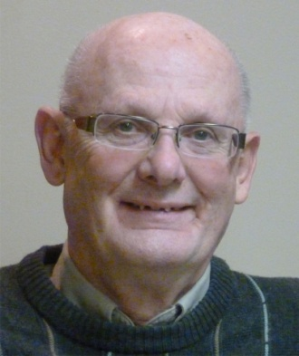
including his younger sister, only stayed in Canada for a few years: returning to England in 1949. Graham’s father was employed by the UK Atomic Energy Authority. In 1957 the family, now including Graham’s younger brother moved to the north of Scotland, where Graham’s father helped build the Dounreay Nuclear Power Establishment. The family settled in nearby Thurso, a small community whose population more than tripled as a result of the influx of newcomers. The atomic workers were not always welcomed by the local inhabitants.
After graduating from Thurso High School in 1964, Graham went to the University of Aberdeen where he studied history. During his last year, Graham became interested in the fate of the farmers evicted from their landduring the highland clearances in Scotland, at the end of the 18th century. A number of these tenant farmers had immigrated to Canada and settled in Zorra Township. After finishing his under-graduate degree, Graham decided to follow up on this interest, and so that he could be close to the source material in Canada, decided to pursue graduate studies at Western
After completing his Masters, Graham decided to teach high school, qualifying in 1971. Montcalm Secondary in London was his first school and over the next 30 odd years he worked for the London Board in a variety of positions, retiring as principal in the year 2000. Not quite ready to fully retire, Graham took a position with the Faculty of Education at Western until 2007 when he put down his chalk for good.
In 1969, Graham met his wife, Maureen, and they were married in August 1971. They had two sons, Simon, born in 1973 and Ian, born in 1975. Graham has many happy memories of his young family. In addition to numerous camping trips through-out North America, the whole family occasionally went back to Scotland to visit his relatives. Both his sons are now married and Simon has two daughters, Stella and Sarah.
Tragically, Graham lost Maureen very suddenly and unexpectedly, due to a brain aneurism in April of 2006, just two weeks before her 57th birthday. Adjusting to this loss was not easy, but with the help and support of family and friends, Graham was able to come out of this very dark period of his life.
In 2009, Graham met Luba, a retired schoolteacher from Simcoe. In 2010, they were married. The new couple settled in Woodstock as it represented a good compromise between Graham’s interests and friends in London and Luba’s family and friends in Brantford, Watford, and Simcoe. They both love to travel, having already visited the UK, New Zealand and Alaska, together. They also visited Ukraine as Luba still has family there. This spring they are planning to return, to celebrate Ukrainian Easter at the end of a European river cruise.
Graham is staying active by continuing his volunteer work in London. He also curls and plays golf. He is now looking forward to a happy life together with Luba, traveling, enjoying their families and friends, new and old. As Graham expressed it,
“That's ‘Who I Am’, though I do find that these days, the question I more often ask is ‘what the heck am I doing here’ when I walk into the room for something”.

Rob Bryant
When Rob Bryant was sixteen he was paid $14.50 a week by a local Stratford pharmacy to roar around in a Mini Minor. One deduction. Five cents a week for Canada pension. Looking at the CCP today, was that nickel a good investment?  When he turned eighteen, he considered his driving habits and thought that it might be a good idea to donate blood. Just in case. Since 1966, Rob has donated 500 units of whole blood plasma and platelets. | 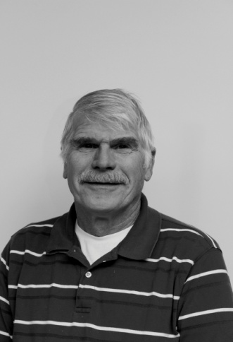
In 1969 he qualified as a school bus driver and his first assignment was driving student nurses from Stratford to the Doon Campus at Conestoga College where by chance he had started an electrical technician's course. He was paid to commute. One of those student nurses, Christine Hastings, will have a future role in Rob's life. For probably very good reasons, he started auditing Christine's biology classes. He discovered that biology was actually very much more interesting than Ohm's law. He switched to nursing. Following his graduation, he accepted a position as a graduate nurse at the Goderich Psychiatric Hospital.
In April of 72, Christine and Rob were married. In 1973 their daughter Tracy was born followed a year later by Shelly. The family was completed with the arrival of a third daughter, Rebecca. Three years later Rob became a single dad. Raising three daughters was a challenge, but, "they turned out very well rounded adults so I must have made some good decisions"
Much of Rob's professional career was involved in the area of Psychiatric nursing and the skills being portable, he worked in many facilities throughout southwestern Ontario. On occasion he would be responsible for transferring patients to the federal facility in Penetanguishene where Canada's most dangerous psychiatric patients are housed.
While at London Psychiatric Rob joined a recreational hockey group and is still playing 45 years later. About the same time he was encouraged by a friend to get his Amateur Radio Operator's license (YE3OUB) and has combined his radio skills with his love of aviation to take in active role in many air shows, here and in Ohio.
In 1993 Rob met his second wife, Dianne, and in July of 1995 they were married. In Sept 2000, Rob retired for the first time but went back to work several times before finally calling it quits for good in 2009. Now, apart from all the children, grandchildren, friends etc, Rob has a new passion - fishing. Ask him about the one that got away.

Dan Byers

Our newest member, Dan Byers was introduced to the club by Fred Freeman, our membership secretary. He was born in 1941 on a farm near Fergus Ontario. Dan was the first of the Byer clan to be born in a hospital. He attended public and high school in Guelph and later obtained his B.S.A from the University of Guelph. After completing his undergraduate degree, Dan | 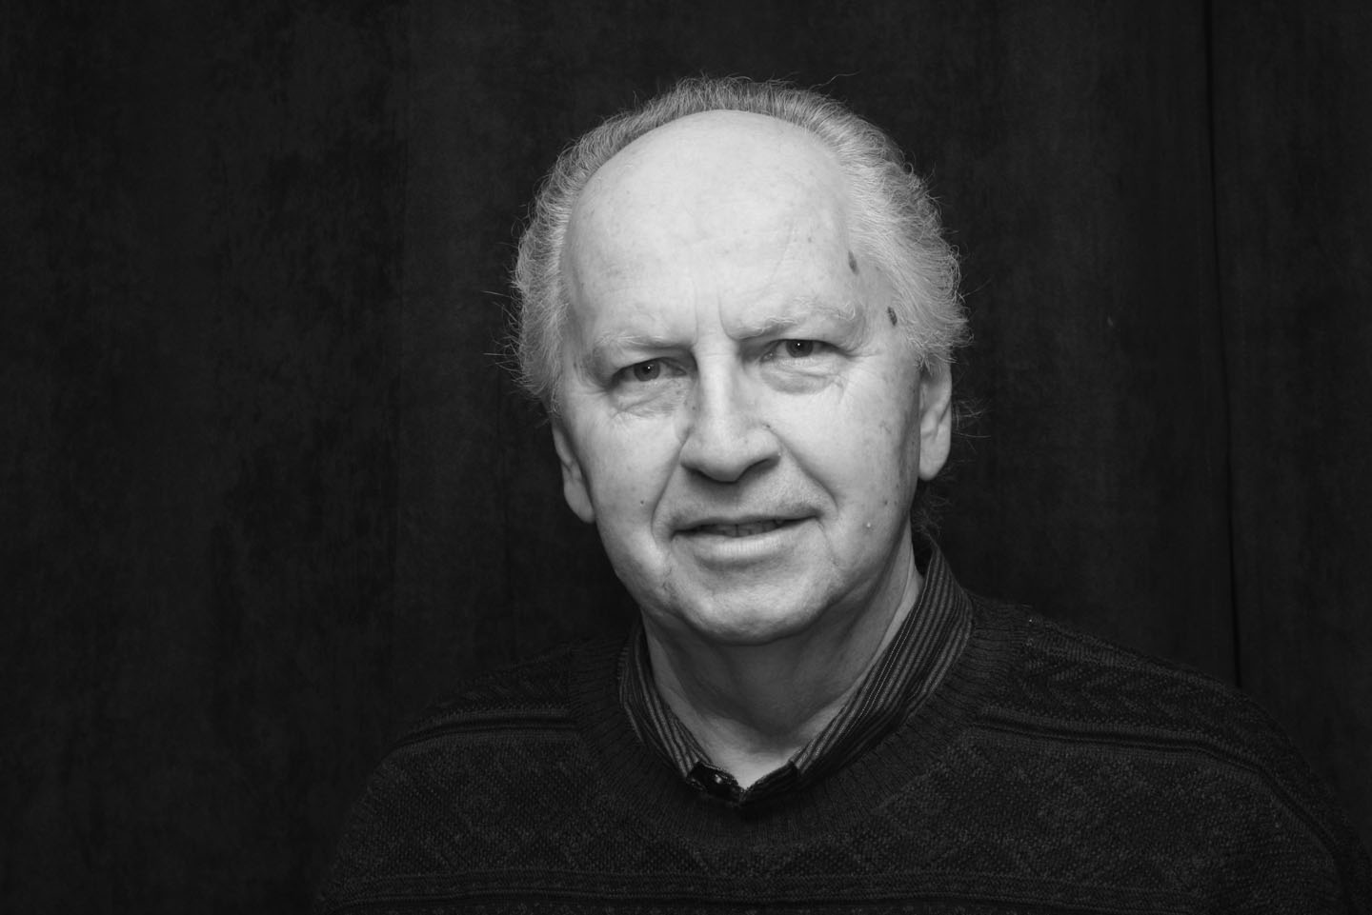
attended Althouse Teachers College in London. Dan started his teaching career at Huron Park Secondary School in Woodstock. Thirty years later he retired from teaching at Huron Park, having taught a wide range of subjects including science, physics and biology. Dan is interested in photography, woodworking and travelling. Dan has been married to Leila for 42 years. They have two children one of which is a minister. A welcoming round of applause greeted Dan as he received his membership package and his official Probus nametag. Then it was time for coffee!

Bernard Calder

Bernard treated us to a very entertaining and informative ‘Who am I’. We were reminded that every new member receives a copy of the Probus constitution as part of their membership package. Unlike many of us, Bernard had read his copy and used its suggestions to craft his ‘Who am I’. Bernard is trained in the law!
A ‘Who am I’ should include such details as to where you
were born, something of your schooling, how many children you have, and so forth. He set the tone for his presentation when he wryly observed that the only question he might have some trouble with was ‘Where did you meet your spouse?’.
Bernard spoke of his background. How his mother, Lillian, had been born and raised in Lancashire. How she had immigrated to Toronto in 1929 where she had met William Calder. How William had taught school for ten years before studying law at Osgoode Hall. How they had married and settled in Woodstock.
At the time of the Napoleonic Wars an ancestor of William Calder became embroiled in a lawsuit that took until 1842 to be settled. The family lost the case and subsequently moved to Ontario, finally settling in Oxford County.
Bernard and his brother George lived with their parents on Buller Street. He spoke of his parent’s love of music: his father’s well-loved performances of the Scotch songs of Harry Lauder and of his mother’s singing and piano skills. Both his parents were active in the community: William in Rotary and Lillian in the IODE.
Bernard attended Victoria and Central Public schools and subsequently matriculated from Woodstock Collegiate Institute. Bernard received both his BA and LLD degrees from Queen’s University in Kingston. After graduation he moved to Toronto where he attended Osgoode Hall for his bar admission course. He articled at McCarthy and McCarthy a huge firm at the time: thirty-five lawyers. Today they have over 650.
Here, in brief, is how and where Bernard met his spouses. He met Diane, who is from Windsor, at a tea dance at Queens. They both shared an interest in Gilbert and Sullivan. They were married in 1962. Bernard met Elaine, his second wife, at the Woodstock Little Theatre while acting in a play together. They married in 1971. Bernard met his third wife, Alizabeth, at a Christmas party held by an associate, Brad Bennett. Alizabeth was Brad’s sister-in-law. They were married in 1991. Bernard had been acquainted with his fourth wife, Martha, for at least 20 years before their marriage. They first met while acting together in amateur theatrics. In 1998 they were married, and subsequently divorced. They had no children together. In total Bernard had been married for over thirty-eight years. He remains on very good terms with all of his former partners, which is a good thing: particularly where children are involved. His many years of the practice of family law has driven home this message.
Here is something about his children. His oldest daughter, Michael, 44, works as a librarian in Toronto. She is married with no children. His oldest son Aaron is married to Donna and they have one child, Skye (Bernard’s only grandchild to date). Aaron has a master’s degree in Kinesiology from McMaster. He teaches and coaches at De La Salle College, a catholic private school, in mid-town Toronto. Their mother is Diane
Allegra, 36, is a graduate of McGill and Oxford Brooks University in the UK where she studied urban design. She is married to Gabriel. They live in Seattle where she works in the field of urban design. Her mother is Elaine.
Bernard has two teenagers, Jeffrey, who is seventeen, and Avery aged fifteen. They are both students at Markham District High School. They live in Markham with their mother Alizabeth.

At the end of his presentation Bernard shared some of his thoughts about the practice of law. He used the analogy of writing words on the sand by the seaside. You write the words, the tide comes in and the words disappear. As a lawyer, you intersect with people at critical points in their lives, you offer up what advice and skills you have to assist them through this crisis. The crisis passes, they move on and so do you. You don’t necessarily learn the rest of the story.

Bernard summed up his attitude to life with a bit of philosophy borrowed from Harpo Marx, “I don’t know if my life has been a success or a failure but not having any anxiety about being one or the other and taking things as they come along, I’ve had a lot of extra time to enjoy life.”

Ross Campbell
Ross was born On April 26th, 1942. His mother, Dorothy, was a former schoolteacher and his father, Gerald, ran a cold storage locker and egg grading station in Hickson. Ross has a younger sister, Joyce, and a brother, Allan. In 1987 Ross married his wife, Dorothy, and immediately was part of a family of two boys and two girls. The three eldest were already established on their own, while the youngest was still in high school. | 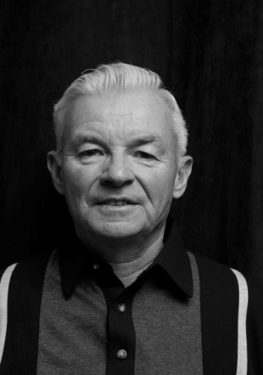
Ross went to Hickson Public School and completed his formal education at Huron Park Secondary. One of his classmates was our own Phil Dunbar and it is clear from what Ross remembers, Phil has not changed much in the intervening years.
As a youngster, Ross was an enthusiastic member of the local 4 H Calf Club where he had his first ‘hands-on’ experience with livestock. Under the Club’s direction he raised his own calf. In his second year, he chose to raise a Jersey calf and this was the beginning of a lifelong interest in that breed. Armed with the proceeds from a paper route, Ross started raising cows as a moneymaking hobby and by the time he finished high school he was milking a herd of five cows. Now remember, Ross wasn’t a farm kid, so his early interest in livestock was unusual even for those times.During summer vacations and after he left school, Ross worked for a neighbouring farmer who did a lot of silo building. This meant that he had the chance to see a lot of farming operations at first hand. As Ross put it, “I got to see a number of farms, the good, the bad, and the ugly. Some farms were really good, and a lot of them could teach you something, and some, you just knew, there was something you shouldn't follow”.
In 1963 Ross, with his father’s help, moved his high school dairy herd to a rented farm near Innerkip. After about two years, he was milking around thirty cows. In 1965 he bought his present farm where he continued with his dairy operation until 2005.
Ross also took an interest in local and national dairy associations. During the mid 1960s Ross was involved with the Oxford Milk Committee and Oxford Milkways. As a member of Jersey Canada, Ross attended events hosted by the Dairy Farmers of Canada in all ten provinces. He served on the Board of Directors of Gay Lea for six years. Gay Lea is a large farm owned co-op that these days has sales approaching half a billion.
For someone from the city, I was fascinated most in hearing about Ross’s first hand experience with the pesticide Atrazine. In the early sixties, Atrazine was the wonder chemical: spray on 2 lbs. per acre and, bingo, no weeds. Well, two or three years later it was 4 lbs. per acre, then 8, and so on. Eventually, Ross started to feel poorly after spraying the chemical on his land. Then one year at the London Farm show he was introduced to a new method of cultivation that would reduce or eliminate the need for pesticides. Eventually, the Campbell farm went completely organic and Ross now sells his organic grains to Oak Manor Farms.
Ross has been active in his community. For a number of years he was a member of the Hickson Lions, he served on his church council and has just finished a term as the Chair of the Tavistock Community Health Inc (approximately 7,000 area patients use the Health Centre's services).

Dr Wayne Campbell
Wayne Campbell is a proud and active father and grandfather who has dedicated his working years to dentistry. Wayne is the second of three generations of dentists from the Campbell Clan who have helped keep Ontario smiling. Looking back on his many successful years as a Woodstock dentist, he fondly remembers the many families (up to three generations) that he faithfully served. He was often the first in Ontario to introduce new techniques and procedures. He is best remembered as a | 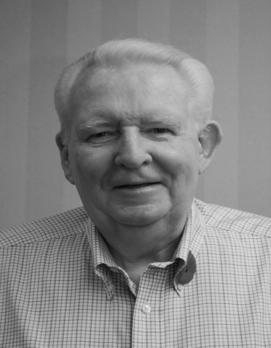
pioneer in NEW and CREATIVE improvements to restorative dentistry including permanent tooth implants that have improved the practice of dentistry and the quality of life for patients as we have moved into the 21st Century.

John Carley
John Carley is a retired policeman. He was born in 1943 and he grew up in the west end of Toronto, around Bloor and Jane. He attended high school in Etobicoke and after graduating he decided that he had had enough schooling. He liked action so he thought either the Police Department or the Fire Department would probably suit, but he didn't like heights. For a | 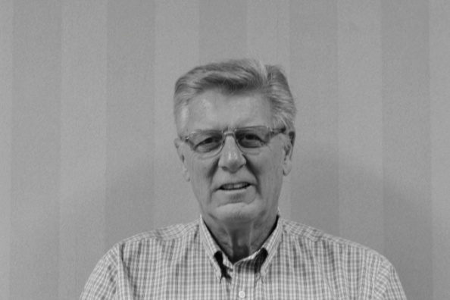
couple of years he worked as a police clerk and took a gap year in Mexico.
Now he was ready. Having achieved the age of twenty-one and gained the requisite number of pounds, John was inducted into the Toronto Police. After three months training at the police college he took up his duties at the downtown 52 Division. Very early in his career he was part of the police contingent that provided security for the Beatles' legendary visit to Maple Leaf Gardens. Unbelievably noisy. Desperate. Two 38 shells fitted nicely as earplugs. John remarked, "Away from the stage, the higher you went, the higher you got".
Later he transferred to his home patch in Etobicoke where his beat included detective work, youth bureau and community service. Looking forward, John started taking additional programs at Humber College and earned his promotion. At the time there was an urgent need for the police to improve their tactics when dealing with sexual assaults and child abuse and John was among the first to be trained up to this role.
In 1990 it was time for a change and John decided to match his long standing interest in things nautical with a transfer to the Marine Branch of the Toronto Police. Seventeen vessels, almost a small navy, it proved to be an exciting place to work. During his time he was involved in rescues, enforcement (party boats), fires, airplane crashes and the inevitable recovering of victims.

Meanwhile, switching back to those early days in Etobicoke, John explained that being a shift worker had curtailed his social life to a degree. But where there is a will, there is a way. Nurses and airline attendants also worked variable hours and it is from this smaller but equally desirable dating pool that John met his wife, Karen. The family was completed with the addition of two girls. By chance, both daughters moved to Woodstock so it seemed only natural that a year and a half ago, when they were ready to downsize, John and Karen moved to the Friendly City.

Dr. Paul Carter
Paul was born in Stratford, ON. in 1939. I guess it was natural that he would be employed in the Shakespearean Theatre originally the “Tent”. He worked up to souvenir program manager even had occasion to meet Princess Margaret.  Paul took medicine at UWO and met and started to date this pretty nurse at St Joe's. They got married and decided to have a large family. Paul started in the ER doing things “I had | 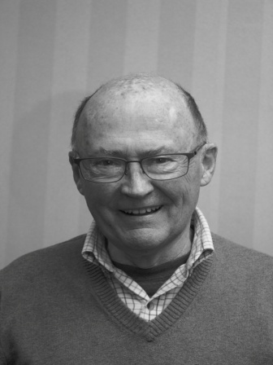
never seen or done such as stabbings, gunshots, etc.” He never saw those in London. One day "A mean drunk" was being abusive to a nurse. I gave him a bloody nose for assaulting her and then packed his nose for him. Paul was actually thinking, “Will I lose my internship”? Happily the answer was “nope”! Lucy, who was now a nurse, once threw his chief of cardiology out of the pediatric nursery for not gowning up.
Paul returned to UWO for specialty training in internal medicine and cardiology he made $300.00 a month. Dr. Pickard used to slip me $20.00 frequently to take Lucy out to a restaurant on Dundas St, now long gone called the "The Short Horn Steakhouse". Short Horn special was chopped sirloin was 98 cents. He received a "kick" under the table when they had no money for wine.
Editor’s note, Chris and I also frequented the Short Horn for steak and strawberry short cake.
Paul’s father died while he was still training, but within 3 years Paul’s mother met and married Don Crabbes (FMC); undoubtedly known to many Probians. A wonderful dad and Chief Resident at St Joe's in London. In 1972 Paul came to Woodstock and joined Dr. Wilkey. He went on to start the first ICU with Dr. Wilkey and to assume various roles over the next few years including Chief of Medicine and Chief of ICU at WGH.
Paul went on to work with CPSO (College of Physicians and Surgeons) after they assessed his practice. He worked for them 30 yrs. Paul ran around the province doing practice assessments. That led to similar duties in the maritime security each summer. He retired with an Emeritus Status.
Lucy became very active in the community as a volunteer and consummate gardener. Their best Devonshire Ave experience was getting Bob and Keri as neighbors. The worse Devonshire experience was losing Bob and Keri. Paul retired from WGH 2002 and went on to UH for a further 5 years, then at Woodingford lodge for 14 yrs and retired June/15, 2015. He let his license go, finally, to be sure he did retire this time (the third) and last time.
Lucy and Paul have been fortunate to travel the world, but in Dec. 2015, she became very ill. They had been in Berlin and then Mexico with their whole family and after their return she ended in Victoria Hospital just before Christmas and then UH for 3 weeks with major cardiac surgery! Lucy is doing very well with her tissue valve. They have been blessed with 8 grandkids including 2 yr old twins.

Ian Clark
At the beginning of his talk, Ian told us that while he had thought a lot about what he planned to say, he hadn’t written anything down, nor was he planning to illustrate his presentation with any pictures. Ian’s promise of presenting an old-fashioned, low-tech, Who Am I was met with more than a few good-natured cheers from the technophobes in the crowd. | 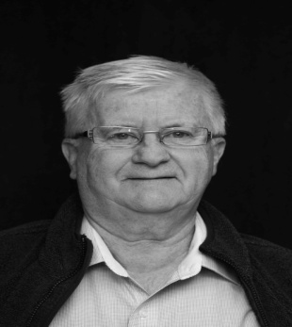
Both sides of Ian’s family settled in Woodstock around 1910. Ian’s maternal grandfather, Everrett Ray, was a well-known figure during the early part of the 20th century. He was a Pharmacist by profession, but also served two terms as mayor and was chairman of the board of education. In 1919, Everrett Ray purchased the home where Ian and Yvonne live to this day.
Ian was born in 1947 and as a young child had problems speaking. Luckily, a young woman who lived down the street was trained in speech pathology and she gave young Ian the help he needed. As a youngster, Ian was very busy. Starting in Grade 7, he held down a part time job and was also a serious badminton player. Among others, Ian thanked fellow Probian, Art Robar for mentoring him and encouraging his interest in the sport.
In 1970, tragedy struck when Ian’s father died suddenly at the age of 55. A year later, after graduating from Ryerson, Ian fell into a deep depression that lasted for seven long years. Fortunately, by 1978, Ian was feeling much better and in his words “in 1979 things got really good”. A friend arranged a blind date with a Dutch girl from Chatham and two years later Ian and Yvonne were married.
For thirty-three years Ian worked at Holland Hitch. Ian continued to take courses at Fanshawe and with this knowledge and his experience he was recognized by Holland Hitch as a flexible and valued employee. He was also respected by his fellow workers and as a result when the Union and Holland Hitch were looking for a time study expert, Ian was chosen. Ian
must have been doing something right as the Union continued to select him for the next 24 years. Always active in his community, Ian served on the executive of the Woodstock Badminton Club and the Woodstock Y Men's Club. Ian also served on the executive of the Oxford Presbytery of the United Church.

Earl Clayton
Before turning the podium over to Earl, our president, Dave Clowes, recalled a story from his teaching days. There was a spelling mistake in a student’s essay, just one misplaced letter turned the tedious into the hilarious. As Dave put it, “a lot of funny things happened in Norwich “. Dave’s story proved to be a good lead in for Earl; the first thing Earl said (and he said it with an ironic smile) was that he’d been born in Norwich in 1938. The crowd loved it. | 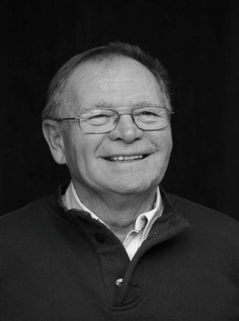
His parents, Howard and Violet Clayton, were of Quaker stock. They gave Earl a solid grounding in life, but were also broadminded enough to allow him to develop independently, and to accept the individual he has become. At this point, Earl looked up from his prepared notes and said, “I am waiting for Ian Hart to butt in here with "probably strange". This was the first of many times that Earl would invite someone in the room to confirm something he was saying. Earl seems to know most of the people in the room.
Earl was still in grade 13 at NDSS, when he met his wife, Ruth. She was the oldest daughter of Elmer and Ileen Almost of Otterville. He was eighteen and Ruth was just sixteen. After attending NDSS in Norwich, Earl earned a diploma in Animal Husbandry from OAC (1959).
After Ruth and Earl were married in 1960, Earl worked for his uncle Gordon Walker, trucking livestock to Kitchener, looking after the hogs, picking apples in their orchard, milking cows, and generally helping with work on the farm. In 1962, Earl’s father decided that he had had enough of farming so Earl and Ruth took over the family farm. In 1963 their first son, Morrie, was born. 1966 saw the birth of their second son, Ryan
In 1984, Earl was elected as a Director at Oxford Milkway Transport Co-op, serving two 3-year terms, including one year as Chairman. In 1990 he was asked to succeed Jim Fleming as Secretary-Treasurer and acted in that position until 1999.
In 1987, their eldest son graduated from Fanshawe and became a full partner in the family enterprise. Although Earl officially retired in 2000, he was able to slow down gradually, helping on the farm until 2006 when a health issue meant giving up this role. The year 2007 brought great sorrow. As Earl said,”2007 saw the passing of my wife, the mother of my boys, my best friend and co-worker”.
Earl now lives on Concession 14 of East Zorra Tavistock, across from the Burtch Farms Estate Winery. His acreage gets farmed during the summer and Earl cuts the grass around the buidlings. For recreation, Earl disks in the winter with his friends Moe Cosyns, Mory Robinson, Jim Elliot and Ian Hart and in his words,”depends on my host of friends to keep retirement meaningful”.

David Clowes
David gave his presentation in a nice relaxed and off-the -cuff manner.  We learned about the when (Sept 30th, 1943 and the where (Princess Street in Woodstock), about boyhood pals (Phil Dunbar and Dave Tabor), his education (Princess School, Central, WCI, WLU and Teachers | 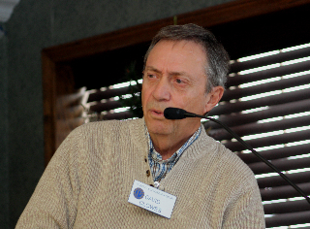
College), his family (wife, Joanne and children, Heidi and Ken) and where he worked (Standard Tube, Norwich High School, Canada Post and Glencoe High School).
However, it was in his telling of the small stories from his life that his presentation shone. In just a few short sentences he was able to recreate what it was like to be a college student in the sixties. Just mentioning Thursday Pub Night brought back lots of memories for me. What about his story about the plumbing problems at Norwich High School? It showed that even the teachers could learn something about physics and arithmetic from a plumber, “You see your problem is you’ve got a three inch pipe and a four inch ....“. And his time at the post office. If I had to deal with a mail cartage driver like “chicken brains”, perhaps I would have gone on strike too. During his teaching career, it is clear that David had a great concern for and an interest in his rural students at both Norwich and Glencoe. His one hundred and twenty mile round trip commute to Glencoe speaks for itself.
In closing, Dave summed up his life so far by saying that with lots of golf in the summer and curling in the winter, his two years of retirement has proved to be the best job ever.

Mike Connell

It was lying on his back in a pool of warm, sticky, sour milk at Levitt’s Dairy one hot summer day that convinced an eighteen year old Mike Connell that maybe going on to university wasn’t such a bad idea after all.

After graduating in Psychology from Waterloo Lutheran, Mike spent a two-year internship at the Ontario Regional
Hospital in Woodstock where he trained as a psychometrician (one who analyzes questionnaires and tests). After a time Mike realized that his real calling was in social work and with the support of his employer he studied social work at U of T. In addition to his work at the ORC, Mike taught at WLU, instructing field workers from the Southwest region.

In the 1970s, the standard approach in children’s mental health was to sit with the child and talk. Mike’s innovation was to take the kids down to a park and knock some balls around, while working through their concerns. Having already adopted this strategy Mike was well primed when David Bond and George Ireland approached him about starting a Big Brothers group in Oxford. Mike was part of Big Brothers for about a dozen years.

With the closing of the ORC, Mike was involved with introducing computers into Ontario’s Psychiatric Hospitals. Mike attended the DEC school where he studied minicomputers (an early form of computing device). He later supervised their installation in locations throughout the province. After retiring, Mike started a computer support business.

Along the way Mike married Mary Jane and they raised three children. Now, there are two lovely granddaughters on the scene. Living up to their expectations keeps Mike hopping.

John Cook
John Cook was on the podium for this section of the meeting. He was born in Paisley, Scotland in 1943. His father's failing health prompted a move out of Scotland and they landed in Canada on Christmas Eve, 1947. (His father's health problems were subsequently solved by the invention of penicillin and he lived to age 83.)

John hit a responsive chord with many in the audience when
he spoke of Woodstock as being a great place to grow up in, and the 1950s as a great decade to be a teenager ....free of the terrors of war, with stability and prosperity, and the morality of family values more in evidence than today. Good education withdedicated teachers and high standards were remembered and he noted that two Probians (Art Robar and John Harvey) were his teachers at WCI. Particular praise, for whatever character formation may have developed in him was given to the YMCA and its youth programs then, which were much more extensive than the simple exercise facilities we see today. The winter programs and the summer camp at Fisher's Glen were seen as wonderful resources for community youth development and he owes much to those who had the foresight to develop them. The community is seen to be much poorer for not having programs such as the Y used to have.
Many people who grew up with him think of John as a pharmacist as he spent many of his early years working for Standard Drug and apprenticing as a pharmacist there and at the hospital. However, he eventually took a degree in Economics and Business at WLU and went to work at Timberjack where he worked in many departments, becoming VP of Operations. In 1976 he left Timberjack to become the President of Champion Road Machinery in Goderich where he stayed until 1982 before leaving to do merger and acquisition work. In 1985 he joined the Ivy Group in London to turn around Dashwood Industries in Centralia and prepare it for sale. In 1987 it was sold to Trussjoist (now a division of Weyerhauser) where he stayed on until he retired for the first time.
After a year of (boring) retirement he started doing volunteer work for the Business Development Corporation giving management direction to businesses going through hard times. In 1997, he was asked to take a look at a family business, Bailey Metal Products and to mentor the generation that would take over the business. He retired again in 2004.
On returning to Woodstock he was approached in a store by an old acquaintance who spoke to him as if he had never been away. This is the 'sense of place' that he thinks is important about Woodstock. (We think so too John. Thanks for an interesting talk.)

Morris Cosyn

Glen introduced Morris Cosyn who filled the “Who Am I?” slot. After telling something of his background and family, Moe told of his early days in design in Windsor doing the artwork (hand drawing and airbrushing) for the 57 Plymouth and Dodge. In 1958 he came to Woodstock to work at Huddleston & Barney, later establishing his own studio and finally spending many happy years at CASS teaching art there until his retirement in 1996. He is an avid lawn bowler and does some traveling. Thanks for being available Moe.

Murray Coulter
Murray Coulter presented an interesting 'Who am I' at our February meeting. We learned that he was born in Palmerston on Oct 1st, 1946 where his father worked as an electrician and his mother was a registered nurse. He maintains a connection with his hometown as his sister Isobel has remained a lifelong resident.  His early days were typical for the time and place except for one thing. Being born in October he was already among the | 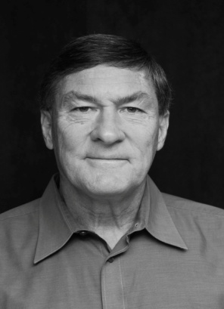
youngest when starting grade 1. When he started grade 3, the grade 3 and 4s were taught in the same classroom. Young Murray's progress during that year was so rapid he was promoted directly to grade 5. He ended up being almost two years younger than most of his classmates. Conventional wisdom suggests that finishing school sooner is always 'a good thing'. Murray argues that there are some unforeseen social consequences. You end up being out of step with your peers. In grade 10, when his 16 year-old classmates had their driving licenses, Murray was still pedaling his bike. He graduated from University at the age of twenty and before his 21st birthday, he was teaching a grade 12 glass at a high school in Brighton. Murray mused that being removed from his peers is not necessarily the best thing for growing up.
After teaching for just a few years Murray decided to study Law. He graduated from Western with his LL.B in 1972. In April of 1974 he joined what was to become the firm of Nesbitt Coulter LLP where he continued until his retirement 34 years later.
Murray Coulter's interests include history, travel, amateur theatrics, automobiles, motorcycle touring, federal and provincial politics (Liberal candidate for Oxford in 2004), and he collects stuff – the first forty copies of the Scrooge McDuck comic series, for example.
He participated in high school athletics and was a member of the neighbouring town of Harriston's midget softball team that went on to win the 1963 Ontario championship. Later on, he coached his daughter's little league softball team for several years. He has also been a life time fan of the Chicago Cubs. He continues to enjoy bicycling and during the winter curls several times a week.
His community pursuits have included freemasonry, the Oxford Law Association (President) and St. David's United Church. He has served on the Woodstock Hospital Foundation and was involved in the planning and development of the Woodstock District Community Complex.
Saying that Murray’s interests include travel is an understatement. Murray and his wife have visited 137 countries and he is the only person I know who has visited Timbuktu. In his closing remarks he reminded us that there is more to travel than just moving about. For Murray, to stand at the tomb of Cyrus the Great, to stand where Alexander the Great had stood, was to stand in the shadow of giants.
At an earlier meeting, Murray and Bronwyn, his daughter, presented an illustrated talk on the experience they shared together, walking the Camino de Santiago. The Way of St James as it is known in English, is the 900 year old pilgrim’s path that stretches from the French border in the Pyrenees to the city of Santiago de Compostela, near the Atlantic coast in north-west Spain. The entire trek covers about 700 km. Walking at 20 km a day, it takes about 35 days to cover the distance and traditionally you carry all of your gear on your back, staying in often primitive hostels. However, completing a more modest one hundred kilometres qualifies as an official pilgrimage. Murray, conceding that his hosteling Days are over, opted for a more civilized approach. He engaged Marly Tours, a Camino specialist based in Madrid. They provided transportation to the starting point, and while walking the trail Marly guides were on hand to provide assistance. At the end of each day's walk a van would pick them up and take them to their accommodation superior meals and accommodation at the end of each day.

Bronwyn and Murray did a wonderful job of re-creating their time in Spain. It sounds like walking the Camino was a wonderful experience and I would certainly enjoy trying it someday. But, even better, spending an entire week of quality time with your grown-up daughter, what a great holiday! Priceless!.

