Who Am I? D-K

Don Downing
Don was born on June 5th, 1937 and except for a brief period he has been a lifelong resident of Woodstock. When Don was in grade 11 he quite literally bumped into a pretty grade 10 student, Margot Boss. At the time he told his father that he thought he had met the girl he was going to marry. He was right: Don and Margot were married in 1958 just after he had finished Teachers | 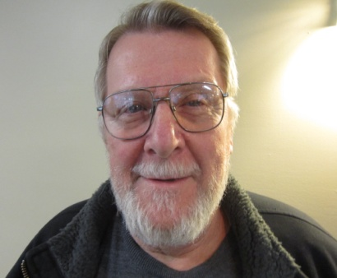
College.
Two years after they were married a daughter Catherine Louise was born and then seven years later a son, David. Three years later the Downing family was complete with the arrival of a second son, Geoffrey.
The young couple had settled in Sarnia for a time and while there a chance encounter opened up a whole new world. As Don says, “I luckily met a fellow there who changed my way of life. He taught me about canoeing, fishing, snowmobiling and hunting and these are things I have participated in ever since.”
Don and Margot returned to Woodstock in 1960 where he taught at Central School. In 1967 he joined the staff at the newly opened College Avenue Secondary School where he remained until he retired in 1992.
Following his new found interest in the out-of-doors; Don eagerly took part in a canoe trip organized by another teacher at the school. Big mistake. “It was the worst trip I have ever been on, I don’t know how we all got back alive.” Undaunted, he decided to start a proper canoe club at CASS. Before going on a trip, the students were given 25 hours of classroom instruction and 8 hours in the canoe. As an added safety precaution the students had to spend one hour in the Y pool fully dressed just so they would have some idea of what to do if a canoe capsized. All of this preparation paid dividends as in the forty-four trips that followed there were very few incidents.
Perhaps the most serious occurred was when Don’s son David shattered his leg early one morning.
Amazingly, Don was able after several hours of paddling and portaging to reach a telephone. Within a short time a helicopter evacuation was arranged and his son was admitted to University Hospital in London by 4 PM. All this before the invention of the cell phone and GPS.
Don decided he should take a course in running canoe trips and this led to his involvement with the Ontario Recreational Canoe Association. Before the course was over he had been elected treasurer of the organization, a position he held for twenty years. For six of those years he served as a Vice-President of the Canadian Recreation Canoe Association representing Ontario and Quebec.
Apart from running the CASS canoe trips Don has been involved in a number of organizations. For 15 years Don worked with Frank Smith as a chef with Operation
Sharing and also served on the board. Don was on his church board for around 15 years and he also joined the cemetery board, which he is still on. He can still be found working as a groundskeeper at the Anglican cemetery.

Al Driedger
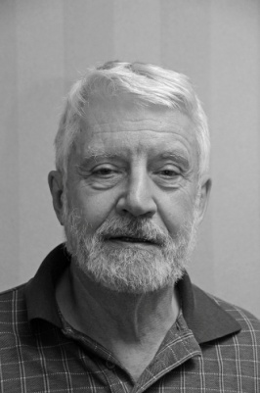
My father was born in 1907 in what was then Tsarist Russia, now
Ukraine. His mother died when he was 9 years old. A subsequent
stepmother decreed that children from the previous marriage were
put up for adoption. When he was 10, the Tsar was overthrown in
a bloody revolution. There followed several years of unrest
punctuated by civil war, famine and the flu pandemic.

The combatant armies in the civil war largely provisioned themselves by pillaging the countryside helping themselves to provender, farmers’ horses and whatever else might prove of use in their struggle. My father at the age of 11 or 12 was conscripted into military service and it wasn’t clear to him by which side; I cannot tell you if he ever held a gun in his hands; he never spoke about what actually went on in the fighting but I have a sense of what he may have experienced from reading Mikhail Sholokhov’s novels concerning those times. During my father’s life we didn’t have the term, but it is clear now that he suffered every day from post-traumatic stress, PTSD. From early morning until late at night he worked like a man possessed, trying to push away his memories; whenever he stopped working if only for a drink or a meal, some painful story from his childhood would emerge. And we, his family, would respectfully listen even if we had heard it before.

One of his memories was of a time when the fighting seemed to be over and he was alone, asking his way across the unmarked countryside toward home. How does a mere boy do that? Moving along roads that were no more than trails, in the general direction he believed to be toward home, he needed at times to stop for directions and sometimes to beg for food and shelter. He discovered that the help he needed was not forthcoming from the countryside’s Mennonite or Russian villages but that the Jewish settlements were always welcoming. In one of those encounters, told with tears, he recalled coming into a Jewish shtetel toward evening where he was greeted by a man at the gate to the first house, who called him to come in for the night. On entry into this modest hut, he was shocked to find an obviously starving family, listless children with swollen bellies, gaunt and eyes as big as saucers. His host seated him with the family for their evening meal and then evenly divided his one crust of bread among them including a piece for him. He remembered how the children’s hollow eyes followed the course of his postage stamp-sized crust to his mouth and how they watched him as he chewed it down.
Those were turbulent times and I expect that this generous Jewish patriarch and his family, their names long forgotten, perished soon after that encounter. One could argue that this enormous act of terminal kindness to an unknown Gentile waif may have saved the life of the man who became my father and made the lives of his family possible.

In contrast to my father, in my life almost everything has come up roses; the most exciting opportunities in enriching education and fulfilling work have been mine. I’ve been married for 57 years to the same lovely woman. We were privileged to parent in an era when there was no call to send our children away to war. My grandchildren show all the signs of future joyful excellence and diligent citizenship. My father’s descendants now extend into three generations and are to be found in Canadian and international businesses, professional academies and in the arts. At age 80 I still have dreams and plans that extend beyond the mere avoidance of pain or an urgent focus on survival. When I think on these things, I remember that we may owe all we are and have been to that now-nameless Jewish peasant (or was he a saint?) who willingly shared what may have been his own last supper with a stranger. All that remains as evidence of his ever having existed is the scrap of a memory of my father’s story that I carry in my head, but even that has become its own kind of sacrament. My anonymous saint surely was a man for the ages.

Phil Dunbar
A Woodstock kid, he grew up in the east end of Woodstock in the area around Massey-Ferguson and Harvey Woods and was a member of the "Princess Street Gang". He married a Woodstock girl, Cris Croxford, who retired after29 years in the Nursing Profession. Their daughter Theresa lives in Oshawa and has 2 children. | 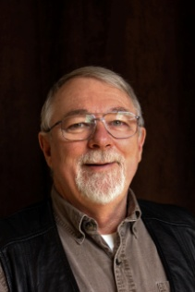
His formal training was varied, including Princess, Central and Huron park schools in Woodstock Sonar and Demolition schools while serving in the military, Barber school, Fanshawe College for Graphic Design and Audio visual, and Coastal School of Deep Sea Diving in San Francisco, California.
One day in school, a friend Bob Tonner suggested they skip class and investigate a military recruitment office that had opened in Woodstock. Bob went back to school but Phil signed up, He completed military schooling and became Sonar Operator. He sailed on the HMCS Buckingham, a WW2 Frigate, where he trained Officer cadets and Reservists. Ports of Call included all provinces except 3, trips to
Britain & Ireland, Europe and the east coast of the United States. Also, during a one year period, he was back and forth to Bermuda 13 times. Lasting memories include North Sea Storms, Atlantic Hurricanes, first motorcycle and Cuban Crisis.
After the Navy, he had jingle in his pocket and was in no hurry to get a job. His folks had a different view, so he worked for Metropolitan store, Woodstock Lamp,
Woodstock General Hospital and Searle Fur store in Stratford. None were a fit, so he went to Barber school in London and started work at Mayberry's Barber Shop, which he later purchased and moved to a new shop across from Williams Coffee shop called Phil's Barber shop, with 4 barbers on the floor.
Another career change saw him head to Caledonia and the Coastal School of Deep
Sea Diving where he trained with Vietnam veterans. Jobs included underwater pipe lines, Bridge abutment work in the Welland Canal, Search & Rescue, including 5 body recoveries and $10,000 in diamonds from Pittock Lake. He was a scuba instructor at the local YMCA, at the University of 'Waterloo, with the RCMP in Ottawa and for the RCR's in London. He has also presented papers at Underwater Conferences in San Diego, Miami, Chicago and Toronto.
Back to school at Fanshawe to finish high school and study Graphics and Audio-
Visual, after which he landed a job at the Oxford Regional Center as Publicity Photographer in the Audio-Visual department.
Phil's next venture was in ballooning. He bought his first one in 1978 while his wife was visiting her sister in North Carolina. His current balloon is his fourth and he is one of only 6 qualified balloonists over the age of 60 in Canada, where there are approximately 1,000 balloonists" He helped start the Ontario Ballooning
Association and co-ordinate the first safety seminars in Kingston, Galt and
'Woodstock.
Other hobbies include Photography, Motorcycles, Tai chi, and curling. He has spent life at 3 levels - the majority on the ground a few thousand hours underwater and over 1,000 hours above ground.

John Eacott
John pointed out at the beginning of his remarks that his appearance at our September Meeting was actually his third appearance in front of our members. Years earlier, before he joined Probus, John gave us an illustrated talk on his experiences running a teachers college in the Middle East. On another occasion, after joining Probus he stepped in to replace a scheduled speaker who had cancelled at the last moment.

John told us that while thinking about his Who Am I presentation he suddenly realized that it was his own mother, many years earlier, who had been the first person to offer him an existential challenge. When one of his actions irked her, she retorted, “Who exactly do you think you are?” After about seven decades of reflection, John told us that among other things he is interested in science and history. A swab of his spit and a DNA test identified John as a descendant of the Cro-Magnon Western Atlantic Modal Haplotye wave of early migration (c 40,000 BCE): John is an Englishman of ancient lineage indeed. More information about personal DNA testing along with more conventional genealogical treasures can be found at John’s well researched website: www.Eacott.info.
John has recently written a book entitled “Becoming John”. In it, he recalls some of his recollections of growing up in Tillsonburg in the 40s and 50s. In the brief section he read to us John created an affectionate picture of a small town bakery shop, free cookies for a small boy, and also a portrait of a somewhat seedy small town baker. “Becoming John” is available at Merrifield’s
After finishing his schooling in Tillsonburg John attended Teachers College in London. He began his teaching career in Burlington but soon moved to Oxford County. After teaching in a number of schools in the area for a number of years he was invited to join the staff at the Teachers College in Toronto. Ten years of living in Toronto was enough. In fact, John decided he wanted a complete change of career. So he returned to our area and set up his own consulting business. Over the next 15 years John worked on projects with around 60 to 70 organizations. These included the luggage maker, Samsonite, and the plumbing manufacturer, Waldec. As John had previously reported, he finished his working career at a newly established Teacher’s College in the Sultanate of Oman, where he was appointed Dean.
John is married and he and wife, Donna, have two grown children. Their son, Jonathan, teaches at the University of California in Riverside and their daughter, Erin, is a federal prosecutor in Edmonton. Erin has one daughter already and a second child is expected at any time now, so John will be a grandfather twice over.
Apparently you can teach an old dog new tricks as John took up tennis about seven years ago. He enjoys playing during the summer months here in Ontario and also down south in Florida during the winter.

John Eacott
Our speaker for this meeting was one of our members, John Eacott, sharing his unique experiences from his time in the "Sultanate of Oman". He had quite a few slides in his presentation, on which he based his talk. Oman is part of the Arabian Peninsula, with lots of desert area.

John went to Nizwa in September, 1996 as the Dean of a new Teachers College, which had just opened the previous year.
The turnover rate was very high as the 6 colleges in the country had 18 Deans during his 3 years in the country and only one other person lasted the full three 1,ears. John worked for a Canadian company who had contracts with the government to supply teachers. One of his primary jobs was to supervise the construction of new buildings for the College, including computer labs. During the fina1 few months of his stay, they were planning for a new Stadium and Fields for sporting events. John suggested they arrange to use the modern facility already in Nizwa, which was rarely used. They said they would rather build their own as there was lots of funding available. At one point, the students were upset with the Ministry of Education and wanted to stage a demonstration. They approached John and requested permission to break some windows. He talked them into submitting a petition signed by all concerned. This was appreciated by his superiors because some colleges received quite extensive damage during their demonstrations.
There were 2 customs that made the staff meetings of 110 people very unusual. A salutation and handshake for everyone in the room was given individually, even by those arriving late for meetings. Muslims also pray 5 times a day, so it was not uncommon for those attending to just get up, go to the side of the room and recite their prayers.
John was accompanied by his '"wife, one of only 7 western women in the country. In all, the Western community in Nizwa, a city the size of Woodstock, only totaled 30 people. The first year they spent in a small apartment building, and thought of not returning to Oman due to the disturbing actions of one of the families in the building. They were able to obtain a 3 bedroom house for the last 2 years, which made for a much more enjoyable lifestyle. They enjoyed parties and picnics with other staff members and also activities with the other westerners. They were also able to do some exploring and sightseeing.
Nizwa, the size of Woodstock, is 8,000 years old and is a 2 hour drive from Muscat, the bustling main city of Oman. It is nestled at the foot of a range of mountains, with nothing but miles of sand and gravel on the other side. They have an ancient mini-waterway through the city with an intricate system to control water use by the residents.
The coastal towns of Oman were renowned for their shipbuilding and navies.
There are 2 large military bases in the country, which are the main staging areas for the British and U.S. forces in the Middle East.

Peter Ewing
Peter began his presentation by leading us in a team cheer and offering a prize to anyone who could guess where he was born. It was the Hamilton Tiger Cat cheer and Larry Lake was the first to guess correctly. Did you get your prize Larry?

Peter was born in Hamilton on June 14, 1941. His father was an accountant with Firestone Rubber Company and his mother was a Piano Teacher. His grandfather, Alexander Ewing,
operated the Star Bakery in the early 1900's and had the first automated bakery in Hamilton and motorized delivery. Peter's mother died in 1945, shortly after the birth of his brother, who was raised by his mother's best friend. Peter stayed with his father, who became the most significant person in his life. They also became best friends and Peter lived with his Dad in the same house in Hamilton for 25 years. At a recent school reunion Peter found that his Dad was also remembered as great friend and coach by other children who had grown up in their area of Hamilton.
His early memories include the A.M. Cunningham playground, where you just arrived and there would be a game of some sport in progress and you simply joined in the fun. There was also the police Minor Baseball and Hockey Association which Peter grew up with for many years.
His education started with the A.M. Cunningham School, then Delta School which just celebrated it's 75th Anniversary. He attended McMaster University from 1961 to 1965, taking 3 yrs. of History and Physical Education & Health in his last year.
He was on the basketball team for the 4 yrs. under a great coach, Bill Fowler. In his final year he was the Captain and MVP for his team and was named to the 2nd All-Star team for the Province.
In 1965 there was a teacher shortage, so Peter went to Summer school for 8 weeks and then started his teaching career at C.A.S.S. with George Symons as Principal,
Don Young as History head and Dick MacKenzie as Physical Education head. He coached Football, Basketball and Track & Field, was made Physical Education head after 2 years and remained at C.A.S.S. for 14 years. Peter has wonderful memories of playing basketball for the Woodstock Kings, a team organized by
Dick MacKenzie and supported financially, and in person at their games, by Mr. and Mrs. V.B. King.
In the 1979-80 school year, the Oxford County Board of Education wanted to transfer some Dept. heads and approached Peter and 2 others. The others said no thank-you (or No), but Peter agreed to go to W.C.I, and feels it was one of the best things that has happened for him. A quote he likes to remember is 'life is a series of golden opportunities brilliantly disguised as impossible situations." After adjusting to W.C.I. and coaching against his former school, he was offered the chance to move from Physical Education to Guidance, and later to Co-operative Education. A humorous memory from the Co-op program involved Jessica Hagan on assignment at Woodingford Lodge. He went to the Lodge to review her progress and wound up as the pin setter for the bowling game she was organizing for the seniors.
His second best decision was to retire in 1997 after 32 years of teaching.
His best decision was to cut in on a dance with Carol Tupling in 1966. They were married in April, 1967 and have 3 children and 3 grand-children.
Another highlight of his life was working at the Olympia Sports Camp near Huntsville. He and his family went there for 26 years with Peter coaching Basketball and his family holidaying.
Peter got an idea from Dr. Paul Willoughby and divides his time between the 4 boxes of Life; Family, Community, Hobbies and Play. At a deeper level he has 5 anchors in his life which include Christianity, taking one day at a time, and interaction with other People.
He would like to be remembered as follows: "Being of healthy body, sound mind and positive spirit, he spent them."
John Farley
I was born 29 Jan., 1938 in Saskatoon. My mother taught school and my father worked in the Royal Bank prior to going overseas in 1939. That was the year my younger brother was born. I never saw my father again until I was seven years old. During the war we lived on my uncle’s farm. My mother was a school principal, a job she held at my school on my first day. | 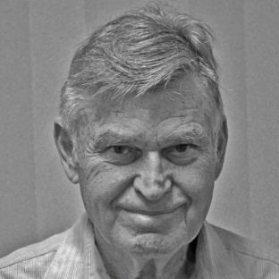

After the war my father rejoined the Royal Bank as an accountant in Weyburn. That is where my youngest brother was born in 1948. My father bought a hotel in Netherhill and my mother started teaching again. I was going to school and farming. I lived on the farm during high school and rode my horse to school. Winter made the ride interesting when the temperatures hovered around thirty below zero. My horse would cover the three miles in ten to fifteen minutes. Roads were not a problem because my horse could clear one in two jumps including ditches. I had to remain alert because he had no fear of cars. My only distinction was that when I graduated from high school the principal said that I missed more school working on the farm in my 12th year than anyone else in the history of the Delisle school. In 1956 I went to U of S and took Mechanical Engineering. During the summers I worked on the farm.
I worked one year as a field office manager for Bannister Pipeline. In 1960 I moved to Montreal and worked at Pratt and Whitney aircraft as a design engineer, in inspection and testing. I worked on PT6 turbo prop engine. Perhaps the most complicated installation for a turboprop governor is the PT-6 engine. This is due to the fact that the free turbine design of the PT-6 mandates control of the engine and propeller simultaneously.
I then Moved to Thompson Manitoba and worked with Inco as a mechanical trouble shooter in the Maintenance dept. In Thompson I got married to my dear wife Jean who has put up with me for the last 55 yrs. My first daughter Robin was born in the Thompson district of Mystery Lake. Thompson at that time was one of the largest integrated nickel plants in the world.
We moved to Winnipeg in 1964 where I worked in engineering with Malco Mfg. designing farm equipment. Malco Mfg. was purchased by Allied Farm Equip of Chicago and I worked as Chief Engineer for them for a number of years. My other 2 daughters were born in Winnipeg, Morgan in 1966 and Cynthia in 1970.
I moved to London Ontario in 1972 and worked with Eagle Machinery as Chief Engineer. Eagle was subsequently purchased by George White Comp and I worked with them as chief engineer.
I then moved to Woodstock and joined Timberjack. While in Woodstock my wife Jean got a degree from UWO and then worked in Real Estate in Woodstock for 30 years. With Timberjack I worked both as a designer and chief engineer of special products. Mine products and tree trimmers were purchased by Timberland Equipment.
I then moved to Timberland as a design engineer and worked with them on hoists, winches and very large units like one shipped on the Antonov AN 225 Mryia aircraft to Asia, we had to strip guards as it was too large to fit in hold of the aircraft.
I retired at 65 but I was asked to come back after some months of retirement and worked with Timberland till I was fully retired at 71. I now specialize in being retired, golfing and curling. My goal at present is to golf my age.

Fred Freeman
Fred reached the magic age of 65 this past summer which should tell us that he was born in 1928. Home town is Iroquois Falls, which is not far from Timmins. It was a pulp and paper town at that time with Abitibi Pulp and Paper as the mainstay of the town until the dirty thirties, when it went into receivership.

Iroquois Falls survived all this and remains a modern
progressive community to this day. The Freeman's have three children; a son is a minister in Orillia, another son works with Fred at Rentquip Supply Ltd. and a daughter who is a civil engineer in Water1oo.
Fred moved to Brantford in 1942 which he found to be somewhat less than "friendly" as opposed to Woodstock. He later moved to Niagara Falls, Toronto, and Sarnia and, in 1965, to Woodstock which he now terms as a friendly City.
During his working lifetime Fred has had three career changes. He started off as an electrician with Ontario Hydro at Niagara Falls. Teaching was his next working experience in Toronto and then in Sarnia. The Sarnia School Board, as it turned out, was not high on Fred’s list of good-guys.
Fred then described to the members how he came to establish Rentguip which he and his son own and operate. Much of the Company's success is attributed to an industrial extension cord which was made available from the start of the company. Fred’s adventures in the equipment rental business started in London in 1969 with the operation of a franchise outlet, when lo and behold, the parent franchising company went broke.
Fred and his son then decided to go it on their own in 1975 with Rentquip Supply Ltd. He left with us a sample of the extension cord, his 1975 price list and a copy of a recent rental catalogue. His company supplies rental stores in Canada with specialized rental equipment for the use of the public. Repackaging of consumable products into smaller quantities is a significant part of their operation.
Fred then told us of his adventures down east including a Newfie joke he came across. Ask him about it if you were not at the meeting.
And there you have Fred Freeman.

Wayne Geall
Although Wayne was born out west in Lloydminster, his roots run deep in Woodstock having arrived here in 1942 by troop train. 1942 by Troop train? Hold on, Just how old is this guy? Well actually, it was his dad who arrived by the troop train. His dad had been assigned to Woodstock as an instructor at the wartime Woodstock Training Grounds and the family never left.  How the city has changed! When he started school, in spite of living on Devonshire Ave, Wayne attended Tollgate. A long | 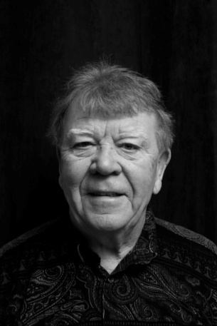
walk on short legs. But in those days Woodstock ended half way across Devonshire and the Gealls lived on the north side. In grade 10 he bought his first car and Wayne suggested that his preoccupation with automobiles may explain why his academic career went, in his own words, "kaput". He's been ‘a bit of a car guy' ever since. Right now, he has a Jaguar and a '55 Thunderbird, both convertibles, a 'Florida' car down south and a van for day- to- day driving.
In 1960 Wayne married Dorothy Metherell, a Woodstock girl, who, in Wayne's words, "never moved out and is still stuck with a 'Woodstock guy." in time, Wayne became the proud father of two daughters, Jackie and Peggy. After settling down, Wayne had a few jobs but no real career path. After a time Wayne and Dorothy decided that he should try to find a career suited to his interests and strengths. Aptitude testing pointed him toward insurance, undertaking and, strangely enough, floral designing was on the short list as well. He chose insurance.
In 1964, Wayne took the plunge and rented his first offices on Dundas Street at sixty dollars a month. He enjoyed the insurance business and he claims that he'd still be in the business today but he just got too old. Wayne's ability to consistently meet or exceed the goals set by the agency sales incentive programs offered by the large insurance companies meant that he was able to fulfill a childhood ambition to ‘see the world'. Over the years Wayne and Dorothy were able to travel to Europe many times and spend holidays in Hawaii and the Caribbean. In 2001 he retired. He and Dorothy spend six months of the year at their home on Summit Crescent just north of Pittock. The balance of the year is spent either in Florida or with visits to see their teen-aged grandchildren. So, in the summertime, keep your eye out for Wayne. He'll probably be driving by, and let’s hope the top is down.

Les Goodall
Leslie Frank Goodall was born to Harry Leslie Goodall and Elva Alice Goodall (nee Butts) on December 28, 1938. The fami1y were living on the Tollgate Road just east of the Ontario Hospital. His father was one of five children. Les is one of five children, and he and his wife Lois have five children, so five is a prominent number in his life.

In the early 20's and jobs were scarce, his father immigrated to
Flint Michigan, and learned the trade of Vu1canizing tires. Three of his sisters had also immigrated to Michigan and had married Americans. As his Father had not given up his Canadian Citizenship, they returned to Canada and proceeded to run the small acreage on the Tollgate Road. They had 6 or 8 milking cows, 1 or two beef cattle, 2 or 3 sows, a flock of chickens, a cat, 2 dogs, and a ferret to keep the mice and rats away.
Les's academic career started out at To11gate School, were bused to Hickson for grades 6 to 8, and on to the Woodstock Collegiate Institute. After graduation, Les went to work for Mutual Life and took his initial training as a Branch Cashier in Brantford, with stints in Waterloo and Windsor before being transferred back to Woodstock on the retirement of the then Branch Cashier.
In 1951 he met a Norwich gir1, Lois Fewster, and married in July 1962, they have 5 children and 3 grand children, Les retired from Mutual Life at age 54 and now has a couple of part time positions of taking pictures of properties insured by State Farm Insurance and Poole's, where he enjoys meeting o1d and new friends.
Les and Lois are ardent members of Central United Church and work very actively on the session and presbytery. Les is currently Secretary of Oxford Lodge No. 76, A.F. & A.M.

Doug Goodbun
Doug Goodbun was born in 1936 on a 160 acre farm near Roblin, Manitoba, a small community 250 miles north-west of Winnipeg. Life was not easy. It was the dirty thirties. There was no electricity, no running water and no indoor plumbing. School was a one-room school house and there were no buses: you either walked or you rode a horse to school. When not cracking the books, Doug played hockey and he curled. After high school Doug wanted to be a druggist, but unlike today, | 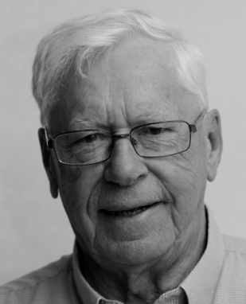
aspiring pharmacists were obliged to serve a two year apprenticeship before attending university. Doug combined practical training with study while working at the local drug store. For twenty dollars a week he tells us.
In 1958 he graduated from the University of Manitoba and returned to work at the same drugstore in Roblin, but this time as a registered pharmacist. The pay was better - ninety dollars a week. If Sylvia, his girlfriend, had stayed in Roblin, his life might have been completely different. Perhaps later on, as a highly respected local druggist, he might have become the mayor of Roblin? But his girlfriend, Sylvia, had moved to Winnipeg. Doug was undaunted.
So I would work all day on Saturdays from 9 am 'til 11 pm in the evening and then jump in my car and drive for 5 hours on mostly gravel roads to visit Sylvia. After just a few hours, I would jump back in the car and drive another five hours to be home for work on Monday morning.
This extreme commute didn't last too long. Doug moved to Winnipeg. The young couple married in 1960 and Doug took a pharmacy job at the Winnipeg General. In June 1961 their first child, Lisa, was born. This first move to Winnipeg proved to be one of many.
In 1962 Doug became the first pharmacist at the Brandon Mental Hospital. This milestone reflected the growing importance of pharmaceuticals in the treatment of patients with mental illness. In 1963 their second child, Robert, was born.
In 1965 the Goodbuns moved again as Doug had enrolled in a Hospital Administration Program at U of T. Being a student meant a couple of lean years for the family, but in 1967, as a new graduate, Doug returned to the Brandon Mental Hospital as the assistant administrator.
In 1969 Doug started work with the Ministry of Health in Ontario. First at the Brockville Psychiatric Hospital and then at the Oxford Regional Centre. In 1986 he took a position with Ministry of Community and Social Services in Waterloo and for the next twelve years acted as a liaison between the Ministry and local agencies in the region delivering social services.
In 1993, Doug went back his first love, pharmacy, first at the Woodstock Hospital, and later at the Rexall's in Sobey's plaza. Here's one last thought from Doug.
I have been truly blest during my life. I was born in this great country, Canada. I was born at the right time, the best time, in the 20th century. I was born into a good caring family. I was given many, many great opportunities. And, I have a great family that I love very much. So what more could a guy, pushing 80 from a small town in Manitoba, ask for?

Peter Harrison
Born in 1947, Peter considers himself a pretty lucky guy. In Scarborough his primary and secondary education took place in new facilities featuring new programs. Peter’s immediate family was surrounded by a very close extended family that got together often. He studied civil engineering at the University of Waterloo. His parents were active in his local church. The benefits of that church connection have remained with him causing him to remain active in his church. Peter | 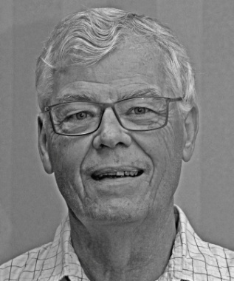
played a lot of sports and in a Scarborough that was still on the edge of Toronto he wandered the undeveloped valleys of the Don River tributaries.
His high school teachers, women and veterans of WWII brought dedication, discipline and a sense of maturity to the class room. He excelled in maths and sciences but languages, French and Latin, not so much. Peter played football on a winning team, learned how to fence and, in cadets, learned how to assemble a Bren gun, but not without pinching his fingers.
St. Paul’s College was where Peter met a number of lasting friends. One would become his wife. It was while he attended the University of Waterloo he was exposed to a range of possible career choices through the co-op program. This “earn while you learn” approach helped pay for his education and instilled true entrepreneurship. He married and became the father of a daughter, Christine, before accepting a position at the MOE in Toronto. Peter returned to Waterloo, following the birth of his son Brett, and entered the Master’s program in Water Resources and graduate courses before joining Kilborn Engineering.
Peter bought his first house in the neighborhood where his grandmother lived and had raised his mother. It was an area of old homes and young families working on “fixer uppers”. After four years the search was on for a new home. They found a home in Leaside. It turned out to be a great move and they enjoyed this small town atmosphere like an island in the sea of Greater Toronto. It was during this time that Peter felt a great need to explore several business opportunities. Over Peter’s career he worked in mining, petroleum, development projects and the design of water and waste water programs. He reported to work in Ontario, Quebec, Newfoundland /Labrador and as far away as Riyadh in Saudi Arabia.
The lure of faraway places was hard on family life and Peter kept the time away as short as possible. It did not prevent Peter from participating in community activities like scouting, minor sports and church committees. Both my children are successful in their careers and devoted to their families and communities and I am proud of them.
Once the kids had left home Peter, at the behest of a head hunter, accepted a position in a small consulting firm in Port Elgin. They loved Port Elgin but a sharp downturn in the local economy meant the business Peter was hired for soon dried up. His time was filled up as a consultant and filling in, as a manager of campus facilities for the University of Western Ontario. He then joined the Ontario Clean Water Agency to develop a new process for contracting water and wastewater design and construction projects. During the Walkerton water contamination incident Peter became the spokesperson for the agency when the OCWA took over the operation of the water and wastewater system. This challenging time saw Peter in meetings with senior government officials including the Premier, presentations with town council and 50 media interviews.
Once the dust had settled in Walkerton Peter went to work for B. M. Ross & Associates. For the next 14 years he would work on a reduced work schedule from his home in Port Elgin. Living in a rural community gave Peter the opportunity to participate on boards and committees he may not have found in larger urban centers. Organizing committees for children, the Saugeen Memorial Hospital Foundation and the Rotary Club where he served in a variety of positions allowed Peter to give back to the community. The Friends of MacGregor Provincial Park, Habitat for Humanity and the Cameroon Hand Up Committee, an off shoot of Rotary, also benefitted from Peter’s involvement.

In 2008 the Walkerton tainted water scandal claimed its final victim. Peter’s marriage had suffered during that stressful time and added pressures finally brought an end to his marriage. Peter kept busy with Rotary and other community activities and it wasn’t until 2012 he met Sharon Kruse. In 2013 he bought a house in Woodstock. Peter is looking forward to enjoying many more years with his new friends in Woodstock.

Ian Hart
Ian Hart was born on a farm near Woodstock where he attended Tollgate and Dunlop Schools. Then off to WCI. So far, so good. Now, here’s where it gets interesting. Halfway through grade ten, Ian did something that I’m sure almost all of us sometimes wished we had done: he ran away to sea.  Ian’s education really started when he joined the Canadian Navy. At boot camp, Ian was tested for mechanical aptitude. He achieved the highest score ever recorded up to that time. The Navy’s choice: to train Ian as an aircraft mechanic, a very | 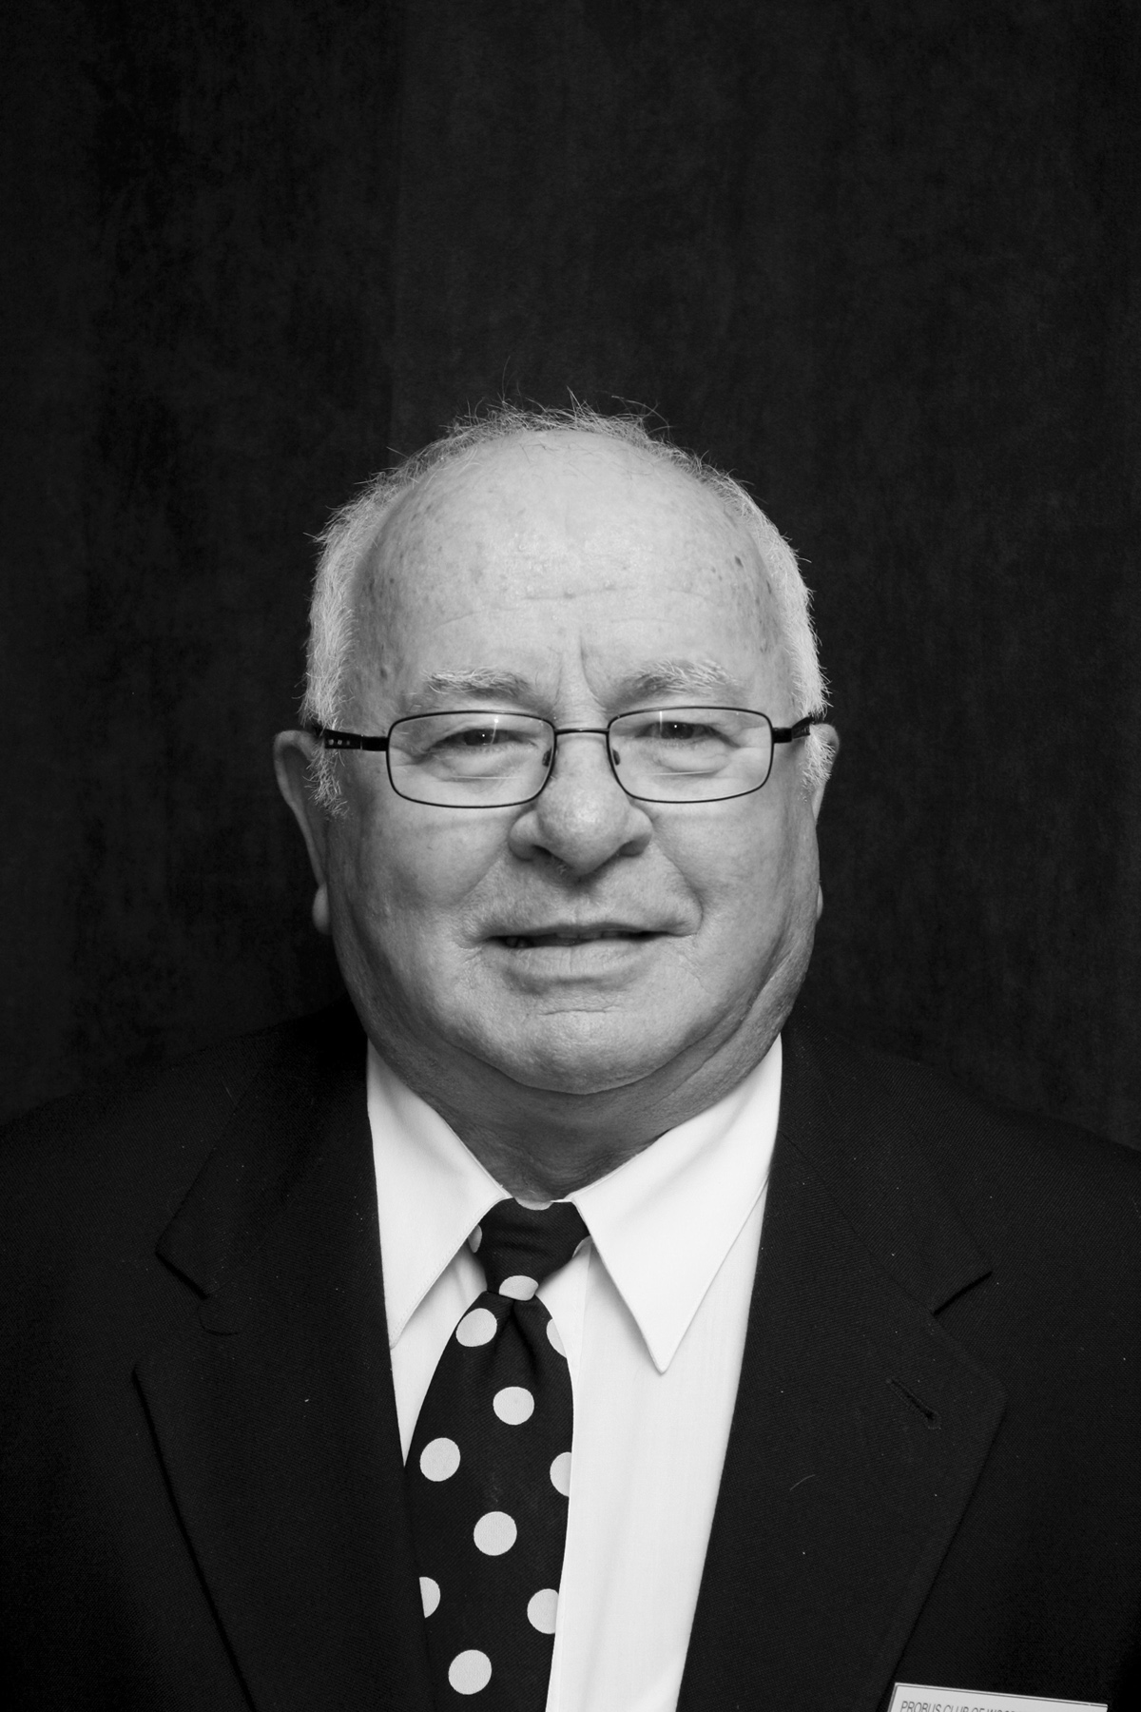
responsible position.
After receiving his training, Ian was assigned to the Bonaventure, Canada’s third and last aircraft carrier. In just a few short words, Ian created a vivid picture of life on board. Some of the more technical details about the ship and the planes on board went over my head but even so, Ian shared with us the excitement of life on board this massive ship during the early days of the cold war. He hinted at a daring race across the Atlantic to confront Russian submarines lurking in the Grand Banks: something not reported in the news at the time.
Summing up, “The Bonaventure was a lifetime experience for me”. The Bonaventure was de-commissioned in Halifax on July 3, 1970 and was scrapped in Taiwan in 1971.
When speaking of the loss of the Bonaventure, Ian couldn’t help but remember the big ship’s role in moving men and materiel to support the Canadian Forces positive and optimistic role as UN peacekeepers. He contrasted those efforts with Canada’s present day role as an active participant in NATO’s risky adventures in Afghanistan and Libya. Ian shook his head sadly, saying, “But now, we are into a war mode, and that worries me greatly. [Today] when you are recruited, you have to sign an infantry clause that allows them to train you with guns and send you to Afghanistan.
“I really think that we should get out of Afghanistan immediately. It is an un-winnable war. In fact, any war is un-winnable. We were far better off peace keeping. I love our country and I think it is a shame the way they are driving it down”
At this point, Ian stopped his narrative. He promised that at another time, he would tell us something of his work experiences with Field Aviation in London and Eastern Provincial Airways in Newfoundland.

Bruce Hartley

Bruce grew up on a farm outside of Norwich and attended Quaker St. and Burgessville elementary schools and Norwich District High School. He went on to the (then new) University of Guelph and took the one required French course, not intending to go further in the study of the language. However, after a summer school immersion program on the south shore of Quebec and the summer of 1967 at Expo in Montreal, he
was hooked on the language and culture and later pursued further study in the south of France.

In 1968, Bruce was a “Young Liberal” delegate at the party convention that chose Pierre Trudeau as leader.
Bruce returned to Oxford County as a French teacher at College Avenue S.S. where he met and married his wife Ruth. They have two grown sons.

He became a French Consultant with the Oxford Board during an exciting time when a new emphasis was being put on Canada’s second official language. He later taught at Huron Park S.S. and retired from there in 2001. Bruce mentioned that he has had no regrets about entering the teaching profession or about retiring from it when the time came.

In retirement, Bruce volunteers for the Cancer Society and the V.O.N. His hobby is photography and he is a member of the Woodstock Camera Club.

David Hay
In his own words, here is the short version of David Hay's "who am I",  "Who am I? I am husband, father, grandfather, teacher, Christian, Lion and Scouter. "  but here's the rest of the story. Although he left his birthplace 45 years ago when he moved to Woodstock, David is still a Montrealer at heart: he cheers on the Canadiens and spends time each summer at the family cottage in the Laurentians, but he is | 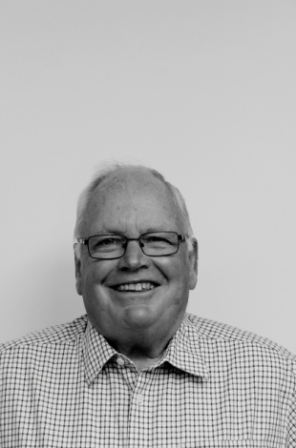
also very proud of his adopted city. Life in Woodstock has been good for him and his wife Claudia: both have had successful careers, they raised and educated three children: Lorraine, Jonathan and Krista, and are now the proud grandparents of eight.
Why Woodstock? After graduating from Sir George Williams University and obtaining his teaching qualifications, Dave taught in Montreal for six years. During that time he met and married Claudia. In 1969 they were expecting their first child. 1969 also saw the initial violence brought on by the Separatists movement. Bombs planted in mailboxes, in stock exchanges and in armories. Was Montreal going to be a safe place to raise a family?
Family and friends urged prudence and that's why David found himself in Toronto one Saturday in March. He was at the Royal York Hotel for the "cattle auction" (a day-long marathon where teachers and school boards sized each other up, filled out applications and contracts were signed). With a leap of faith he returned to Montreal with a signed contract from a place he had never heard of - Woodstock.
David's teaching career started at Huron Park where he taught mainly maths and it there that he met up with a group of young teachers including Bob Thornton, Tony Sheldon and Dan Byers among others. After 12 years he moved on to Norwich where he was able to teach his first love, history. Dave also took on his first administrative role as the school's night school principal. This led to a daytime job of vice principal at both College Ave Secondary School, where he met the redoubtable Moe Cousyns and Ingersoll Collegiate.
The Hays moved to Sweaburg in 1990 where Dave became the principal of both East Oxford School and Sweaburg School. This meant he was working with the families in their new neighbourhood, 'a positive experience". Dave's final months were spent in a town he referred to as "Brigadoon", the mystical Scottish village that appears but once in a hundred years. He was talking about Princeton, which he described affectionately as "the town that time forgot,'
On January first of 1998 he retired from the Oxford board but not from teaching. For the next 12 years he worked as a 'marker' for history exams: a necessary but not always exciting task. Much more to his liking is his ongoing connection with teaching history to seniors with our fellow Probian Deward Yates. This highly successful program has enriched the lives of scores of seniors who gather once a week to look back at where we have come from.
Dave's life was not all teaching. The Hays established roots in their new community. They joined St. Davids United Church. After the kids were in school Claudia joined the nursing ream at the Woodstock General. Dave started coaching. He coached football, hockey and wrestling. With his mentor, Cecil Gracie, he led the HPSS wrestlers to the Oxford-Elgin championship seven years out of nine. The memories of many in the audience were jogged by his recounting of the influence Cecil Gracie had played in his life. Dave also took an active role in the scouting movement. At its conclusion David's presentation was greeted by a hearty round of applause from those of us in the audience.

Sid Hewitt
Sid Hewitt was our presenter in this section at the October meeting. He was born in Allenford (near Owen Sound) in 1940 at home because they were snowed in. He is the son of a United Church minister who pastored a series of small-town rural churches in such places as Belmore, Bluevale and Auburn. From 1950 to 1954 the family was in Capreol-- a town of 1800 people which is the main junction of the CNR north of Sudbury. When he went there he saw only steam
engines on the railroad and by the time they left, diesel had taken over.
From Capreol, Sid and the family moved to Holstein where he attended High School in Mount Forest, participating in all sports and taking piano and music theory lessons.
He has a brother in Kitchener, a sister in Bramalea and a sister in Renfrew.
Sid's working life has always revolved around the livestock and poultry feed business development in this field looked like this:
- early sixties....manufacturing, sales and management at a regional feed mill and at United Cooperatives of Ontario.
- later sixties ...owned a feed business in Maple Hill, with a partner. Lost it in a fire in l967
- 1967...married Donna, a registered nurse from Holstein and moved to Mount Forest to work for Mount Forest Elevators.
- 1972....started working for Central Soya (a.k.a. Canadian Provimi) in a sales position with a territory covering Grey, Bruce, Huron, Wellington and Perth counties....for 17 years during which his territory expanded to cover most of Ontario and Manitoba. The tornado of 1979 wiped out the plant on Juliana drive and changed the business dramatically, from a complete feed and supplement company to a micro premix company.
- 1980... family moved to Woodstock and have enjoyed living here ever since.
- 1990...took a sales and management position with a large regional feed business (Jones Feed Mill) in Linwood.
- late nineties...managed their operation in Heidelberg for five years and did some buying for them.
- 2005...retired, after having a career that spanned 45 years and saw major changes in manufacturing, distribution, nutrition and customers.

Sid and Donna have two children (Blake and Cara Lee) and one grandchild.
Hewitts enjoy travel, antiques, theatre, jigsaw puzzles and reading. Sid sings with the Choralaires and the St. David's church choir.

Thanks, Sid, for giving us a look into your life!

Ash Holloway

Ash Holloway was born in Niagara Falls, Ontario in 1924. Sometime later the Holloway family moved to Brantford where Ash attended Ryerson public school and subsequently Brantford Collegiate. He left school after grade 11 and started an apprenticeship at Waterous Engine Works, a wartime manufacturer of shells for the Canadian army and marine engines for Corvettes.

In 1942 Ash enlisted in the RCAF and served as a wireless gunner. Several years earlier, he had learned Morse code from his father so Ash was sent to Calgary on a wireless course. Next he was sent to Mossbank Saskatchewan to gunnery school. Mossbank was not too exciting for a young fellow. When they were not flying and practicing gunnery, about all there was to do was shoot gophers out on the prairie. After training he was stationed in Bournemouth, England, and Bishop’s Court in Northern Ireland. On one occasion his crew was doing a dingy search over the Irish Sea and they got lost. They landed safely at another airfield but this information was never passed on. Back at their home base they were reported as “missing in action”. They eventually returned to their base two days later. Meanwhile, a lot of his things had disappeared from his locker. When his barrack mates spotted him they looked like they had seen a ghost and sheepishly returned his stuff.

After he graduated from gunnery school and before he went overseas Ash returned to Brantford on leave. The main entertainment in those days was roller-skating and Ash spent a lot of time at the old Alfred Street Arena in Brantford. That is where Ash met his wife, Betty. They must get along as they just celebrated their sixtieth wedding anniversary last June the 28th.

Ash has two children; a daughter who is a biochemist and lives in Dundas and a son who is with the OPP marine division in Owen Sound. Since retiring Ash and Betty have enjoyed traveling and they covered a large part of globe. Ash enjoys curling and golf and goes fishing whenever he can. In Ash’s words “Well, I guess that’s who I am”

Martin Jamieson
Martin began by giving some information concerning his ancestry, which can be traced back to King James the Second who ruled Scotland from 1430 to 1460. The surname originates from the words Jamie and son, and they are part of the Stewart clan, whose crest reads, '"Courage grows strong at a wound". For the next 600 years the name fell into obscurity, then in the mid 1930's, his cousin Agnes Jamieson was appointed the first female coroner in Ontario during the term
of Premier Gordon Conant. She has a library-museum in Minden named after her. His father was born in Detroit, but moved to Cochrane when he was 2 weeks old and later obtained a Canadian passport. His father quit school when he was 14, but later went back to school in Woodstock and on to Pharmacy school.
Martin was born in Oshawa in 1944, where he was educated and in 1964 went to work for General Motors. He was married in 1967 and his wife gave birth to their daughter in 1971. He was a manager in the Parts & Distribution Center from 1967 and in 1975 was asked to come to Woodstock to work in the new National Parts Distribution Center. His family settled in Burgessville as they wanted a small acreage with horses and chickens. He was initiated to this snow-belt area through car problems and 2 roof collapses from the snow load at General Motors.
He had an unpleasant year in 1980, when his mother died and he also became divorced. The next year he met a lovely woman with similar interests, outlook and attitude who he is still with. She also worked at GM. In 1988 they both quit GM, drove through the Canadian Wilderness to Alaska, returned south via the inland waterway by car ferry to Victoria. They then drove south to Yellowstone Park, witnessing several large wildfires. For three years they spent summers on the golf course and winters in Florida until finances dictated a return to work.

Mary Ann worked for Cami for 2 years, then went to work for Dr. Paul Quigley and plans to retire this coming spring. Martin worked for Autrans Corporation for 22 months, then started a cleaning company, getting sub-contracts to maintain floors for Sobey stores in Barrie, Brantford, Grimsby, Paris and Woodstock. He retired from this in 1999 and looks after the cooking and house work while Mary
Ann is still working. They plan to start traveling again after Mary Ann retires.

Art Jones

I was born at Grace hospital in Windsor on Dec 5, 1940 and raised in Amherstburg where I attended public and high school. While at General Amherst High School I was juvenile track and field champion for two years. During the summers I worked at Boblo Island, an amusement park on the Detroit River. I operated some of the amusement rides and I also had the exciting job of mowing the grass. Best of all, sometimes I would drive the little passenger train that hugged the island’s
shoreline.

After High School I attended the Western Ontario Institute of Technology (now St Clair College). In June of 1963 I graduated in mechanical engineering technology and I was hired by Timberland-Ellicott (Timberjack). I moved to Woodstock and started working as a design draftsman in the Engineering Department. In 1968 I moved over to Research and Development.

My wife Elizabeth was from Windsor as well. We were married on October 10th 1964. Liz graduated from Windsor Teachers College and started her teaching career at Tollgate Central School. We have two boys: Brian, born on Feb 22 (George Washington’s Birthday), 1967, and Brent, born on March 3rd, 1972. We are lucky as both live nearby: Brian in Simcoe, and Brent in Hickson.

In the seventies I helped develop a program called Mobile Equipment Technology at Fanshawe College. In 1977 the College asked me to assist in teaching a part of that program. On leave from Timberjack, I taught applied engineering mechanics and mobile hydraulics for two and a half years.

I returned fulltime to Timberjack in 1980 and shortly after I was appointed Service Manager. In 1989 a Finnish company, Rauma-Repola, acquired Timberjack. This was an exciting time for us as the Finns introduced new forestry technology. I was appointed technical training manager with the responsibility of training North American dealers on the new equipment. During this time I traveled extensively in Canada and the US: the only states I didn’t get to, didn’t grow trees. I also visited Australia, New Zealand, Brazil, Indonesia and Iran (Iran isn’t all desert! There are extensive forests near the Caspian Sea). In 2000, the company was bought by John Deere and from that time until I retired in 2004 I was responsible for training John Deere dealers on Timberjack products.

Since retiring I have spent a lot of time at Craigowan (we’ve been members since 1977) and I have been enjoying woodworking in a lovely new workshop in our new home. Elizabeth and I are both active members at the Church of the Epiphany. In the past, I have served as Church Warden and I am currently Deputy Church Warden. As an aside, I draw your attention to Epiphany’s rose window restoration project. The rose window is a memorial to all in our community who served in the First Great War. Please consider making a donation to this worthy cause.

I volunteer at Northdale Public School where my grandson attends. This year, I was lucky enough to mentor a young boy from Jamaica. He was in grade eight and I had the satisfaction of helping him improve his skills to a level where he was able to graduate and move on to grade nine. In addition, I have in the past driven for the VON Meals on Wheels program.

Seeing Keith Latter, Bob Beattie, Don Post, Keith Thompson, Ted Young, John Cook and others in today’s crowd brought back memories of the Y’s Men’s Club that we all belonged to in the late sixties and seventies. I feel, in a way, we’ve come full circle.

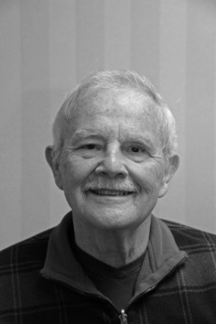
Jim Jones
I am James or Jim Jones
But Who Am I? A good question
Fearing I am going to look like a deer caught in the head lights
I am here to try and explain to you how I got here and what I
have done with my life.
In 1924 my grandfather on hearing his two sons were immigrating to Canada decided they would all do it as a family. The entire family, somewhat reluctantly, was soon aboard a ship to Canada. Upon arrival in Canada the immigration people decided my grandfather, one time coal miner and delivery person of coal, would make a good farmer. A small unproductive farm in Princeton ON was to be the next home for this inexperienced farmer and his family. While some of the family put their education to work in securing employment two had to leave school and take up farming to contribute to the family income.
Upon returning from service during the war my father got a position as lead hand for the railroad. He met and married my mother in 1940. Three boys were born in 1941, 1945 and 1958 from their union.
Hampered by a learning disability my primary and secondary education was not memorable except for one night when the goal posts at WCI became decidedly purple and white before a big game. I suspect there is in this room people who are aware of the significance. After working at various jobs I realized I would need more education to achieve employment that would be enjoyable and rewarding.
I enrolled in the electronic technician training offered at Fanshaw College. After completing this I found a signal apprenticeship program at Canadian National Railway and spent the next 32 years of my life working from an apprentice signal person to a supervisory position. I started with the railway signal department well before an extremely complex system that controls train movements began and I have been instrumental in installing and up grading many of them.
In 1971 I was introduced to my future wife Bette and we were married in 1972. We raised two beautiful daughters.
In the mid-1980s Bette was diagnosed with Multiple Sclerosis, a huge blow to our family. At this time we became involved with the accessibility movement that was just starting to gather momentum in Canada. I joined a number of organizations that were lobbying for more accommodation of folks with different abilities and eventually Accessibility Advisory Committees were mandated for all municipalities. Bette and I were appointed to the Woodstock committee and for the next number of years Woodstock was a strong voice and leader helping to introduce new endeavors for accessibility in Woodstock and Ontario.
Today I volunteer at South Gate Seniors centre to help keep accessibility up to date and I sit on the Woodstock Hospital Patient and Family Advisor Council. It addresses any concerns of patients or family at the hospital and does a good job of trying to see problems that might arise and resolve them before they become issues.
I hope this account explains who I am and what I have done with my life to this point. Thank you all for listening.

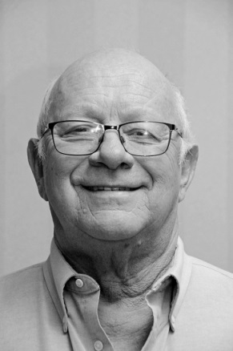
David Lorne King
I was born Friday Sept 13th 1946. My parents both grew up on
farms in Victoria County and ran a family farm for over 50 yrs. My grandmother was a Bernardo girl, Maud Fane. I have lived in, rented or owned 21 houses in my life. While my family lived in or near Cambray I completed my primary
education in seven yrs. Then I went to Lindsay Collegiate and
Vocational School where I completed grade 13. There I played
on several championship teams and also won a Gold medal for
Poetry.
My son, Eddy, was born on Dec 7th1965. He was 7 weeks premature with pyloric stenosis but after some struggles was just fine. In 1967 a second son Rodger arrived for centennial and a celebration of the last Leaf Cup. I got a job at Firestone Tire and Rubber Co in Lindsay and started a career that took me from the factory floor to the Vice President. After Firestone closed up shop in 1968 I went to work for Goodyear Tire for the next 25 years rising to Engineering Mgr.
From my parents farm I moved into my father-in-law’s house then to a 2 room apt in Cambray and, after the 2nd baby, to a small house also in Cambray. Shorty after Rodger arrived I started in the real estate business, and I bought my first house, a 2 bedroom bungalow, for $11,500 on an agreement of purchase and sale @ $90 per month PIT, and my father-in-law co-signed. Over the next several years we moved between Collingwood, Oshawa, Orono, Quebec City and Bowmanville. I also started my coaching career and studied under Roger Neilson, Captain Video. I achieved a level III coaching certificate in the OMHA.
After my divorce I met Norma. We bought a house on Catherine Street and joined our families just one short of the Brady bunch. I was now working in Toronto as Plant manager and we purchased a home in Oakville. The Goodyear plastics operation has sold to the Huntsman Corp.
Tragedy struck in 1989. My son Eddy and his wife Tina were killed in a drunk driving crash near Bowmanville. As a result of this tragedy my wife Norma and I started a chapter of MADD in Toronto and Halton. I was the 1st chairman of MADD Canada. We went on to build a national organization with over 100 chapters across Canada. We received the Queens Golden Jubilee Award for our efforts.
After being a weekend farmer in Lindsay and managing the plant in Toronto we moved to Danville, Kentucky, as plant manager of the biggest operation in the USA. We purchased a home. Along about here we started having grandchildren and now have 8; 4 boys and 4 girls. In 1999 we moved to North Canton, Ohio, as Vice President of manufacturing.
In 2001 we moved to a house on Bunker Hill as Vice president and General Mgr of Huntsman International. My responsibilities were for manufacturing and sales in Europe, Austral Asia, Mexico and Canada. I travelled to one of those countries each week. Then in 2003 we moved to Orillia to manage a new acquisition and the plants in Toronto and a plant in Barrie.
After moving to Orillia I retired and lived in Bayshore Village where both my wife and I spent time on the management board including president. I also served as president of the Orillia Heart and Stroke Chapter, and received the Heart and Soul award.
Two years ago we moved to Woodstock to be the support our daughter needed. I enjoy golf, curling and Probus.
Thank you for the opportunity to give you a glimpse of my life story because that’s certainly all you will get in 10 minutes. A good friend of mine once told me when giving a speech you need a strong beginning and a good close with not too much time in between. We have accomplished pretty much everything we are going to accomplish in life, and I am okay with that as it has been a pretty good ride.

