Who Am I? K-Q

Jerry Klages
Gerald (Jerry) was born in April 1947. Due to a late snowstorm he did not get home for nearly a month. He and his eleven siblings, of which he is the oldest,  lived on a farm that produced mixed livestock, hay and mixed grain. Jerry drove the tractor from age 7 and earned the name “Road Runner”. Most of his siblings still live and some farm in the area. After attending a one room schoolhouse Jerry went | 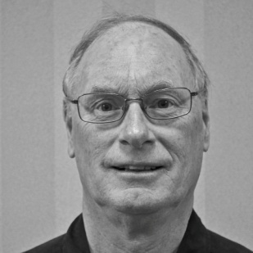
to high schools in Walkerton and Chesley. There his interest in planes, cars and engines earned him the name “scientist”. He would go on to Ryerson Polytechnic and graduate as a Mechanical Engineer, with honours. With farming not in his future Jerry took a position in electrical design at Electrohome, in Kitchener. His work and designs led to an 8 track that used plastic molding. It was with great pride when he saw his design featured in a window display in an Electrohome dealer.
Jerry’s interest in the automotive took him to Standard Tube in 1972. He moved to Woodstock where he would design overhead crane cabs that are still in use today. He also designed a long tube ID seam grinder and scarfing unit. Later working mostly on automotive applications he developed a process of making variable wall tubes. These are now used in axle tube for Dodge and GM pickups. The company received a patent and awards for this process. Jerry’s next venture was into hydroforming where he got to design the first bent and hydro formed tube. Jerry did some of the part design and developed all of the welded joints. This process was called pressure sequence hydroforming. Hydroforming now being used in production by GM, Ford and Chrysler was retained by Vari-Form when Standard Tube Company was sold off. Jerry’s designs are now used in Canada, USA and Europe. His last project was called hydroplast which was used in Ford Australia. Jerry retired in 2008 having acquired 12 patents.
In 2006 to he married Chris who is involved with developmentally handicapped adults. With her came 4 children who now live in Ontario and Eastern Canada. Sadly one of those children, Craig, was killed by an IED while stationed in Afghanistan. A park in Dartmouth has been named in his honour. Jerry keeps busy, these days with woodworking and repairing a Cockshutt 540 tractor. He is active in his church, the Historical Society, Probus and community events when not globetrotting.

Bill Koleszar

Bill Koleszar presented his Who Am I presentation at April’s meeting. To break the ice, Bill started his talk with an amusing story about an ambidextrous golfer who sometimes golfed left-handed and at other times right-handed. The answer to this puzzle delighted the members. Bill’s background is Hungarian. Bill’s parents were married in 1925. His father came to Canada in 1930 with the intention of working for a few years and then returning to Hungary. As 1930 was the beginning of the Depression this plan didn’t quite work out as
expected. Instead, Bill’s mother and older brother joined his dad in Canada in 1934 and they settled in the Tillsonburg area where the family worked in tobacco. In 1945, the family bought their own farm.

Bill received his early schooling in a number of one-roomed schools. The family moved around a lot, so Bill ending up attending five schools in eight years. He completed his formal education at Annandale High School in Tillsonburg. After that Bill returned to the family farm where he worked for the next six or seven years. During this time Bill married and had a son, but the marriage only lasted about four years.

About this time Bill applied to and was accepted by the OPP. There was only one problem: the OPP had a minimum weight requirement of 160 lbs and Bill weighed only 148. This lack of poundage put his police career temporarily on hold.

About a year later the OPP contacted him again and, for whatever reason, the weight requirement was no longer an issue. He trained two weeks in Toronto and then was assigned to a detachment in Essex. For the next few weeks Bill traveled with a more seasoned officer and after that, when he received his uniform, he was on his own. Unlike today, policing was largely self-taught.

Bill stayed with the OPP for a little under two years and then took a job with the Green Giant canning plant in Tecumseh. During his time in Essex County, Bill met Patricia, his present wife. They were married in October 1966 and two years later they bought the family farm from Bill’s parents. Farming can be a tough business - after two wet years and one broken leg, Bill and Patricia decided that they should sell the farm and try something new.

Bill found work at Timberjack, but after three years he was laid off. Several times, in quick succession, he was called back and laid off again. One time when Bill was back at Timberjack, General Motors were hiring employees for their large operation that was just starting up in Woodstock. Bill told his foreman, Alex Keeping, that he had a dental appointment on the day of General Motor’s job fair. When Bill arrived at Timberjack later that day, Alex asked him how the dental appointment had gone. Figuring Alex had already guessed where he had been Bill replied, “There sure were a lot people ahead of me with dental appointments.”

Bill was hired by GM and continued to work there for nearly 27 years. They were good years and Bill is especially grateful to GM for providing his two sons with summer employment while they went to university. Both his sons are married: his older son has two daughters, six and three years old, while his younger son has a six month old baby daughter. Bill looks on his three granddaughters as the most important accomplishments of his life.

Bill’s other interests include stamp collecting, photography, golfing, curling, hunting and fishing. Bill has been a Legion member for over 25 years. For 10 years Bill was active in Cubs and Scouts. His trip to the Canadian Scouting Jamboree held at the Bow River Valley in Alberta stands out as a highlight of his scouting experience: a two week extravaganza with 30,000 participants.

Jim Lefler
Jim was born in Woodstock Ont. in 1930, to Lorne and Ruth Lefler nee (Canfield). He received his formal education in the Woodstock Public School system and the Woodstock Collegiate Institute, and in 1956 graduated from the University of Toronto with a Bachelor of Engineering Science Degree, Civil Engineering. He joined the James A. Vance Construction Limited, as resident Engineer, Project Superintendent and Construction Manager.

Jim is married to the former Pat Parkes, sister of Wall of Famer, Bill Parkes, and they have two children James and Susan, and are blessed with two grandchildren.
From 1962 to 1988, he served as Vice President of James A. Vance Construction Limited. Vice President and Director of Engineering, and Chief Design Engineer for Safety Related issues on the job site. From 1988 to 1993 served as President, responsible for Financial Control, and Personnel, Chief Design Engineer, with extensive industrial experience with the design of overhead cranes and Machinery Foundations.
Jim is a member of the Professional Engineers of Ontario (1959), the Canadian Society of Civil Engineering (Life Member, Fellow), the American Concrete Institute, National History Committee C.S.C.E., Member of the Organizing Committee C.S.C.E. Conference 2000, Former Warden Camp II, Organizing the Obligation Ritual and the Iron Ring Ceremony of the University of Western Ontario and Founding Chairman C.S.C.E. London and District Section (1993).
Principle owner (1993-1998) J.C. Lefler Engineer, offering service in Building Engineering, Structural Engineering in Concrete, Steel and Timber, Safety Engineering, Building Code interpretation and review; Site Selection and Feasibility Studies, Quantity Surveying and Estimates, Project Criteria Review and Recommendations .

Many projects both 1oca1 and in Western Ontario came under Jim's Supervision for various Companies such as Timberjack, G1obal Stone, Standard Tube Incorporated, Vestag Canada Incorporated, Thomas Bros. (Plants # 1, 2 and 3, ) Woodstock Stampings and many more.
Jim has received many honours and awards over the years: The Canadian Pacific Railway Engineering Medal (March L997) in recognition of many years’ service and Leadership. C.S.C.E. awarded Lifetime member for over Forty Years of continuous service to the C.S.C.E. and the Canadian Council of Engineers (awarded in 1981).

Larry LeGallais
Larry’s ancestors were French Huguenots. To escape persecution the family fled to the Isle of Jersey. Eventually his family moved to Canada, settling in the Gaspé. In the late twenties Larry’s father went to work for the St. Lawrence Corporation at their Baie-Trinité facility on Quebec’s isolated North Shore.

Larry had lots of stories about growing up in this pioneer territory but one in particular stands out. As a very young lad he had seen a plane arrive on the frozen lake. He decided to go out and see what was going on. On his way to the plane he passed some men cutting ice blocks out of the lake. He got too close and fell in. It was only because of his red scarf that one of the guys noticed him and pulled him out. Without that scarf, Larry’s “Who am I” would have had to have been cancelled.
Larry went to elementary school in the area where he became fluent in French. He then went to the English high school in Quebec City. While attending UNB, Larry spent a couple of summers as part of a timber cruising team. Timber cruisers live rough in the bush and by a statistical measure determine the value of the forest for logging purposes
Larry started with Timberjack in 1962 where his fluency in French and his north woods experience were invaluable. For the next 31 years Larry lived in Quebec City where he managed Timberjack’s Quebec sales team. In 1993, Larry moved to Woodstock where he took over Dealer Development for North America. Larry retired in 2002.
Elly and Larry were married in 1965. They have two wonderful daughters. Laurie lives in Ottawa and has a son and a daughter. Catherine lives in Montreal with her son, Sacha.
While working at Timberjack, Larry and Elly combined business with pleasure by including sightseeing as part of many business trips in North America and Europe. Since retiring they have continued touring, including
holidays in Mexico, a cruise in the Mediterranean and visits to Australia, New Zealand and Malaysia. Another highlight was an African Safari led by our own David Livingston (Doug Puddicombe). Larry can ride an elephant and he has the picture to prove it. Larry’s other pastimes include golf and curling. Larry spends most summers in his beloved La Belle Province where he continues to enjoy his passion for fishing.

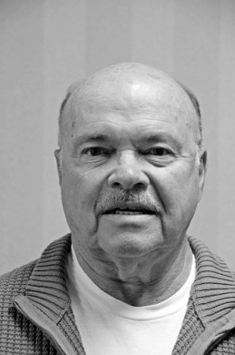
Ed Majernik
Ed was born in Montreal in 1936. Being able to speak
Czechoslovakian and English at home, he soon learned street
French playing with the children in his Montreal neighborhood.
With great pride he related the new words he had learned from his
friends, “Criss de coalice de tabernak”. Perhaps it was just as well
the family moved to Windsor while his father looked for a dairy
farm to purchase.
A farm was found and the family moved near Norwich. Ed was enrolled in a one room school. He went on to high school for five years where he was an army cadet, as well as participating in basketball and football. He was Ed Majernik the captain of the football team. He decided he wanted to be a teacher and taught at Maple Dell for two years while going to teachers’ college.
Ed was next hired by the DOT to be part of the surveying crew that worked on highway 401. Ultimately he decided this was not for him and he worked at various farm jobs to get by.
With a wedding in the offing Ed contacted an old teacher friend and was soon contemplating a return to teaching. He was now teaching “Industrial Arts”. Ed went to Toronto where he took a summer school course and taught the intermediate course. He started teaching metal shop at Huron Park Secondary School. Ed married his high school sweetheart in 1961.
Ed enjoyed his teaching career at Woodstock but in the mid-sixties change was coming to industrial arts courses. These changes were coming at the urging of the ministry of Education so Ed requalified choosing machine shop as his major. He would continue taking summer courses for the next twenty years during which Ed and his wife had three sons and five granddaughters. He also built his own house, acting as his own contractor, where the family would live for the next thirty one years.
In Ed’s final fifteen years he was voted Technical Director at Huron Park. Happy is the man who has lived long enough to see his students blossom into adults and thank him for his contribution to their success. Reaching the thirty five years and out mandate Ed retired from teaching. He also moved to a condo in Woodstock. But he soon allowed himself to be drawn out of retirement into putting on trade shows, up to eight per year. The area he covered went from Woodstock to Ottawa and down into New York state. Ed ended his curriculum vitae with a story that I will not repeat here for fear that I would not do it justice.

Glen McDonald
Glen, the youngest of three children, was born to Sam and Nellie McDonald in
Clinton, Ontario. His father had been born in the township of Zorra between Embro and Kintore, while his mother was born in Eastwood, just east of Woodstock.

His mother was a teacher but was required to give up her
profession upon marrying. His father worked for the Canadian Oi1 Company, better known to many as White Rose. Around 1925 he was awarded a distributorship in the Clinton area. By the time Glen was 15 years of age, Dad had eight gas trucks and Glen drove one of them.
Bureaucracy was apparently in its infancy in Ontario at that time. At the age of sixteen Glen applied for a driving licence but was told by a friendly examiner, a customer, that he didn’t need to bother since he had been driving so well for so long. But he got it anyway, without a test.
During his presentation, Glen philosophied that through his life he had been influenced by "five fathers". First, his own father from whom he learned the work ethic. Then others who, in one way and another, directed him into the field of education and ultimately teaching. George Simmons being one.
In 1972, in consequence thereof, Glen became Vice Principal at Woodstock’s CASS, and Principal in 1975. Five years later he became Principal at Huron Park Secondary School. Later he became Superintendent of the Board of Education and retired in 1994 after over thirty years in the educational system.
By far the most important of Glen's "fathers" has been his Heavenly Father. A man of strong Christian belief, he is a member of Oxford Street Baptist Church and a volunteer with the Upper Deck Youth Centre. He is also a chorister in a gospel quartet called the Bonds of Love which, for the past 14 years, has been performing all over Ontario. His outreach goes still farther as current co-chairman of the loca1 United away appeal campaign.
Married to his wife Bev, he is the proud father of three children.

Glen McDonald, on Australia
The Who Am I segment at February’s meeting was presented by Glen McDonald. Glen spoke on his travels to Australia. Glen‘s son, a schoolteacher, has lived in Moree, New South Wales, for a number of years. To keep in touch, Glen and Beverley have made the long trek to Australia several times. Apart from visiting family, they have also toured extensively.
Like son, like father. I guess you could say that when it comes to teaching, Glen is definitely an “old block off a new chip”. In a remarkably short time, he gave us a very well organized thumbnail sketch of the geography and some of the history of this far off land.
The pictures Glen showed us were taken during their most recent trip and included scenes from the Great Barrier Reef, Ayers Rock, Cairns, Sydney and Brisbane.
Interspersed with these sunny scenes from 2008, were some really spectacular pictures showing the devastating effect of the recent flooding in Queensland. But remember, just one year ago, rivers were drying up, and great swaths of the Australian state of Victoria were consumed by bushfires. Global warming? Climate change? | 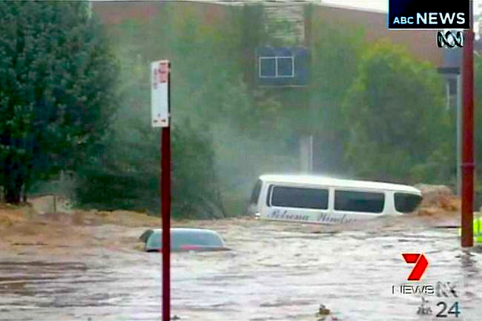  Toowoomba Floods 2001
When we think of Australia, we think of a hot, sunny, and dry land, baked red by the sun, but as Dorothea Mckellar pointed out in her iconic poem, My Country,
I love a sunburnt country,
A land of sweeping plains,
Of ragged mountain ranges,
Of droughts and flooding rains.
extremes of drought and flooding have always been part of Australian life.

John McDougall
John was born on September 24th, 1936, at home, in a little cottage house in Ancaster, Ontario. He still feels sorry for his mother as he was a bouncing 12 pound baby. His parents had a small farm in Ancaster along with a Thor Electrical Appliance store at 212 King St. East in Hamilton. During his pre-school years he spent many days and evenings at the store because his mother ran the store while his father was on deliveries or repairs.
His Dad was the top Thor appliance salesman in Canada in 1930. They closed the store in 1942 and moved to a larger farm on Hwy. #53, still in Ancaster.
He started school in a one room school, attended Westdale Secondary School in Hamilton, where he played football with Russ Jackson as his quarterback. He received a Certificate in Business from Mohawk College.
In 1957 he met Doris Ecker at a Wentworth County Junior Farmers dance, and two years later they were married. They built a house in Binbrook and lived there until moving to Woodstock in 1969. They have three children and eight grandchildren. He and Doris are active members at St. David's United Church.
John's working career began n 1952 at continental can company where he was a Maintenance Mechanic for 4 years. In 1956 he joined Bell Telephone as Central Office Technician and later Construction lineman. He left Bell to work for Dofasco as a licensed Compressor operator and Maintenance Mechanic.
During these years he continued an interest in AJ, the Artificial Insemination of livestock. He was accepted to train to be an Inseminator and received his licence from University of Guelph in 1959. The next two years he was a part time technician with Hamilton District Cattle Breeders while working ful1 time at Dofasco. In March, 1963 he left Dofasco to work full time with Hamilton District Cattle Breeders, rising to the position of General Manager in May, 1969.
In July, 1969 Western Ontario Breeders Inc. was formed with the amalgamation of Oxford- Hamilton and Essex Breeders, with Dr. R.J. McDonald as General Manager. John moved to Woodstock and worked as Director of Field operations for 7 years. In 1976 he became Assistant General Manager and in 1988 was appointed General Manager. Another merger took place in June, 1996 when WOBI and United Breeders joined to form Gencor.
John took early retirement in July, 1996, but did contract work for the next 6 years, finally retiring in March, 2002. He enjoys their grandchildren, music, computers and camping in their Winnebago Motor home, and looks forward to spending more time in these areas.

George McEwen
George McEwen was born in Culloden in south west Oxford in 1922, the youngest of four children (3 boys and 1 girl). His mother and her family had come to Canada from England when she was only two years of age. They settled in Culloden. His maternal grandfather was a tin smith and handy man, and was known on those parts as Tin Willie. On his father's side, his great great grandfather had come from Ireland and acquired
crown land on the 5th concession of Dereham Township.
George's father was born in Verschoyle and operated a mobile threshing mill and also a grist mill. He was a particular man in servicing his equipment, an attitude obviously inherited by George. Unfortunately he died in 1933 when George was only eleven years of age. Times were tough, and food was short, but boyhood pleasures were still enjoyed, ice hockey on farm ponds using horse dung pucks being one example. At twelve years old he went to work.
In 1939, George obtained a job with Standard Tube. It was about that time that he met a young lady, Eva by name, whom he would marry some years later. He joined the RCAF In 1942 and served as an aero engine mechanic at #4 RD in New Brunswick, carrying out major overhauls on Spits, Mosquitos and Lancs, to name a few. He was discharged toward the end of 1945 and married Eva in 1946. Their family consists of three children and five grandchildren.
Fo1lowing a spell with Boys' E1ectric, George went into partnership with an associate and formed Campbell and McEwen, a heating and sheet metal business in Woodstock, installing up to 100 furnaces a year. Illness unfortunately caused George to eventually dissolve the partnership in 1971 after almost twenty years of successful operation. He, however, continued his interest in the heating industry, working for another company as a designer and salesman, a job which took him throughout Canada. In 1987, George retired.
His interests today include travel, gardening, photography (witness the Probus Directory); though he claims he is out of focus. He delivers the Newsletter, and is a volunteer driver for the Cancer Society and the Red Cross. He joined Probus in 1990, and we are proud of him.

Dr. Gerald McKay
Gerald McKay was born in 1930, one of three children, on the family farm located on the 13th line north of Woodstock, now part of Pittock l.ake. He was delivered by Dr. C. McKenzie McKay, a relative of the fami1y, and well known Woodstock physician and military doctor.

His great grandparents on his father's side hailed from
settled near Braemar, but shortly after moved to better 1and. His maternal great Scotland, and originally grandparents, Dunn by name, came from England, and settled north of Woodstock. Gerry's father farmed and also barbered, charging 25 cents for a haircut.
Gerry first attended the Tollgate school on highway 59, followed by high school at WCI in Woodstock. Outside entertainment in those days consisted of shinny and ice skating in winter and, in summer, swimming, plus, of course, farm chores and the raising and harvesting of cucumbers.
In 1948 he entered the Veterinary College at Guelph, at that time part of the University of Toronto. While a student, he was hired by Dr. R. J. McDonald of the Oxford Holstein Breeders as a technician. This aroused his interest in cattle reproduction and infertility in both male and female animals. Thus began a life-long career.
Graduating as a veterinary doctor in 1952, he applied for and obtained a position with the Oxford District Cattle Breeders Association under the direction of Dr. McDona1d. His early years were spent out on the farms on pregnancy diagnosis, rectal examinations and other related matters from which he gained valuable experience. Eventually, he became head of the Semen Production Unit in the revamped Western Cattle Breeders Inc., located on highway 59, home of the world famous bull Hanover Hill Inspiration, and the first bull from which over one million doses of semen were so1d
Dr. McKay retired in 1995, and, with his wife Fran, enjoys travelling, cottage life and bird watching. They have a son and a daughter, both a married, and two grandchildren.
Curling, golfing and reading round out a busy retirement schedule, just reward for a busy and productive career.

Jim McNamara

Fred Freeman introduced our newest member Jim McNamara. Jim was raised on a farm in southwest Norwich Township. After his education Jim went into the insurance field in nearby London as an insurance adjuster. He arrived in Woodstock in 1970. Jim joined Jamieson Hilts in 1983. He retired in 2005. Jim is interested in golfing, cottage life, and fishing. His son and daughter now operate the business. | 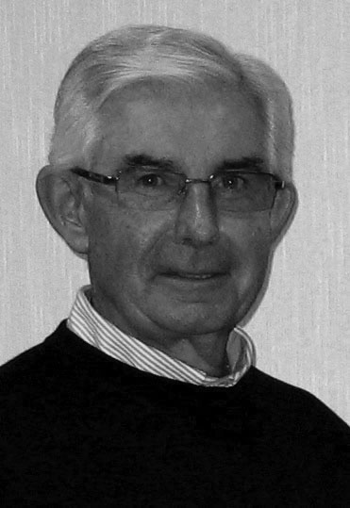

Bob McTavish
Bob and his wife, Doris (nee Klein), both hail from Bruce County. Bob was born and raised in Kincardine where he received his public and high school education. At that time, the principal industry was the production of hard wood furniture. His father was a finishing room foreman with one of the major furniture manufacturers in town, the Andrew Malcolm Furniture Company. His mother, for a period of time, was librarian in the 1oca1 library in the Walkerton area, between Mildmay and | 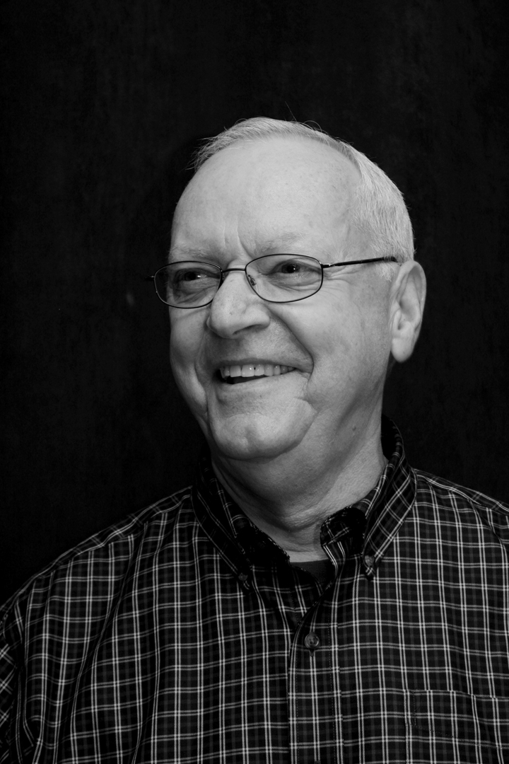
Clifford. She attended a one room school, the Klein School, named after her family, and later attended high school in near-by Walkerton. She went on to study nursing and in 1963 graduated as a registered nurse. Her father was a mixed grain and dairy farmer while her mother taught school.
Winter in Kincardine could be difficult, often cut, off and isolated due to blowing snow off Lake Huron, but as Bob explained, 'being mostly of Scottish heritage, it was a very tight knit community." In the summer months the town welcomed an influx of families, usually for the entire season, from all over south western Ontario and Michigan. It was a 'dry town', back then, but well known for its golf course, glorious sunsets and Saturday night bagpipe parades but very little e1se. The action, apparently, was in Port Elgin or Grand Bend.
Bob spent his working career of some thirty eight years in the food industry starting with an I.G.A. Food Store distributor called M. Loeb Limited, at that time a family owned food distributor based in Ottawa.
Climbing the Loeb corporate ladder necessitated many early department and store manager transfers throughout south western Ontario, including stops at Elmira and Woodstock. He also held several regional positions and in 1975 became Director of Regional Store Operations in the same geographic area.
It was while stationed at Elmira that he met Doris for the first time. She needed an escort to her class graduation ceremony and banquet, and her twin sister's boyfriend persuaded her to take a chance on Bob. Today, that boyfriend and Bob are brother's-in-1aw married to twin sisters. Later, Bob and Doris moved to Woodstock and have remained Woodstonians ever since. They have two sons and one grandson. Both sons are in the Toronto area pursuing their separate careers.
During his dissertation, Bob talked about his life in Woodstock and recalled his tumultuous encounter with the 1979 tornado, an unforgettable experience.
Recently retired, Bob is happily adjusting to life free of corporate decisions and planning ahead to when Doris will give up her part time nursing. Future plans call for travelling, gardening, golfing and charitable endeavours, and of course – Probus.
He is already helping with the signup sheet for our Golf tournament at Stonehaven on June 9th. Welcome aboard, Bob.

Bill Meek
Bill Meek’s roots in Oxford County are deep. He was born in Ingersoll in 1939 and was raised on a farm where ‘the title went clear back to the crown’. In the 1830s his ancestor, William Meek, a stonemason, arrived to take up 400 acres of heavily forested land in West Oxford. William kept this land, but purchased a second farm on the Old Stage Road. The family prospered. A son, Peter, developed the original land, acquired the timber rights and built a sawmill. Peter’s wife Margaret set up a cheese factory. | 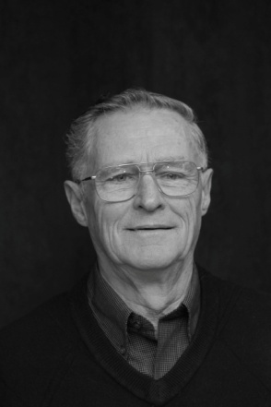

Bill attended school at Foldens Corners where he insisted that he was ‘basically a good student’ but did admit to doing something mildly mischievous at least once. The bricks on the wall of the school were quite soft and it was a tradition for students to scratch their initials on the bricks. Bill found a brick that was soft enough to carve his whole name. Bill had completely forgotten about it. Guess what happened next. In Bill’s words, “When the school was torn down in the 1960's, Monty Towne, came to my door one day and handed me that brick. Imagine the chances of ever finding that”.
In 1960, Bill met his wife Sharon. Last year they celebrated their 50th anniversary.
The Meeks have three children and three grandchildren. While his children were growing up Bill was involved with cubs in Salford. From 1960 until it moved to its Southgate facility, Sharon managed the Woodstock Seniors’ Centre.
After graduating from OAC, Bill joined his father’s dairy operation. In 1969 they switched from dairy to hog production. Bill was a member of the Pork Producers and over the years he served on the executive in a variety of positions
In 1988 Bill changed careers, joining Ayr Tractor in Hickson, working on repairing small engines. After six months his employer enrolled him in the small engine apprenticeship program. This combined two years of on–the-job experience along with two years at Sir Stafford Fleming College in Peterborough. At the end of the program he received his small engine licence. Since 2000 Bill continues to do small engine repairs from his home.
Sharon and Bill still live on the original family farm. However, now the land is rented out except for a couple of acres of sweet corn. According to Bill, ”Growing the sweet corn is more of an excuse to work my antique tractors”. Bill and his brother have a collection of eight machines. If you are travelling between Foldens and Sweaburg in August and September you might see Bill’s little veggie stand sitting out by the road.
Music has always been a big part of Bill’s life. He started learning the clarinet at age thirteen; taking lessons from Tom Brooks. In high school he took up the alto saxophone. He was part of a group (including fellow Probian, Bernard Calder) called the Double Dribble Nine. They cheered on WCI at football and basketball games. Later he played with the Norwich Musical Society Band. Bill is not only an accomplished musician but he sang with the Woodstock Choralaires for 27 years, touring in Britain and Europe.
Blair Kelner, Bruce Jakeman and Tracy Buchannan have joined Bill as part of a musical foursome. There is a music room set up in his basement complete with mikes and amplifiers. The gang brings their instruments and Bill provides the beer. In July the group played at the Canterbury Folk Festival in Ingersoll and we will all have a chance to hear Bill’s group at the Probus Social.

Ken Minler

Ken Minler was raised on a dairy farm near Embro and has farmed practically all his life, specializing in dairy cattle and field crops. Ken also does auctioneering and appraisals for household items, cars and trucks. He presently lives near Beachville. Ken enjoys attending religious concerts and sings in the Masonic Choir. Ken is a Shriner. He enjoys sports and, in spite of everything, is still a fan of the Maple Leafs. He plays hockey on Friday nights in Ingersoll. Ken is community minded. He served on the Zorra Council for
nine years. A stepson has recent returned from Afghanistan. His best friend and partner is Barbara.

Everett Mossman
The son of a deep-sea fisherman, Everett Mossman was born and raised in Lunenburg, Nova Scotia. After high school, he attended Waterloo University College for his undergraduate degree and Waterloo Lutheran Seminary where he studied theology. He was ordained in 1967.  Everett spent the following thirty-four years as a Lutheran pastor. His first charge was at St. Mark's in Kingston where he combined pastoral duties with prison outreach. At St John's in Waterloo he was part of a team ministry and then he moved to | 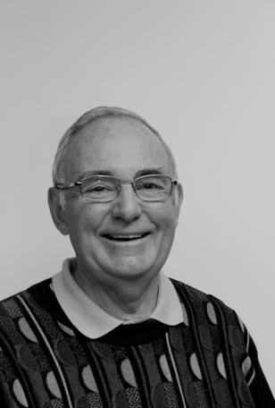
Cambridge where he led the congregation at St Paul's Lutheran.
Accepting a call from Peace Lutheran in Lower Sackville meant a return to his Nova Scotia roots, but it wasn't too long before Ontario beckoned again and he continued his full-time ministry serving congregations in Conestoga, St Jacobs and Tavistock, where he and his wife, Betty, settled down. At age sixty he retired, but he continued his ministry by serving a number of parishes on an interim basis for a further twelve years.
The Mossmans have now moved to Woodstock. They are living at 900 Chieftain and are finding that they really enjoy the freedom to just lock the door and take-off, feeling secure that all will be well when they return. Everett is involved with the curling club and has been known to play a round or two of golf during the off-season. They have two children and four grandchildren.
It was an interesting and carefully thought out presentation. I think for most of us it was a rare chance to learn something about the life of a minister as lived from the inside. He also shared with us what it is like to spend a lifetime trying to help people as they grapple with the big questions of life.

Harry Mott
Harry Mott's father, Everett, was born in 1897 on a farm near Thamesford. In 1929 he married Hazel and the couple settled in Ingersoll where they raised a large and lively family: six brothers and three sisters. Harry was born on May 25th, 1942.  Jobs and money were scarce in the thirties. Harry's dad worked as a stationary engineer, tending the boilers in factories. A fancy sounding title, but as Harry put it, “In those days you | 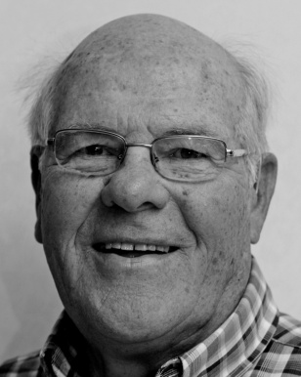
shoveled a lot of coal”. His dad worked hard. The Motts had a large vegetable garden to help feed the growing family. Lots of potatoes to hoe and plenty of berries to pick, but what sticks in Harry's memory is his regular trip to the huge rhubarb patch, returning with a big armful. “Don't stint”, his mother would say. She believed it was as easy to make 8 pies as it was to make 2. There were always a goodly number of young Motts running around Victory Memorial School. The principal gave up trying to keep them all straight. When he wanted to speak to any one of them he just called out “brother Mott” and that was that.
Harry attended IDCI where he recalled with pleasure his time with the school basketball and football teams. Harry said he had lots of opportunities. Half of the IDCI students came by bus and had to leave by 3:30, so it was sometimes hard to find enough bodies to a team. One year the players never left the field, they were on for the whole game, both offense and defense. Good times on the field, but perhaps more often, bad numbers on the scoreboard.
I liked his recollection of the IDCI Cadet Corps with its spring ritual of marching up and down the football field. It brought back painful memories to many of us who had donned scratchy wool uniforms and formed ragged lines on hot spring days, 'fainting' for “Queen and country”.

Harry's first job was with the Ingersoll Tea Factory working as a “chef” in the margarine division. The cooking involved filling a big vat with 1800 lbs of corn oil, adding salt, milk and “a can of this, and a bit of that”. But before too long factory life paled.
Harry's life in law enforcement? It happened almost by accident. Harry needed work and Woodstock was in need of a constable. He filled out a form and the chief said”you're hired”. Harry thought he'd give it a try. Thirty five years later he retired, still a young fellow of fifty-six.
Here's how he summed up his police career,
I met a lot of good people and of course we dealt with a few bad ones but you forget about them. Woodstock is a good place to live and I have enjoyed it.
While still working at the Tea Factory, he married his high school sweetheart, Sharon Moore. They had two boys, Kevin and Brian, and then a daughter, Susan.
Today the Motts are enjoying their seven grandchildren.

Richard Orton

How did Richard Orton come to be born in Gravenhurst? Richard’s grandfather came to Canada in 1918. In Britain, he was a bristle maker, and the Rubberset Company in Gravenhurst made lots of brushes. Richard’s father and mother came to work for Rubberset as well. Richard’s mother was also famous for her baking. | 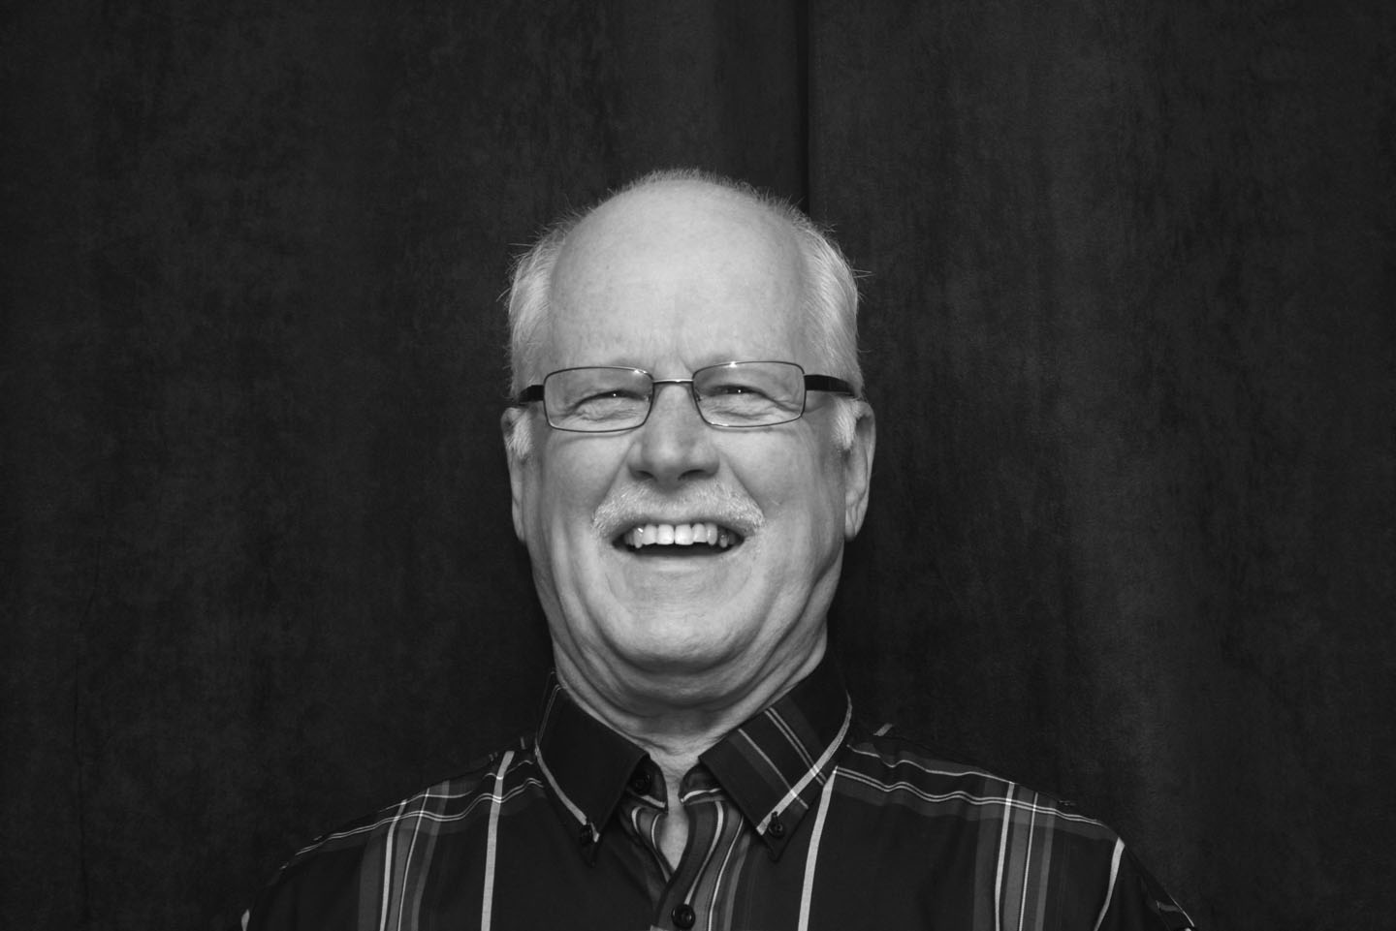
Sloan’s Restaurant, a local landmark, always featured “Mrs. Orton’s apple pie”.

Richard began his education in a one-room schoolhouse (a distinction that is becoming rarer as time goes by). He played hockey as a kid (goalie) and his early exposure to northern life planted the seeds for a lifelong interest in the out-of-doors, camping, fishing and hunting. In high school he became involved with cadets and, as a young adult, Richard followed this interest by joining the militia.

Richard, too, went to work for Rubberset, but by 1962 had set his sights on the new field of Data Processing. So he moved to Toronto where he attended the International Data Processing Institute. His first job was with Household Finance where he stayed until May 1976.

Once Richard was established in Toronto, he felt confident to propose to his future wife Jean. Jean and Richard have two children, Andrew and Jo-Anne. Andrew works with students at Sheridan College in their Technology Department. Jo-Anne trained in social work and is currently employed with Community Living Ontario. She lives here in Woodstock with her husband and two children, Jack, who is fourteen, and Eva, who is two years younger.

In 1976, the lure of the north called, and Richard and Jean settled in North Bay, where they worked in real estate for a few years. Although they enjoyed the life in the north, the income stream was not always steady. So in 1978, Richard took a computer-related position with Fisher Controls in Woodstock, where he worked until Fisher Controls shut down in 1997. As fate would have it, the Guarantee Company of North America had just decided to relocate its Information Systems Dept to Woodstock. Richard found employment there until his retirement in May of 2008.

Since his retirement, Richard and Jean have taken up modern square dancing. The exercise is great: 2½ hours of dancing is the equivalent of walking 5 km. It is fun and it provides a great opportunity to make new friendships. During the summer months Jean and Richard can often be found on the golf course. Their lively pet dog, Maggie, is also a source of great interest. Of course, there is always yard work and maintaining the fishpond.

Ken Ovington
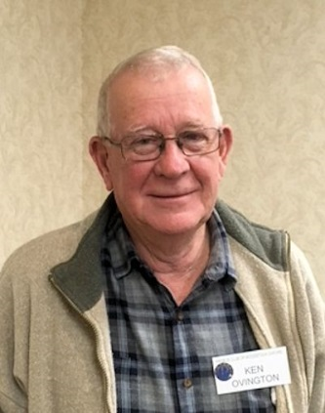
I was born on November 29, 1944 at Cathcart, ON. My
father grew tobacco (a share grower) in Burford, where I
attended Burford Public School until Grade 4. We moved
to the Woodstock area around 1954 where we started a dairy
farm and I went to Bonds Corners Public School. I got interested
in sports (baseball and track and field). Added football when I
went to HPSS where I was on the 1960 football championship
team that beat Tillsonburg (that team later got into the
Woodstock Sports Wall of Fame and started HPSS's football dynasty). In 1961 we moved to Brant/Oxford county line where we expanded the dairy herd. All through high school, I played hockey and baseball at Eastwood, Ingersoll, Norwich and Oxford Centre. I worked in tobacco in the summer and started at The University of Guelph in the fall of 1964 where I worked at the university in the summer and joined cross country and wrestling teams I graduated from Guelph and taught at HPSS for 2 years (taught environmental science and coached x-country and track). I taught Animal Science at Fanshawe College for 3 years (coached hockey team). I started farming in 1973 (cash crop and swine) - quit in 1973 due to health problems. I went on to work at Ontario Livestock Electronic Selling of feeder pigs which started the decline of auction barns and drovers. I went on to work at Hay Bay Genetics and Daco Feeds as a consultant from Ontario to New Brunswick finishing my career at Maple Leaf Agresearch as the swine division manager. I retired in 2008.
I spent 25 years managing and coaching hockey and ball in Burford, Oxford Centre and Norwich including 1978, where I co-coached an all Ontario Championship Atom team (a first for Burford) 40 years later this team was inducted into the Brant County Sports Hall of Fame. I curled with the Norwich Curling Club for 20 years. Also belonged to Woodstock Coin club where my wife and I designed commemorative medals for Beachville's first Baseball Game and the Zorra Tug of War champions. I belonged to Poultry Association, Ornamental Pheasant Game bird Association, Burford Minor Hockey Assn, Norwich Curling Club executive, 1970's Woodstock Senior Club Executive, South Oxford Minor Ball, Norwich Industrial Hockey League and was Past President of 68 OAC.
My hobbies are hunting, fishing, woodworking, restoring cream separators, travelling (Canada coast to coast, the Yukon, cruising eastern seaboard, Hawaii, and the Baltic, Bluejays Spring Training Camp, Spain and Portugal) I also enjoy reading (nonfiction-World War books and History, Sports). I am now researching the Family Tree.
Family

I met Eleanor in High School. We have three children, Jim, Ken Jr., and Laura, and seven grandchildren.

Tony Paladino
After being introduced by Art, Tony greeted us in English, and then in French. He could, if he'd wished, greet us in Italian, and we learned rather surprisingly, in Portuguese and Spanish as well. This fluency dates back to the time he spent working in Brazil. A colourful chapter in his life, and if things had turned out differently, Tony might well have given his Who Am I to the Sao Paulo Probus Club rather than our club here in Woodstock. Tony was born in Rome in 1936. | 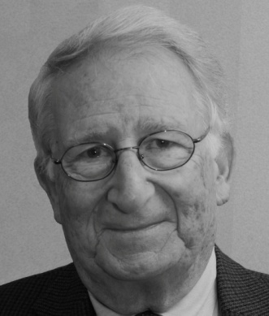
His father was a businessman who owned two candy factories, one in Rome and one in the south, in the seaside city of Bari. His was a large family, two boys and six girls, and we learned, happy and harmonious to this day. He received an excellent education at his local state primary and secondary schools and afterwards went to a small engineering school located right inside Vatican City. Tony graduated as a fully qualified civil engineer specializing in agriculture. Meanwhile he had obtained his private pilot's license.
This knowledge of flying and agronomy led to a job with an aerial surveying company. Plans for Italy's autostrada were underway and the first need was for aerial photographs. Soon after, his company was approached by the Brazilian government to undertake a similar survey in the wilds of the Amazon. This was looking forward to the construction of the new capital, Brasilia.
Tony's company wasn't interested (wisely it turned out), but Tony was. So off he went to live in the jungle. His first inkling that this might have been a mistake was when he was issued a pistol to shoot any menacing snakes that might turn up. Scary! And that was just on the ground. It was even more frightening up in the sky with nothing but impenetrable forest beneath you and one postage stamp sized airfield to land on.
“from two, three, four thousand feet it looked like it was my coffin”
Two months later he was back in civilization, working in Sao Paulo at an engineering design office. Here's an amazing 'isn't this a small world' moment. A stranger came by the office where he was working and overheard Tony speaking in Italian. The stranger was Italian too. But he wasn't really a stranger. Many years before in Bari, the stranger had been his father's original partner in the candy factory. What are the odds! This chance encounter resulted in Tony getting a better job at a more important engineering office.
In 1960 Tony decided to come back home for a vacation. In 1956, Tony had met Anna, his future bride, for the first time while vacationing in Malta. Both, it turned out, lived in Rome. But in spite of their initial attraction, they had gone their separate ways. And Tony took off for South America. In 1960, on his brief vacation, the spark was rekindled, but once again Tony had to go back to Sao Paulo. This could have been the end, but the 1960s were bad times in Brazil and after another couple of years Tony sold up and moved back to Italy. This time the spark burned brightly and Tony and Anna were married.
In Italy at this time there was compulsory military service. Tony had had a deferment while at school and obviously couldn't serve while out of the country, but on his return the Carabinieri came to call. Tony served for 18 months and has a $32.00 a month Italian government pension to prove it.
Back on 'civvy street' Tony returned to engineering design. He tells us that one of the bridges over the Autostrade from the Rome Airport is his work. It was a tricky spot, very soft ground. The first bridge had fallen down almost right away, Tony's is still standing. But in spite of all this Tony was feeling cramped by life in Italy. Class ridden, with promotions based on who you knew and family status, not on merit. Canada, in the form of Timberland, beckoned.
Once established in Woodstock the Paladinos raised two boys, Richard, a computer analyst with Timberland, and Ronald, a tool and die maker. Now this may seem like a rather abrupt way to end Tony's Who Am I but this is what happens when you are a wonderful story teller. You run out of time and that is what President Art had to reluctantly tell Tony. Perhaps someday we will hear more about his interesting life here in Woodstock.
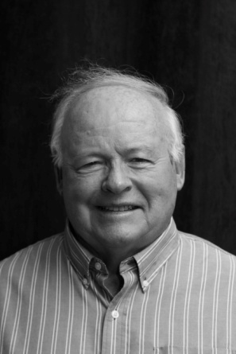
Dave Palmer
Dave is a dedicated father, grandfather of 8 grandkids and businessman but by his own admission, perhaps a travelling spouse. Dave married Cheryl in 1968 to start 45 years of business success that eventually led to his legacy, Davon Sales Inc. off Lansdowne in Woodstock. Cheryl was hired as a Woodstock elementary teacher who climbed the ranks to Principal. They are now world travelers with dozens of countries and many thousands of memories and kilometers in their picture files.

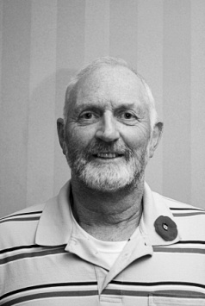
Jack Pasma
Jack began his talk by telling us, according to him, “If it isn’t
Dutch it ain’t much”. He spent the balance of his talk proving
how wrong a person can be with one simple statement. Born in
Holland Jack came to Canada with his family when he was 13.
They landed in Halifax. Jack went back to tour the Pier 21
museum and walked on the same floor that they walked on
66 years before. His father’s first work was on a farm near
Aylmer ON. The family moved around while Jack’s father
accepted work at several locations before they moved into a large
house they would share with Jack’s uncle. In 1960 Jack’s father purchased a 140 acre farm near Springfield ON.
After graduating from an agriculture course Jack joined the family farm which had grown into an exclusively dairy producer. In 1974 Jack was smitten by the vision of an Aurelia Vandervaart in church. She had come to Aylmer to teach. Jack knew at that very moment he was looking at his future wife and in 15 months she became Mrs. Pasma. The wedding was followed by a one day honeymoon; I wonder how many of our generation followed this pattern. Jack and his father continued on the farm till his father’s untimely death. Seven years later with his children showing no interest in carrying on with farming Jack sold out. He moved into poultry production just outside of Woodstock. Jack’s next employment would be at Fleetwood Manufacturing. He would remain there till he retired at age 67.
Even prior to his retirement, Jack had been approached by Ian Clark about joining Probus when he retired. Probus, woodworking, tinkering with his 1951 Ford pickup and traveling have taken up much of Jack’s free time since then. Oh, I almost forgot, Jack also likes to watch the Maple Leafs play hockey. Judging from their record since 1967 it is an infrequent event. So much so it is Jack’s wish that six Maple Leaf players act as his pall bearers. That way the Leafs can let him down one last time. Jack ended by telling us to “lighten up and enjoy life. After all we’re not Americans”.

Don Post
Don’s roots are firmly planted in Southwestern Ontario with connections to the Harris Family of cheese making fame in Ingersoll, and on the Atkinson side of his family, extending to Lucan, home of the legendary Donnellys. Don was born in 1930 on a 100-acre dairy farm just south of Beachville. Don's father never got beyond sixth grade, but in Don's words, "Sure knew how to farm and to get cows to produce milk."

The times were tough when Don was growing up. In winter, his lunch would often consist of a single large potato, baked on the schoolroom stove during the morning, and washed down with a jar of milk.
During WW II, the Posts were assigned a German prisoner of war to help on the farm. Donald would often take a twenty-two, and he and the POW would go woodchuck hunting. It doesn’t sound like Stalag 13.
Don had been a good student while at school in the country but the move to WCI, combined with the temptations of adolescence, led to an indifferent academic record.
Later, Don filled in the gaps in his education in his own way. Here is how he did it. He ran a door-to-door poultry business in Ingersoll, tried his hand in retail sales, hired on as a factory worker at Harvey Woods, learned butchering at Dominions, gave boxing a try, worked as a “newsie” on the CN trains, joined the merchant marine, worked for a wiring company in Hamilton, learned stone cutting back in London, worked ‘hands on’ in the auto body trade. At BF Goodrich he got into ‘sales’ with a sideline in ‘debt collection’. He was so good at collecting overdue accounts that this led to a promotion to a credit-operating manager. After a time he became a store manager in Brantford, and then a regional manager.
After Don left B F Goodrich, his ‘hands on learning’ served him well for the balance of his working career. He ended up owning all or part of a paint business, an appliance store, some furniture stores, a farm equipment business and a resort in northern Ontario. After working so hard and accomplishing so much Don tried retiring for a time, but it didn’t take. It wasn’t long before he got back into harness: this time overseeing a group buying enterprise.
I will have to stop here as Don ran out of time. Perhaps, at another time, Don will have a chance to tell us what he has been doing since he retired a second time.

Doug Puddicombe
Doug received a unique gift from his wife last Christmas, that turned out to be quite a chore. As a fund raiser, the Big Brothers Association and the Woodstock
Museum sold a number of certificates, allowing a person to fill an 81/2" x 11" sheet of paper with information about themselves, to be placed in a Millennium Time Capsule to be opened 100 years from now. His sheet was as follows.

'Dear Reader: This is a difficult thing to write as you are reading this 100 years after I have written this letter. Who was Doug Puddicombe? Doug Puddicombe,
845 Sunset Blvd., Woodstock, Ontario was born in Stratford, Ontario on July 3,
1942. He married his wife Gail whose maiden name was Newell, who was born on April 1, 1942, in St. Marys, Ontario. Doug moved to Scarborough after completing Teachers' College in Stratford. He began his teaching career there. On
July 10, 1964 Doug and Gail were married in Stratford. Gail moved to Scarborough and taught there until June of 1969.
On June 30, 1969, Doug and Gail moved to Woodstock. They really enjoyed moving into their new home. Doug started to work at the Woodstock Jail as a guard for the summer. Their daughter Sarah, born on July 22, 1969, moved into the house and things were never the same. What a delight to have a new born.
Doug was hired by The Oxford County Board of Education to teach at Central Senior School in September. He taught science and Geography to grades six, seven and eight. On January 1, 1970, he was appointed principal of Princess School. This was a kindergarten to grade six school. He was there until June, 1973
Their son Richard was born on February 26, 1971. Gail and Doug now had two children in diapers!!
In September of 1973, he transferred to Princeton Central School. This was a kindergarten to grade eight school. In September of 1977, he went to Northdale
School (k-6) until he transferred to Springbank School (k-6) for September 1981.
January of 1984 he was appointed to Oliver Stephens senior School (k-8). In September of 1990 he returned to Northdale School. It was during this time at Northdale that he co-ordinated the planning and construction of Algonquin School which he opened on January 4, 1994. Doug remained at Algonquin until his retirement on January 31, 1997. Doug always said how lucky he was, having a career in teaching for 35 years. He felt he was paid well and just loved what he did.
Every day was exciting.
Woodstock was very good to Doug and Gail. They attempted to pay back the community by becoming very involved in it as volunteers. Doug volunteered in agencies such as The Woodstock General Hospital's Board of Trust, The Woodstock Non-Profit Housing Corporation, the Board of Management of St. James Wilmot Anglican Church and Cemetery Board, the restoration of the cemetery at St. James for its re-dedication on June 11, 2000. (This was also the date and place for the Christening of their first grandchild Ryan Douglas Puddicombe, son of Richard and Corrine Puddicombe.), the first fund-raising Chair for the Woodstock District Community Complex, (his committee raised over $2,000,000. for the project), he, along with his friend Bill Ebel, announced the hockey games for the Woodstock Navy Vets, he was Campaign Manager for a number of Progressive Conservative Federal and Provincial politicians. (Doctor
Bruce Halliday, MP in 1974, 1979, 1980 and 1984, Dick Treleaven, MPP in 1981 and Ernie Hardeman, MPP in 1999).
Other volunteer work included being president of the Lions Club of Woodstock, Chair of the Board of Governors of Fanshawe College in London and being a Beaver leader. (Beavers "was a group for boys ages 5 - 6). Doug enjoys community work and being with people."

John Richardson
John was born in Darby, England, in 1944. John and his wife, Jill, who was born in Sheffield, have two children who were born in Britain. He left school in 1959. There were not a lot of jobs available so John registered with the labor exchange. John was offered an apprenticeship painter and decorator position. Fortunately for him he received art college training as part of that apprenticeship. When John finished his apprenticeship he decided this was not what he wanted to do so he took a job with the General Post Office. He held several positions with the GPO before deciding to | 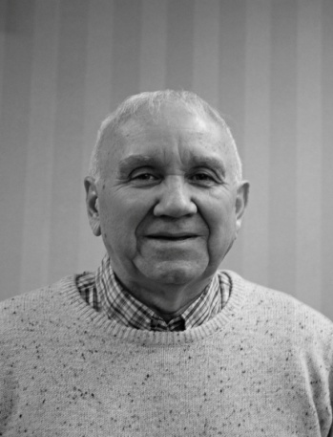
immigrate to Canada. He had done his homework and discovered that of all the countries people had left for Canada had the greatest rate of retention.
With wife and kids he arrived in Canada in June, 1973. With few jobs available John ended up working as a painter in Simcoe. Soon he was laid off. Luckily a friend told him of an opening and John was soon working a night shift in a tobacco factory. In the spring John got a call from Bell with a job in Brantford. He was soon transferred to Simcoe where he worked on the major companies in the region.
He also started coaching soccer, hockey and was a member of the Chamber of Commerce. Later he moved to Woodstock working at the Bell Control Centre again coaching hockey and soccer. Another move came for John to London where he coached and worked for Bell.
After eighteen years in London he accepted a buyout from Bell that greatly enhanced his pension. At fifty three John was not ready to do nothing so he ended up managing the Oxbow Glen Golf Course. When he left there he came back to Woodstock to be more central to his grandchildren who needed coaching in sports. John did a few more jobs then retired again. Looking back, life has been good, Canada has been good and he is living the good life golfing, watching hockey and being in Probus.

