Who Am I? R-Z

Ken Riehl
Ken started his comments off with a story about ministers. Ask him about it, if you missed this opportunity.Ken then proceeded to tell us he is a very private person probably as a result of his childhood. He was born on Feb. 28th, 1930, the second of two sons of Hilda and Fred Riehl. They lived in New Hamburg on Queen Street. Although it was a very short street, the neighbours were of a different stature.
One was trafficking in liquor and another was a junk dealer, a bootlegger and a fence and eventually spent time in jail. With neighbours like that Ken is entitled to be private! His grandfather and father were brick and stone masons and worked in the area quite extensively. The depression had a severe affect on the family and particularly Ken. To this day he does not care for turnip, cabbage or rabbit as food staples. And, as a result of a junk-yard fire he was involved in, he still has a healthy respect for gas.
Ken recalls many of the 1oca1 activities in New Hamburg including hockey with the Meekers, including Howie. His involvement with that sport cost him his teeth!
Along about this time, his mother and dad split up with Dad going to Toronto and the family remaining in New Hamburg. As a result of this Ken became much more involved in school, the library and church. When grandfather sold the house, Ken eventually boarded at a chums place on a farm nearby. He completed high school but could not attend University for financial reasons.
Ken did, however, attend Normal Schoo1 and eventually became a teacher. He met Carolyn Snyder, his future wife there. He first taught at Hampstead, north of Shakespeare. Ken married Carolyn in 1954 and in l955 they moved to Woodstock. He taught at Central School.
During this time he completed his degree at Western University through extension courses. In 1960 he moved on to W.C.I. for 14 years and eventually specialized in history. In 1974 he returned to elementary school as Principal at Drumbo Central. Being on the verge of burnout, he returned to teaching, again at Central Schoo1 in 1980.
Carolyn and Ken have one daughter, Mary and two sons, John and Chris as well as a daughter-in-1aw, Jeanna and a 4 year old granddaughter, Stephanie.
Ken and Carolyn are enjoying their retirement and love to travel. They spend their summers at Sauble Beach. Cancer Society, Heart and Stroke Fund, church activities and bridge round out their lives.
Ken admitted to us that, Carolyn is the brains in the family. When the family was grown she then had time to secure her degree in English.
His hobby is reading and collecting books and in fact, has a used book store and does the antique shows. With that Ken concluded his talk.
And there you have Ken Riehl.

John Rowell

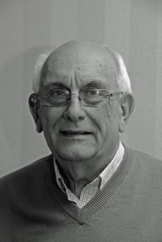
John Rowell the only son of Francis and Clara was born in Toronto.
He moved to Woodstock at a young age where is grandfather operated
a taxi service. John’s father purchased the Watson Funeral home and
they moved to the apartment located above. The magic rule became
‘Quiet Please”.
After completing grade 12 he started his apprentice in the family funeral home business and graduated the Canadian School of Embalming in 1962. Running a small funeral home entailed his fair share of washing vehicles and becoming all too familiar with a broom and vacuum. There were also memorable moments like the time he ran out of gas during a funeral procession. He took over the operation when his father died and soon began looking around for other opportunities.
John’s persistence in obtaining a radio system license finally paid off in 1972 when he was granted a license to operate a radio paging system. He launched “Oxford Communications” with 8 customers the following year and added an answering service from MacLean- Hunter a few months later. The company soon employed over 25 full and part time operators to cover over 100 customers, including doctors, 24/7. Realizing he could not run the funeral business and continue to grow the communications business John sold the funeral home. In 1979 he enlarged the company foot print by adding transmission sites and opening offices in London, Windsor and Kitchener with agents in the smaller communities.
Oxford Communications was a member of the Canadian Radio Common Carriers Assoc. when they finally were granted the right for full interconnection to the telephoned switched network. The company soon became fully automated, eliminating the need for operators and dispatchers. In 1985 John sold the answering and paging system back to MacLean-Hunter but not until the paging base had grown to between 3 and 4 thousand units. When Bell and Cantel began to roll out their cellular networks our two-way radio business became agents for both, eventually becoming exclusively Cantel. It became a Rogers dealership operating as Oxford Cellular Ltd. till 2009. The towers that had been built to facilitate radio and cellular networks were sold as a package in 2014.
John retired in 2016 to a home he shares with Dawn, his wife of 45 years. He has 5 children, 9 grandchildren and 2 great grandsons. About 15 years ago, after searching for 2 years, John, who had always know he as adopted, discovered his birth family. He is thankful for the time he has had building a relationship with both his brother and sister. After a career of 57 years John is ready for new activities including Probus.

Norm Ryder

Norm Ryder started his address by telling us that he has been happily married for 39 years to Betty and has two married daughters and two granddaughters. Norm is a retired secondary school principal, having been principal at Annandale School in Tillsonburg and before that vice-principal at IDCI and at Huron Park. His teaching career before administrative positions involved technical education--machine shop, welding and wood shop.

Norm is an entrepreneur with many interests and he outlined these ventures, starting at a very young age. Consider these ventures growing out of his farm background:

- at age 11, started working in tobacco, mastering most jobs in the industry
- at age 13 he raised rabbits with his own kill line to supply various butcher shops
- dabbled in drag racing at Sparta
- as a teenager, bought and sold many cars, some classic and antique
- bounty-hunted wild dogs for Windham township
- learned carpentry skills working for Backus Lumber
- pit-roasting of pigs, sides of beef, turkeys in barrels
- constructed fiberglass canoes as a night school course 63 in one year. (Your scribbler still has one of these conversation pieces!)
- starting raising rainbow trout in 1981 on four ponds on my property, currently experimenting with raising Koi
- at the shop on my property recently installed a spray paint booth, restoring a 1931 Plymouth, design and make furniture and prototype equipment
- flying remote-control planes
- making wine
- curling at Norwich, including building maintenance and club director
- a Mason for 26 years and a Shriner
- steward on Board of Management at Burgessville United Church

Thanks Norm, we can see why your friends call you "Stormin' Norman".

Larry Sales

I was born in Ingersoll on August 9th, 1949. My parents called me Lawrence Arthur Sales. I have an older brother and sister who are about ten years older than me and I have a younger sister who is three years younger. Another sister, Karen, died when she was six weeks old. Had she lived she would have been about a year older than me.

After high school I had hoped to attend the Royal Military College in Kingston but around that time my parents realized that I had started to walk awkwardly. I was diagnosed with Pes Planus, a foot condition, which can seriously affect walking. My prognosis was such that I might well have been confined to a wheel chair by the age of twenty-five.

I was fortunate to be placed in the hands of Dr Harvey Bailey, the well-known London orthopedic surgeon, who over the next ten years performed twenty operations on my foot. With his skill, and my own determination I am still walking today even though it still hurts.

Thirty years ago this coming August I married my wife, Sylvia. Sylvia taught school in Oxford for 30 years and since her retirement from the Board continues to teach part-time at the Plattsville Christian School. We lived in Sweaburg for 21 years where we raised our family. After my retirement we moved to Woodstock.
Twenty-six years ago our very special son Brad was born. Brad was born with a shortened left leg. After much soul searching we followed the recommendations of his doctors and agreed to have Brad's left foot amputated when he was ten months old. I think that this was the most difficult decision I had to make in my entire life
Brad was a real fighter and he never would quit. As a youngster he took up competitive swimming in a big way. Eventually I had the supreme joy of being in the stands at the Para Olympics in Sydney Australia where I saw my son standing on the podium with a Gold Medal around his neck. It just doesn't get any better.

Emily is my daughter. She is 23 and has just graduated with a Bachelor of Medical Radiation Science from McMaster University. Emily is a qualified sonographer and is employed at the London Health Science Centre. A sonographer is a specialized healthcare practitioner who performs medical sonography or ultrasound. Emily also swims, lifeguards and teaches swimming.

I should also tell you something of my work experience. In high school I joined the Elgin Regiment Reserve. My involvement with the regiment led to four wonderful summers spent at Camp Ipperwash. I did a variety of things including drill instructing, driving (from jeeps on up to eighteen wheelers) and in my final year I was promoted to Staff Sergeant where I was head chef for the Sergeant's mess.

After attending London Teachers College in 1968/69 my first teaching job was back at Victory Memorial School. I had been hired to teach grade eight but seven days before school started I was abruptly re-assigned to teach grade six. Several years later I learned that my principal had suddenly realized that there were at least two girls in the grade eight class who were already sixteen years old. As I was only eighteen at the time, he thought it prudent to make this adjustment in my teaching duties.

After twenty-one years of teaching in Oxford I moved to Perth County where I became a Vice Principal. Still living in Sweaburg I commuted to Stratford and subsequently worked in the small town of Gowanstown just north of Listowel. In five years I drove 850,000 miles, wore out three cars and seven sets of tires. I then moved to Park Hill and finally back to Oxford County. So after thirty-four years I ended my teaching career almost where it began, at Drumbo Public School.

Since retiring I have continued to do some supply teaching, I worked for a year at Dean Michaels as a chef, and now I occasionally drive the courtesy van at Gord Anderson’s. I really enjoy coming to the Probus club when I am able and I am also an active member of Oxford Baptist Church where I sing as part of a worship team. I have sung with the Choralaires for the past twenty years. I have been a longtime member of Lions International with a special interest in the Club's work with diabetes as I have been a diabetic for the past twenty years.

My dad always told me to remember that life is short and to live it every day. I had to take his advice to heart in 2006. I had a very eye opening experience. It started with a car accident in January, followed by a heart attack in February and then my kidneys stopped in March and I had to go on dialysis for six weeks. I was one of the fortunate few. Most people who come off of dialysis last only 6 to 8 months. This December it has been thirty-one wonderful months and I get up every day and say to myself the grass in green and the sun is shining and here I am. The most important part of life is to smile every day. That’s who I am.

Jim Savage
Jim was born in Sudbury in 1940 where his father worked for Inco as a geologist. In 1947 the family moved to the town of Swastika near Kirkland Lake. With a combination of nature (dad's geology gene) and nurture (mining was in the air) it is not too surprising that Jim has followed a lifelong career in the mining industry.  After finishing Grade 13, Jim moved south, where in 1963, he graduated from the Hamilton Institute of Technology. In | 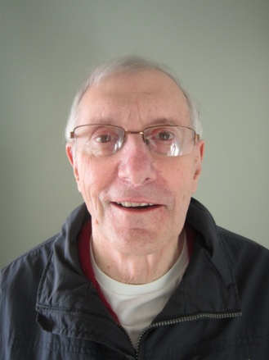
June of that year, he accepted a position at Timberjack. Art Jones also started at Timberjack on the very same day. As they were both new to town and without a place to stay, they ended up sharing an apartment for the next year and a half until both fellows got married. This all happened fifty years ago this month.
In 1968, Jim was hired by the exploration drilling company, Heath and Sherwood, based in Kirkland Lake, so Jim found himself living in his boyhood town, Swastika.
Within a short number of years he became branch manager. In 1986, when a group from the management team bought out the previous owner, Jim was appointed president. After his retirement, Jim and his wife, Marylin, moved to Sudbury where Jim had family. Later the Savages moved to Woodstock joining their children who now live in Guelph and Waterloo.
Around the time Jim started with H & S, the company developed a new process for drilling known as 'slim hole wire line core drilling'. In exploratory drilling, as the drill moves through the rock, the on-site geologists are keen to assay the mineral content at the drill head. In conventional drilling, every time the core is examined the entire drilling mechanism must be raised to the surface, one section at a time (a very time consuming process when drilling to 10,000 ft). The 'slim hole' method allows core samples to be extracted without dismantling the drill – the core at the rock face is pulled up to the surface by a wire attached to a device at the business end of the drill.
Slim hole wire line core drilling quickly attracted interest in Canada. Heath & Sherwood did several projects for Inco in the Sudbury area drilling to over 10,000 ft in the Precambrian shield. During the course of Jim's career, work assignments took him to sites in the Canadian Arctic, the USA, China, Sweden, Australia, Jamaica and South Africa. The South African mining companies were so impressed with the amazing capabilities of the Canadian equipment that they started to compete with one another on how deep into the ground they could go. When one company reached a record 17,792 ft they didn't want to stop, that is, until they realized that should the equipment fail the South Africans would be on the hook for half a million dollars in lost aluminum connecting rods.
It was clear from Jim enthusiasm for the topic that Jim's working career full of challenges and was very interesting and rewarding. He did a fine job of making a quite technical topic accessible to his fellow Probians.

Tony Sheldon
Tony informed us that his roots are in Oxford County, with his Dad coming from Ingersoll and his mother from Thamesford. His father was in sales, so his family left Woodstock when he was five and he attended 8 different schools before he enrolled at McMaster University.

On Remembrance Day, after the service at the Legion in Woodstock he also went to the Cenotaph in Ingersoll, where
the names of all locals who served are listed with a poppy opposite those who did not come back. He was fortunate since his father and three uncles all returned. His father was in the 1st Regiment of the Royal Canadian Horse Artillery, the “Red Patch" who went from England to Italy, France, Germany and finally the Netherlands.
Tony is married to Leslie Anne, also a retired teacher, who earned her degree from Western at age 44. They have 2 children, Sarah and David.
He has been retired for over 5 years, giving him time to pursue his hobbies of woodworking, digital cameras, portrait photography, macro photography and exercising by walking daily and going to the "Y'.
A great deal of his time is spent in the volunteer sector, mostly with the Canadian Mental Health Association for the last 5 1/2 years. He started on their board in 1998 when they had a staff of 8 and a budget of $600,000. Today they have a staff of 28 with an annual budget of $1,500,000. They serve about 300 people with Serious Mental Illness, and operate a 24/7 Crisis Line. The Ministry of Health provides funding for 27 of the staff, with 1Education and Volunteer Co-coordinator funded by the United Way. The main office is on Dundas St. next to Tina's restaurant; however they are starting a building project of $1.5M on the south Elliot Bros. parking lot, with the hope of opening next June.

Most of his time with CMHA-Oxford has been spent on Special Projects. The Retired Teachers of Ontario contributed $3,650 to a project that included "The Last Taboo" for county school libraries and a consumer, client and family workshop. A topic that interested Tony was Discretionary, Testamentary or Henson trusts. Anyone setting up a will for a family member with addiction, mental disabilities or a mental illness should seek information along these lines.
He was involved in a six month Peer Review pilot project, spending a week in Thunder Bay and Fort Francis. A "Volunteer Task Force" was another 6 month project centering on "The International Year of the Volunteer". That report is available on their website for other groups.
Tony was also on the "Mental Health Implementation Task Force", an 18 month project that is still in the news today since the last government would not release the reports. You will see reference to these reports in the near future.

Ken Shrubsall
Ken Shrubsall was in the spotlight for this portion of the program. He was born in 1945 in Stratford where he spent his growing-up years along with a father who was an agent for London Life, a stay-at-home Mom, two brothers and a sister. His youth interests were scouting (becoming a Queen's Scout and then a Rover), music and the piano. His interest in musical theater was furthered greatly by being an usher at Stratford’s Avon Theater productions of Gilbert and Sullivan Operettas.

Subsequently he directed student productions of G & S but has never accomplished his lifelong ambition of playing the captain of the HMS Pinafore. He attended Avon School, Stratford Central Secondary School and Stratford Teachers' College (where he met his wife Eleanor). Ken did his further education the hard way. After teaching a full load during the week, he took classes on Saturdays, weeknights and summer school to complete a B.A. in Geography and Music from Wilfred Laurier University and later an M. Ed. in curriculum design from U.W.O.
Ken and Eleanor have two grown and married children (Rick and Susan) and three grandchildren (Emily, Madison and Aden). Trips to see these families involve going to Maitland (in Eastern Ontario) and to London.
For a while Ken and Eleanor were in the sandwich generation looking after both aging parents and growing children. However, since the parents are now in retirement homes and the children with families of their own, opportunities present themselves to devote more time to pursuits for their own entertainment and cultural enrichment.
Ken taught vocal music for most of his 33+ years of teaching and was part of the original staff at East Oxford Central School in 1966. He subsequently moved to Tollgate, D.M. Sutherland, Drumbo Central and finished at Algonquin in Woodstock.
Volunteer activities, both before and after retirement, play a part in their life. In addition to producing operettas and other school extracurricular activities he has found time for the following:
- a church choir member for fifteen years and later choir director at Chalmers
Church
- served on various boards and chair of the Church Council at Chalmers
now active at St. David's Church
- involved at various levels of the Ontario Diabetes Association culminating in becoming the Ontario Provincial President of the organization and sitting on the national executive as well. Participation in this area came about as a result of his son Rick contracting insulin dependent diabetes at age 10.
- since retirement, has been involved with the board of the Oxford County
- Museum school in Burgessville, which preserves artifacts of years past and is living educational history for school field trips.
- baritone vocalist with the Woodstock Fanshawe singers

Ken and Eleanor love to travel and have had trips to both coasts, Disney World (3 times), Cancun, Hawaii, Alaska, the Yukon and are planning a trip to Australia and New Zealand.
Presently, they are involved with Elections Canada, working in the current federal election.

David Smith
This exercise has given me an opportunity to reflect a bit, something I have not done for a very long time, so, as you can imagine, it required some serious editing.

David was born in 1940 in London, Ontario. Not an unusual beginning, except that both his parents were blind. His mother lost her eyesight at 9 months old from meningitis, while his
father lost his sight at 5 years old when a bottle exploded in a store he was in. Both parents attended the Brantford School for the Blind, lived in residence, so they were away from their parents for 10 months each year. He has one sister, and none of the family regarded the parent's blindness as a disability.
His father was a piano technician and travelled throughout the area using public transportation or hitchhiking to out of town customers. The Canadian National institute for the Blind was a great support for the family in terms of recreational activities.
He attended Tecumseh Public School, South Secondary School and Beal Technical School. He had a London Free Press paper route, saved his money and bought a TV set, which had not been a priority at their house. His father died suddenly in 1958, requiring David to quit school and find a job to support the family.
He worked for 2 years in the parts department of London Motor Products. [n 1961, he *'as accepted on the London Police Department. in 1975, he joined the security staff at the new General Motors Parts Centre in Woodstock, later becoming a supervisor in the warehouse. He retired from GM alter 25 years.
David met Sylvia a nurse, while on the police force and they were married in 1962 (Sylvia spoke at our December meeting on the benefits of physical fitness for seniors.) They had 4 children during the next 8 years, but he
found time to coach hockey and baseball and be a Cub Leader. Summer holidays r*'ere spent camping.
They now have 7 grandchildren and attend their school activities and sports events. They will be in Welland on the May 24th long weekend to support a grandson competing in a rowing regatta.
Their travel has included winter vacations in Jamaica, Aruba and Cuba and a trip England, Scotland and Wales for their 25th Wedding Anniversary. After a trip outside Canada they are always thankful to return to this great country of ours. He hopes to realize one of his goals with a trip to Alaska next year.
David has joined Southgate Centre and participates in singing, exercise programs and their band, most recently joining a quartet formed from the band.
Over the last two years he has made a couple of trips with another new member, Bob Beattie. It sounds like they need major help with map reading.

Duncan Sinclair
Duncan Sinclair is a native of Woodstock. His parents were Fran and Alex Sinclair and his paternal grandfather, Duncan James Sinclair, was a Woodstock surgeon. Dr Sinclair actually delivered his own grandson, Duncan, on June 2nd, 1943. Duncan has one sister, Eleanor.  Growing up in Woodstock in the late forties and early fifties sounds like it was fun: building forts out of empty refrigerator boxes, playing cowboys and Indians in South Side Park, and, | 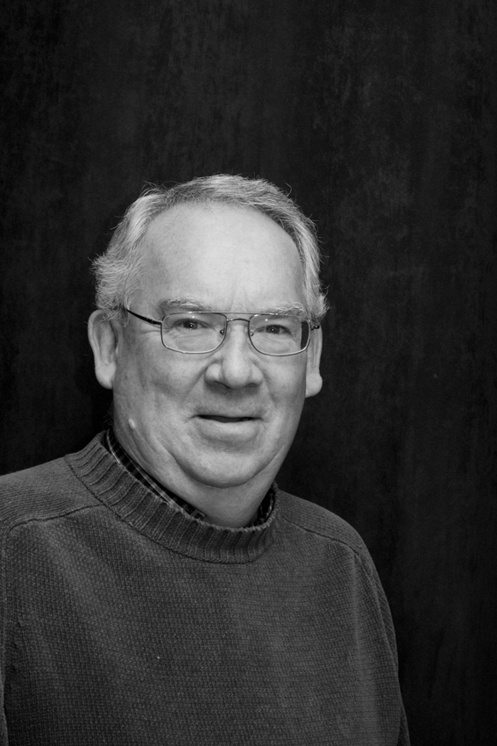
uniquely, using old radio vacuum tubes for BB gun target practice. This minor mayhem occurred in the basement of a pal’s house that happened to be the Millard Funeral Home.
A self-declared indifferent student (how about a mid-term mark of 19 in Grade 13 geometry!), Duncan had the very good fortune to be noticed and nurtured by his shop teacher at CASS, George Simmons. George added a “Technical Special Course”, which Duncan successfully passed. I met George Simmons late in his life, long after he had retired, so I particularly enjoyed hearing Dunc speak about George’s influence as a teacher.
After graduating, Duncan enrolled in the Ontario Vocational Centre London, (the fore-runner of Fanshawe College) where he took a two year Mechanical Technicians Course. After graduating he was hired by Roy Nixon at Truck Engineering in Woodstock. This was the beginning of Duncan’s life-long involvement with truck trailer design. For the next 25 years Duncan worked for King Trailers where the work was interesting and challenging as King designed and built custom applications including Ingot Trailers, Dumps, Bulk Pneumatic Tanks, Logging Trailers, Low Beds and Steering Dollies.

After 12 years Duncan moved from engineering to sales when he became King’s Eastern Regional Sales Manager. Being of a sociable nature, Duncan enjoyed meeting with his many customers and even became friends with many of his competitors (they would meet at trade shows). However, in 1991 King closed the trailer side of its business. Duncan was quickly snapped up by Tusco Trailers near Lambeth, but within 25 days Tusco went bankrupt.
After a brief hiatus, Duncan embarked on a successful 13-year career with Paron Trailers in London. In 2004, Duncan joined Holland Hitch where he was quickly promoted to Service Manager for Canada. Duncan described those last five years with Holland as the best of his working career. Duncan conducted technical sales presentation at conferences in Halifax and Victoria. He travelled across Canada as well as to Germany and New Zealand for product training and customer support.
Shortly after starting at King Trailers Duncan noticed Bess Walker, a sales secretary in the office. Bess drove a VW Bug and their first date was at a VW car rally. The couple took first place: an auspicious beginning. In 1969, on September 13th, Bess and Duncan were married. They started their new life at 262 Dent Place, where, contrary to the usual pattern, they remain to this day.
As time marched on the Sinclairs increased their family with the birth of our daughter Jodi in 1974 and a son Jeff in 1975. Since retiring the Sinclairs have done some travelling (Bermuda in March of this year)) and have been enjoying family times with their grandchildren.

Gerry Sokalski
Gerry was born in Winnipeg, and therefore can withstand the coldest days. When his grandparents immigrated from the Ukraine and Poland, they were given land grants for farming, thus Gerry spent his early years north of Brandon in the communities of Angusville and Silver. His father worked as a head cook in lumber camps, requiring him to be away from his family. This was hard on the family so, in 1942, they moved to
Toronto. His grandparents came with them and were able to look after Gerry, allowing his mother to work at Dominion Bridge making artillery shells, and his father to work at Canada Iron Foundry.
In his first year of high school he took a typing course, which served him well over the years with essays, reports and continuing now with computer keyboards. Hockey, baseball and football helped keep him on the straight and narrow. After high school, he completed the first year of Mechanical Engineering at University of Waterloo in 1961. He took a job rather than continue the course. Two years later he resumed his education and completed the course at Ryerson in 1965. After several more exams and a thesis, he received his Professional Engineer status. He has seen the tools of his trade change from slide rules and drafting boards to computers with CAD programs.
His work history started with a small Toronto company, Beckett Elevators, who were competing with Turnbull, Otis and White for high rise and office buildings.
When they moved to Woodstock, he found work with Timberland Ellicott as a designer and sales engineer for construction hoists and exterior building maintenance equipment, which consisted of an electric powered suspended platform that was lowered from the roofs of tall buildings to carry out window washing, glass replacement and other exterior maintenance. In 1977 he joined Emco in London, eventually becoming Manager of Plant Engineering & Maintenance. A victim of downsizing in 1985, he joined Babcock Wilcox in Galt as Senior Plant Engineer. He went from production processes with orders for 10,000 pieces in three weeks of parts weighing only ounces to manufacture of steam boilers and generators weighing up to 500 tons and requiring three years to manufacture. He retired last year after l6 years of just scratching the surface of the knowledge that goes into manufacturing their products.
He met Judy McFaddin at a friend’s wedding in 1962, and they were married 4 years later. He was glad her Scottish family would accept someone called Sokalski without reservation. Judy quickly learned how to spell her new name and mastered the knack of making cabbage rolls and porgies. They have two daughters and two grandsons.
Gerry enjoys travelling, gardening photography and spending time with his two grandsons.

Gary Stephens

Gary was born in 1950 in Petrolia. Along with his brother and two sisters, he was raised on a farm near Brigden. In spite of working hard at the chores that are expected of children on a farm, he recalls that the kids still had lots of time for fun - messing about in the creek and exploring the local bush lots. It was a good place to grow up in. | 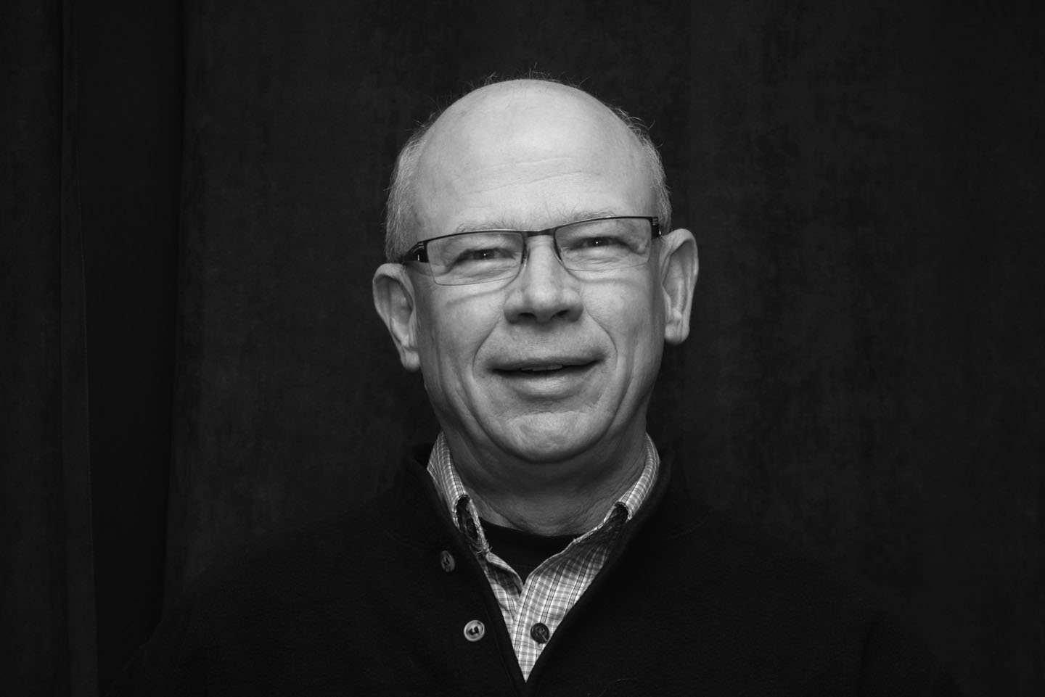

Gary’s first school had only one-room. It must have been quite an experience to share that one room with seven other grades. Next he attended high school in Petrolia. After high school Gary was accepted by University of Guelph where he earned a degree in Agriculture, Economics and Business.

After graduation, Gary was hired by the Ontario Ministry of Agriculture and Food (OMAF) to work as an Assistant Agricultural Representative in Haldimand County. He was involved with 4-H Youth, farm business management, and Crop and Livestock development. Six years later he moved to Woodstock where his responsibilities included providing programs in a variety of farm activities. One topic that had never occurred to me was the importance of Succession Planning as part of a successful farm strategy. After the year 2000 Gary’s responsibilities were enlarged to include non-farm rural businesses as well as assisting rural municipalities. In 2009, after 35 years service, Gary retired from OMAFRA (OMAF’s successor). In Gary’s words, “Why not give someone else a chance!”
In 1975, Gary married Janet Scott, a local girl from Brigden. Janet has enjoyed a long career in the child-care field and continues to work for County of Oxford, specializing in childhood literacy.

Gary and Janet have two children: Sarah, a U of Waterloo graduate, who works with TELUS Mobility in Toronto and Mark, who is a graduate electrical engineer from UBC and lives in Vancouver. Mark is employed in the design of the next generation of electric bicycles. Sarah is “expecting” and Gary and Janet are anticipating holding their first grandchild in April.

Although it is early days yet, Gary has thrown himself into a variety of retirement activities including home renovations, cottage and camping life near Halliburton, and winter vacations in Arizona. Back in Brigden, Gary maintains a woodlot/farm with his brother, Bruce.

Gary is the secretary the Optimist Club of East Oxford – Oxford Centre and has been a Member for 30 years. He is looking forward to learning opportunities and good fellowship that Probus will provide. Gary’s retirement motto is “Work Less & More Fun”. It is clearly more honoured in the breach rather than the observance.

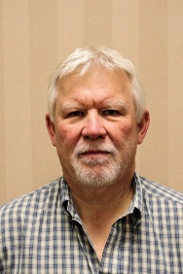
Dean Stewart
I was born in Woodstock, ON. My parents came to Woodstock after
the war. My father worked at Bickle Seagrave, AKA King Seagrave
and my mother worked at hospital till she retired. I attended school
here, in fact a couple of my teachers are here today. Wow that means After high school I enrolled in Lambton College, Sarnia, for three years
earning the title Engineering Technologist. It was here that I met my wife of 43 years.
I spent the next twenty years as a part time student of the University of Western Ontario earning several more degrees. my first job was at Pneubore Systems, in Woodstock. I installed salt systems into plants the Heinz in Leamington. Remembering the amount of salt they put into their ketchup and mustards keeps my usage low. I left after 20 years. I worked for a couple of firms before joining Timberjack in Woodstock in 1997. As the manager of supply management and global sourcing I travelled the globe.
When Deere bought and then closed Timberjack I was offered a position Iowa. The year was 2006 and I was off to live in Davenport for the next 11years across the river from head office in Moline Illinois. Deere made graders, articulating dump trucks, 4 wheel drive loaders and the forestry equipment from Woodstock. I controlled the unit that built all the cabs for Deere equipment. My next project was manager for MRP system. The system for purchasing, finance and engineering was fully implemented, companywide for $20 million dollars. That compares quite favourably to the Canadian payroll system that is currently $1 billion and counting. I next became manager for materials flow for the global operation in the USA, Europe and South East Asia. The group consisted of 81 people who were responsible for $2 billion of inventory per year from buying to inventorying manufacturing and delivery. In 2016 Deere made me a retirement offer I couldn’t refuse. I moved back to Woodstock. Since then they have called me back sending me to Italy. I am going again in July and October.
Since retiring I have discovered, while doing my family tree, that I am related to Lord Nelson. It seems that one of my illustrious forefathers was a gardener on the Nelson estate. When the daughter confessed to being pregnant it became obvious that he was planting more than flowers. The couple was banished across the ocean to Nova Scotia.

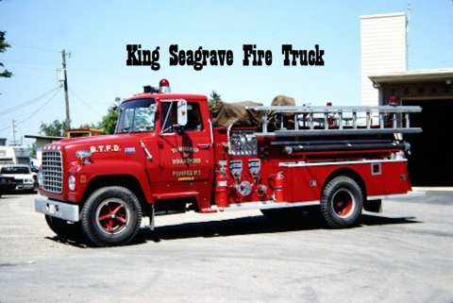

David Stock
Recently retired Woodstock lawyer David Stock was at the podium to give us some insight into his life and career. He has lived in Oxford County all his life and his children are the sixth generation in Canada.

David went to WCI and had many reminiscences about the teachers and life there that provided nostalgic memories for many in the audience. He took a science degree at the University of Guelph and later went to Osgoode Hall Law
School before settling in to practice in Woodstock for 4l years, a career he described as quite satisfying.
While working in his law office he continued to operate the family farm located south of Tavistock on Highway 59 where he still lives.
David told a couple of stories about his involvement with political figures ....Clark Murray, Jim Hutchinson and introducing Mike Pearson.
While at the University of Guelph in 1955 he became involved with the Navy through the University Naval Training Division. We heard several stories of experiences at sea and how subsequent involvement with the Navy Reserve has shaped his life.
David concluded his talk by naming some of the organizations he is involved in.....a diverse and extended list of local activities. (Thanks David, for a thorough presentation.)

David Tabor

David was born in 1943 at Woodstock General Hospital, the only son of Jim and Gladys Tabor. David’s earliest memories are of the family home on Rathbourne Avenue and the many friends he made while living there. In 1953, the Tabors moved to Bayswater Street, which at the time was a new development with perhaps four other new houses and no roads or sidewalks  One of David’s happiest childhood memories involved regular visits with his uncle to the CNR train station to watch | 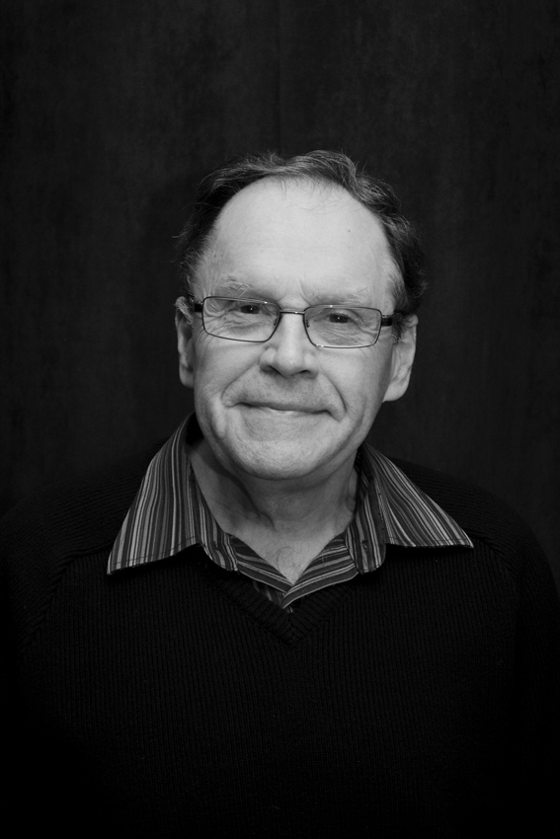
the steam locomotives. The station was a busy place in those days with three trains arriving each evening at around eight. To this day, David still collects “steam era” memorabilia.

David attended Princess School, Huron Park (now Hillcrest) Public School, and Central Senior Public School. He completed his education at Huron Park Secondary School and the Wells Academy, a commercial school established in Woodstock in 1931.

Jim Tabor, David’s father, worked at Mundy’s Grocery Store. Later, he became a partner. Mundy and Tabor was on Dundas Street East, just about where Williams Coffee Pub is today.

After finishing school, David worked for his father in the grocery business. His fondest memories from this time were of the fishing excursions at Port Rowan organized by Frank Palling, and, of the rail excursions to Detroit to watch the Tigers play ball. After working in the grocery business for four years both his father and his mother (perhaps seeing the handwriting on the wall for the independent grocery) encouraged David to apply to the Woodstock General Hospital. David was hired by the WGH in March of 1967. After working in the stores department for 18 years, David became a nursing porter and continued in this work until his retirement in 1998. To this day he is greeted by many of the hospital patients whom he transported to the physiotherapy department.

David met his wife, Carol, at the hospital where she was a nurse on the maternity ward. Some matchmakers on that floor told him that there was somebody there who wanted to meet him. Being a shy man, he introduced himself by sending a valentine. It must have worked as they have now been married for 37 years. Carol and David have one son, Darryl, who works as a nurse in London. A year ago Darryl got married and this past June a grandson, Brody John, was born.

David enjoys bowling in the winter and lawn bowling in the summer (which he started two years ago). He is a golfer. He enjoys watching sports on TV and singing with the choir at St David's United Church. On weekends in the summer, Carol and David enjoy a trailer they own at Happy Hills near Embro. Since retiring they have done some travelling to California, Arizona, Texas, Hawaii and parts of Canada.

Robert Keith Thompson
Keith was born and raised in Point Edward, near Sarnia, and educated there and in Michigan. He is the product of a World War One romance. His father hailed from Portland, Oregon, but joined the Canadian forces. He was wounded at Vimy Ridge, and while recovering in hospital met Keith's mother to be. She was a nurse and came from Greenwich, England.
In the mid 1950s Keith began a career in the Public Service, his first job being in the Assessment office of the city of Sarnia. It was at that time he met his wife Marion whom he married in 1963. That same year he became Deputy Registrar of Deeds for Lambton County, a position he held for ten years.
In 1973 he was appointed Registrar of Deeds and Master of Titles for Oxford, thus becoming only one of seven Registrars of Land Registration to be appointed in the county over a period of 196 years. He is also the only one retire from the post, all others died.
Seven years later Oxford County was chosen by the provincial government as the site for developing a new, fu1ly computerized, land registration system, and Keith was put in charge. When completed, this sophisticated program turned out to be too expensive for the government to afford and it was sold to private interests. For his efforts Keith was appointed Deputy Director of Land Registrations for Ontario, awarded the Employee of the Year Award for developing the program, and charged with working closely with the private sector in its implementation both here and abroad. A brief description followed.
In 1996 Keith retired, but the development of sophisticated programs was not Keith's only interest. Over the years he has been a keen swimmer and a recognized stroke judge. Scouting has also been high on his list, becoming a Queen Scout in 1954, a participant in the World Jamboree in Niagara on the Lake the following year, and for a period of time an Assistant District Commissioner of Scouting.
Keith is married with two children, a boy and a girl, both now adult. He is a member of the Anglican Church, and has been associated with the YMCA. Currently he has taken up curling and golf in addition to gardening, woodworking and ancient cars, not forgetting, of course, his interest in Probus which be recently joined. Welcome, Keith Thomson.

Ken Thompson
Ken Thompson started his talk by telling us that he wanted the talk to give us a sense of what it was like to be involved in agriculture in Oxford Count-v tor -50+ years "....for those of us not lucky enough to be farmers".

Ken's father had a small dairy and delivered milk 7 day's/week by horse and wagon, or sleigh in winter. He attended Broadway school until his father bought a farm on the 10th line of East Zorra. There he found an extended
family at the l0th line school and described the sense of community and comradery that he found among the farm families.
Attending WCI at that time involved cadets and memories of marching were described. He followed up High School with the Diploma Course at Ontario Agricultural College in Guelph. Studies in crops and livestock laid a foundation for continued learning to this day.
After OAC, Ken began working as an Artificial Insemination Technician with Oxford Cattle Breeders (later called Western Ontario Breeders Inc.). He worked there with fellow Probians Rusty McDonald, Gerry McKay, Bill Budd, and John McDougall. (Is Probus really, a subcommittee of the WOBI retirees club?) The work was interesting, even exciting, as they were pioneering a revolutionary genetic industry. He worked as an A.I Technician for 10 years and then moved gradually into advertising and sales, traveling to Western Canada where semen from Ontario bull studs began selling extensively. Since then, the industry has grown to have markets in 117 countries.
In 1955 he married Ann. They have since enjoyed over 50 years of marriage with three sons and nine grandchildren.
In 1965 he became a part-time farmer with the purchase of 100 acres on the l5th line of EZ, where they started raising pigs in a farrow to finish operation. This became full time in 1972 when he also became active in the Ontario Pork Congress. To improve the health of pigs and have total control of genetic source a system of three production sites was implemented. An interest in genetics led to a partnership in Shamrock Genetics which improved the outlook for the swine industry until the market price collapse of 1998.
By 2002, the business had 550 sows and things were going so well that Ken decided to sell and the sale was completed about a year ago so that now he has time for Probus and his hobby of travel throughout this large country.
(Thanks Ken, for an enlightening talk about agriculture, especially for the benefit of those of us ".......not lucky enough to have been farmers")

Phillip Thorne
Phillip Thorne was born on Aug 24th, 1949, in Woodstock. In 1951 the family relocated from Centre Street to 525 Lee Avenue. Back then, that area was largely open fields: a great place for a kid to grow up. Phil fondly remembers Naif Shaheen, Ken Riehl and Art Robar from his days at Northdale Public and WCI.  In 1969 Phil attended Fanshawe College where he took a two-year accounting course. Later, as a mature student, he attended UWO, earning a BA in Accounting and Computer | 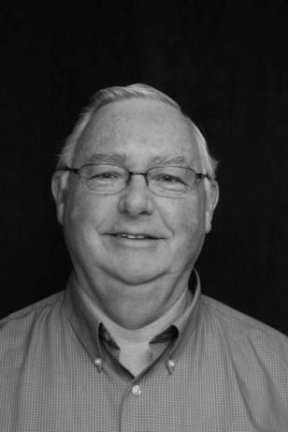
Science. Over the next 35 years Phil worked in accounting: first as a Cost Accountant, and later as a Cost and General Accounting Supervisor and finally as the Controller for a number of manufacturing companies in the Woodstock area.
In July of 1970, Phil married Brenda, his high school sweetheart. In 1977, twin sons, Mathew Edward and Stephen Clark, were born (a logistical challenge that Phil dismissed by saying, “it was just a matter of getting into a routine”). In April of 1981, the Thorne’s family was rounded out with a daughter, Sarah Andrea.
In 2004 their daughter Andrea married Andrew Milne and the couple moved to Edmonton where Andrew continues his PhD studies. In 2005, Stephen married his wife, Michelle, whom he met while living in Austin, Texas. In 2006 Stephen and Michelle moved to Waterloo. Mathew is also in Waterloo pursuing a PhD in computer science and animation. Stephen and Michelle now have two young sons. When Phil speaks of them, you can tell that they’ve stolen their “papa’s” heart.
Brenda and Phil love to travel: even with three young children vacation time was spent on the road exploring the Eastern parts of the US and Canada. In October 2005 their horizons expanded with a cruise round the Hawaiian Islands. This was followed by cruises on the East Coast (2007) and in Alaska (2009). When Phil returned from Alaska, he decided to retire. In his words, ” We joined the government payroll”.
In 2010 they took an amazing trip to Europe that included visits to WW 1 and WW 2 battlegrounds, cemeteries and monuments. Canadian losses during the Great War had personal significance for both Phil and Brenda: Phil had lost a great–uncle in 1916 at Ypres and Brenda’s grandfather was wounded on the last day of that famous battle.
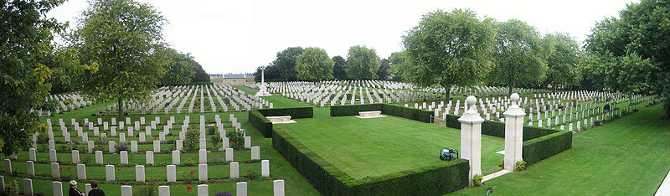
Burtonpe, "Beny-sur-Mer Cemetery"Sept 2006, Creative Commons Attribution
When not travelling, Phil likes to curl in the winter and in the summer plays a little golf. Phil is restoring a 1977 Corvette and with friend John Hincliffe is re-assembling John’s 1932 Desoto roadster. Phil continues to be involved in Scouting, being on the camp committee at Camp Shegardaynou and serving on staff at the Woodstock International Camp. Phil and Brenda have also developed a keen interest in family history, using the Internet for archival research combined with field trips to North Carolina and Manitoba to learn more family lore from family connections.

Bob Thornton
Bob Thornton (Robert Bruce Thornton) was born at Woodstock Hospital on July 23rd, 1939 and if you do the math, you'll see that just this summer Bob had a fairly significant birthday. He grew up on his parents' farm just north of Woodstock. The farm sloped down to the Thames River and so it was called Thameside Farm. The Thorntons still live on that farm, just to the west of the Woodstock Meadows Golf Club. As a young lad, he helped out on his dad's dairy farm. They had a flock of laying hens, a few pigs | 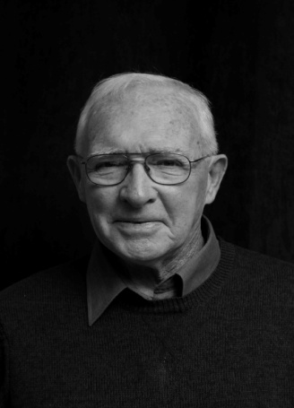
and three work horses. The tractor didn't arrive until around 1948.
Bob attended a one-room school located about a mile north of the farm. Everyone walked or biked to get there. Small, but a good place to learn. Bob reflected,
Yes, there was a strap in that school, but I don't recall every seeing it used. I realize now that we had an excellent teacher who didn't need to use the strap to get good results. Her name was Mrs Thelma Kennedy.
As Bob grew older he became involved in sports, playing minor hockey and baseball in town, and once he was in high school, he played football and volleyball. In 1953, when he started at WCI, it was the only high school in the city. It was very overcrowded. Space was so short that in his first year, his class met in a makeshift room in the basement. It was an all-boys class. A book could have been written about the escapades that took place in that classroom.
After grade 13, Bob went to OAC and in his third year opted for the general science option. In 1961 he graduated with a BSA degree. In the spring of his last year at university, Stan Blair, the principal of Huron Park Secondary School invited him for an interview. Bob was offered the chance to teach at Huron Park. As Bob put it, I arrived that September and after a six week summer course, I was supposedly ready to teach high school. I must have been OK. After four years I became head of science, the position I held until I retired in 1995. For the next 34 years I had the privilege of teaching
and coaching around 3000 students. Some of my colleagues at Huron Park have also become Probus members; Dan Byers, Tony Sheldon, Dave Hay, Norm Ryder and Glen McDonald. They must have known I was speaking this morning. I don't see any of them here.
After his first year of teaching he married Jean Lazenby. He had known Jean since both attended that one-room school, but they didn't reconnect again until Bob's third year at OAC. Two years ago the couple celebrated their 50th wedding anniversary They have three children: Janice, John and Kathy. All have graduated from university and all are married. Here's the current roster: six grandchildren (three girls and three boys).

Roy Vardy
Born in Bracebridge in 1939, where he lived for a short while before his family moved to Toronto. Attended school in Toronto and then went to work for the Toronto Telegram. He worked in Finance, Data Processing and was a manager in the Circulation department when they closed the doors in 1971. In October of
1971 he was hired by Henderson General Hospital in
Hamilton as Director of Health Records. In 1975 he became Director of Materials Management for the Housekeeping, Dietary, Purchasing and Stores departments.
Roy was the successful candidate for a new position, Director of Hospitality Services at the Woodstock General and started work in January, 1979. He was responsible for all non-patient areas, except finance. He retired in 2003 as Vice President of Services.
Roy married Ruth in October, 1961. She was diagnosed with cancer in 1997 and passed away in December, 1998, just 3 months after attending their daughter's wedding in Brandon, Manitoba. His daughter, Janis, and her family moved back to Woodstock last year. Roy has 2 grand-children, 3 year old Caitlin and 7 month o1d Jared. Since 2001, Roy has shared a house with Ilene Buchanan, a Nursing Director at Woodstock General.
He has been involved with a number of Community agencies - on the board and President of Oxford Victorian Order of Nurses, - on the board and President of The Oxford Children's Aid Society; - served two 3-year terms on the Thames Valley District Health Council.
Roy enjoys curling (20 years), reading, fishing and traveling. He and Ilene have visited France, England, Spain, Belgium, Portugal, Jamaica and Hawaii. He recently purchased a boat which he docks at St. Williams. He looks forward to his involvement with Probus.

Doug Vincent

Doug Vincent presented a very interesting Who Am I segment at our August meeting. His talk focused on three main areas of his life: family member, community member and businessman. Doug was born in Ayr in 1947, and educated at the University of Guelph. His connection with Woodstock began in 1977 when the family firm, Vincent Farm Machinery, opened a branch just outside of Woodstock on Highway 2. In 1984
Doug and his family moved to Tollgate Road, near Woodstock, where he and his wife raised a son, Rob, and a daughter, Tracy.

In addition to working in the farm business Doug has developed a rather unique career as a consultant to other family owned businesses. Doug described himself as a “third generation graduate” of a family business and this reinforces the fact that Vincent Farm Machinery has prospered through two generational changes in leadership. As we know from the stories we hear concerning such well-known dynasties as the Billes family at Canadian Tire and the McCain family food empire achieving a smooth generational change in a family enterprise is no mean accomplishment. Based on his own experience Doug has carved out a very successful career by acting as a consultant to other family-based business as they face this unique challenge. His consulting work has taken him to all continents except Antarctica.

Doug’s involvement in the community is also very important to him, although in his case the community extends to the four corners of the globe. Doug was one of the charter members of the Woodstock Oxford Rotary club and through his involvement with Rotary he has traveled the world. In fact he is now a roving ambassador for Rotary International. He has been involved in any number of important projects. One that is very important to him is Soul of Africa a cooperative venture between Rotary International and a leading South African shoe company. Soul of Africa is more than an initiative to raise funds for South African orphans; it also fosters sustainable development in a region stricken by AIDS and poverty. The Soul of Africa initiative raises money to assist organizations that house, feed and educate AIDS orphans through the sale of moccasin shoes. These shoes are hand stitched by village women from KwaZulu-Natal, South Africa, who are not only earning a living but also learning valuable new skills.

Doug is also a Rotary International representative to the United Nations. In this role he has attended conferences all over the world, most recently in Los Angeles. Doug attended sessions of the United Nations on a regular basis and part of his mandate is to encourage Canadians to take a more active part in the UN activities. Doug will be at the UN in November and is planning to take a group of Canadians there on an informational tour. Any member of Probus would be welcome to join him on this excursion.

Terry Wallace
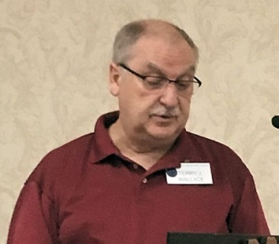
By way of “Who Am I” Terry Wallace introduced himself
to our group. Terry, who joined Probus in January, and his
wife came to Woodstock about seven years ago. In
preparing for his introduction Terry experienced the same
fear your cub reporter and editor experienced. That being
the fear that after 5 minutes the listeners might be bored
and after 10 minutes absolutely comatose. This was certainly not the case.
Born in Raymore Sask. Terry lived there until he matriculated. He made good use of his suitcase, his graduation gift, and was off to Edmonton. There he was living with his childhood sweetheart and now wife, Donna when he went to work for Bird Construction. He also got a diploma in Building Construction and Engineering after seven years of night school.
Over the next 27 years Terry worked for several companies in Alberta, BC and the NWT. He became part owner of a Quantity Survey company during this time. A highlight was the estimation, negotiation and construction of the Edmonton City Hall.
In 1995 Terry was off to Calgary and Graham Construction where he built a house and ran a B&B. He was “head hunted” becoming the Canadian Chief Estimator for the Walter Construction Group who built the bridge to PEI. After 10 years the “head-hunter” called again and he was off to Ontario.
In Toronto he worked as Chief Estimator for Aecon. Next was a position in Morriston, ON, where he worked on water and waste water treatment plants. After 4 years Terry was downsized at age 62. He then moved to Ellis Don Construction as a floating estimator travelling between London and Toronto. He officially retired in 2016 but continues on a consulting basis working on projects from BC, ON to Bogota, Columbia. One of his current projects is the Gordy Howe Bridge between Windsor and Detroit. Terry has been a reservist with CAF since 1969 earning a Long Service award along the way.
Both Terry’s children are living far from home, one being a teacher and the other working with the RCMP. Terry and his wife love to travel and count 50 countries as removed from their bucket lists. They are also involved in the Hospitaller Order of St. John of Jerusalem. They were also asked to sit on the board of their condo association and sit as president, treasurer and secretary. His current and all-consuming hobby is collecting military medals.
Terry enjoys his association with Probus sharing his enthusiasm for the monthly meetings and events.

Harold Walls
Born in London Ont. on June 3, 1931. Due to illness, he was raised by his grandmother in Ilderton where he grew up skating and playing hockey in the Ilderton Arena.

Following High School at Central Collegiate in London he studied telegraphy and subsequently joined the C.N.R. in the summer of '49’. Spent the first winter at Hornepayne and
Minnipuka in Northern Ontario, where trains could be on time but be a whole day late.
In 1951 he was working at Hamilton Jct. and witnessed “the best train wreck I have ever seen", due to a maintainer who had trouble with Rule G (no drinking before work or during). The result was 3 Diesel units flopped over the bank towards Hamilton Bay and 10 cars falling across the westbound main line right in front of an oncoming passenger train. Fortunately, the passenger train had received a red signal and slid to a stop before hitting the toppled cars. The whole system was tied up for 2 days while the mess was cleared away. In 1959 he thought he was rich, as he was the C.N.R. Agent and also Clerk-Treasurer for Newbury, Ont.
In Jan., 1964, he quit the C.N.R. and started his Municipal career as Clerk-Treasurer for the Town of Essex. He studied Municipal Government with Queen's University and received his designation in 1967. He also completed Public Administration at University of Windsor in 1970.
In 1971 he went to Goderich and held numerous municipal positions, was secretary to several boards, had a busy social life and also was President of Rotary for 1976/77.
In 1977 came to Oxford County as Clerk, Deputy Treasurer and was fortunate to have Ken Peers as Warden to help in his transition to County Administration which was totally different structure than at the local level. Oxford was in year 3 of its' own restructuring program and became the model for other counties. When he retired in 1995, the counties' budget was $50 Million and is now in excess of $80 Million due in part to downloading from senior government.
He is married to Barbara and lives at 41 Northland Crescent. He has spent most of his life golfing, and wasted the rest of the time.

Paul Ward
Paul was born on Apr 27, 1944 in Toronto; the same day a Boston Braves knuckleball pitcher hit a home run to help his team beat the Brooklyn Dodgers before a weekday crowd of 1900 fans. He said most people centre this kind of talk around their work life, which does not necessarily explain who they are. He remembers an aunt, who worked for Bell Canada,
when asked what she did, would simply say she went out to do business. Ask about her family though and she would talk for quite some time.
He then related a story from a book, Time Quirk, by one of his favourite author's.
Like the one Fred Bates Johnson told one time while I and some others were hunting deer and moose in Canada. Someone had to do the cooking or they would all starve to death. They drew straws to see who would cook while the others hunted from dawn to dusk. Fred said it was father who got the short straw and he could cook, and anybody who complained about his cooking would then become the cook. He prepared worse and worse meals while the others were having a great time in the forest. As they marched off one morning Fred's father found a fresh pile of moose droppings, so he cooked it in motor oil. That night, the first man who tasted it, blurted out "that tastes like moose droppings", but quickly added, "but good".
Paul's own father was born in Toronto in 1907. His mother was born in England in1908 and came to Canada in 1912.
Paul has a BA from Waterloo Lutheran University. He also studied Library Science at the University of Toronto. At U of T, he met and wooed Mary-Ann, who he married in 1971 and to this day she will introduce him as her first husband.
Their eldest daughter is going in to her 3rd year at Queen's University. Their middle daughter is in her 4th year of Health Services at Waterloo. Their youngest will start her 1st year at York University this September.
Paul accompanied himself on the Banjo and gave us a stirring vocal rendition of the song, “Blackfly of Ontario”, which was received with enthusiastic applause.
His working career began at the Canadian Meteorological Service in their library.
Because they were the only ones in Canada using the UDC system of filing books, Paul had no one second guessing his work, his decisions were final. Every three months he had to attend French language classes. In the 3 years he had to take French, he only used it once in his capacity as a Civil Servant. In1976 he joined his brother John in the family business, where he sold periodical subscriptions to Medical Libraries. The family business was sold to their main competitor and Paul continued working for them for 2 years, when he had enough, so he quit and moved to Woodstock in 1990. Paul stopped at this point after checking his watch and said perhaps he will have the chance to continue his story another day.

Bob Watson

Bob started off by telling us that he felt somewhat intimidated by all the “Who Am I” speakers he has heard in the 8 months he has been with Probus. A feeling I am sure we all have felt. He told us of being born and raised in west end Toronto. His father, George, was a RAF pilot who trained in Canada during WWII. George met Bob’s mother, Doris, while training in Dauphin. They were married when George left the RAF and returned to Canada, | 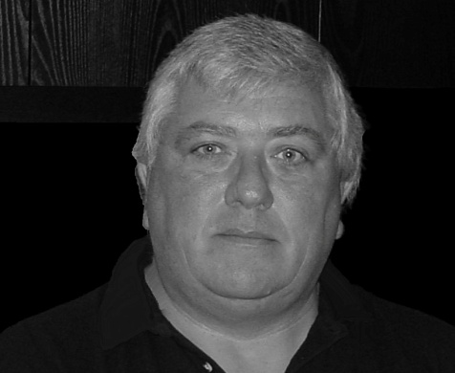
after the war. Bob still visits friends he made while growing up in what was then a brand new subdivision. Bob and his sister also had the good fortune of spending many summers near Coboconk involved in all the activities associated with cottage life. He was well suited for a baby boomer with an appreciation for “Rock and Roll” muscle cars and fast boats.

Bob had a need for speed and in the job market he seemed to gravitate towards sales and selling light bulbs door to door was where he landed. This led to employment with CGE lamp division. By 1975 he was managing a large part of South Western Ontario and over 1 million dollars in sales.

In 1979 he met Anne Sawtell in the CGE office. They were soon married. 1980 saw Bob transferred to Windsor where he became involved in the Leamington greenhouse operations. Working with 400 watt high pressure sodium lamps he was hugely successful in increasing the production of roses. Bob moved to Elora when he and Anne accepted positions in Guelph. His next career move, Bell Canada yellow pages advertising, came in 1983 and lasted for 24 years. In 1986 Bob moved to Glen Morris where they would live for the next 20 years.

In 2006 he took a buyout package from Yellow Pages moved to Woodstock in 2007, where he has the distinct pleasure of belonging to a unique neighborhood.

Bill Weatherston
Born in Brantford, he was raised on farms in the Troy and Caledonia areas. He attended Woodhill Public school and Lynden and Caledonia High schools. At
Caledonia he played on the Juvenile baseball team winning the Ontario title. He also played Fastball with the Ancaster and Mt. Hope teams.

Bill finished High School then worked for a year at International Harvester in Hamilton, before continuing his education at the Ontario Agriculture College, now known as the University of Guelph. After graduating, he worked 1 year for
Norwich Co-op, before returning to the home farm to work. He was still playing baseball with Mt. Hope when they defeated Elliot Lake to win the OASA Intermediate B title.
He was a member of the Haldeman Junior Farmers and was one of four chosen to go to the UK for 10 weeks. They visited and stayed on farms in Northern Ireland, Scotland, England and Wales. They also went to larger centres and he was able to take close up pictures of the Queen at The Royal Show.
An eventful year in 1965 saw Bill retire from baseball, get married to Janet and purchase his parents farm. They had 2 children while in Caledonia, while their youngest was born in the Woodstock area. They had to sell in 1969 when Hydro decided to build a substation in Middleport and the lines going to Nanticoke would go through their property.
In 1971 they moved to a 200 acre farm just north of Sweaburg and continued with
the dairy herd and their seed business. They sold for Pioneer Seeds for 35 years
and travelled with the company to Brazil, Hawaii, Jamaica, Barbados, California,
Los Vegas, the Caribbean and Alaska. The still like to travelled with some of the friends they made on these trips.
In1992, they sold the dairy herd, rented additional land and cash cropped. In 1997 Bill had heart surgery to replace an aortic valve. In 2000 they decided to slow down, so they rented out their land. Last year they sold the farm and built a home in Woodstock.
While farming, he was involved in a number of organizations - International
Plowing Match, Oxford Milkway Transport, Oxford Milk Committee, Oxford Corn Producers and Ontario Corn Producers Association. He is also a Charter Member of Sweaburg and District Lions Club.
In retirement, they visit children and their families in Dorchester, Calgary and Sackville, N.B. They spend a couple of weeks down south in the winter.
Bill enjoys curling in the winter, golf in the summer and visiting at Tim Hortons.

Bill Weir

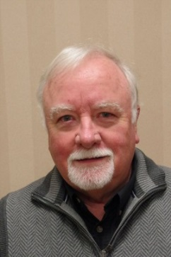
I only started to attend meetings last October, but I must
compliment all the previous orators whose life stories seemed
much more complex and interesting than what I planned to say.
So, I had to press ‘rewind’ to start my life flashing before my
eyes. They say that a picture is worth a thousand words, so
I was born and raised in Woodstock, and have lived in, or near
the city since 1949.
My father came from Saskatchewan and was an airplane mechanic in the Air Force during the war – stationed in Ontario. Growing up, we didn’t have a lot, but were comfortable. We didn’t get a TV until I was 12, so we had to make our own entertainment. We never got an allowance. You were expected to help out around the house without being paid. To make spending money, we had to find some kind of work. As soon as I was big enough, I started cutting people’s lawns, raking leaves or other chores. I got a used bicycle and applied for a paper route with the LFP. I had a very long route with 55+ customers. That taught me how to be responsible enough to get up early in the morning rain or shine.
When I got to high school, my first real job was working at Featherstone’s Market, a small store on the corner of Wellington and Dundas St. I was the only employee for the couple that owned it. I think I made $ 1.40 an hour – part time, but learned priceless life lessons there. A couple of years later, I got a summer job with the Woodstock PUC, driving trucks, digging ditches, and learning to stand around in a group and look busy! They paid $ 2.00 an hour, and I was there 4 summers. Watching how they used their hydraulic equipment really helped me get a great job later on.
I enjoyed school; and my first 15 minutes of fame was in Grade 6, when a girl partner and I won the city-wide spelling bee contest. Also in the elementary grades our music teacher discovered that I could hold a tune, so I was encouraged to participate in the Rotary Music Festivals as a soloist and in several choirs right into high school. It was always my dream to get into a rock group. Finally in grade eleven, I started a real rock n’ roll band with my cousin Don, which also included our president, Phil. We used to play mostly high school gyms and teenage hangouts – like The Place, and used to practice on my parent’s large wooden front porch in the warm weather. The second version of The Bishops won a battle of the bands in Brantford against 12 other groups. Sadly, while we were debating whether we could turn pro, we found that the RCA prize was a scam. Later, my parents made me quit the band – when I failed chemistry at the end of grade 12 (because school always came first!).
Stepping back a few years I attended Central Senior Public School. In grade 7, my English teacher noticed some of my short stories, and encouraged me to try public speaking was something I discovered a liking for. I won the trophy in both 7 and 8, and as a result was chosen to be the valedictorian. I continued competing when I got to high school. Public speaking was to be a great help over my entire career.
The other very important high school event was meeting my future-wife Terri in grade 10 English class. We got married in June of 1970. Like most kids of 19, I didn’t know what I wanted to do after high school. I knew I could talk, so I thought teaching might be a good career. After one year at University of Waterloo, I ran out of money – so enrolled at London Teacher’s College. I thought that would get me started working sooner, and I could get my BA later - to teach secondary grades.
A buddy of mine told me the possible income in manufacturing was double my teaching salary, so I went over to the “dark side”, joining the staff of Truck Engineering (later King Equipment) as a Sales Coordinator working in both their Trailer and Utility equipment divisions. My summers with the Woodstock PUC soon paid off when I started working exclusively with their King truck-mounted digger derricks and aerial devices. Because I was good with paperwork and large corporate bureaucracy, I looked after major house accounts from government agencies to our company branches and dealers. I spent 16 -1/2 years at King and got to meet lots of great people and do some travelling for work as well. Including big equipment shows in Kansas City or Louisville. It was a nice break from sitting in an office.
After King closed, I continued in sales and sold cars for about 5 years – and then joined Timberland Equipment in town. Initially it was inside sales, but later included marketing & selling to dealers in the 4 Western Provinces and direct sales to a number of big construction companies in the US. That involved more travelling – to develop face to face customer relationships. After 6-1/2 years, the 9/11 tragedy happened and Timberland’s sales to the States took a nose dive. I was the newest sales person, so I was also a casualty. I was hired by Cornell Welding & Fabricating as a marketing and sales manager. I retired from there after 15 plus years. Part of my job was to make sure the customers were kept happy, produce a newsletter, a web site, digital communication and social media.
On a personal note, my wife Terri worked at the Bank of Commerce and later Royal Trust – before a 21 year stint as a salaried employee at CAMI Automotive. She is retired. She is very involved in genealogy. She also knits extremely well and enjoys scrapbooking and card making.
Back in 1984, we started having August holidays at a Lodge on Sparrow Lake – just north of Orillia and continued for 26 years. Eight years ago, we purchased a family cottage on the lake. We now spend more time there making memories.
We enjoy travelling, and in 2010 had the experience of a lifetime on a Canadian War Memorial Tour (along with Phil and his wife Brenda) to France, Belgium and London, England.
Together Terri and I have 4 children, three girls and a boy. They all graduated from university. One daughter lives in Vancouver, and the others all live in London. We also have 5 grandkids – from 3 to 14 years of age, and we see them often.
I am super busy being retired, but have long time hobbies of photography, buying & selling on eBay, and drag racing HO scale slot cars. We started that hobby back in high school, but now it involves computer controlled electronic timing systems. Some ‘boys’ still like to play with toys!
Anyway, that’s my story – and I’m stickin’ to it!
Thanks for listening.

Dave Wright
History records that in 1630 his forbearers arrived in Plymouth, Mass. In 1800,  Philemon Wright led a number of families from there to settle on a land grant he received from the British crown encompassing the north side of the Ottawa river on what is now Hull, Quebec. His father, Cordner, studied Forestry at UNB in  Fredericton, NB, and married a local girl Margaret. | 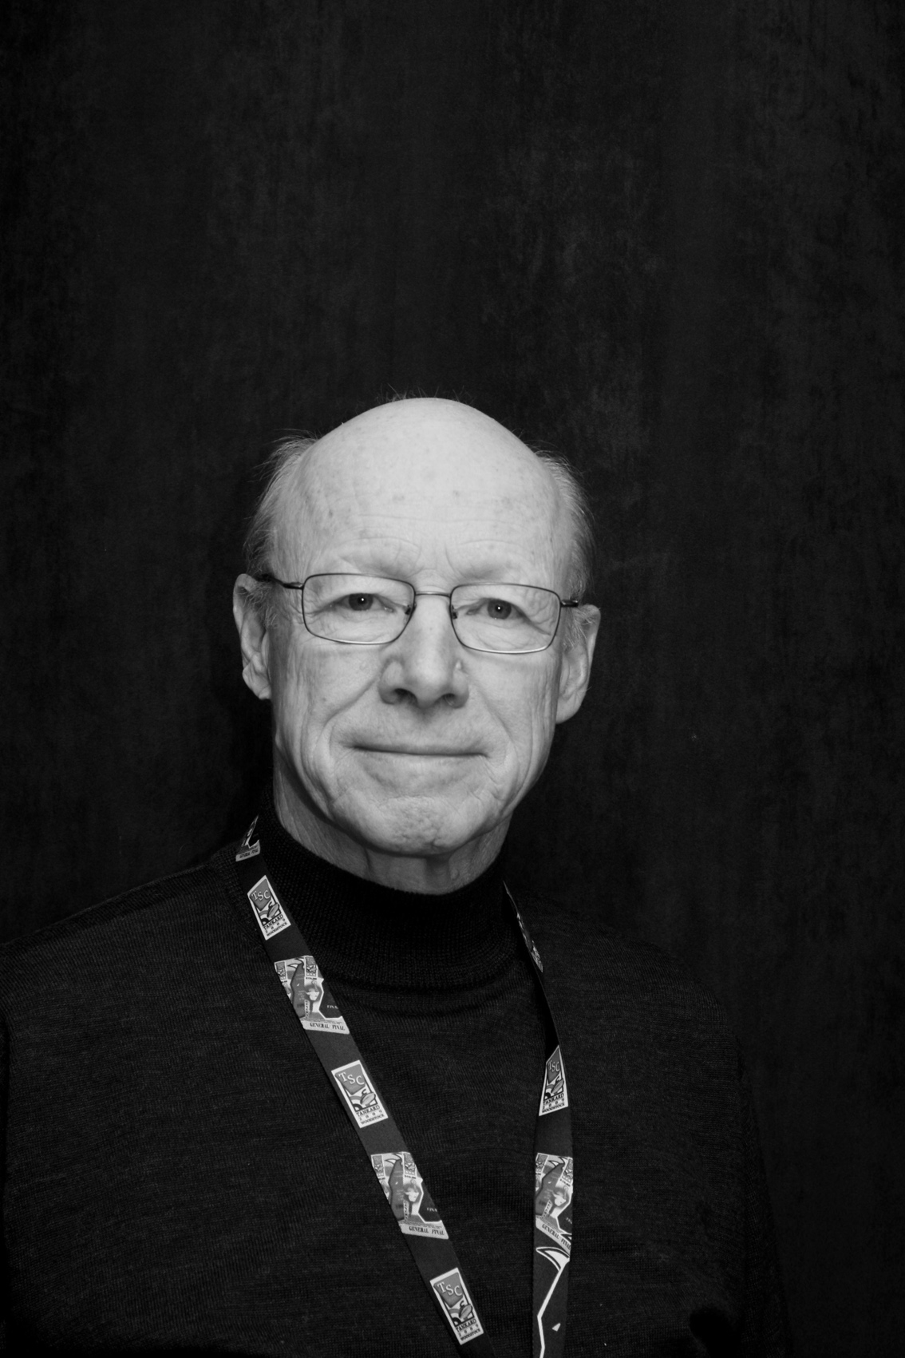
His father's career in the forest industry meant moving at least every 3 years. He and his brother and sister were all born in Port Arthur, now Thunder Bay. In 1939 they moved to Longlac in northern Ontario, He remembers walking to school on wooden sidewalks and rutted wagon trails, past the Hudson Bay post store and sometimes hitching a ride on a slow moving freight train. There were also long train rides to Fredericton, NB, with white table cloth service and polished shoes in the morning.
Moving to North Bay in l943 he marveled at the Lancaster and Mosquito bomber training activity out over the lake, and shuddered when the artillery lined up on the adjacent beach to fire at targets placed on the spring ice. On to Neenah, 'Wisconsin, where his father bought a sail boat and Dave would crew for him in weekly races on Lake Winnibago. Back to Kapuskasing where he completed high school he spent 2 years studying engineering at the Royal Military College, then 4 years at U of T to obtain a degree in Forestry.
Dave was hired by Kimberly Clark as a forester in May, 1962. He enjoyed a variety of opportunities and challenges while in their employ. As production foreman at a camp of 60 to 100 men he supervised the labour intensive harvesting of forest products by men using bucksaws and horses. A labour strike that winter started the phasing out of horses and introduction of Timberjack skidders. One of the most satisfying assignments was from 1966 to 1974, when he was construction
Engineer for Woodlands operations and supervised the building of many miles of first class logging roads, where truck/trailer units moved wood at 40 to 60 mph. They also built some major bridges and an airport runway at Terrace Bay. He later became Superintendent of Woodland Operations for 2 years, then was appointed Manager of Human Resources.
After retirement, he and his wife, Joan decided to move south for better medical services, shorter winters and major transportation hubs. They chose Woodstock and moved to their new home in 2000. His sporting interests had been skiing, curling, tennis and running. They now are curling, golf and the "Y'.
Dave and Joan do volunteer work with Meals on Wheels and the Soup Kitchen.
They enjoy local theater and also attend performances at Stratford and the Shaw.
They look forward to some traveling and discovering the historical and artistic gems of this area.

Deward Yates

Deward Yates was born in Edmonton in 1946 and moved to the Woodstock area in 1949. He attended public schools in Centreville and Beachville and later went to WCI. Next, Deward went to Western where he specialized in geography. After attending Althouse Teachers College, he taught for five years in Langstaffe, just north of Toronto. Deward then moved back to the Woodstock area in 1975 where he was appointed head of Geography at Delhi High. Deward retired from Huron Park Secondary School in 2001. | 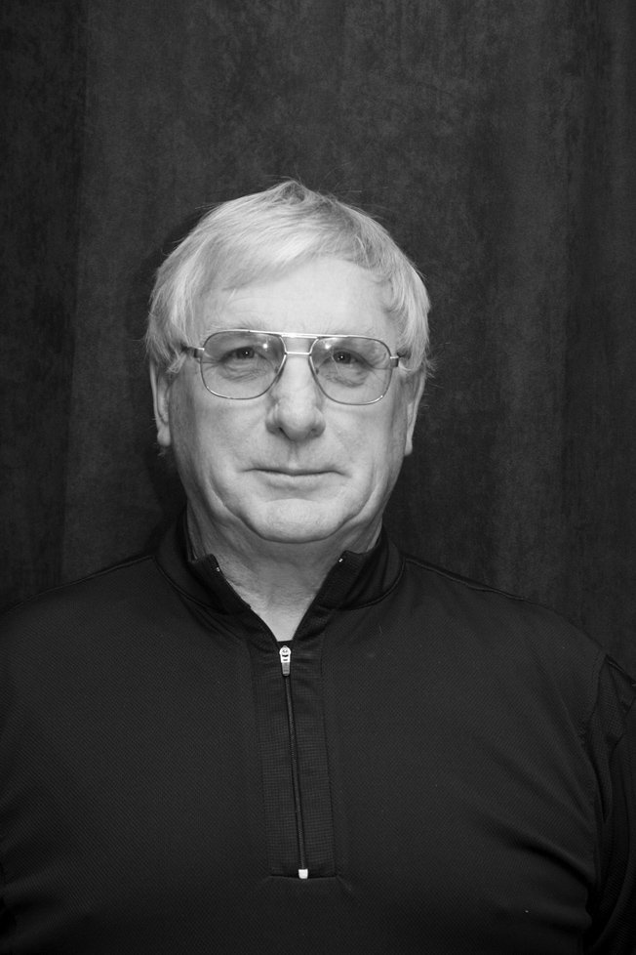

He is interested in canoeing, woodworking, and cross-country skiing. Deward loves to read. He is presently teaching an education class at Southgate Centre. Deward has been married to Candice since 1970 and they have two children, a son and a daughter.

