**Al Driedger**

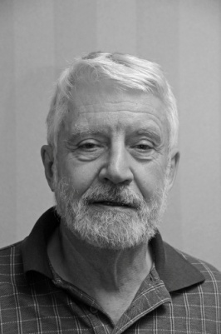

My father was born in 1907 in what was then Tsarist Russia, now

Ukraine. His mother died when he was 9 years old. A subsequent

stepmother decreed that children from the previous marriage were

put up for adoption. When he was 10, the Tsar was overthrown in

a bloody revolution. There followed several years of unrest

punctuated by civil war, famine and the flu pandemic.

The combatant armies in the civil war largely provisioned themselves by pillaging the countryside helping themselves to provender, farmers’ horses and whatever else might prove of use in their struggle. My father at the age of 11 or 12 was conscripted into military service and it wasn’t clear to him by which side; I cannot tell you if he ever held a gun in his hands; he never spoke about what actually went on in the fighting but I have a sense of what he may have experienced from reading Mikhail Sholokhov’s novels concerning those times. During my father’s life we didn’t have the term, but it is clear now that he suffered every day from post-traumatic stress, PTSD. From early morning until late at night he worked like a man possessed, trying to push away his memories; whenever he stopped working if only for a drink or a meal, some painful story from his childhood would emerge. And we, his family, would respectfully listen even if we had heard it before.

One of his memories was of a time when the fighting seemed to be over and he was alone, asking his way across the unmarked countryside toward home. How does a mere boy do that? Moving along roads that were no more than trails, in the general direction he believed to be toward home, he needed at times to stop for directions and sometimes to beg for food and shelter. He discovered that the help he needed was not forthcoming from the countryside’s Mennonite or Russian villages but that the Jewish settlements were always welcoming. In one of those encounters, told with tears, he recalled coming into a Jewish *shtetel* toward evening where he was greeted by a man at the gate to the first house, who called him to come in for the night. On entry into this modest hut, he was shocked to find an obviously starving family, listless children with swollen bellies, gaunt and eyes as big as saucers. His host seated him with the family for their evening meal and then evenly divided his one crust of bread among them including a piece for him. He remembered how the children’s hollow eyes followed the course of his postage stamp-sized crust to his mouth and how they watched him as he chewed it down.

Those were turbulent times and I expect that this generous Jewish patriarch and his family, their names long forgotten, perished soon after that encounter. One could argue that this enormous act of terminal kindness to an unknown Gentile waif may have saved the life of the man who became my father and made the lives of his family possible.

In contrast to my father, in my life almost everything has come up roses; the most exciting opportunities in enriching education and fulfilling work have been mine. I’ve been married for 57 years to the same lovely woman. We were privileged to parent in an era when there was no call to send our children away to war. My grandchildren show all the signs of future joyful excellence and diligent citizenship. My father’s descendants now extend into three generations and are to be found in Canadian and international businesses, professional academies and in the arts. At age 80 I still have dreams and plans that extend beyond the mere avoidance of pain or an urgent focus on survival. When I think on these things, I remember that we may owe all we are and have been to that now-nameless Jewish peasant (or was he a saint?) who willingly shared what may have been his own last supper with a stranger. All that remains as evidence of his ever having existed is the scrap of a memory of my father’s story that I carry in my head, but even that has become its own kind of sacrament. My anonymous saint surely was a man for the ages.