Bill Meek
Bill Meek’s roots in Oxford County are deep. He was born in Ingersoll in 1939 and was raised on a farm where ‘the title went clear back to the crown’. In the 1830s his ancestor, William Meek, a stonemason, arrived to take up 400 acres of heavily forested land in West Oxford. William kept this land, but purchased a second farm on the Old Stage Road. The family prospered. A son, Peter, developed the original land, acquired the timber rights and built a sawmill. Peter’s wife Margaret set up a cheese factory. | 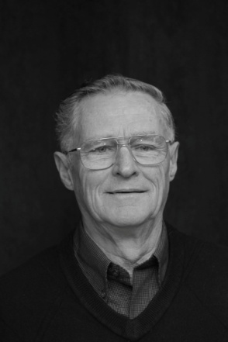

Bill attended school at Foldens Corners where he insisted that he was ‘basically a good student’ but did admit to doing something mildly mischievous at least once. The bricks on the wall of the school were quite soft and it was a tradition for students to scratch their initials on the bricks. Bill found a brick that was soft enough to carve his whole name. Bill had completely forgotten about it. Guess what happened next. In Bill’s words, “When the school was torn down in the 1960's, Monty Towne, came to my door one day and handed me that brick. Imagine the chances of ever finding that”.
In 1960, Bill met his wife Sharon. Last year they celebrated their 50th anniversary.
The Meeks have three children and three grandchildren. While his children were growing up Bill was involved with cubs in Salford. From 1960 until it moved to its Southgate facility, Sharon managed the Woodstock Seniors’ Centre.
After graduating from OAC, Bill joined his father’s dairy operation. In 1969 they switched from dairy to hog production. Bill was a member of the Pork Producers and over the years he served on the executive in a variety of positions
In 1988 Bill changed careers, joining Ayr Tractor in Hickson, working on repairing small engines. After six months his employer enrolled him in the small engine apprenticeship program. This combined two years of on–the-job experience along with two years at Sir Stafford Fleming College in Peterborough. At the end of the program he received his small engine licence. Since 2000 Bill continues to do small engine repairs from his home.
Sharon and Bill still live on the original family farm. However, now the land is rented out except for a couple of acres of sweet corn. According to Bill, ”Growing the sweet corn is more of an excuse to work my antique tractors”. Bill and his brother have a collection of eight machines. If you are travelling between Foldens and Sweaburg in August and September you might see Bill’s little veggie stand sitting out by the road.
Music has always been a big part of Bill’s life. He started learning the clarinet at age thirteen; taking lessons from Tom Brooks. In high school he took up the alto saxophone. He was part of a group (including fellow Probian, Bernard Calder) called the Double Dribble Nine. They cheered on WCI at football and basketball games. Later he played with the Norwich Musical Society Band. Bill is not only an accomplished musician but he sang with the Woodstock Choralaires for 27 years, touring in Britain and Europe.
Blair Kelner, Bruce Jakeman and Tracy Buchannan have joined Bill as part of a musical foursome. There is a music room set up in his basement complete with mikes and amplifiers. The gang brings their instruments and Bill provides the beer. In July the group played at the Canterbury Folk Festival in Ingersoll and we will all have a chance to hear Bill’s group at the Probus Social.

