Bob Thornton
Bob Thornton (Robert Bruce Thornton) was born at Woodstock Hospital on July 23rd, 1939 and if you do the math, you'll see that just this summer Bob had a fairly significant birthday. He grew up on his parents' farm just north of Woodstock. The farm sloped down to the Thames River and so it was called Thameside Farm. The Thorntons still live on that farm, just to the west of the Woodstock Meadows Golf Club. As a young lad, he helped out on his dad's dairy farm. They had a flock of laying hens, a few pigs | 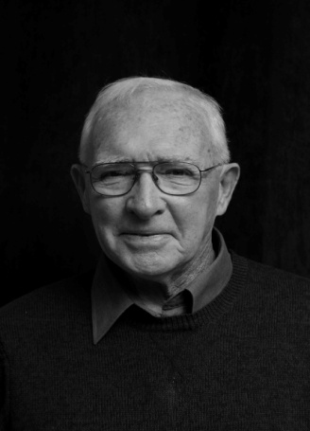
and three work horses. The tractor didn't arrive until around 1948.
Bob attended a one-room school located about a mile north of the farm. Everyone walked or biked to get there. Small, but a good place to learn. Bob reflected,
Yes, there was a strap in that school, but I don't recall every seeing it used. I realize now that we had an excellent teacher who didn't need to use the strap to get good results. Her name was Mrs Thelma Kennedy.
As Bob grew older he became involved in sports, playing minor hockey and baseball in town, and once he was in high school, he played football and volleyball. In 1953, when he started at WCI, it was the only high school in the city. It was very overcrowded. Space was so short that in his first year, his class met in a makeshift room in the basement. It was an all-boys class. A book could have been written about the escapades that took place in that classroom.
After grade 13, Bob went to OAC and in his third year opted for the general science option. In 1961 he graduated with a BSA degree. In the spring of his last year at university, Stan Blair, the principal of Huron Park Secondary School invited him for an interview. Bob was offered the chance to teach at Huron Park. As Bob put it, I arrived that September and after a six week summer course, I was supposedly ready to teach high school. I must have been OK. After four years I became head of science, the position I held until I retired in 1995. For the next 34 years I had the privilege of teaching
and coaching around 3000 students. Some of my colleagues at Huron Park have also become Probus members; Dan Byers, Tony Sheldon, Dave Hay, Norm Ryder and Glen McDonald. They must have known I was speaking this morning. I don't see any of them here.
After his first year of teaching he married Jean Lazenby. He had known Jean since both attended that one-room school, but they didn't reconnect again until Bob's third year at OAC. Two years ago the couple celebrated their 50th wedding anniversary They have three children: Janice, John and Kathy. All have graduated from university and all are married. Here's the current roster: six grandchildren (three girls and three boys).

