David Clowes
David gave his presentation in a nice relaxed and off-the -cuff manner.  We learned about the when (Sept 30th, 1943 and the where (Princess Street in Woodstock), about boyhood pals (Phil Dunbar and Dave Tabor), his education (Princess School, Central, WCI, WLU and Teachers | 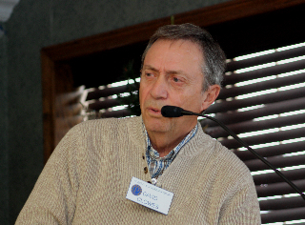
College), his family (wife, Joanne and children, Heidi and Ken) and where he worked (Standard Tube, Norwich High School, Canada Post and Glencoe High School).
However, it was in his telling of the small stories from his life that his presentation shone. In just a few short sentences he was able to recreate what it was like to be a college student in the sixties. Just mentioning Thursday Pub Night brought back lots of memories for me. What about his story about the plumbing problems at Norwich High School? It showed that even the teachers could learn something about physics and arithmetic from a plumber, “You see your problem is you’ve got a three inch pipe and a four inch ....“. And his time at the post office. If I had to deal with a mail cartage driver like “chicken brains”, perhaps I would have gone on strike too. During his teaching career, it is clear that David had a great concern for and an interest in his rural students at both Norwich and Glencoe. His one hundred and twenty mile round trip commute to Glencoe speaks for itself.
In closing, Dave summed up his life so far by saying that with lots of golf in the summer and curling in the winter, his two years of retirement has proved to be the best job ever.

