Deward Yates

Deward Yates was born in Edmonton in 1946 and moved to the Woodstock area in 1949. He attended public schools in Centreville and Beachville and later went to WCI. Next, Deward went to Western where he specialized in geography. After attending Althouse Teachers College, he taught for five years in Langstaffe, just north of Toronto. Deward then moved back to the Woodstock area in 1975 where he was appointed head of Geography at Delhi High. Deward retired from Huron Park Secondary School in 2001. | 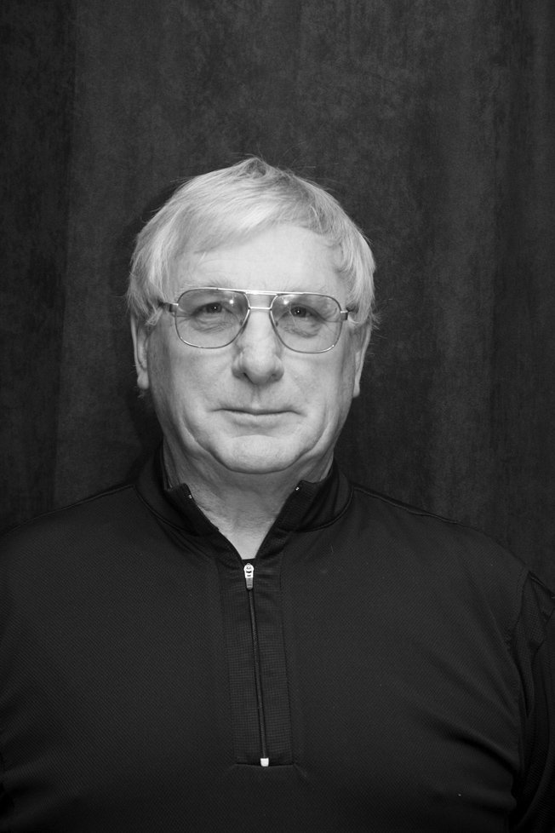

He is interested in canoeing, woodworking, and cross-country skiing. Deward loves to read. He is presently teaching an education class at Southgate Centre. Deward has been married to Candice since 1970 and they have two children, a son and a daughter.

