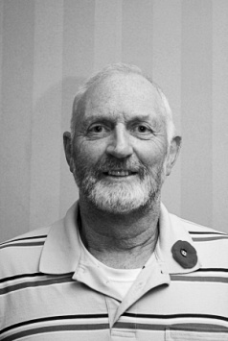**Jack Pasma**

Jack began his talk by telling us, according to him, “If it isn’t

Dutch it ain’t much”. He spent the balance of his talk proving

how wrong a person can be with one simple statement. Born in

Holland Jack came to Canada with his family when he was 13.

They landed in Halifax. Jack went back to tour the Pier 21

museum and walked on the same floor that they walked on

66 years before. His father’s first work was on a farm near

Aylmer ON. The family moved around while Jack’s father

accepted work at several locations before they moved into a large

house they would share with Jack’s uncle. In 1960 Jack’s father purchased a 140 acre farm near Springfield ON.

After graduating from an agriculture course Jack joined the family farm which had grown into an exclusively dairy producer. In 1974 Jack was smitten by the vision of an Aurelia Vandervaart in church. She had come to Aylmer to teach. Jack knew at that very moment he was looking at his future wife and in 15 months she became Mrs. Pasma. The wedding was followed by a one day honeymoon; I wonder how many of our generation followed this pattern. Jack and his father continued on the farm till his father’s untimely death. Seven years later with his children showing no interest in carrying on with farming Jack sold out. He moved into poultry production just outside of Woodstock. Jack’s next employment would be at Fleetwood Manufacturing. He would remain there till he retired at age 67.

Even prior to his retirement, Jack had been approached by Ian Clark about joining Probus when he retired. Probus, woodworking, tinkering with his 1951 Ford pickup and traveling have taken up much of Jack’s free time since then. Oh, I almost forgot, Jack also likes to watch the Maple Leafs play hockey. Judging from their record since 1967 it is an infrequent event. So much so it is Jack’s wish that six Maple Leaf players act as his pall bearers. That way the Leafs can let him down one last time. Jack ended by telling us to “lighten up and enjoy life. After all we’re not Americans”.