Peter Harrison
Born in 1947, Peter considers himself a pretty lucky guy. In Scarborough his primary and secondary education took place in new facilities featuring new programs. Peter’s immediate family was surrounded by a very close extended family that got together often. He studied civil engineering at the University of Waterloo. His parents were active in his local church. The benefits of that church connection have remained with him causing him to remain active in his church. Peter | 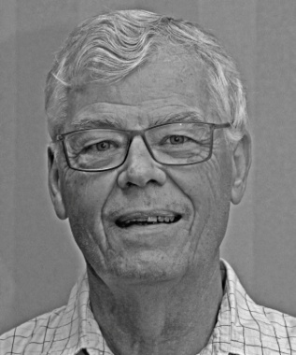
played a lot of sports and in a Scarborough that was still on the edge of Toronto he wandered the undeveloped valleys of the Don River tributaries.
His high school teachers, women and veterans of WWII brought dedication, discipline and a sense of maturity to the class room. He excelled in maths and sciences but languages, French and Latin, not so much. Peter played football on a winning team, learned how to fence and, in cadets, learned how to assemble a Bren gun, but not without pinching his fingers.
St. Paul’s College was where Peter met a number of lasting friends. One would become his wife. It was while he attended the University of Waterloo he was exposed to a range of possible career choices through the co-op program. This “earn while you learn” approach helped pay for his education and instilled true entrepreneurship. He married and became the father of a daughter, Christine, before accepting a position at the MOE in Toronto. Peter returned to Waterloo, following the birth of his son Brett, and entered the Master’s program in Water Resources and graduate courses before joining Kilborn Engineering.
Peter bought his first house in the neighborhood where his grandmother lived and had raised his mother. It was an area of old homes and young families working on “fixer uppers”. After four years the search was on for a new home. They found a home in Leaside. It turned out to be a great move and they enjoyed this small town atmosphere like an island in the sea of Greater Toronto. It was during this time that Peter felt a great need to explore several business opportunities. Over Peter’s career he worked in mining, petroleum, development projects and the design of water and waste water programs. He reported to work in Ontario, Quebec, Newfoundland /Labrador and as far away as Riyadh in Saudi Arabia.
The lure of faraway places was hard on family life and Peter kept the time away as short as possible. It did not prevent Peter from participating in community activities like scouting, minor sports and church committees. Both my children are successful in their careers and devoted to their families and communities and I am proud of them.
Once the kids had left home Peter, at the behest of a head hunter, accepted a position in a small consulting firm in Port Elgin. They loved Port Elgin but a sharp downturn in the local economy meant the business Peter was hired for soon dried up. His time was filled up as a consultant and filling in, as a manager of campus facilities for the University of Western Ontario. He then joined the Ontario Clean Water Agency to develop a new process for contracting water and wastewater design and construction projects. During the Walkerton water contamination incident Peter became the spokesperson for the agency when the OCWA took over the operation of the water and wastewater system. This challenging time saw Peter in meetings with senior government officials including the Premier, presentations with town council and 50 media interviews.
Once the dust had settled in Walkerton Peter went to work for B. M. Ross & Associates. For the next 14 years he would work on a reduced work schedule from his home in Port Elgin. Living in a rural community gave Peter the opportunity to participate on boards and committees he may not have found in larger urban centers. Organizing committees for children, the Saugeen Memorial Hospital Foundation and the Rotary Club where he served in a variety of positions allowed Peter to give back to the community. The Friends of MacGregor Provincial Park, Habitat for Humanity and the Cameroon Hand Up Committee, an off shoot of Rotary, also benefitted from Peter’s involvement.

In 2008 the Walkerton tainted water scandal claimed its final victim. Peter’s marriage had suffered during that stressful time and added pressures finally brought an end to his marriage. Peter kept busy with Rotary and other community activities and it wasn’t until 2012 he met Sharon Kruse. In 2013 he bought a house in Woodstock. Peter is looking forward to enjoying many more years with his new friends in Woodstock.

