**Terry Wallace**

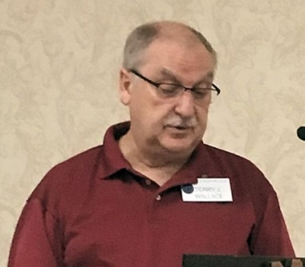By way of “Who Am I” Terry Wallace introduced himself

to our group. Terry, who joined Probus in January, and his

wife came to Woodstock about seven years ago. In

preparing for his introduction Terry experienced the same

fear your cub reporter and editor experienced. That being

the fear that after 5 minutes the listeners might be bored

and after 10 minutes absolutely comatose. This was certainly not the case.

Born in Raymore Sask. Terry lived there until he matriculated. He made good use of his suitcase, his graduation gift, and was off to Edmonton. There he was living with his childhood sweetheart and now wife, Donna when he went to work for Bird Construction. He also got a diploma in Building Construction and Engineering after seven years of night school.

Over the next 27 years Terry worked for several companies in Alberta, BC and the NWT. He became part owner of a Quantity Survey company during this time. A highlight was the estimation, negotiation and construction of the Edmonton City Hall.

In 1995 Terry was off to Calgary and Graham Construction where he built a house and ran a B&B. He was “head hunted” becoming the Canadian Chief Estimator for the Walter Construction Group who built the bridge to PEI. After 10 years the “head-hunter” called again and he was off to Ontario.

In Toronto he worked as Chief Estimator for Aecon. Next was a position in Morriston, ON, where he worked on water and waste water treatment plants. After 4 years Terry was downsized at age 62. He then moved to Ellis Don Construction as a floating estimator travelling between London and Toronto. He officially retired in 2016 but continues on a consulting basis working on projects from BC, ON to Bogota, Columbia. One of his current projects is the Gordy Howe Bridge between Windsor and Detroit. Terry has been a reservist with CAF since 1969 earning a Long Service award along the way.

Both Terry’s children are living far from home, one being a teacher and the other working with the RCMP. Terry and his wife love to travel and count 50 countries as removed from their bucket lists. They are also involved in the Hospitaller Order of St. John of Jerusalem. They were also asked to sit on the board of their condo association and sit as president, treasurer and secretary. His current and all-consuming hobby is collecting military medals.

Terry enjoys his association with Probus sharing his enthusiasm for the monthly meetings and events.