Tony Paladino
After being introduced by Art, Tony greeted us in English, and then in French. He could, if he'd wished, greet us in Italian, and we learned rather surprisingly, in Portuguese and Spanish as well. This fluency dates back to the time he spent working in Brazil. A colourful chapter in his life, and if things had turned out differently, Tony might well have given his Who Am I to the Sao Paulo Probus Club rather than our club here in Woodstock. Tony was born in Rome in 1936. | 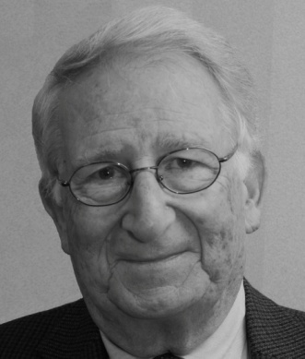
His father was a businessman who owned two candy factories, one in Rome and one in the south, in the seaside city of Bari. His was a large family, two boys and six girls, and we learned, happy and harmonious to this day. He received an excellent education at his local state primary and secondary schools and afterwards went to a small engineering school located right inside Vatican City. Tony graduated as a fully qualified civil engineer specializing in agriculture. Meanwhile he had obtained his private pilot's license.
This knowledge of flying and agronomy led to a job with an aerial surveying company. Plans for Italy's autostrada were underway and the first need was for aerial photographs. Soon after, his company was approached by the Brazilian government to undertake a similar survey in the wilds of the Amazon. This was looking forward to the construction of the new capital, Brasilia.
Tony's company wasn't interested (wisely it turned out), but Tony was. So off he went to live in the jungle. His first inkling that this might have been a mistake was when he was issued a pistol to shoot any menacing snakes that might turn up. Scary! And that was just on the ground. It was even more frightening up in the sky with nothing but impenetrable forest beneath you and one postage stamp sized airfield to land on.
“from two, three, four thousand feet it looked like it was my coffin”
Two months later he was back in civilization, working in Sao Paulo at an engineering design office. Here's an amazing 'isn't this a small world' moment. A stranger came by the office where he was working and overheard Tony speaking in Italian. The stranger was Italian too. But he wasn't really a stranger. Many years before in Bari, the stranger had been his father's original partner in the candy factory. What are the odds! This chance encounter resulted in Tony getting a better job at a more important engineering office.
In 1960 Tony decided to come back home for a vacation. In 1956, Tony had met Anna, his future bride, for the first time while vacationing in Malta. Both, it turned out, lived in Rome. But in spite of their initial attraction, they had gone their separate ways. And Tony took off for South America. In 1960, on his brief vacation, the spark was rekindled, but once again Tony had to go back to Sao Paulo. This could have been the end, but the 1960s were bad times in Brazil and after another couple of years Tony sold up and moved back to Italy. This time the spark burned brightly and Tony and Anna were married.
In Italy at this time there was compulsory military service. Tony had had a deferment while at school and obviously couldn't serve while out of the country, but on his return the Carabinieri came to call. Tony served for 18 months and has a $32.00 a month Italian government pension to prove it.
Back on 'civvy street' Tony returned to engineering design. He tells us that one of the bridges over the Autostrade from the Rome Airport is his work. It was a tricky spot, very soft ground. The first bridge had fallen down almost right away, Tony's is still standing. But in spite of all this Tony was feeling cramped by life in Italy. Class ridden, with promotions based on who you knew and family status, not on merit. Canada, in the form of Timberland, beckoned.
Once established in Woodstock the Paladinos raised two boys, Richard, a computer analyst with Timberland, and Ronald, a tool and die maker. Now this may seem like a rather abrupt way to end Tony's Who Am I but this is what happens when you are a wonderful story teller. You run out of time and that is what President Art had to reluctantly tell Tony. Perhaps someday we will hear more about his interesting life here in Woodstock.

