PROBUS CLUB OF WOODSTOCK-OXFORD
Box 20052, Woodstock, Ontario N4S 8X8

Web Site: woodstockprobus.ca

Meets monthly – 2nd Tuesday at 9:45 A.M. Quality Hotel - Woodstock
President Dave King Vice President Jerry Klages 2nd Vice President Bill Weir
Past President Phil Thorne Secretary Robert Ball Treasurer Ken Shrubsall
Club Auditor Bob McTavish Probus Website Chris Hannon Audio/Visual John Richardson
Club Archives Bob McTavish Who Am I David Palmer Club Services David Tabor
Speakers Peter Harrison, Ian Clark, Membership Larry Asp, Richard Orton
Directory Bruce Hartley, Tony Sheldon Newsletter Bob Axon, Phil Thorne, Bill Weir
Get Well/Sympathy Robert Ball Special Events Bob Axon, Rob Bryant, John Carley, Dave Hay, Bill Meek

Our March Club Newsletter
(Volume 30, Issue 7 – March 12, 2019)

Vice - President’s Message

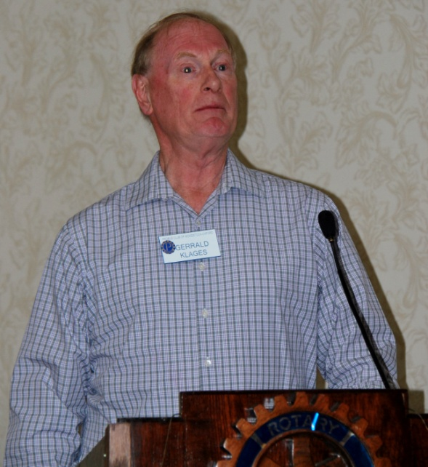
Vice-president Jerry Klages did a very admirable job filling in during Dave King’s absence.

He opened the March meeting with O Canada, our Probus song, and a series of humourous jokes - that warmed up his audience.

Jerry only looks a wee bit surprised in this photo.

He also wanted to remind everyone (with a curious mind)
- that the regular Science Club meeting will start at 8:30 am., prior to our April club meeting !

Who Am I – Keith Reibling

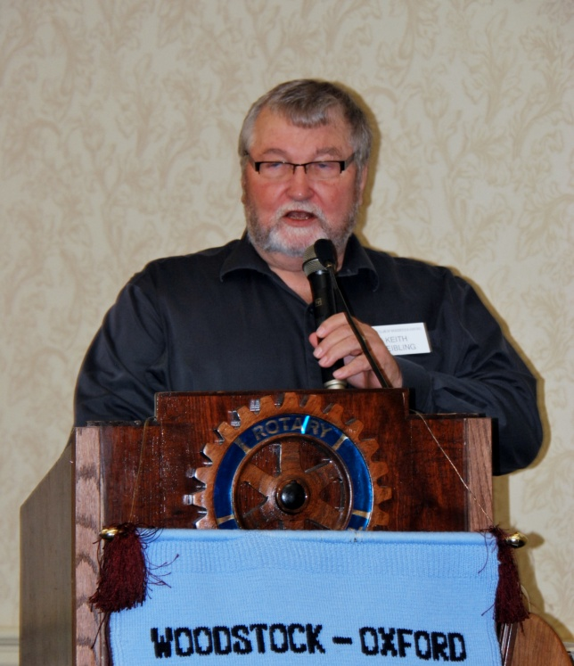
69 years ago in February, I entered this world at Grand River Hospital in Kitchener, Ontario. I was the oldest child of LaVerne and Dorothy (Harmer) Reibling. My first home ended up being an apartment in Winterbourne, a small village near Kitchener-Waterloo. My father was a mason, running his own business where he built houses, from concrete block foundations, plastered interior walls and brick exteriors.
My 2nd home was a farm house adjacent to RIM park in Waterloo. In 1954 we moved to a new house that my father constructed again near Winterbourne where I attended public school from Grades 1 to 4. I started Grade 1 at 4 years old because I was a foot taller than the next door neighbor boy, 1 of my 2 best friends of the time. Today we are the same height and probably I am 1 foot wider.

I am amazed that I recall in October, 1954, at Age 4, hearing the roar of the Grand River as it went through Conestoga. This was part of Hurricane Hazel, dubbed the storm of the century. I vividly remember riding with my father and being scared as I watched the flooded river going over roads and the now Conestoga Golf Course. In those early days the milk man and the bread man stopped by the house regularly in a delivery truck to deliver supplies. Also in those days you played in the countryside with the children in the area. Age didn’t matter as we built forts in the adjacent bush, learned to skate, ride a bicycle, ride a pony etc. As I remembered back, life as a child seemed simple and I have very fond memories.

When I started Grade 5 my parents were building another new house this time in St. Jacobs where I attended Grades 5 and 6. I remember biking a distance of 8 km. to take my father’s supper over to our new home construction site in St. Jacobs so Dad could work until dark. One of the highlights of living in St. Jacobs was Darryl Sittler was in my Grade 5 and 6 room. He also was born in 1950. In the winter of 1972 I went with a friend to a Toronto game at the Maple Leaf Gardens. This was my first and last time to watch the Leafs play in Toronto. Ironically Sittler never went to a Leafs game in Toronto until he was playing for them. The night we were there the Leaf’s won and Darryl got a couple of goals so in my dream world I thought that I had brought him good luck.
In 1961 my parents bought Grandpa’s farm north west of Bright and I attended a one room school in the country for Grades 7 and 8. One of the Sommers boys from the Sommers Generator business in Tavistock was my teacher. This was quite a shock to my system as I remember, walking or biking 3.5 km. on a gravel road in an open desolate rural area compared to the shorter journey in a built up village like St. Jacobs with sidewalks and paved streets.

I started high school at Huron Park in Woodstock and was sitting in my home room during the afternoon of November 22, 1963, when we were informed that JFK, President of the United States was assassinated. College Avenue Secondary School was a new technical high school that opened in 1963. I was happy to enroll at CASS in 1964 for Grade 10 in a 4 year Business and Commerce course. I despised my first year of High School in the Arts and Science 5 year program where algebra and French language were an important component. Coming from a one room country school I was like a duck out of water when it came to participating in gymnastics. I was fortunate to have an understanding gym teacher who gave me a passing mark because I tried hard. During Grades 10 to 12 I was successful in school by obtaining marks that placed me on the honour roll. I enjoyed the basic math, was an excellent typist, which Mom claimed was the result of 4 years of earlier piano lessons.

It was during this time that I learned how to smoke, a bad habit I enjoyed for 22 years. You could really fit in for 38 cents a week (the cost for a package of cigarettes) and everyone was doing it. I also realized when I was 14 years old that a 16 year old female classmate was pregnant. I went right home and discussed this with Dad and was quite surprised on what he shared, he completely opened up on the topic. I was the oldest child in a family of 5, 2 sisters and 2 brothers. Also during this time I started roller skating and curling Friday nights at the Plattsville Club in a school boy curling league. I bought my first car and had my first date, WOW.

My first job was in the Office Services Department at the new car frame plant in Kitchener known as Budd Automotive starting in June, 1967. Because of my new work commitments, I was unable to go to Expo in Montreal. In 1968 I went over to the Uniroyal Tire Company and worked in the office for over 2 years, quitting in early 1970 to take a 7 week road trip to California, up to Vancouver, and home through the western provinces. I then went to work with my father doing pig farming, and masonry which involved being the labourer for plastering, block laying and bricking. This work provided money over my teenage years and was great knowledge when I was building 2 new houses for my family. I realized that this isn’t what I wanted to do so after 1 year of this work I went back to the Budd Plant and worked in the records and scheduling area of the maintenance department. It was during this time in 1971 that I legally could consume alcohol since I was 21. Later that year the government dropped the legal drinking age to 18 which changed the whole teenage culture. The new life of going to the pub after work with the foremen was lots of fun but I soon learned I couldn’t keep up financially because I didn’t earn the big money of the factory worker.

In July, 1972 I stepped outside of the box, applied for, and was appointed as the Clerk-Treasurer, Tax Collector of the former Township of Blandford. I worked alone in a one room school building known as the Carter’s School, North East of Innerkip where the Township Public Works yard still exists. At the time I didn’t have a steady girl friend and I remember being concerned how will I ever meet a new girl in this setting. The next January I met my wife Tory at an Ontario Junior Farmers Choir competition at the Royal York Hotel in Toronto. I was active in the Junior Farmers organization for many years prior to getting married. It was ironic that Tory lived her entire life in Tavistock, a place where I spent a lot of time and I didn’t know her. Her father was a 50% partner at Krug’s Meat Market in Tavistock and while dating Tory I use to tell my friends that I had a 25% interest in the successful meat market business because she only had one brother and I had a 100% interest in Tory.
I was fortunate that the County of Oxford amalgamated on January 1, 1975 and the former Township of Blandford and the Township of Blenheim merged resulting in my job being shifted to Drumbo. I continued to work there until retiring in August, 2010 after over 38 years of service in the top administrative role. I tried on a couple of occasions, unsuccessfully to move to another municipality with a more defined role. Being at the top at a young age I became involved in everything and was unable to specialize in anything. Since I didn’t have an education beyond high school I was unable to move in the top role in a larger municipality in southern Ontario and Tory and family didn’t want to move to northern Ontario. Thus the old saying,”Bloom where you are planted” in other words be satisfied with what you have.

After marrying in 1975 we built our 1st new house in the King Subdivision in Hickson. This was the only subdivision in Hickson for many years. We had the privilege of meeting the Bob Axon family who already lived there in the new subdivision. I Joined the Hickson Lions Club the next year and of course met Ross Campbell, an area farmer who also joined the Club. It was here, in Hickson, that our 3 daughters, Karla, Janelle and Leah were born between 1977 and 1982 with Dr. Neal assisting with the birth of the 2 younger girls. Thank-you Doug!
In 1983 I convinced Tory that we should consider moving to Blandford-Blenheim Township so we bought a residential lot from Jack Vink in Outerkip, the affectionate name that Dr. Paul Willoughby gave to the rural subdivision where he and his family also lived. We got up enough nerve to sell our home in Hickson where we loved the Community and the neighbours in 1987 and built our last new home. I worked with Jack Vink over the years as he developed his farm into a residential subdivision where we now live and the adjacent Innerkip Highlands Golf Course. It was when the 9 hole golf course opened in the early 1980’s that I started to play the game on a regular basis. Like most golfers I always hoped it would get better, but now settle for just being happy that I am able to play the game. While living in Innerkip we had great next door neighbours. It was I believe 1993 that Larry & Elly LeGallais moved next door and lived beside us until 2012 when they retired to their current home in Woodstock. Our family has been part of the Legallais family since first meeting them by attending church, curling and golf.
It was in 1994 that I thought I should start curling more intensively having played for several years on the Tavistock arena ice with Tory. We took the $100.00 deal at the Woodstock Club (pair of shoes, 1 broom and membership for a year). I joined a Parkes team with the late Chuck Phelps (who also took the deal) and the late Bob Bowie. Both of these gentlemen taught me how to be a better curler and how to stay up late and still go to work the next morning. I miss those fun times but continue to enjoy the daytime curling at the curling centre. I served for 5 years on the Board 2001 until 2005 and considered that a sufficient sentence for my long term membership at the Club. I have a real appreciation for all the hard working Board members that have followed since.

I am the Secretary of Mission to Haiti – Canada at the present time having gone to Haiti 7 times for 2 week Mission trips. I don’t think I will go back again (last time was 2017) because as you age I worry about picking up a virus and I don’t want to do hard work anymore. How lucky we are to be able to call Canada our home. I am happy to serve on the Mission Board and assist with the fundraising efforts for this worthwhile charity.
We try and go to Las Vegas annually as well as one other extensive destination per year having travelled to London, England last summer. I really appreciated the refresher that Phil Thorne provided at the December Probus breakfast video. I was able to relate completely to his trip in London, England
I continue to enjoy playing the card game Solo which I participate in 2 evenings a week. We enjoyed our church community of Hickson United which sadly had their last service this past Sunday and continue to enjoy Innerkip United by participating in all the activities of the Church. We are blessed to have 5 grandchildren, ages; 4 months to 13 years and share in their lives as often as possible and when we are needed. I volunteer as a Referee at the annual World Crokinole Championship held in Tavistock the first Saturday of June every year. My family was raised to play the game so we spent many hours participating. I also volunteer at the Canadian Open Golf Tournament, volunteering wherever it is held for the past 10 years. I have experience in driving pregnant women, in labourer, to the hospital over the years starting with my Mother in 1968 to deliver my brother who is 18 years younger than I, 3 times for Tory and 4 months ago for our youngest daughter.
When I look around the room I recognize many people after serving for 42 years with the Lions Club, as well as my work, Church and sports contacts over the years. I thank Phil Dunbar for suggesting many times that I should join the Probus Club of Woodstock.
I am very appreciative of the great life I have lived thus far with family, health, work, friends and lots of love.

Future “Who am I”

April: To be confirmed

Special Events Calendar 2019

A Historic Woodstock Walk is tentatively scheduled for June, starting at the Old City Hall and ending at the Carbide Wilson home on Vansittart Ave. The group will be limited to 30 members.

CLUB NEWS

Nominating Committee

The following position for the 2019 Probus management board really needs to be filled.

Newsletter Editor

Any interested & creative members can contact the nominating committee. Dave King, Phil Thorne or Bob Axon

March Birthdays

Al Driedger Ken Minler Bill Weir
Ed Gloin Gary Patterson Lyle Wells
Ed Majernik Norm Ryder

Greeters for April

Ken Minler and Bill Weir

PROBUS SPECIAL GUEST SPEAKER – Amanda Oliver

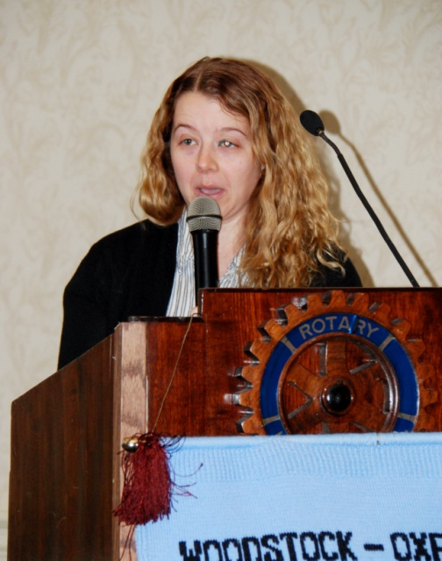
John Richardson had the honour of introducing his granddaughter, Amanda Oliver – who was our special guest speaker that morning. Amanda is an archivist at Western University and an expert on the history of Labatts Brewery in London. That company has the largest collection of corporate information and memorabilia, which takes up almost 2600 boxes at the university library.
John Kinder Labatt was born in Ireland in 1803, and emigrated to Canada around 1834 initially as a farmer. In 1847 he entered the brewing business in a joint company called Labatt and Eccles. He eventually bought out his partner and renamed the company London Brewery, supported by his three sons. In order to grow and expand their markets, Labatt began shipping beer further away using the relatively new railroads in the area. Sadly, John Kinder died in 1866, before he could see the results of the company’s expansion efforts. His son John took over and Labatt eventually became one of the largest breweries in Canada.

Beer was shipped on the London-Port Stanley railway to Lake Erie, to supply bootleggers during the US prohibition. The similar Ontario Temperance Act did not have much effect on beer sales in Canada. Many brewers were becoming quite rich due to the steady demand for their suds, and that lead to criminals attempting to kidnap John Labatt for ransom in 1934. He was kept for 3 days before being released.

During WW1, Labatt shipped 20 million gallons of beer overseas in support of our soldiers, and gained lots of new long term customers. They used wartime themes in their advertising in both of the big wars where Canadians fought. In 1941, Labatt opened an Army Trade School in London, Ont., and lots of women joined the workforce in the beer factories that were converted to produce munitions, etc.

There is a lot more interesting facts about the Labatt company that can be seen on the internet at: LABATTHERITAGE.LIB.UWO.CA

After Amanda’s great presentation, Doug Neal added some insight from his days working at Labatt. Particularly how the company created a great marketing strategy for Labatt best selling Blue and 50 products – at a time when they were not allowed to actually show those products in any advertising!

Always Leave Them Laughing

Irish Weapon Of Choice
- Into the local pub comes Paddy Murphy, looking like he’d just been run over by a train. His arm is in a sling, his nose is broken, his face is cut and bruised and he’s walking with a limp. “What happened to you?” asks, the bartender. “Jamie O’Conner and I had a fight,” says Paddy. “That little shite, O’Conner,” says the bartender, “He couldn’t do that to you, he must have had something in his hand.” “That he did,” says Paddy, “a shovel is what he had, and a terrible lickin’ he gave me with it.” “Well,” says the bartender, “you should have defended yourself - didn’t you have something in your hand?”
- “That I did,” said Paddy. “Mrs. O’Conner’s breast, and a thing of beauty it was, but useless in a fight!”

