**Dave Palmer**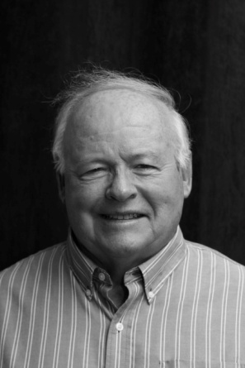

Dave is a dedicated father, grandfather of 8 grandkids and businessman but by his own admission, perhaps a travelling spouse. Dave married Cheryl in 1968 to start 45 years of business success that eventually led to his legacy, Davon Sales Inc. off Lansdowne in Woodstock. Cheryl was hired as a Woodstock elementary teacher who climbed the ranks to Principal. They are now world travelers with dozens of countries and many thousands of memories and kilometers in their picture files.