PROBUS CLUB OF WOODSTOCK-OXFORD
Box 20052, Woodstock, Ontario N4S 8X8

Web Site woodstockprobus.ca

Meets monthly – 2nd Tuesday at 9:45 A.M. Quality Hotel - Woodstock

President Dave King Vice President Jerry Klages 2nd Vice President Bill Weir Past President Phil Thorne Secretary Robert Ball Treasurer Ken Shrubsall Club Auditor Bob McTavish Probus Website Chris Hannon Audio/Visual John Richardson
Club Archives Bob McTavish Who Am I David Palmer Club Services David Tabor Speakers Peter Harrison, Ian Clark, Dave King Membership Larry Asp, Richard Orton, Bruce Hartley
Special Events Bob Axon, Rob Bryant, John Carley, Dave Hay, Bill Meek Directory Bruce Hartley, Tony Sheldon Newsletter Bob Axon, Phil Thorne, Bill Weir, Jerry Klages

Our April Club Newsletter
Issue 8 Volume 30 April 2019
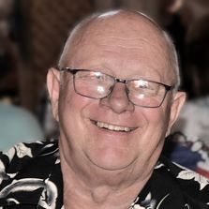
President’s Message
Well I am back from my Florida trip where we enjoyed really warm weather. I apologize for my comments in the January news letter complaining that my snow blower was rusting in my garage. It snowed almost every day after. Thanks to Jerry Klages for filling in for me and Bill Weir for the March Bulletin and Jerry Klages for the April Bulletin.
We really need someone to come foreword to be the bulletin editor. Other positions required for next year are; Who am I director, and 2nd Vice president also another volunteer for the activity committee also one more volunteer for the speaker committee .
Yesterday we had a most successful event ”National Canadian Film festival”, Thanks to Bob Axon and his crew for the event, John Carley for the video production and Phil Dunbar for just being Phil.

President Dave

May Meeting
Greeters - Bill Meek and Bob Axon

Who Am I ? - John Bell

Speaker - John de Bruyn (Ontario Pork Producers)

Science Club - 14 May 8:30 am, Two topics
Tony Paladino presents his fascinating story about one of his favourite inventions that revolutionized farming. “ Developing a better Plow” – started a new world technology here in Oxford County.
Dr. Al Driedger - the concept of 'keystone species' and how changes in the mix of plant/animal populations can unbalance delicate ecosystems. Four examples; one from my brother-in-law's work in the Philippines, two from my recent African experience and one from the forest around my house.
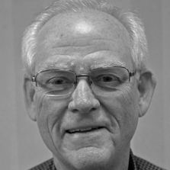
April Science Club - Dr. Al Driedger
Special thanks to Doug Neal for teaching us about “ Beautiful Beer” and the mysteries of production. Formerly Assistant Brewmaster at Labatt’s.
Beer - defined as to drink or imbibe. Originally beer was produced as a liquid to drink in place of contaminated water. Small beer was 1.5 to 2% alcohol.
To make beer three things are needed, water, barley and yeast. The water is not pure but with a good mineral mix of calcium and magnesium, well filtered. The barley is of high quality and may be roasted or otherwise treated for special flavours. Top fermenting yeast produces ale and bottom fermenting yeast produces lager.
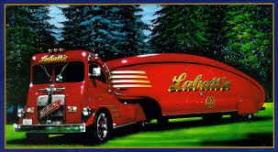
Hops originally were added to increase the longevity when transporting beer but now are used to add flavour. An adjunct of corn meal, rice or other sugar source is used as an additional source of starch. Malting is a 5 day process that causes the barley germ to grow and change the seed starch into sugars. The brewing kettle is filled with a mash of malt, adjunct and hops that cooks and produces liquid wort. The wort is filtered, cooled, yeast added and pumped into fermenting towers where the yeast converts the sugars into alcohol. Lagers ferment about 8 days at 55 degrees F. Ale is fermented at a lower temperature.

Special Events Calendar 2019

1. A tour of the Jet Museum in London is being arranged. Cost will be $7.50
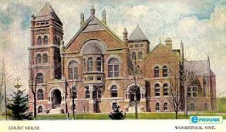
2. Our First Historical Walk. The Woodstock Men’s Probus Club is inviting you to be part of a guided walk of about 75 minutes duration to view and hear about some of our historical buildings. Probus members Murray Coulter and Dave Hay will be the guides for the tour which will illuminate the mysteries and stories of our precious Woodstock heritage sites .
Wednesday June 12 , 2019 Starting from the Museum at 10:00 am sharp. 30 men will be able to participate on this first walk. A $10 charge for each participant. Signup sheets at May 14th Probus meeting.

3. Summer Social - details to follow

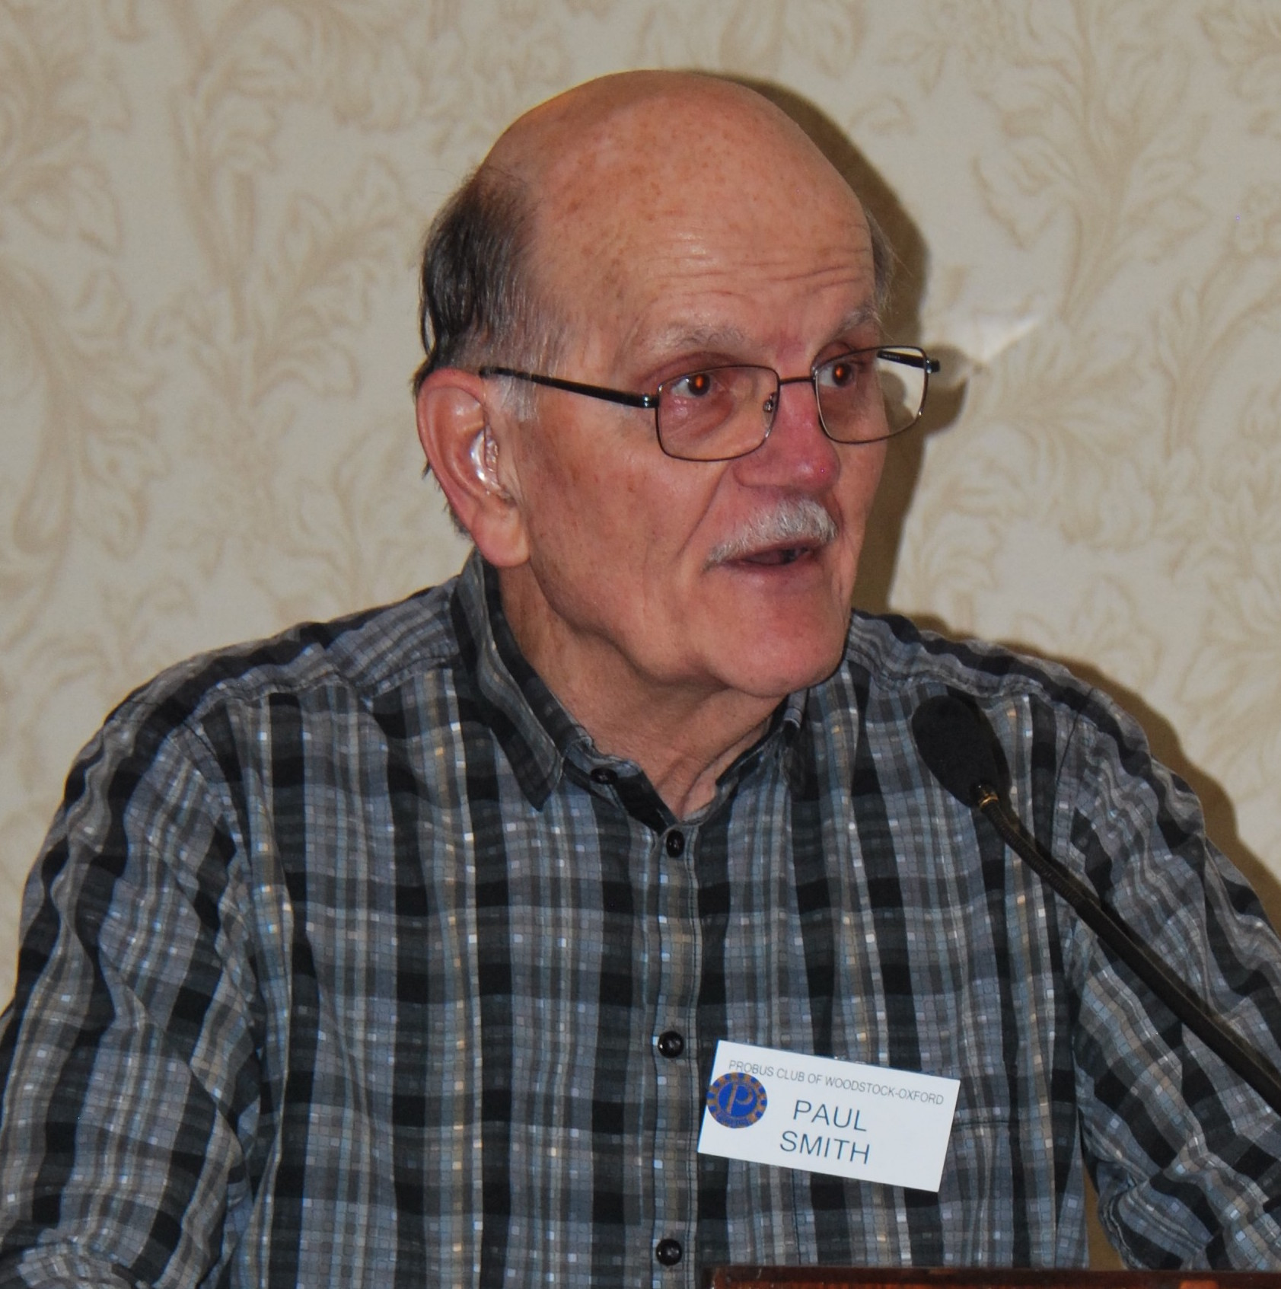
Who Am I? - Paul Smith
I was born in 1940 in historic St. Andrews, New Brunswick. My father was born and raised in Burford, Ontario. St. Andrews is an old Loyalist town dating back to the American Revolution. It was a major port and summer resort for the wealthy. St. Andrews was my playground around the estates of Sir William Van Horne, Sir William Tilley and Sir Charles Tupper in St. Andrews. During the summers I worked at the Algonquin Hotel and Golf Course.
I graduated from the University of New Brunswick majoring in Geology in 1962. I married Pat who was born and raised in Brantford Ontario in 1962. We had met while working in the Algonquin Hotel. We moved to Ottawa to teach high school and later moved to Woodstock where I taught geography at Huron Park, Norwich High School and WCI until my retirement in 1996.
We have three children, Jennifer, Martin and Alison and six grandchildren. I enjoy traveling and photography. We have a cottage in St. Andrews. I enjoy golfing and curling. We spend our winters in Mexico, summers in St. Andrews. We still tour many countries. Our neighbours say we are never at home.

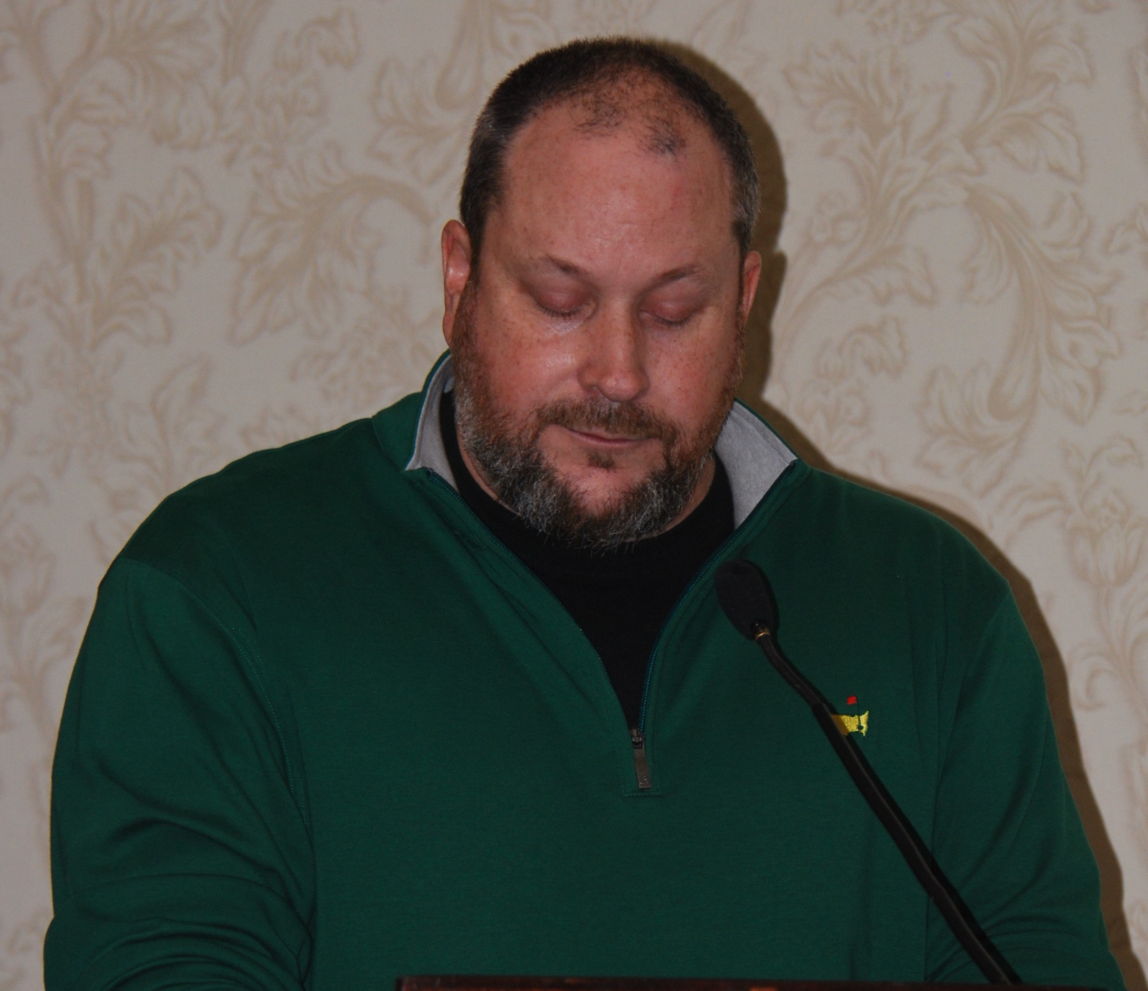
Speaker - Drew Simmons
Drew shared his experience on the golfing tour. It is a tough competition as an amateur golfing champion and as a professional PGA golfer. His best year was 2001 as a Pro. Drew played and caddied with David Hearn and Cory Conners.
Golfing is tough mentally. Some golfers are ego driven and worry about the things that cannot be controlled. Some golfers are mastery driven - how can I get better, just do my best.
In the PGA you get paid if you can make the cut, otherwise the only money to be made is from the sponsor. You still have to pay for travel and the caddy - $1000. A caddy also makes a percentage of the golfers tournament purse (up to 10%).
A typical tournament
Monday - registration and practice
Tuesday - practice and rest
Wednesday - Pro Am - support sponsors
Thursday/Friday - golfing, hope to make the cut
Saturday/Sunday - play days, pay days
The travel is stressful since a tournament ends on Sunday and the next starts on Monday throughout the season. The joy of golfing comes from playing with the upcoming great golfers and the recognition from the many tournaments.
National Canadian Film Day – 2019
On Wednesday April 17 we celebrated the 6th annual National Canadian Film Day by viewing the award winning documentary, Come From Away.
Between 60 and 70 Probus members, their spouses and friends gathered together at the Woodstock Curling Centre to view this documentary which told the story of how the people of Gander and area in Newfoundland and Labrador hosted several thousand people whose flights were diverted to Gander as a result of the terrorist attacks in the United States on September 11, 2001.
Many thanks to Bob Axon who arranged to have this outstanding film shown and to John Carley, the projectionist.

Future Speakers
June 11 Karen Chatfield (Osteoporosis Canada)

July 9 Don Downing (Jet airplane museum)

April Birthday Boys
Jack Bingham Ross Campbell Wayne Campbell Jerry Klages Glen McDonald
Gerry McKay Bill Meek Everett Mossman Ken Shrubsall Keith Thomson
Paul Ward

Management Committee Positions Nominations
The following positions are open for nominations for the next club year.
Second Vice President
Archivist
Treasurer
Who Am I ? Coordinator
Newsletter Editor

Please apply to the nominating committee for any position you are interested in. Your nominations committee is Dave King, Phil Thorne and Jerry Klages.

Always Leave Them Laughing

Kevin walked into a doctor's office and the receptionist asked him what he had. Kevin said: 'Shingles.' So she wrote down his name, address, medical insurance number and told him to have a seat.
Fifteen minutes later a nurse's aide came out and asked Kevin what he had....
Kevin said, 'Shingles.' So she wrote down his height, weight, a complete medical history and told Kevin to wait in the examining room.
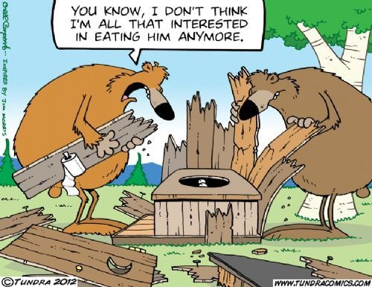
A half hour later a nurse came in and asked Kevin what he had. Kevin said, 'Shingles..' So the nurse gave Kevin a blood test, a blood pressure test, an electrocardiogram, and told Kevin to take off all his clothes and wait for the doctor.
An hour later the doctor came in and found Kevin sitting patiently in the nude and asked Kevin what he had.
Kevin said, 'Shingles.' The doctor asked, 'Where?'
Kevin said, 'Outside on the truck... Where do you want me to unload 'em?'

