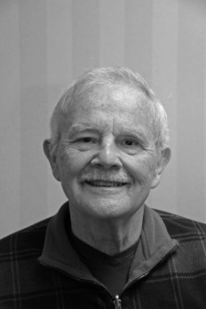**Jim Jones**

I am James or Jim Jones

But Who Am I? A good question

Fearing I am going to look like a deer caught in the head lights

I am here to try and explain to you how I got here and what I

have done with my life.

In 1924 my grandfather on hearing his two sons were immigrating to Canada decided they would all do it as a family. The entire family, somewhat reluctantly, was soon aboard a ship to Canada. Upon arrival in Canada the immigration people decided my grandfather, one time coal miner and delivery person of coal, would make a good farmer. A small unproductive farm in Princeton ON was to be the next home for this inexperienced farmer and his family. While some of the family put their education to work in securing employment two had to leave school and take up farming to contribute to the family income.

Upon returning from service during the war my father got a position as lead hand for the railroad. He met and married my mother in 1940. Three boys were born in 1941, 1945 and 1958 from their union.

Hampered by a learning disability my primary and secondary education was not memorable except for one night when the goal posts at WCI became decidedly purple and white before a big game. I suspect there is in this room people who are aware of the significance. After working at various jobs I realized I would need more education to achieve employment that would be enjoyable and rewarding.  
I enrolled in the electronic technician training offered at Fanshaw College. After completing this I found a signal apprenticeship program at Canadian National Railway and spent the next 32 years of my life working from an apprentice signal person to a supervisory position.I started with the railway signal department well before an extremely complex system that controls train movementsbegan and I have been instrumental in installing and up grading many of them.

In 1971 I was introduced to my future wife Bette and we were married in 1972. We raised two beautiful daughters.

In the mid-1980s Bette was diagnosed with Multiple Sclerosis, a huge blow to our family. At this time we became involved with the accessibility movement that was just starting to gather momentum in Canada. I joined a number of organizations that were lobbying for more accommodation of folks with different abilities and eventually Accessibility Advisory Committees were mandated for all municipalities. Bette and I were appointed to the Woodstock committee and for the next number of years Woodstock was a strong voice and leader helping to introduce new endeavors for accessibility in Woodstock and Ontario.

Today I volunteer at South Gate Seniors centre to help keep accessibility up to date and I sit on the Woodstock Hospital Patient and Family Advisor Council. It addresses any concerns of patients or family at the hospital and does a good job of trying to see problems that might arise and resolve them before they become issues.

I hope this account explains who I am and what I have done with my life to this point. Thank you all for listening.