PROBUS CLUB OF WOODSTOCK-OXFORD

Web Site woodstockprobus.ca

Meets monthly – 2nd Tuesday at 9:45 A.M. Quality Hotel - Woodstock

President Dave King Vice President Jerry Klages 2nd Vice President Bill Weir Past President Phil Thorne Secretary Robert Ball Treasurer Ken Shrubsall Club Auditor Probus Website Chris Hannon Audio/Visual John Richardson
Club Archives Who Am I David Palmer Club Services David Tabor Speakers Peter Harrison, Ian Clark Membership Larry Asp, Richard Orton
Special Events Rob Bryant, John Carley, Dave Hay, Bill Meek, Tony Sheldon

OurJuly Club Newsletter
Issue 8 Volume 32 July 2019
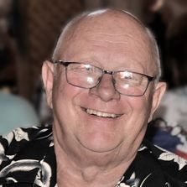
President’s Message

Well summer has finally arrived and none too soon , Longest and wettest spring on record. Thanks to Bob and the activities committee for an excellent tour of some of Woodstock’s oldest and most historical buildings. Thanks again to Bob Axon for the June newsletter and Jerry Klages for the July newsletter. We still have a couple of openings for the board for next year Editor, Treasurer, Who Am I, and Archivist. Please pass on any candidates to the nominating committee. Norma and I have just returned from a trip to historical Quebec City. We enjoyed it very much.
President Dave

July 9 Meeting

No Science Club meeting

Greeters - Bill Hardy, Robert Ball

An extra presentation!

Speaker - Don Downing - The Establishment of the Jet Airplane Museum
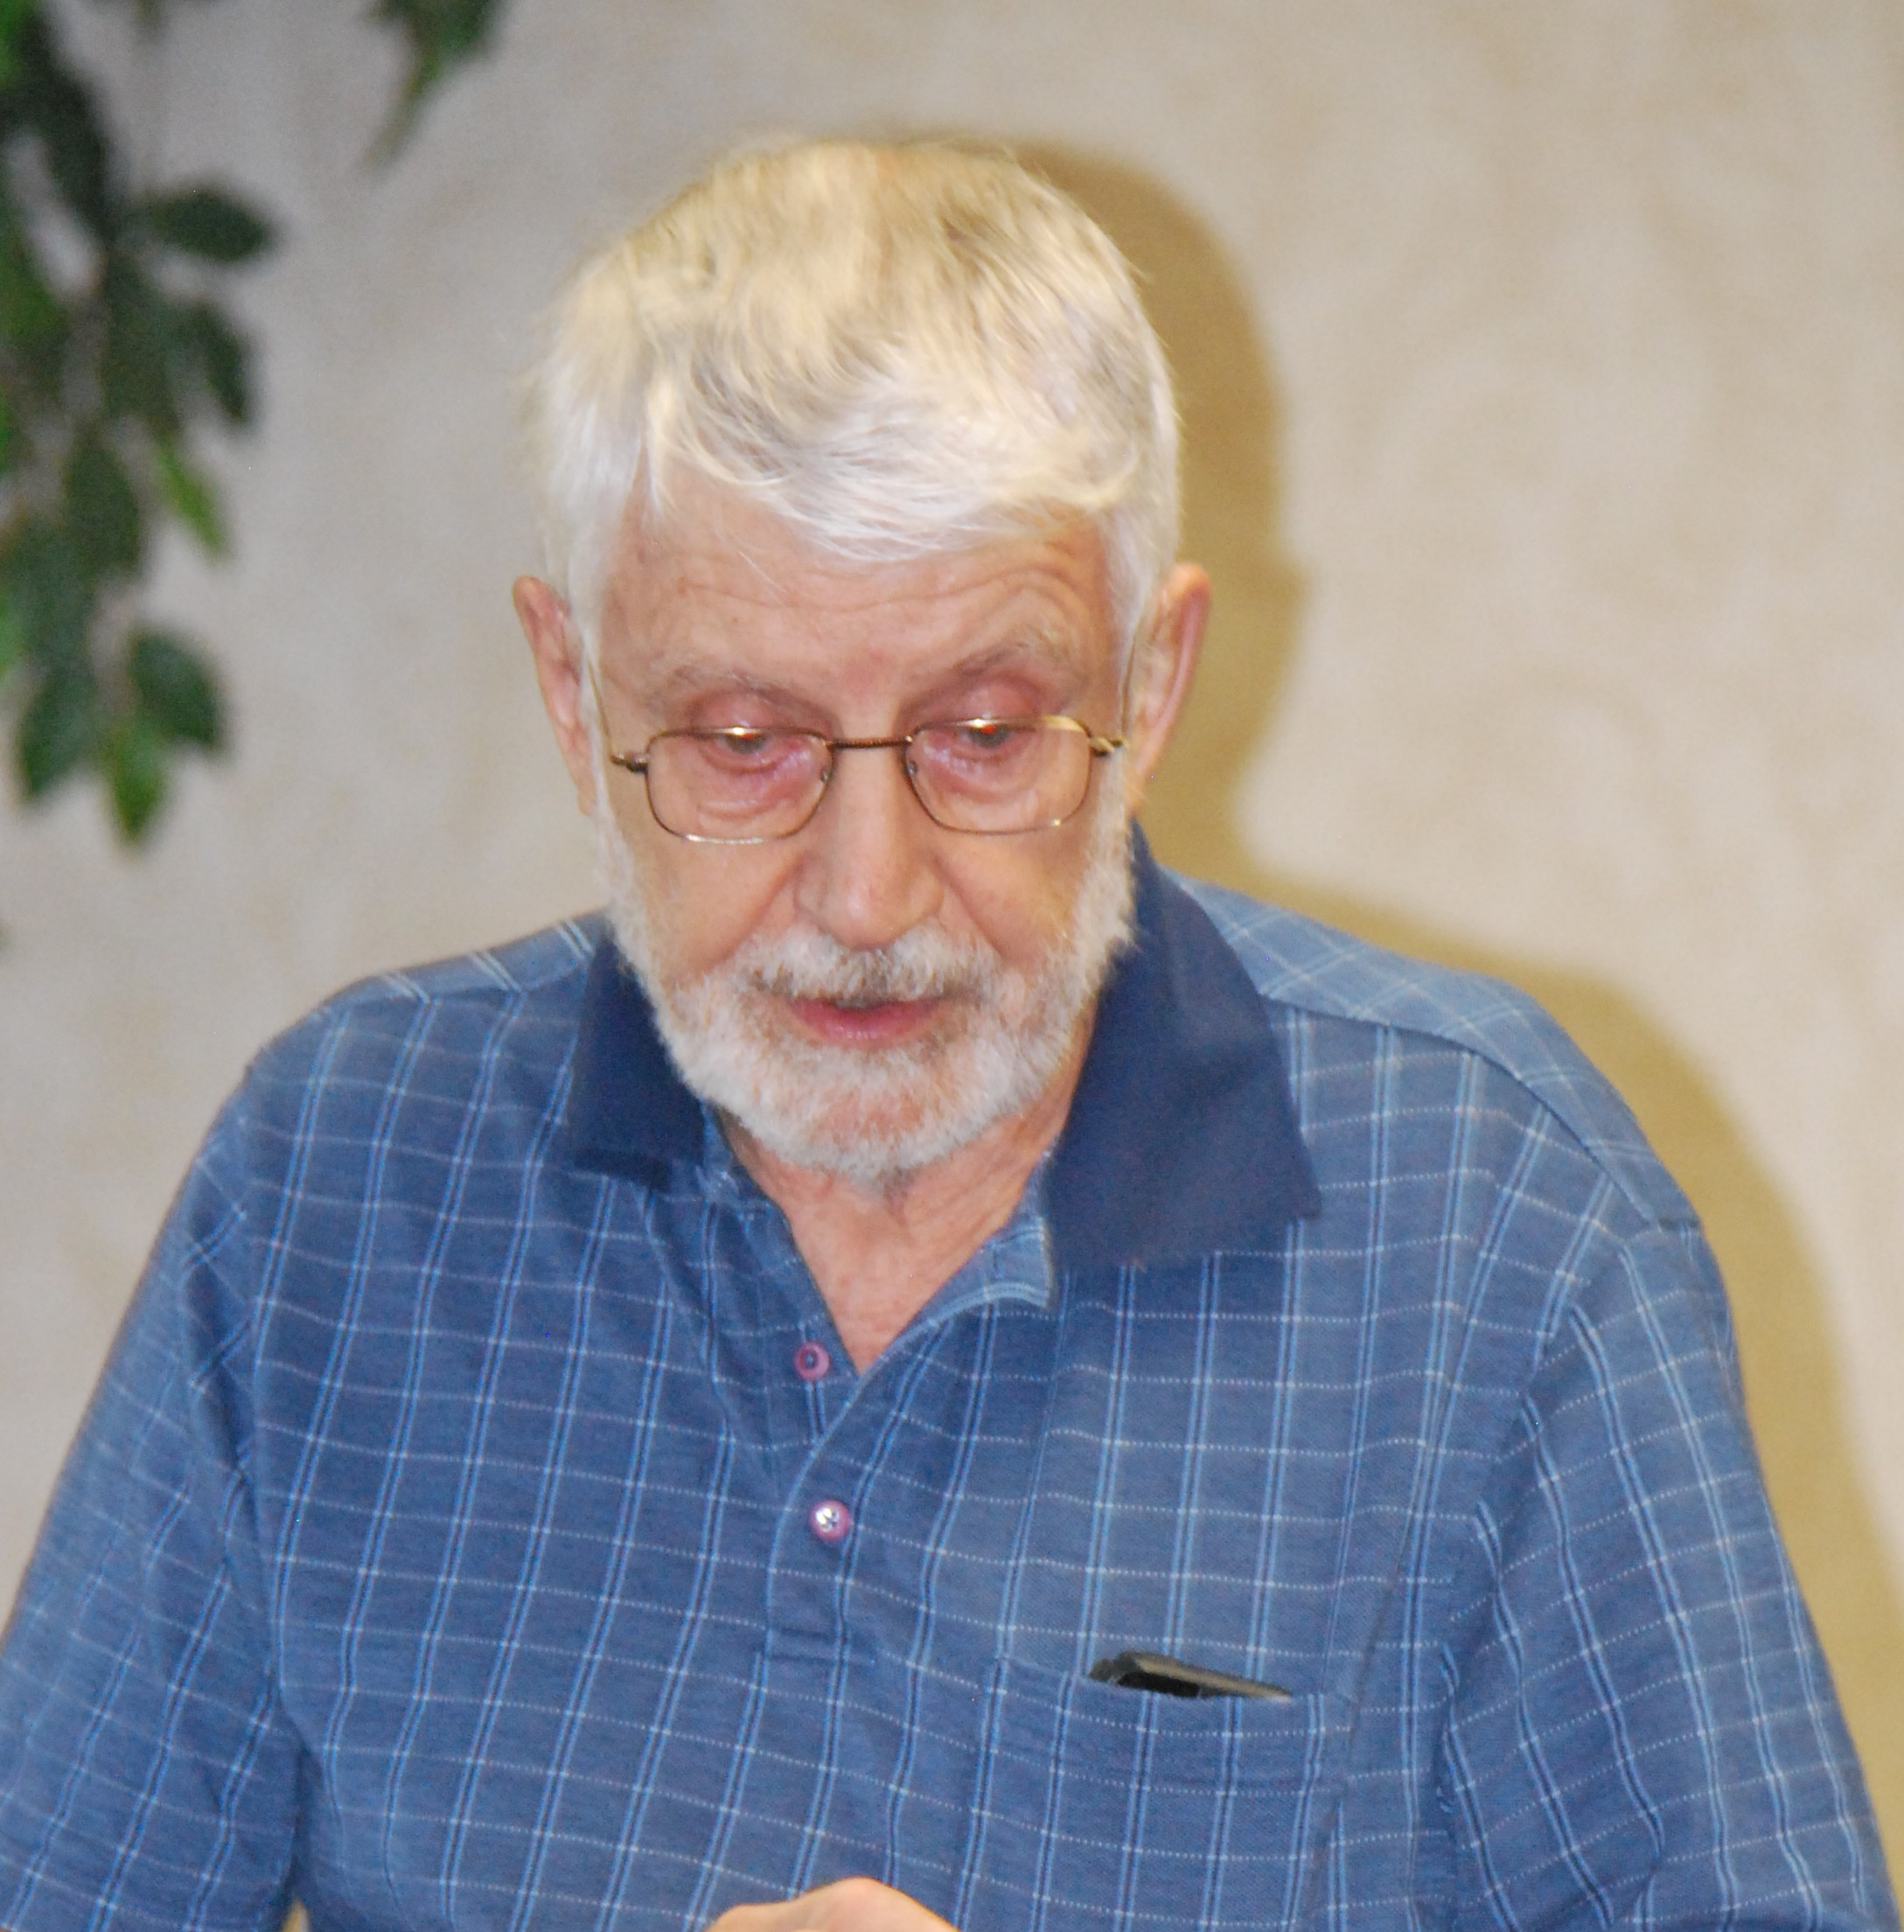
June Science Club - Dr. Al Driedger

Would you eat 'Genetically-Modified' (GM) food?
Our understanding of modern genetics is now such that gene selection and transfer techniques are quite accurate. In short, plant and animal breeding is now somewhat of a plug and play exercise. It must be emphasized that the end-products of genetic manipulation are not different from those of selective breeding, only much faster and simpler. At the same time, the continued growth of the human population and internationally shared goals for human nutrition are placing ever increasing pressure on food production. If we are to avoid food shortages and social unrest, we need to dramatically increase food supply; since, there is no more land available to bring newly into production, it is essential to increase yields.
One recent example of increased yield from a GM improvement is that of flood-proof rice. Rice farmers in the Far East often face floods from untimely rains and the commonly-grown strains will die if submerged for three days. However, geneticists first identified a wild strain of rice that resists drowning and then transferred a critical gene to domestic rice. In so-doing, they achieved a rice strain that survives submersion for 13 days, enough time for many floods to subside without crop loss. The International Rice Research Institute estimates that this alteration will produce additional rice, enough to feed an additional 37 million people each year.
Other possible modifications currently under study include attempts to increase the efficiency of plant photosynthesis and to improve on plant nutrition with less fertilizer application by promoting plants such as wheat and corn to develop relations with soil bacteria similar to the legumes.
In the sphere of domestic animals, there have been advances through GM in the production of disease-resistant strains (hogs resistant to porcine respiratory and reproductive syndrome; chickens resistant to bird flu) among others.
The same class of techniques that apply to food production are in common use to produce medications for treatment of common diseases. Human insulin is produced in modified E. coli bacteria that bear a transplanted human gene for insulin production. Many auto-immune diseases (eg, rheumatoid arthritis, scleroderma, lupus) as well as a number of cancers (esp. lymphomas, some breast cancers and others) are commonly treated with specific antibodies produced in cells that are the result of human-mouse hybridization.
In summary, the earlier opposition to GM technology was largely driven by opposition to the roll-out of Roundup-resistant crops where a single corporation that owned the intellectual property on both the new crop strains and the herbicide was in an undeclared conflict of interest. We have many things to consider in relation to GM technology in the realms of ethics, economics, health and trustworthy governmental regulation.

"For July and August there will be no Science Club. The Science club will resume in September.

July Birthday Boys
Larry Asp John Bell Peter Boleszczuk John Eacott Fred Freeman
Doug Puddicombe John Rowell Tony Sheldon George Sibbick Bob Thornton David Wright

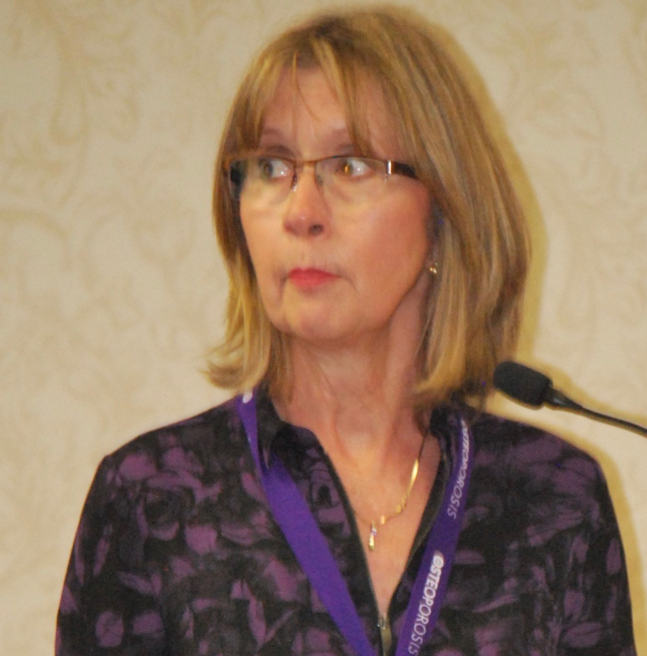
Speaker - Karen Chatfield, Osteoporosis Canada
Karen was diagnosed with osteoporosis when she was 42 years old. She was healthy and active. She had no indication of her loss of bone mass. Ten years later her Bone Mineral Density (BMD) tests have stabilized due to good eating habits, exercise and medication.
Osteoporosis is not just a woman’s disease, it is a bone disease that creates porous bones and reduces bone strength. 1 in 5 men will suffer a broken bone from osteoporosis. 37% of men who suffer a hip fracture will die within a year of the fracture. A broken bone from a minor injury or fall is often the first sign of osteoporosis. After age 50 the risk of breaking bones increases. After age 65 all men should have a BMD test regardless of their health.
Some risk factors: smoking, more than 3 alcoholic drinks per day, taking steroids, high risk medications, low body weight, weight loss, family history and having rheumatoid arthritis.
To maintain strong bones requires good nutrition. Eating a balanced diet, taking a vitamin D supplement, getting calcium from food sources particularly dairy items, limiting alcohol and stop smoking. Also required is exercise to keep bones and muscles strong - Includes strength training, balance exercises, posture awareness, spine sparing activities and aerobic physical activity. Be ‘Too fit to fall or fracture’.
All men with osteoporosis and found to be at a high risk of fracture require medication.
For more information contact Osteoporosis Canada at www.osteoporosis.ca.

The Woodstock Men’s Probus Club First Historical Walk
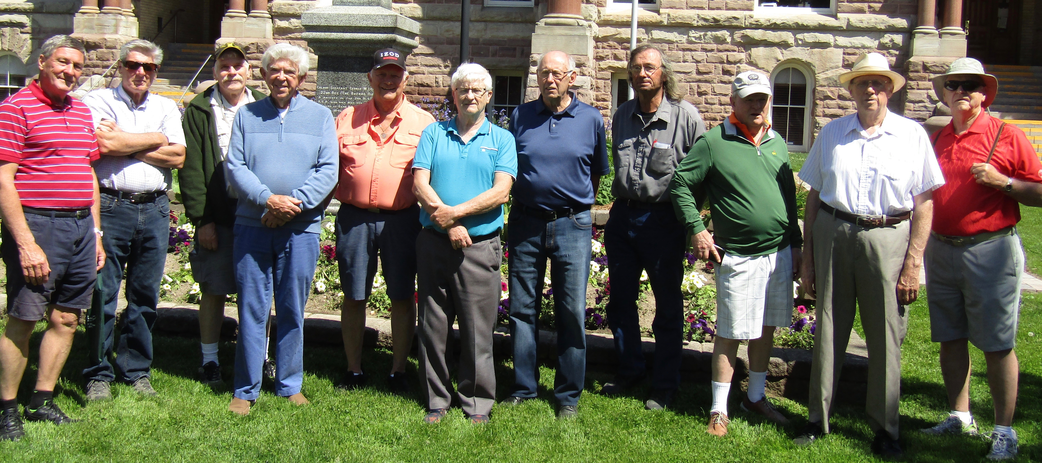
One of the two groups - recognize any one?

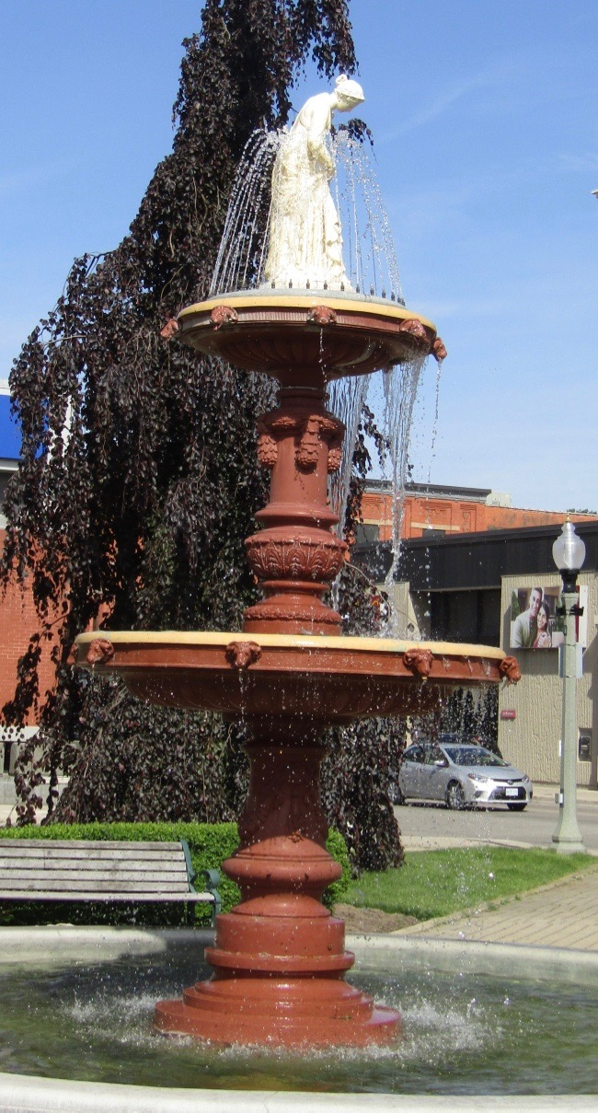
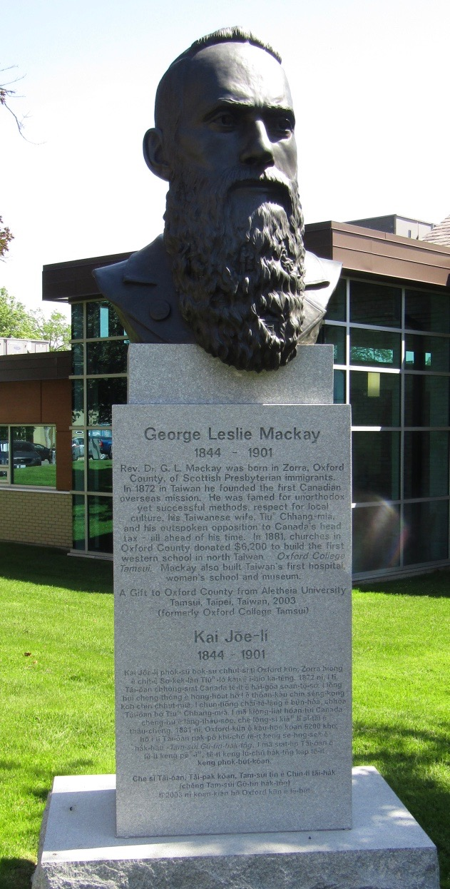
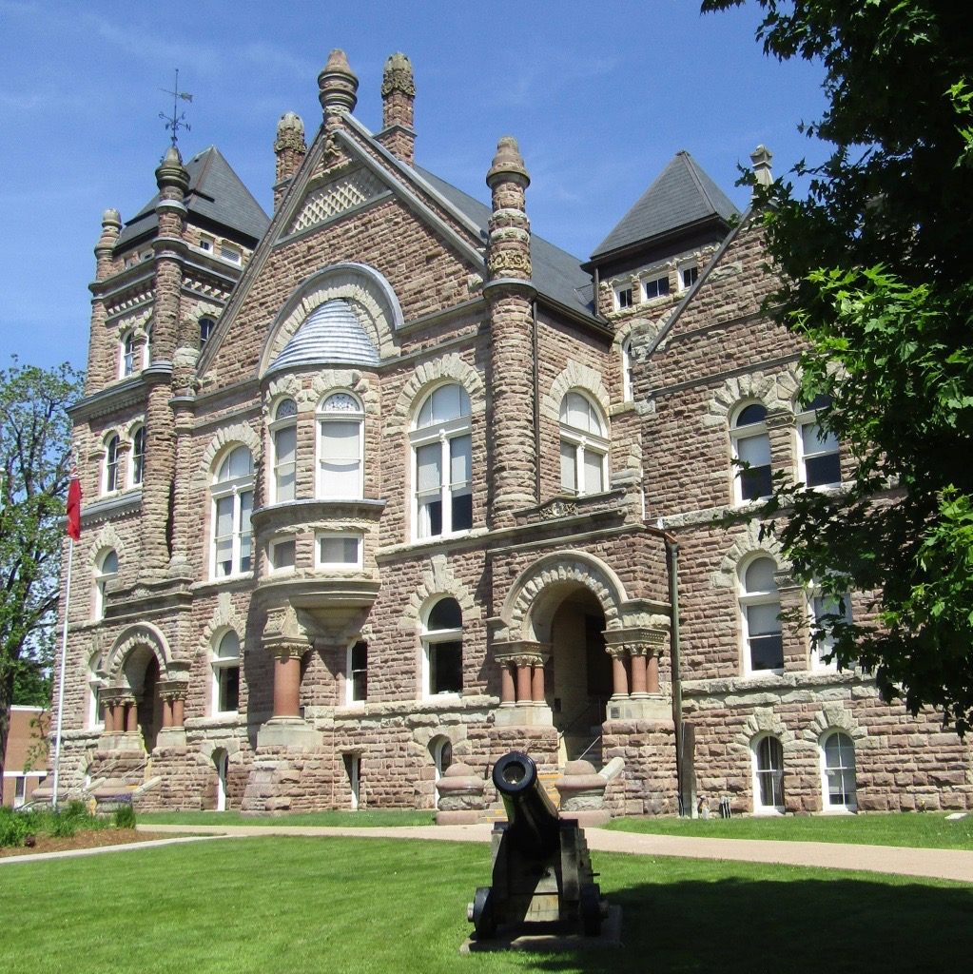
The Woodstock Men’s Probus Club First Historical Walk was held on Wednesday June 12, 2019 - to view and hear about some of our historical buildings. Probus members Murray Coulter, Bob Axon, Peter Harrison and Dave Hay were the guides for the tour which illuminated the mysteries and stories of our precious Woodstock heritage sites. The tour started at the Woodstock museum and ended at the old Harvey Woods sock factory with snacks. The tour fees were used to make donations to the Woodstock Museum and the “Not-for - Profit:” Indwell, owners of The Harvey Woods units!
Special Events Calendar 2019
1. The Jet Aircraft Museum Probus Club outing takes place on Tuesday, July 16 at a cost of $7.50 per participant. We will carpool from the Cowan Park parking lot on Ridgewood Drive at 9:30 a.m. We will leave at 9:45 a.m. targeting a 10:15 a.m. arrival at the Museum, 2465 Aviation Lane Unit #2 London.
After the tour, lunch will take place at Trissa's Restaurant on Hwy #2 just east of the airport followed by coffee at Timmies in Thamesford.
The "Red Knight" is their signature jet and has been restored and still flies. This should be a magnificent day!
The Jet Aircraft Museum tour on Tuesday July 16 is now "waiting list" only. Check with Tony Sheldon at tony.sheldon809@gmail.com

2. Summer Social - We are expecting about 80 people to attend our Summer Social at the Bill Meek Estate on August 21 starting at 4:00 pm for Social and Supper at 6:15 pm, Bring a chair. The raindate has been set this year for Thursday August 22.
Cost is $30, sign up at the Probus Meeting. Some additional tickets will be available at the social. Payment either when you sign up or at the social.
Menu includes - Coffee and Tea, main course. glasses and silverware and pie.
Suggested Menu
Oven baked chicken with mushroom gravy on the side
Roasted pork slices with roasted mini potatoes
Garden salad and dressings
Summer Cole Slaw
Pasta/vegetarian salad dressed
Pie and coffee
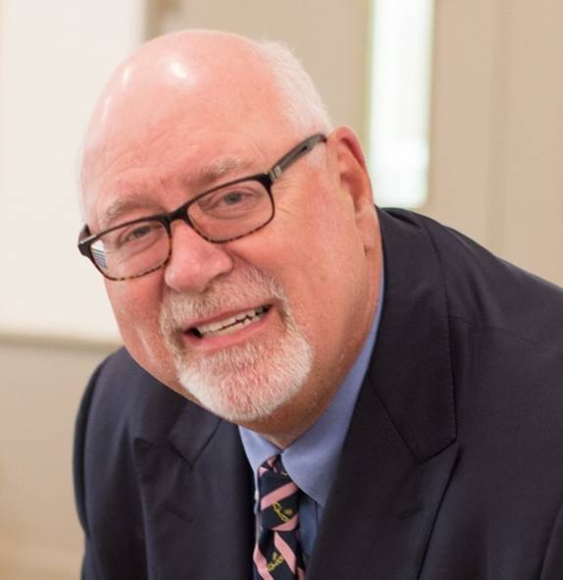
Who Am I ? - Richard Fanning
Born and raised in Peterborough, Ontario, I lived there with extra curricular activities in Scouting and the Armed Forces Reserves and then began a work career in banking. I then moved on to Toronto, continuing roles in commercial banking Account Management.
After twenty years, I moved to Edmonton as a District Manager. While there, I took on a new role as Director for Rogers Communications of their retail cell phone stores.
Rogers brought me back to SW Ontario and after some time there, moved to some exciting times with a private debt collection agency. In a final career change, I joined Oxford Small Business Support Centre, working with new and growing businesses in Oxford County.
This last position took me through to retirement where I've been involved in local community activities and enjoying more time with my wife, Kimberly.
We have two daughters, both named Ashley, one in Stratford and the other in Edmonton and three grandchildren.

Article - 5 June 2019 - Sentinel Review (Woodstock)
Two Woodstocks poised to become sister cities
KATHLEEN SAYLORS
Ever wondered about our namesake city in Woodstock, England? The city of Woodstock is considering adding the English township as a “sister city” this week, as well as a Japanese city.
A memo by Woodstock Mayor Trevor Birtch on Thursday’s council agenda urges the city to consider adding two new sister cities, one of them Woodstock, England – a town of 3,100 about two hours northwest of London in Oxfordshire County.
Birtch is also asking council to consider the addition of a sister city in Japan, though a specific city has not yet been identified. Woodstock already has two sister cities: Pesche, Italy, established in 2002, and Sylvania, Ohio, established in 1992. Woodstock has been active in the sister cities arrangement with Sylvania. “Exchanges take place in the form of goodwill and involvement in community events such as parades, festivals, exchanges between service clubs and more,” the memo notes.
The possibility of entering a sister cities agreement with Woodstock, England, was identified after a collaboration of two service clubs, the men’s Probus clubs (Rotary clubs for retired members) of each Woodstock.
Birtch said he took part in a discussion in December with both clubs and the mayor of Woodstock, England, regarding a heritage twinning.
“In discussions regarding a possible heritage twinning of the two Woodstocks, our director of culture was quickly able to identify many similarities. This possible twinning was discussed with the sister city committee and all agreed it would be a great relationship to explore based on heritage,” Birtch wrote.
And in Japan, a Southern Ontario Marketing Alliance (SOMA) delegation travelling to the area this fall will be authorized to explore the partnership, if council approves.
“During discussion with chamber of commerce members in Japan, it was noted that many communities in Canada have sister city relationships with Japanese cities. Woodstock has a very diverse economic tie to Japan with multiple companies including some of the largest manufacturing investments in Ontario, and has yet to formally seek a sister city status in Japan,” Birtch notes in the memo to council. Woodstock sister city relationships are managed by a committee.
A sister city in Japan would be for “economic development” purposes, Birtch said, and noted the city’s economic development officer is in agreement that a sister city twinning is “long overdue.” A sister city in Japan would be chosen to align with Woodstock’s industrial background, and selected with the help of the Canadian embassy, consul general and Canadian Chamber of Commerce, to be located in Japan’s “industrial heartland.”
Council is expected to make a decision on whether to explore entering these agreements on Thursday.
Future Speakers
August 13 - Tim Burrows - “our transition to electric and self driving cars”

Management Committee Positions Nominations

The following positions are open for nominations for the next club year.
Second Vice President
Archivist
Treasurer
Who Am I ? Coordinator
Newsletter Editor

Please advise the nominating committee the position you are interested in. Your nominations committee is Dave King, Phil Thorne, Bill Weir and Jerry Klages.

Always Leave Them Laughing

Two guys are walking through the woods one day when they stumble across a big deep hole.
The first guy peers into it and says, "Wow! That looks deep."
The second guy says, "It sure does. Let's throw a few pebbles in there and see how deep it is.
So they pick up a few pebbles and throw them in and wait. Nothing. There's no noise.
The first guy says, "Jeeez. That is really deep. I know, let's throw one of these big rocks down there. Those should make a noise."
So they pick up a couple football-sized rocks and toss them into the hole and wait... and wait... Again, nothing.
They look at each other in amazement. Then the first guy gets a determined look on his face and says, "Hey, over here in the weeds, there's a railroad tie. Help me carry it over. When we toss that sucker in, it's gotta make some noise."
So the two of them drag the heavy tie over to the hole and heave it in. Once again, not a sound comes from the hole.
Suddenly, out of the nearby woods, a goat appears, running like the wind. It rushes toward the two men, then right past them, running as fast as it's legs will carry it. Suddenly it leaps in the air and into the hole.
The two men are astonished with what they've just seen and look at each other in amazement.
Then, out of the woods comes a farmer who spots the men and ambles over. He asks them, "Hey, you two guys seen my goat out here?"
The first guy says, "You bet we did! Craziest thing I ever saw. It came running like crazy and just jumped into this hole and disappeared!"
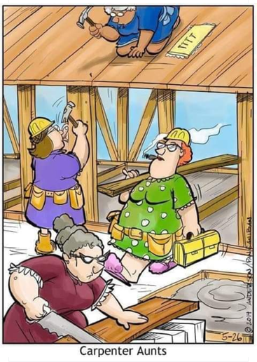
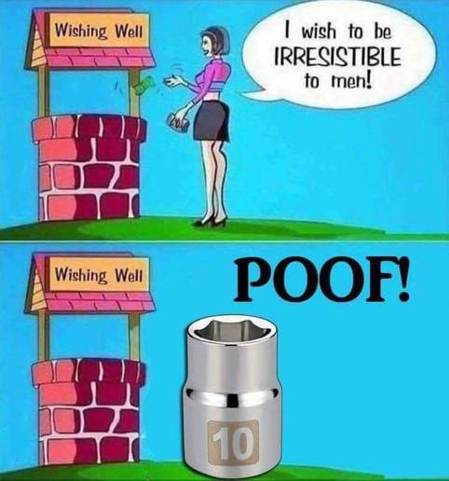
"Nah", says the farmer, "That couldn't have been my goat. My goat was chained to a railroad tie."

