**Ken Ovington**

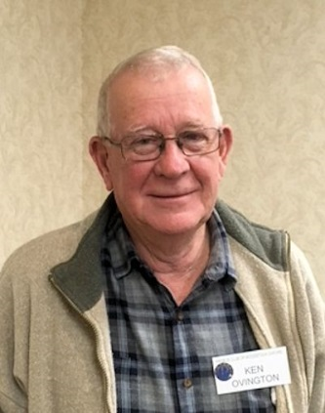I was born on November 29, 1944 at Cathcart, ON. My

father grew tobacco (a share grower) in Burford, where I

attended Burford Public School until Grade 4. We moved

to the Woodstock area around 1954 where we started a dairy

farm and I went to Bonds Corners Public School. I got interested

in sports (baseball and track and field). Added football when I

went to HPSS where I was on the 1960 football championship

team that beat Tillsonburg (that team later got into the

Woodstock Sports Wall of Fame and started HPSS's football dynasty). In 1961 we moved to Brant/Oxford county line where we expanded the dairy herd. All through high school, I played hockey and baseball at Eastwood, Ingersoll, Norwich and Oxford Centre. I worked in tobacco in the summer and started at The University of Guelph in the fall of 1964 where I worked at the university in the summer and joined cross country and wrestling teams I graduated from Guelph and taught at HPSS for 2 years (taught environmental science and coached x-country and track). I taught Animal Science at Fanshawe College for 3 years (coached hockey team). I started farming in 1973 (cash crop and swine) - quit in 1973 due to health problems. I went on to work at Ontario Livestock Electronic Selling of feeder pigs which started the decline of auction barns and drovers. I went on to work at Hay Bay Genetics and Daco Feeds as a consultant from Ontario to New Brunswick finishing my career at Maple Leaf Agresearch as the swine division manager. I retired in 2008.

I spent 25 years managing and coaching hockey and ball in Burford, Oxford Centre and Norwich including 1978, where I co-coached an all Ontario Championship Atom team (a first for Burford) 40 years later this team was inducted into the Brant County Sports Hall of Fame. I curled with the Norwich Curling Club for 20 years. Also belonged to Woodstock Coin club where my wife and I designed commemorative medals for Beachville's first Baseball Game and the Zorra Tug of War champions. I belonged to Poultry Association, Ornamental Pheasant Game bird Association, Burford Minor Hockey Assn, Norwich Curling Club executive, 1970's Woodstock Senior Club Executive, South Oxford Minor Ball, Norwich Industrial Hockey League and was Past President of 68 OAC.

My hobbies are hunting, fishing, woodworking, restoring cream separators, travelling (Canada coast to coast, the Yukon, cruising eastern seaboard, Hawaii, and the Baltic, Bluejays Spring Training Camp, Spain and Portugal) I also enjoy reading (nonfiction-World War books and History, Sports). I am now researching the Family Tree.

Family

I met Eleanor in High School. We have three children, Jim, Ken Jr., and Laura, and seven grandchildren.