Graham Brown
Graham was born on Feb 28th, 1945, in Ellesmere Port, a large industrial town located not too far from Chester in the UK. Graham’s father was a corporal serving with the RCAF as a radar technician. Graham’s mother, a native of Ellesmere Port, met his father while they were both stationed at a radar station on the Isle of Wight.  After the war, the Browns settled in Canada where Graham’s father studied physics at U of T. Graham’s family, now | 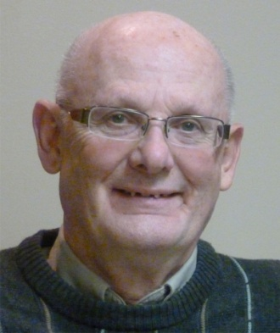
including his younger sister, only stayed in Canada for a few years: returning to England in 1949. Graham’s father was employed by the UK Atomic Energy Authority. In 1957 the family, now including Graham’s younger brother moved to the north of Scotland, where Graham’s father helped build the Dounreay Nuclear Power Establishment. The family settled in nearby Thurso, a small community whose population more than tripled as a result of the influx of newcomers. The atomic workers were not always welcomed by the local inhabitants.
After graduating from Thurso High School in 1964, Graham went to the University of Aberdeen where he studied history. During his last year, Graham became interested in the fate of the farmers evicted from their land during the highland clearances in Scotland, at the end of the 18th century. A number of these tenant farmers had immigrated to Canada and settled in Zorra Township. After finishing his under-graduate degree, Graham decided to follow up on this interest, and so that he could be close to the source material in Canada, decided to pursue graduate studies at Western
After completing his Masters, Graham decided to teach high school, qualifying in 1971. Montcalm Secondary in London was his first school and over the next 30 odd years he worked for the London Board in a variety of positions, retiring as principal in the year 2000. Not quite ready to fully retire, Graham took a position with the Faculty of Education at Western until 2007 when he put down his chalk for good.
In 1969, Graham met his wife, Maureen, and they were married in August 1971. They had two sons, Simon, born in 1973 and Ian, born in 1975. Graham has many happy memories of his young family. In addition to numerous camping trips through-out North America, the whole family occasionally went back to Scotland to visit his relatives. Both his sons are now married and Simon has two daughters, Stella and Sarah.
Tragically, Graham lost Maureen very suddenly and unexpectedly, due to a brain aneurism in April of 2006, just two weeks before her 57th birthday. Adjusting to this loss was not easy, but with the help and support of family and friends, Graham was able to come out of this very dark period of his life.
In 2009, Graham met Luba, a retired schoolteacher from Simcoe. In 2010, they were married. The new couple settled in Woodstock as it represented a good compromise between Graham’s interests and friends in London and Luba’s family and friends in Brantford, Watford, and Simcoe. They both love to travel, having already visited the UK, New Zealand and Alaska, together. They also visited Ukraine as Luba still has family there. This spring they are planning to return, to celebrate Ukrainian Easter at the end of a European river cruise.
Graham is staying active by continuing his volunteer work in London. He also curls and plays golf. He is now looking forward to a happy life together with Luba, traveling, enjoying their families and friends, new and old. As Graham expressed it,
“That's ‘Who I Am’, though I do find that these days, the question I more often ask is ‘what the heck am I doing here’ when I walk into the room for something”.

