Murray Coulter
Murray Coulter presented an interesting 'Who am I' at our February meeting. We learned that he was born in Palmerston on Oct 1st, 1946 where his father worked as an electrician and his mother was a registered nurse. He maintains a connection with his hometown as his sister Isobel has remained a lifelong resident.  His early days were typical for the time and place except for one thing. Being born in October he was already among the | 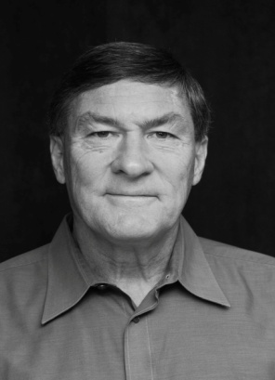
youngest when starting grade 1. When he started grade 3, the grade 3 and 4s were taught in the same classroom. Young Murray's progress during that year was so rapid he was promoted directly to grade 5. He ended up being almost two years younger than most of his classmates. Conventional wisdom suggests that finishing school sooner is always 'a good thing'. Murray argues that there are some unforeseen social consequences. You end up being out of step with your peers. In grade 10, when his 16 year-old classmates had their driving licenses, Murray was still pedaling his bike. He graduated from University at the age of twenty and before his 21st birthday, he was teaching a grade 12 glass at a high school in Brighton. Murray mused that being removed from his peers is not necessarily the best thing for growing up.
After teaching for just a few years Murray decided to study Law. He graduated from Western with his LL.B in 1972. In April of 1974 he joined what was to become the firm of Nesbitt Coulter LLP where he continued until his retirement 34 years later.
Murray Coulter's interests include history, travel, amateur theatrics, automobiles, motorcycle touring, federal and provincial politics (Liberal candidate for Oxford in 2004), and he collects stuff – the first forty copies of the Scrooge McDuck comic series, for example.
He participated in high school athletics and was a member of the neighbouring town of Harriston's midget softball team that went on to win the 1963 Ontario championship. Later on, he coached his daughter's little league softball team for several years. He has also been a life time fan of the Chicago Cubs. He continues to enjoy bicycling and during the winter curls several times a week.
His community pursuits have included freemasonry, the Oxford Law Association (President) and St. David's United Church. He has served on the Woodstock Hospital Foundation and was involved in the planning and development of the Woodstock District Community Complex.
Saying that Murray’s interests include travel is an understatement. Murray and his wife have visited 137 countries and he is the only person I know who has visited Timbuktu. In his closing remarks he reminded us that there is more to travel than just moving about. For Murray, to stand at the tomb of Cyrus the Great, to stand where Alexander the Great had stood, was to stand in the shadow of giants.
At an earlier meeting, Murray and Bronwyn, his daughter, presented an illustrated talk on the experience they shared together, walking the Camino de Santiago. The Way of St James as it is known in English, is the 900 year old pilgrim’s path that stretches from the French border in the Pyrenees to the city of Santiago de Compostela, near the Atlantic coast in north-west Spain. The entire trek covers about 700 km. Walking at 20 km a day, it takes about 35 days to cover the distance and traditionally you carry all of your gear on your back, staying in often primitive hostels. However, completing a more modest one hundred kilometres qualifies as an official pilgrimage. Murray, conceding that his hosteling Days are over, opted for a more civilized approach. He engaged Marly Tours, a Camino specialist based in Madrid. They provided transportation to the starting point, and while walking the trail Marly guides were on hand to provide assistance. At the end of each day's walk a van would pick them up and take them to their accommodation superior meals and accommodation at the end of each day.

Bronwyn and Murray did a wonderful job of re-creating their time in Spain. It sounds like walking the Camino was a wonderful experience and I would certainly enjoy trying it someday. But, even better, spending an entire week of quality time with your grown-up daughter, what a great holiday! Priceless!.

