THE WOODSTOCK – OXFORD
WOMEN’S PROBUS CLUB
www.woodstockprobus.ca

January 2019
Presidents’ Message
Well we made it to 2020! I never thought I would see the day but here it is! Did you make some resolutions? I am always making goals for myself so January isn’t any different than any other month for me but I do like to start the year off with the decorations down and clean sheets on the bed! Funny how exciting it is to get those Christmas decorations up but just as exciting to get them back down! Happy New Year and may you and yours have a blessed year ahead!

Events Committee
Stay for lunch after the meeting in February. The cost is $12 and can be paid by cheque or cash (exact change only, please). The meal will be catered by South Gate and will feature a choice of winter soups, sandwiches and wraps, dessert, tea and coffee. There are vegetarian options.

Christmas Lunch
What fun we had showing off our special sweaters, listening to John Carley’s music and singing along with him and Karen, trying to come up with some correct answers for the Christmas trivia and of course enjoying the splendid meal.

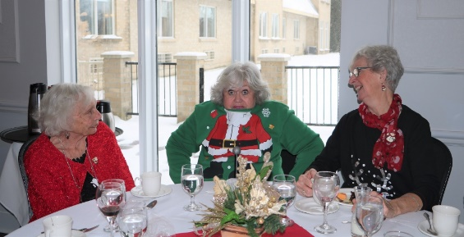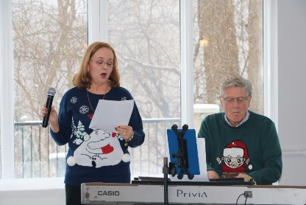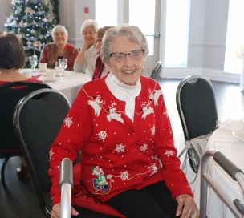

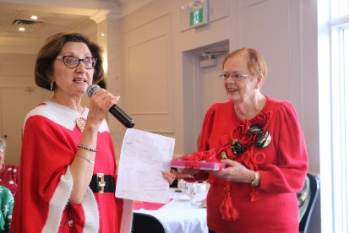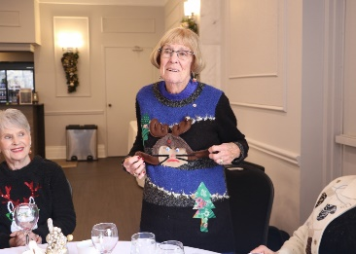

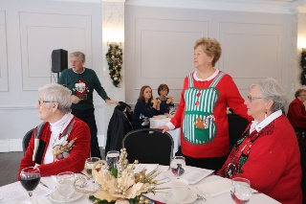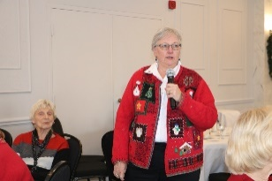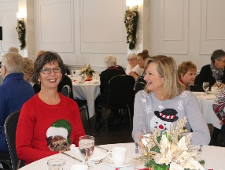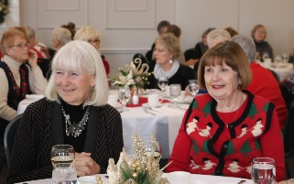
Coming up:
Greeters for January: Karen Seguin and Diana Gorbould
Getting to Know You for January: Mary Donlevy
Speaker for January: Kerry Kijewski on her life as a blind person
General Meeting: Wednesday, January 15, 10 AM, South Gate Centre – reminder: we return to our regular format of starting the meeting at 10 and breaking for coffee before the speaker.

Upcoming Getting to Know You
February Jane Fletcher
March Gisela Charette
April Sharron Poole
May Earla Cockburn

Management Team

President
Judy Hollinger
Vice-president
Jane Fletcher
Past Presidents
Mary Donlevy
Jill Lavin
Secretary
Jan Perrin

Treasurer
Mary Sellars
Program
Marg Overveld
Elizabeth Brekelmans
Lenore Kuenzie
Newsletter
Sandy Smith

Membership
Deb Moss
Lou Campbell
Jan Torrens
Maureen Brankley
Special Events
Norma King
Jan Perrin
Christine Uchacz

Web Design & Editor
Christine Hannon
Getting To Know You
Donna Wallace
Sharon Bale
Nancy Gillespie

Photos
Ann Gunn-Munro
Ruby Reid
50/50 Draw
*Mary Donlevy
*Jill Lavin
Directory
Janet Snider

*temporary – are you interested???

