Gary Stephens

Gary was born in 1950 in Petrolia. Along with his brother and two sisters, he was raised on a farm near Brigden. In spite of working hard at the chores that are expected of children on a farm, he recalls that the kids still had lots of time for fun - messing about in the creek and exploring the local bush lots. It was a good place to grow up in. | 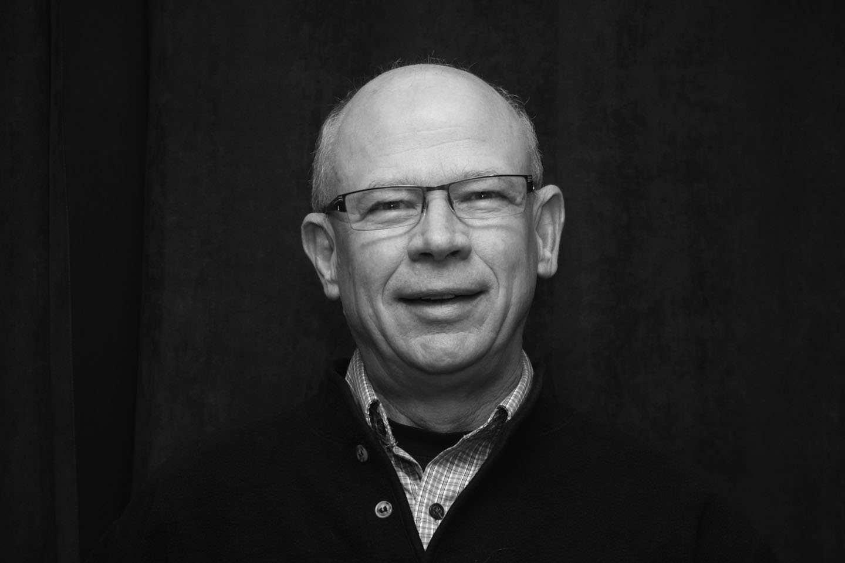

Gary’s first school had only one-room. It must have been quite an experience to share that one room with seven other grades. Next he attended high school in Petrolia. After high school Gary was accepted by University of Guelph where he earned a degree in Agriculture, Economics and Business.

After graduation, Gary was hired by the Ontario Ministry of Agriculture and Food (OMAF) to work as an Assistant Agricultural Representative in Haldimand County. He was involved with 4-H Youth, farm business management, and Crop and Livestock development. Six years later he moved to Woodstock where his responsibilities included providing programs in a variety of farm activities. One topic that had never occurred to me was the importance of Succession Planning as part of a successful farm strategy. After the year 2000 Gary’s responsibilities were enlarged to include non-farm rural businesses as well as assisting rural municipalities. In 2009, after 35 years service, Gary retired from OMAFRA (OMAF’s successor). In Gary’s words, “Why not give someone else a chance!”
In 1975, Gary married Janet Scott, a local girl from Brigden. Janet has enjoyed a long career in the child-care field and continues to work for County of Oxford, specializing in childhood literacy.

Gary and Janet have two children: Sarah, a U of Waterloo graduate, who works with TELUS Mobility in Toronto and Mark, who is a graduate electrical engineer from UBC and lives in Vancouver. Mark is employed in the design of the next generation of electric bicycles. Sarah is “expecting” and Gary and Janet are anticipating holding their first grandchild in April.

Although it is early days yet, Gary has thrown himself into a variety of retirement activities including home renovations, cottage and camping life near Halliburton, and winter vacations in Arizona. Back in Brigden, Gary maintains a woodlot/farm with his brother, Bruce.

Gary is the secretary the Optimist Club of East Oxford – Oxford Centre and has been a Member for 30 years. He is looking forward to learning opportunities and good fellowship that Probus will provide. Gary’s retirement motto is “Work Less & More Fun”. It is clearly more honoured in the breach rather than the observance.

