Dan Byers

Our newest member, Dan Byers was introduced to the club by Fred Freeman, our membership secretary. He was born in 1941 on a farm near Fergus Ontario. Dan was the first of the Byer clan to be born in a hospital. He attended public and high school in Guelph and later obtained his B.S.A from the University of Guelph. After completing his undergraduate degree, Dan | 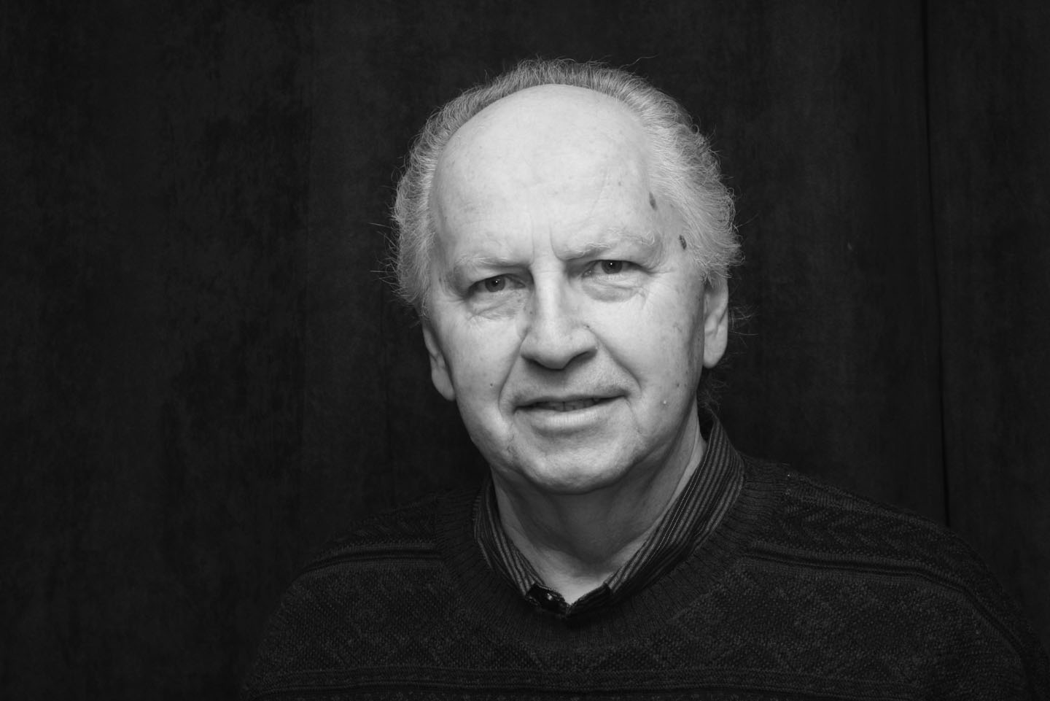
attended Althouse Teachers College in London. Dan started his teaching career at Huron Park Secondary School in Woodstock. Thirty years later he retired from teaching at Huron Park, having taught a wide range of subjects including science, physics and biology. Dan is interested in photography, woodworking and travelling. Dan has been married to Leila for 42 years. They have two children one of which is a minister. A welcoming round of applause greeted Dan as he received his membership package and his official Probus nametag. Then it was time for coffee!

Dan Byers

Our newest member, Dan Byers was introduced to the club by Fred Freeman, our membership secretary. He was born in 1941 on a farm near Fergus Ontario. Dan was the first of the Byer clan to be born in a hospital. He attended public and high school in Guelph and later obtained his B.S.A from the University of Guelph. After completing his undergraduate degree, Dan
attended Althouse Teachers College in London. Dan started his teaching career at Huron Park Secondary School in Woodstock. Thirty years later he retired from teaching at Huron Park, having taught a wide range of subjects including science, physics and biology. Dan is interested in photography, woodworking and travelling. Dan has been married to Leila for 42 years. They have two children one of which is a minister. A welcoming round of applause greeted Dan as he received his membership package and his official Probus nametag. Then it was time for coffee!

