Jerry Klages
Gerald (Jerry) was born in April 1947. Due to a late snowstorm he did not get home for nearly a month. He and his eleven siblings, of which he is the oldest,  lived on a farm that produced mixed livestock, hay and mixed grain. Jerry drove the tractor from age 7 and earned the name “Road Runner”. Most of his siblings still live and some farm in the area. After attending a one room schoolhouse Jerry went | 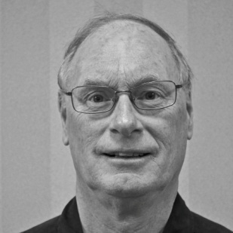
to high schools in Walkerton and Chesley. There his interest in planes, cars and engines earned him the name “scientist”. He would go on to Ryerson Polytechnic and graduate as a Mechanical Engineer, with honours. With farming not in his future Jerry took a position in electrical design at Electrohome, in Kitchener. His work and designs led to an 8 track that used plastic molding. It was with great pride when he saw his design featured in a window display in an Electrohome dealer.
Jerry’s interest in the automotive took him to Standard Tube in 1972. He moved to Woodstock where he would design overhead crane cabs that are still in use today. He also designed a long tube ID seam grinder and scarfing unit. Later working mostly on automotive applications he developed a process of making variable wall tubes. These are now used in axle tube for Dodge and GM pickups. The company received a patent and awards for this process. Jerry’s next venture was into hydroforming where he got to design the first bent and hydro formed tube. Jerry did some of the part design and developed all of the welded joints. This process was called pressure sequence hydroforming. Hydroforming now being used in production by GM, Ford and Chrysler was retained by Vari-Form when Standard Tube Company was sold off. Jerry’s designs are now used in Canada, USA and Europe. His last project was called hydroplast which was used in Ford Australia. Jerry retired in 2008 having acquired 12 patents.
In 2006 to he married Chris who is involved with developmentally handicapped adults. With her came 4 children who now live in Ontario and Eastern Canada. Sadly one of those children, Craig, was killed by an IED while stationed in Afghanistan. A park in Dartmouth has been named in his honour. Jerry keeps busy, these days with woodworking and repairing a Cockshutt 540 tractor. He is active in his church, the Historical Society, Probus and community events when not globetrotting.

