John Farley
I was born 29 Jan., 1938 in Saskatoon. My mother taught school and my father worked in the Royal Bank prior to going overseas in 1939. That was the year my younger brother was born. I never saw my father again until I was seven years old. During the war we lived on my uncle’s farm. My mother was a school principal, a job she held at my school on my first day. | 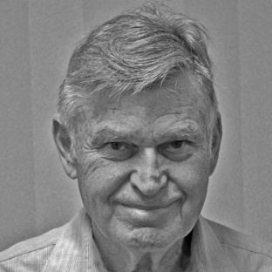

After the war my father rejoined the Royal Bank as an accountant in Weyburn. That is where my youngest brother was born in 1948. My father bought a hotel in Netherhill and my mother started teaching again. I was going to school and farming. I lived on the farm during high school and rode my horse to school. Winter made the ride interesting when the temperatures hovered around thirty below zero. My horse would cover the three miles in ten to fifteen minutes. Roads were not a problem because my horse could clear one in two jumps including ditches. I had to remain alert because he had no fear of cars. My only distinction was that when I graduated from high school the principal said that I missed more school working on the farm in my 12th year than anyone else in the history of the Delisle school. In 1956 I went to U of S and took Mechanical Engineering. During the summers I worked on the farm.
I worked one year as a field office manager for Bannister Pipeline. In 1960 I moved to Montreal and worked at Pratt and Whitney aircraft as a design engineer, in inspection and testing. I worked on PT6 turbo prop engine. Perhaps the most complicated installation for a turboprop governor is the PT-6 engine. This is due to the fact that the free turbine design of the PT-6 mandates control of the engine and propeller simultaneously.
I then Moved to Thompson Manitoba and worked with Inco as a mechanical trouble shooter in the Maintenance dept. In Thompson I got married to my dear wife Jean who has put up with me for the last 55 yrs. My first daughter Robin was born in the Thompson district of Mystery Lake. Thompson at that time was one of the largest integrated nickel plants in the world.
We moved to Winnipeg in 1964 where I worked in engineering with Malco Mfg. designing farm equipment. Malco Mfg. was purchased by Allied Farm Equip of Chicago and I worked as Chief Engineer for them for a number of years. My other 2 daughters were born in Winnipeg, Morgan in 1966 and Cynthia in 1970.
I moved to London Ontario in 1972 and worked with Eagle Machinery as Chief Engineer. Eagle was subsequently purchased by George White Comp and I worked with them as chief engineer.
I then moved to Woodstock and joined Timberjack. While in Woodstock my wife Jean got a degree from UWO and then worked in Real Estate in Woodstock for 30 years. With Timberjack I worked both as a designer and chief engineer of special products. Mine products and tree trimmers were purchased by Timberland Equipment.
I then moved to Timberland as a design engineer and worked with them on hoists, winches and very large units like one shipped on the Antonov AN 225 Mryia aircraft to Asia, we had to strip guards as it was too large to fit in hold of the aircraft.
I retired at 65 but I was asked to come back after some months of retirement and worked with Timberland till I was fully retired at 71. I now specialize in being retired, golfing and curling. My goal at present is to golf my age.

