**Phillip Thorne**

|  |  |
| --- | --- |
| Phillip Thorne was born on Aug 24th, 1949, in Woodstock. In 1951 the family relocated from Centre Street to 525 Lee Avenue. Back then, that area was largely open fields: a great place for a kid to grow up. Phil fondly remembers Naif Shaheen, Ken Riehl and Art Robar from his days at Northdale Public and WCI.    In 1969 Phil attended Fanshawe College where he took a two-year accounting course. Later, as a mature student, he attended UWO, earning a BA in Accounting and Computer | E:\2013 12 Probus booklet Photos\Thorne, Phil.jpg |

Science. Over the next 35 years Phil worked in accounting: first as a Cost Accountant, and later as a Cost and General Accounting Supervisor and finally as the Controller for a number of manufacturing companies in the Woodstock area.

In July of 1970, Phil married Brenda, his high school sweetheart. In 1977, twin sons, Mathew Edward and Stephen Clark, were born (a logistical challenge that Phil dismissed by saying, “it was just a matter of getting into a routine”). In April of 1981, the Thorne’s family was rounded out with a daughter, Sarah Andrea.

In 2004 their daughter Andrea married Andrew Milne and the couple moved to Edmonton where Andrew continues his PhD studies. In 2005, Stephen married his wife, Michelle, whom he met while living in Austin, Texas. In 2006 Stephen and Michelle moved to Waterloo. Mathew is also in Waterloo pursuing a PhD in computer science and animation. Stephen and Michelle now have two young sons. When Phil speaks of them, you can tell that they’ve stolen their “papa’s” heart.

Brenda and Phil love to travel: even with three young children vacation time was spent on the road exploring the Eastern parts of the US and Canada. In October 2005 their horizons expanded with a cruise round the Hawaiian Islands. This was followed by cruises on the East Coast (2007) and in Alaska (2009). When Phil returned from Alaska, he decided to retire. In his words, ” We joined the government payroll”.

In 2010 they took an amazing trip to Europe that included visits to WW 1 and WW 2 battlegrounds, cemeteries and monuments. Canadian losses during the Great War had personal significance for both Phil and Brenda: Phil had lost a great–uncle in 1916 at Ypres and Brenda’s grandfather was wounded on the last day of that famous battle.

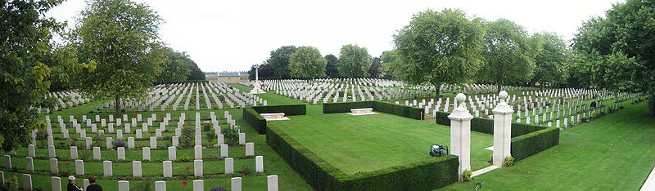

Burtonpe, "Beny-sur-Mer Cemetery"Sept 2006, Creative Commons Attribution

When not travelling, Phil likes to curl in the winter and in the summer plays a little golf. Phil is restoring a 1977 Corvette and with friend John Hincliffe is re-assembling John’s 1932 Desoto roadster. Phil continues to be involved in Scouting, being on the camp committee at Camp Shegardaynou and serving on staff at the Woodstock International Camp. Phil and Brenda have also developed a keen interest in family history, using the Internet for archival research combined with field trips to North Carolina and Manitoba to learn more family lore from family connections.