Everett Mossman
The son of a deep-sea fisherman, Everett Mossman was born and raised in Lunenburg, Nova Scotia. After high school, he attended Waterloo University College for his undergraduate degree and Waterloo Lutheran Seminary where he studied theology. He was ordained in 1967.  Everett spent the following thirty-four years as a Lutheran pastor. His first charge was at St. Mark's in Kingston where he combined pastoral duties with prison outreach. At St John's in Waterloo he was part of a team ministry and then he moved to | 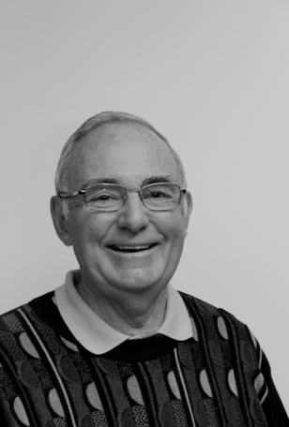
Cambridge where he led the congregation at St Paul's Lutheran.
Accepting a call from Peace Lutheran in Lower Sackville meant a return to his Nova Scotia roots, but it wasn't too long before Ontario beckoned again and he continued his full-time ministry serving congregations in Conestoga, St Jacobs and Tavistock, where he and his wife, Betty, settled down. At age sixty he retired, but he continued his ministry by serving a number of parishes on an interim basis for a further twelve years.
The Mossmans have now moved to Woodstock. They are living at 900 Chieftain and are finding that they really enjoy the freedom to just lock the door and take-off, feeling secure that all will be well when they return. Everett is involved with the curling club and has been known to play a round or two of golf during the off-season. They have two children and four grandchildren.
It was an interesting and carefully thought out presentation. I think for most of us it was a rare chance to learn something about the life of a minister as lived from the inside. He also shared with us what it is like to spend a lifetime trying to help people as they grapple with the big questions of life.

