Rick Bell
Rick Bell came into the world on Oct 7, 1946 in the town of Brampton. Rick weighed in, at a mere 5 lbs, 3 oz. at birth and in his words, “in my early years I spent more time in Sick Kids than anywhere else”. He modestly concluded, “you’d wonder how this fine specimen of manhood ever survived, but I did”. Rick’s family operated a dairy farm just north of Georgetown and Rick loved the life. After finishing high school he would have been perfectly content to start farming | 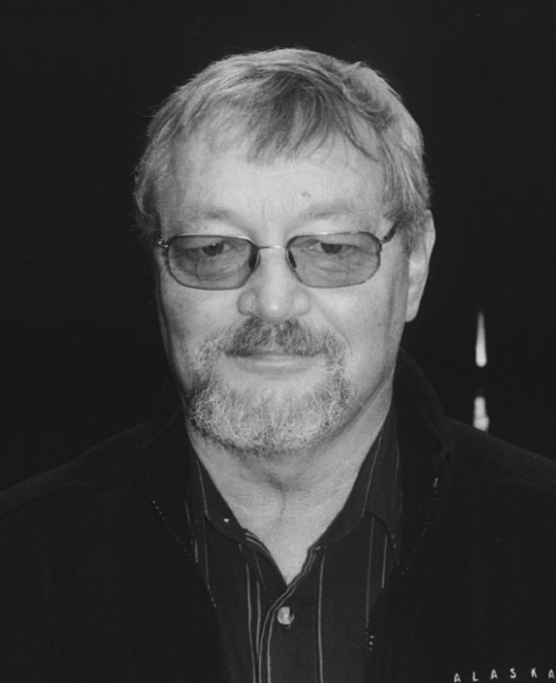
Full time, but his father insisted that Rick continue his education and so Rick found himself at the University of Guelph studying microbiology
After graduating in 1968, Rick’s first job was with the Ontario Ministry of Agriculture and Food, working as a milk inspector. This involved travelling from farm to farm talking to dairymen. Rick was then in his very early twenties. Rick asked us to imagine how well his advice on farming was received by men who had been farming for 30 years. A response involving a pitchfork was mentioned!
Rick’s real ambition was to become a teacher but teaching positions were scarce. Many resumes were mailed out but not much response. Finally, in July of 1969 a high school in Stratford offered him a position. Rick had not yet attended teacher’s college so his new employer asked Rick to prepare a sample 30-minute lesson. Rick’s lesson didn’t quite last 30 minutes; in fact, Rick says it lasted more like five minutes. Never the less, the principal gave him a chance and he persevered successfully through his first year. The following year he attended Althouse College and received his qualifications. After five more years in Stratford, Rick moved to Ingersoll where he taught agriculture and environmental studies for 14 years. The last 10 years of Rick’s teaching career were spent at College Avenue here in Woodstock.
However, there is more to life than just working. Rick met his wife Mary during his third year at Guelph. Oddly enough, the way the couple got together seems very much like meeting on Facebook or Twitter today, if you substitute old-fashioned letters for Internet dating. Rick introduced himself by writing to Mary and a lively correspondence ensued. It was only after five weeks of correspondence that they actually met face-to-face at a dance on St Patrick’s Day. Something must have been right because they became engaged just a few weeks later in May. Mary and Rick have three children. His sons, Derek and Craig, are both involved with IT while his daughter, Amy, works as an auditor for the Canada Revenue Agency.
Getting back to farming. Rick still loved the life out on the farm. Virtually every summer was spent working on various farms in the county and beginning in the early 1980’s he worked steadily with fellow Probian, Bill Weatherston, for about the next twenty years until in Rick’s words “Bill got tired of me and sold the farm”. Rick would put in a full day of teaching and then at 3:30 head out to farm and work there until as late as 11:00 at night.
Since retiring, Rick and four of his friends operate a sugar bush operation that produces about 1,000 litres of syrup each spring. Any other spare time is occupied with a little business he and Don Taylor have started that handles small scale constructions: projects like fences, installing floors, etc. They call their business “Two Fools with Tools”.

