John Richardson
John was born in Darby, England, in 1944. John and his wife, Jill, who was born in Sheffield, have two children who were born in Britain. He left school in 1959. There were not a lot of jobs available so John registered with the labor exchange. John was offered an apprenticeship painter and decorator position. Fortunately for him he received art college training as part of that apprenticeship. When John finished his apprenticeship he decided this was not what he wanted to do so he took a job with the General Post Office. He held several positions with the GPO before deciding to | 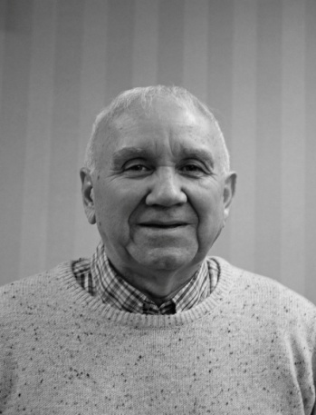
immigrate to Canada. He had done his homework and discovered that of all the countries people had left for Canada had the greatest rate of retention.
With wife and kids he arrived in Canada in June, 1973. With few jobs available John ended up working as a painter in Simcoe. Soon he was laid off. Luckily a friend told him of an opening and John was soon working a night shift in a tobacco factory. In the spring John got a call from Bell with a job in Brantford. He was soon transferred to Simcoe where he worked on the major companies in the region.
He also started coaching soccer, hockey and was a member of the Chamber of Commerce. Later he moved to Woodstock working at the Bell Control Centre again coaching hockey and soccer. Another move came for John to London where he coached and worked for Bell.
After eighteen years in London he accepted a buyout from Bell that greatly enhanced his pension. At fifty three John was not ready to do nothing so he ended up managing the Oxbow Glen Golf Course. When he left there he came back to Woodstock to be more central to his grandchildren who needed coaching in sports. John did a few more jobs then retired again. Looking back, life has been good, Canada has been good and he is living the good life golfing, watching hockey and being in Probus.

