Don Downing
Don was born on June 5th, 1937 and except for a brief period he has been a lifelong resident of Woodstock. When Don was in grade 11 he quite literally bumped into a pretty grade 10 student, Margot Boss. At the time he told his father that he thought he had met the girl he was going to marry. He was right: Don and Margot were married in 1958 just after he had finished Teachers | 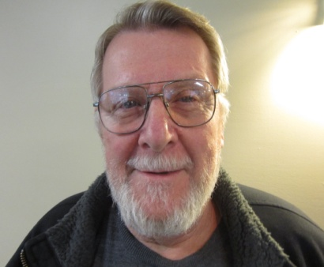
College.
Two years after they were married a daughter Catherine Louise was born and then seven years later a son, David. Three years later the Downing family was complete with the arrival of a second son, Geoffrey.
The young couple had settled in Sarnia for a time and while there a chance encounter opened up a whole new world. As Don says, “I luckily met a fellow there who changed my way of life. He taught me about canoeing, fishing, snowmobiling and hunting and these are things I have participated in ever since.”
Don and Margot returned to Woodstock in 1960 where he taught at Central School. In 1967 he joined the staff at the newly opened College Avenue Secondary School where he remained until he retired in 1992.
Following his new found interest in the out-of-doors; Don eagerly took part in a canoe trip organized by another teacher at the school. Big mistake. “It was the worst trip I have ever been on, I don’t know how we all got back alive.” Undaunted, he decided to start a proper canoe club at CASS. Before going on a trip, the students were given 25 hours of classroom instruction and 8 hours in the canoe. As an added safety precaution the students had to spend one hour in the Y pool fully dressed just so they would have some idea of what to do if a canoe capsized. All of this preparation paid dividends as in the forty-four trips that followed there were very few incidents.
Perhaps the most serious occurred was when Don’s son David shattered his leg early one morning.
Amazingly, Don was able after several hours of paddling and portaging to reach a telephone. Within a short time a helicopter evacuation was arranged and his son was admitted to University Hospital in London by 4 PM. All this before the invention of the cell phone and GPS.
Don decided he should take a course in running canoe trips and this led to his involvement with the Ontario Recreational Canoe Association. Before the course was over he had been elected treasurer of the organization, a position he held for twenty years. For six of those years he served as a Vice-President of the Canadian Recreation Canoe Association representing Ontario and Quebec.
Apart from running the CASS canoe trips Don has been involved in a number of organizations. For 15 years Don worked with Frank Smith as a chef with Operation
Sharing and also served on the board. Don was on his church board for around 15 years and he also joined the cemetery board, which he is still on. He can still be found working as a groundskeeper at the Anglican cemetery.

