Earl Clayton
Before turning the podium over to Earl, our president, Dave Clowes, recalled a story from his teaching days. There was a spelling mistake in a student’s essay, just one misplaced letter turned the tedious into the hilarious. As Dave put it, “a lot of funny things happened in Norwich “. Dave’s story proved to be a good lead in for Earl; the first thing Earl said (and he said it with an ironic smile) was that he’d been born in Norwich in 1938. The crowd loved it. | 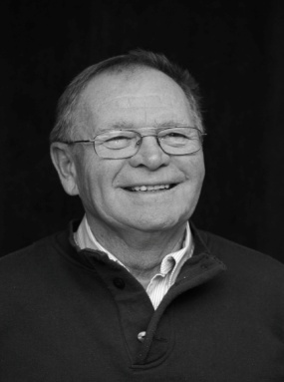
His parents, Howard and Violet Clayton, were of Quaker stock. They gave Earl a solid grounding in life, but were also broadminded enough to allow him to develop independently, and to accept the individual he has become. At this point, Earl looked up from his prepared notes and said, “I am waiting for Ian Hart to butt in here with "probably strange". This was the first of many times that Earl would invite someone in the room to confirm something he was saying. Earl seems to know most of the people in the room.
Earl was still in grade 13 at NDSS, when he met his wife, Ruth. She was the oldest daughter of Elmer and Ileen Almost of Otterville. He was eighteen and Ruth was just sixteen. After attending NDSS in Norwich, Earl earned a diploma in Animal Husbandry from OAC (1959).
After Ruth and Earl were married in 1960, Earl worked for his uncle Gordon Walker, trucking livestock to Kitchener, looking after the hogs, picking apples in their orchard, milking cows, and generally helping with work on the farm. In 1962, Earl’s father decided that he had had enough of farming so Earl and Ruth took over the family farm. In 1963 their first son, Morrie, was born. 1966 saw the birth of their second son, Ryan
In 1984, Earl was elected as a Director at Oxford Milkway Transport Co-op, serving two 3-year terms, including one year as Chairman. In 1990 he was asked to succeed Jim Fleming as Secretary-Treasurer and acted in that position until 1999.
In 1987, their eldest son graduated from Fanshawe and became a full partner in the family enterprise. Although Earl officially retired in 2000, he was able to slow down gradually, helping on the farm until 2006 when a health issue meant giving up this role. The year 2007 brought great sorrow. As Earl said,”2007 saw the passing of my wife, the mother of my boys, my best friend and co-worker”.
Earl now lives on Concession 14 of East Zorra Tavistock, across from the Burtch Farms Estate Winery. His acreage gets farmed during the summer and Earl cuts the grass around the buidlings. For recreation, Earl disks in the winter with his friends Moe Cosyns, Mory Robinson, Jim Elliot and Ian Hart and in his words,”depends on my host of friends to keep retirement meaningful”.

